Supplementary material
Table S1 Primer sequence
Gene | Forward (5’-3’) | Reverse (5’-3’)
Human-PTGS2 | TCCCTGAGCATCTACGGTTTG | CATCGCATACTCTGTTGTGTTCC
Human-NOX1 | GGCTTAGGGATTCACGGCATT | GCCTACAGTGGGAGTCACGATC
Human-TFR1 | GCTGGAGACTTTGGATCGGTTGG | TATACAACAGTGGGCTGGCAGAAAC
Human-GAPDH | ACATCATCCCTGCCTCTACTG | TTTGGCAGGTTTTTCTAGACGG
Mouse-PTGS2 | CTGGTGCCTGGTCTGATGATGTATG | GGATGCTCCTGCTTGAGTATGTCG
Mouse-FPN | TGGAACTCTATGGAAACAGCCT | TGGCATTCTTATCCACCCAGT
Mouse-ACSL4 | TTGGCTACTTACCTTTGGCTCATGTG | TACAATCACCCTTGCTTCCCTTCTTG
Mouse-NOX1 | CTCCAGCCTATCTCATCCTGAG | AGTGGCAATCACTCCAGTAAGGC
Mouse-TFR1 | TCGTGGAGACTACTTCCGTGCTAC | TCTTGGAGATACATAGGGCGACAGG
Mouse-ALOX5 | GGCAGGAAGACCTGATGTTTGG | GCAGCTCAAAGTCCACGATGAA
Mouse-ALOX8 | GATACACCCTGCACATCAACACA | TCAGGCAGACACAGGAGAGAATAG
Mouse-ALOX12 | CAGGTAGTGAGCACAGGTGGAG | GCCAGATCATCAGGAGGACAGAG
Mouse-ALOX15 | AGTTCCTCACCTACTCTACACCATG | CCTCCTCCACCTGTGCTCATC
Mouse-LPCAT1 | CGAGAGTGGTGGTGGTGAGATTG | GCTGGATGGTGGCTAAGGTCTG
Mouse-LPCAT3 | ACCGTCACTGCCGTTATTACTACC | ATTCCCGTCTTTGCCTCCATCG
Mouse-GAPDH | TCACCATCTTCCAGGAGCGAGAC | TGAGCCCTTCCACAATGCCAAAG

Table S2 The number of differential lipid molecules
Comparison | Total | Up | Down | Sum
WT+TP vs WT | 3828 | 983 | 670 | 1653
Nrf2^{-/-} vs WT | 3828 | 1121 | 735 | 1856
Nrf2^{-/-}+TP vs Nrf2^{-/-} | 3828 | 543 | 423 | 966
Nrf2^{-/-}+TP vs WT+TP | 3828 | 862 | 471 | 1333

Figure S1. Genotype identification showed that the Nrf2 knock-out mice were homozygous knockout mice (Nrf2^{-/-}). Primer 1 (F1: 5’-GAAGCATTATCATTTGGTGGGAAC-3’; R1: 5’-TGCACCAGAGTTCAAAGGTAGC-3’, 491 bp) was used to detect mutant alleles. Primer 2 (F1: 5’-GAAGCATTATCATTTGGTGGGAAC-3’; R2: 5’-TGTCTGCCATGAACCCTGTCTC-3’, 513 bp) was used to detect wild type alleles. Homozygotes: 491 bp; Heterozygotes: 491 bp/513 bp; Wild type allele: 513 bp.

Figure S2. Fer-1 treatment reduced the ROS production induced by TP in AML12 cells. ROS was detected by DCFH-DA staining (scale bar=50μm, n=3).

Figure S3. GPX4 overexpression reduced the ROS production induced by TP in AML12 cells. ROS was detected by DCFH-DA staining (scale bar=50μm, n=3).

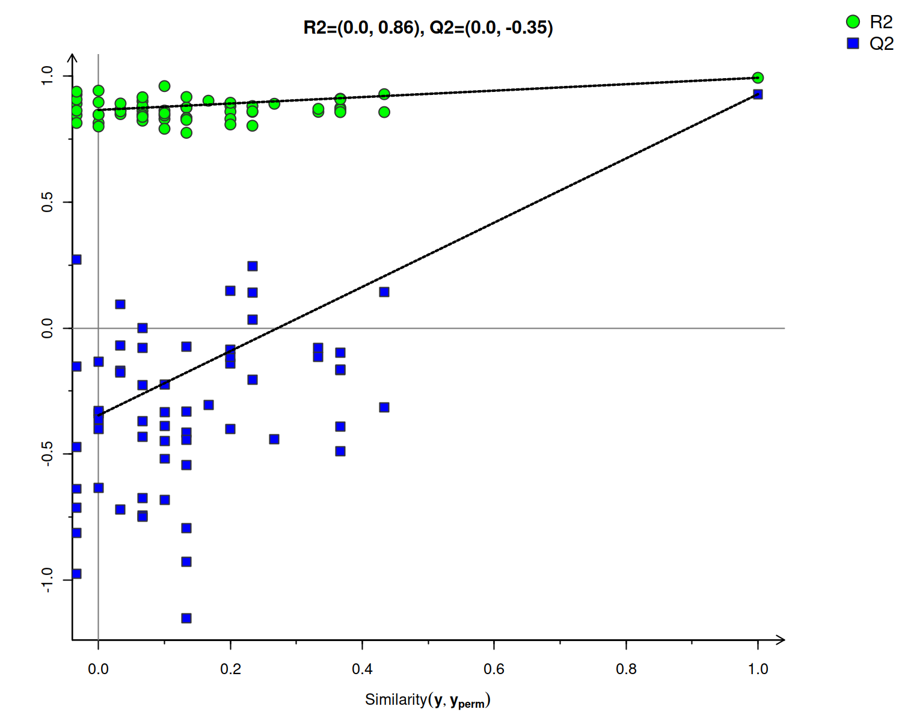
Figure S4. OPLS-DA permutation test plot. The points corresponding to R2 and Q2 in the upper right corner represent the OPLS-DA model parameters for the true grouping of samples, while the left side displays the parameters of different sample grouping models obtained through multiple permutation tests. The figure meets the following two conditions, demonstrating the results are reliable and valid: 1. All blue Q2 points are lower than the original blue Q2 point on the far right; 2. The intercept of the regression line with the vertical axis is less than 0. R² indicates the overall goodness of fit of the model, and Q² represents the predictability of model.

Figure S5. Nrf2 overexpression reduced the ROS production induced by TP in AML12 cells. ROS was detected by DCFH-DA staining (scale bar=50μm, n=3).

