Supplementary Figure S1
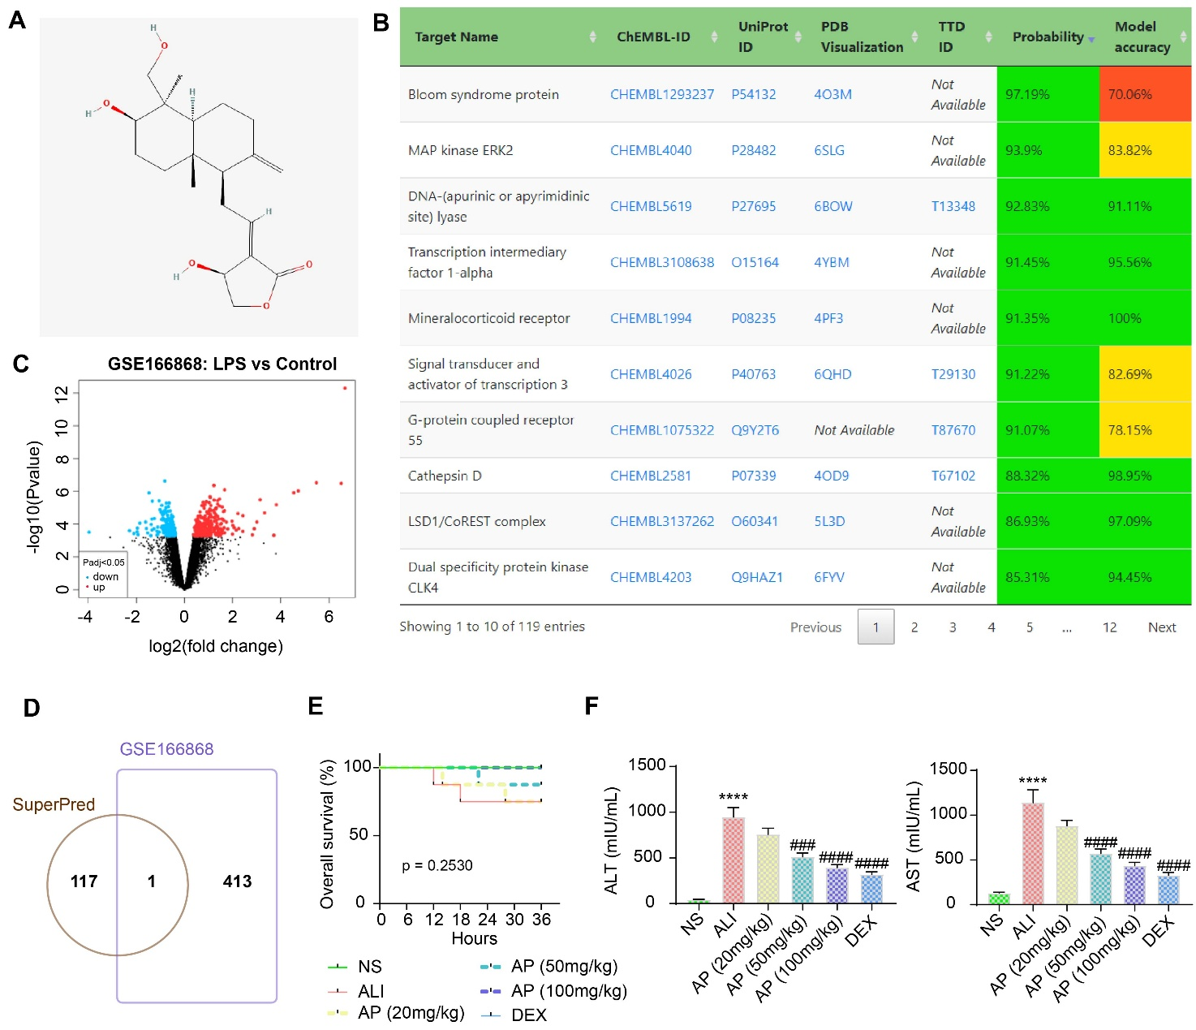
Supplementary Figure S1 Downstream target prediction of AP and the effects of AP on survival in ALI mice. (A) The chemical structural formula of AP. (B) Downstream target proteins of AP are predicted using the SuperPred database. (C) Differentially expressed genes in liver tissues of ALI mice in the GSE166868 dataset. (D) Potential downstream targets of AP differentially expressed in the liver of ALI mice. (E) The survival of mice pretreated with AP and induced with ALI within 36 h was analyzed using a log-rank test (n = 8). Data are mean ± SEM, ****p < 0.0001, ###p < 0.001, ####p < 0.0001 by one-way ANOVA followed by Tukey’s test.

Supplementary Figure S2
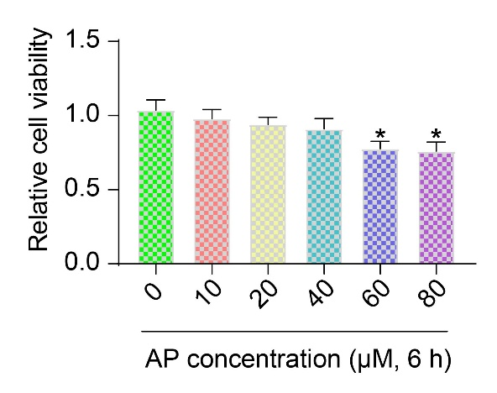
Supplementary Figure S2 Dose-dependent toxicity of AP on liver parenchymal cells was examined using CCK8 assay. Data are mean ± SEM (n = 3), *p < 0.05 by one-way ANOVA followed by Dunnett's test.

Supplementary Figure S3
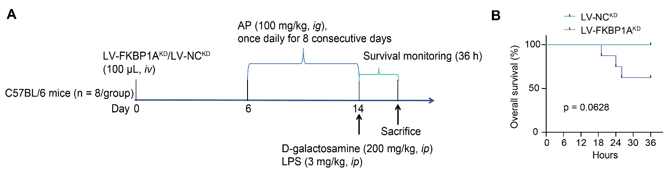
Supplementary Figure S3 The operation process (A) and survival (B) of animals treated with LV-FKBP1A^{KD} and AP (n = 8).

Supplementary Figure S4
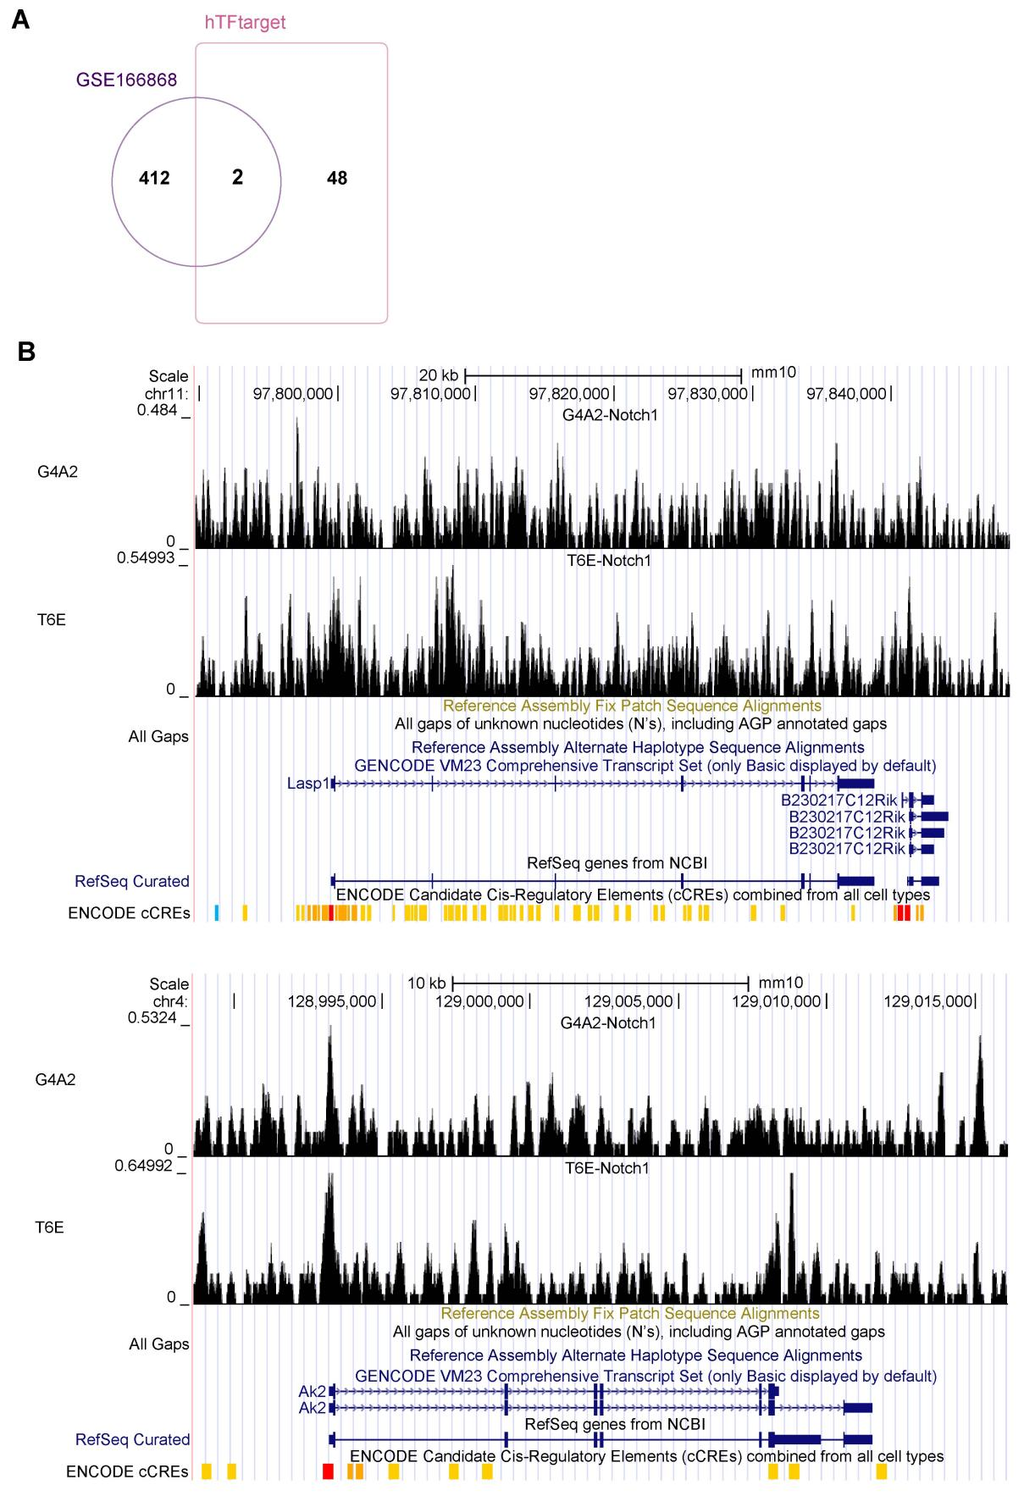
Supplementary Figure S4 Screening of NOTCH1 downstream targets. (A) The intersection of differentially expressed genes in the GSE166868 dataset and potential downstream targets of NOTCH1 in the hTFtarget database. (B) NOTCH1 binding at the LASP1 and AK2 promoter was predicted in the ChIP-seq database.
Supplementary Figure S5
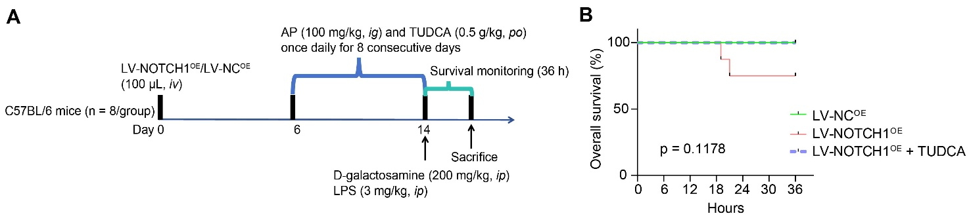
Supplementary Figure S5 NOTCH1 is involved in ALI progression through the ER stress pathway. (A) The operation process of animals treated with LV-NOTCH1^{OE}, AP, and TUDCA. (B) The effect of LV-NOTCH1^{OE} injection and TUDCA on the survival of ALI mice at 36 h was analyzed using a log-rank test (n = 8).

