Supplementary text
Increased reactive astrocytes in hippocampal CA1 region mediated by decreased CXCR7 is involved in postoperative cognitive dysfunction in aged mice
Qiang Liu^{a,†}, Chen-Rui Zhou^{b,†}, Hai-Bi Wang^{b,†}, Yan-Ping Liu^{b}, Wei Dong^{b}, Jie Wan^{b}, Hui-Hui Miao^{c,*}, Cheng-Hua Zhou^{d,*}, Yu-Qing Wu^{b,*}

Materials and Methods
2.1. Reagents
AMD3100 (A5602, Sigma-Aldrich), a CXCR7 agonist, was dissolved in saline before administration. According to a previous study, the injection was given once daily for four days at a dose of 0.5 mg/kg/day (Das et al. 2019), and the first injection was given one hour before the orthopedic surgery. CNO (HY-17366, MCE) was dissolved in DMSO and diluted in 0.9% saline to obtain a final DMSO concentration of 0.5%. The saline solution used for control injections also contained 0.5% DMSO. CNO was administered intraperitoneally once daily for four days at a dose of 1 mg/kg/day, and the first injection was given half an hour before the orthopedic surgery. The recombinant adeno-associated viral vectors utilized in this study were obtained from Brain VTA (Wuhan, China) and OBIO Technology (Shanghai, China), which included AAV-EF1α-DIO-CXCR7-eGFP, AAV-EF1α-DIO-eGFP, AAV-EF1α-DIO- hM4D(Gi)-mCherry, AAV-EF1α-DIO-mCherry. The concentrations of AAV serotype 2/5 are between 1 × 10¹² to 5 × 10¹² vg/mL.
2.2. Stereotaxic surgery and microinjections
Mice were anesthetized with 3% sevoflurane and placed on a small animal stereotactic apparatus (RWD, Shenzhen, China). After sterilization, holes were drilled bilaterally above the target injection site, and the virus was injected bidirectionally at a rate of 0.1 µL/min using a Hamilton syringe needle (33-gauge) and a pump (Harvard Apparatus, Holliston, MA). A 10-min pause was observed to minimize reflux. The volume of the virus suspension injected into the unilateral hippocampus was 0.2 µL. The microinjections targeted the CA1 region (anterior-posterior, -1.94 mm; lateral-medial, ±1.4 mm; dorsal-ventral, -1.5 mm). The following methods was done to ensure the accuracy of the viral injection. Firstly, histological verification, three weeks after the viral injection, animals were perfused, and brains were sectioned for histological analysis. Fluorescence microscopy was used to visualize viral expression and confirm the injection site. Only mice with accurate targeting and robust expression in the intended region were included in the final analysis. Secondly, the quantification of expression, the extent of viral spread and expression levels were quantified using image analysis software (ImageJ). Expression was considered accurate if it was confined to the target region and met predefined criteria (>80% coverage of the target area). Thirdly, the exclusion criteria, mice with off-target injections, insufficient expression, or excessive spread beyond the target region were excluded from the study. The viral injections were administered four weeks before the surgery.
2.3. Behavioral tests
The novel object recognition test (NORT) and object location test (OLT) were performed to evaluate object recognition and spatial memory in mice, respectively, as described previously (Arroyo-García et al. 2021; Companys-Alemany et al. 2020). Both NORT and OLT consisted of three phases: habituation, acquisition, and recall. The experiments were conducted in an experimental box (50 cm in length, 50 cm in width, and 40 cm in height), which was also used for the open field test. During the habituation phase, each mouse was individually placed in the experimental apparatus without any object for 10 min (habituation phase). The next day, the mice were exposed to two identical red cylinders at two corners of the same side for 15 min (acquisition phase). Twenty-four hours after the acquisition phase, the recall session was conducted, where each mouse was allowed to explore the arena for 5 min. For NORT, one of the familiar objects in each pair was replaced with a novel object (yellow rectangular block). For OLT, the two original objects were placed at the two diagonal corners instead of on the same side. The experimental apparatus and objects were thoroughly cleaned with 75% ethanol between trials to eliminate the influence of olfactory cues. The exploration time was quantified in each phase (exploration was defined as sniffing or touching the objects with the nose), and the time spent exploring the novel object was assessed by the recognition memory index, which was calculated by the ratio TN / (TF + TN), where TN is the time spent exploring the novel object, and TF is the time spent exploring the familiar object.
2.4. Western blot analysis
Western blotting was performed as we described before (Liu et al. 2021). Briefly, after the completion of behavioral tests, mice were euthanized by cervical dislocation under deep anesthesia, and whole brains were rapidly extracted within 60 seconds and placed on an ice-cold platform. The hippocampus was immediately dissected from each hemisphere under 4°C conditions. The dissected hippocampal tissue was flash-frozen in liquid nitrogen to preserve protein integrity and stored at -80°C until processing. For protein extraction, frozen tissues were homogenized in ice-cold RIPA buffer containing protease and phosphatase inhibitors, followed by centrifugation at 12,000 × g for 15 min at 4°C. SDS-PAGE (8–15%) was used to separate proteins (30 µg per lane), which were then transferred onto PVDF membranes (Millipore, USA). After blocking, the membranes were incubated overnight at 4 °C with the following primary antibodies: rabbit anti-CXCR7 (1:1000, A12712, RRID:AB_2759553, ABclonal), rabbit anti-PSD95 (1:1000, 2507S, RRID:AB_561221, Cell Signaling Technology), mouse anti-GFAP (1:1000, 3670S, RRID:AB_561049, Cell Signaling Technology), rabbit anti-C3 (1:1000, 72914S, RRID: AB_3698200, Cell Signaling Technology), and rabbit anti-S100β (1:1000, ab52642, RRID:AB_882426, abcam). The membranes were then washed three times and incubated with the secondary antibody (1:2000, ab6789, Goat Anti-Mouse IgG, RRID:AB_955439, Abcam; 1:2000, ab97051, Goat Anti-Rabbit IgG, RRID:AB_10679369, Abcam) conjugated to horseradish peroxidase for 1 h at room temperature. Specific immunoreactivity was detected using enhanced chemiluminescence (Beyotime, P0018S, China). The bands were measured using ImageJ analysis software.
2.5. Immunohistochemistry
The mice were deeply anesthetized and subsequently perfused intracardially with 0.9% saline and 4% paraformaldehyde. The brains were removed and post-fixed overnight at 4°C, followed by cryoprotection in 30% sucrose solution for 72 h. Sections (30 µm thick) were prepared using a freezing microtome (VT1000S, Leica Microsystems). For each mouse, two coronals sections were collected. The first section was taken at Bregma -1.8 mm, with subsequent sections collected at 120 μm intervals. The slices were blocked with 5% goat serum albumin for 60 min and then incubated with the following primary antibodies in a cold room at 4°C overnight: rabbit anti-Iba-1 (1:200, ab178846, RRID:AB_2636859, abcam), mouse anti-GFAP (1:200, 3670S, RRID:AB_561049, Cell Signaling Technology), rabbit anti-CXCR7 (1:100, A12712, RRID:AB_2759553, ABclonal), rabbit anti-C3 (1:100, A6879, RRID:AB_2767439, ABclonal), and rabbit anti-S100β (1:100, ab52642, RRID:AB_882426, abcam). The secondary antibodies were tagged with goat anti-mouse Alexa 594 (1:500, ab150116, RRID:AB_2650601, Abcam), goat anti-rabbit Alexa 488 (1:500, ab150077, RRID:AB_2630356, Abcam), and goat anti-mouse Alexa 647 (1:500, ab150115, RRID:AB_2687948, Abcam). After staining, the sections were mounted onto glass slides. 20X and 40X images in hippocampal CA1 region were obtained using a confocal microscope (LSM 880, Carl Zeiss Microscopy, Germany). To obtain the full area, the image stitching was performed using Zeiss software.
2.6. Enzyme-linked immunosorbent assay (ELISA)
The hippocampal tissues were isolated and homogenized in pre-cold phosphate-buffered saline (0.01 M, pH 7.4) immediately. The homogenates were subjected to centrifugation at 3000 rpm for 10 min, and the supernatants were collected. TNF-α (Cat. No. E-EL-M3063; Elabscience), IL-1β (Cat. No. E-EL-M3063; Elabscience) and IL-6 (Cat. No. E-EL-M0044c, Elabscience) were measured according to the manufacturer’s protocols. The optical density (OD) at 450 nm was measured using an ELISA plate reader (Multiskan GO, Thermo Scientific, USA).
2.7. Golgi-Cox staining
Hippocampal synaptic structural plasticity was examined using Golgi staining, as previously described (Wu et al. 2024). The FD Rapid GolgiStainTM Kit (FD Neuro Technologies, PK401, USA) was utilized in compliance with the manufacturer’s instructions. Briefly, the mice were euthanized under deep anesthesia, and their brain tissues were immediately immersed in a mixture of solution A and solution B for 24 h. The solutions were changed once, and the tissues were stored in the dark at room temperature for two weeks. The tissues were subsequently carefully transferred to solution C and stored at room temperature in the dark for 72 h. Brain sections of 120 μm thickness were prepared with a vibratome. The sections were then immersed in a mixture of solution D and solution E to fix the stain for 10 min at room temperature. The sections were washed twice with double-distilled water for 4 min each, followed by gradient dehydration in 50, 75, 95, and 100% ethanol. Xylene was utilized to clear the sections three times for 4 min each time. The slides were then coverslipped using Permount. The hippocampal neurons were captured by an auto microscope under Z-stack mode (×20 object) for dendritic analysis. The dendrites from hippocampal neurons in CA1 region were captured with Olympus BX53 microscope (× 60 oil object). Dendrite branches were traced by the NeuronJ plugin in ImageJ software, and the dendritic length was calculated. Sholl analysis was applied to measure the complexity of dendrites. For dendritic spine density analysis, dendrite segments were selected from secondary or tertiary branches of hippocampal CA1 pyramidal neurons based on staining clarity, structural integrity, and avoidance of overlapping processes.
2.8. Transmission electron microscopy
Transmission electron microscopy (TEM) was employed to examine alterations in synaptic ultrastructure. Briefly, mice were euthanized under deep anesthesia, and the hippocampal CA1 was isolated. The tissues were immediately cut into small pieces with a size of 1 mm³ on ice and then fixed with 2.5% glutaraldehyde at 4 °C overnight. After washing three times in phosphate-buffered saline, the sections were fixed in 1% osmium tetroxide, stained with a 2% aqueous solution of uranyl acetate, and then dehydrated with gradients of different concentrations of ethanol and acetone. Finally, the samples were embedded in epoxy resin. Ultrathin sections (70 nm) were cut with an ultramicrotome, collected on a copper grid, and stained with 4% uranyl acetate and lead citrate. A previous study revealed that synapses are divided into asymmetric and symmetric synapses, or Gray I type and Gray II type synapses (Shi et al. 2020), which are considered to mediate excitatory and inhibitory transmission. In this study, we examined asymmetric synapses for excitatory synaptic measurements. Post-synaptic density (PSD) thickness was assessed as the length of the vertical line from the post-synaptic membrane to the most prominent portion of the synaptic complex. The widths of the synaptic clefts (SCs) were estimated by measuring the widest and narrowest portions of the synapse and averaging these values.
2.9. Hippocampal slice electrophysiology
Long-term potentiation (LTP) recordings were used to evaluate functional synaptic plasticity as described before (Lin et al. 2018; Liu et al. 2022; Zhang et al. 2018). Mice were anesthetized with sevoflurane and decapitated. The brains were immediately removed and immersed in ice-cold dissection buffer containing the following (in mM): 80 NaCl, 3.5 KCl, 4.5 MgSO₄, 0.5 CaCl₂, 1.25 NaH₂PO₄, 90 sucrose, 25 NaHCO₃, and 10 glucose for 2–3 min. The brains were then cut into 300 μm thick sections using a vibratome in an ice-cold dissection buffer continuously aerated with 95% O₂ and 5% CO₂. Sections were incubated in oxygenated artificial cerebrospinal fluid (ACSF) containing the following (in mM): 126 NaCl, 2.5 KCl, 1.2 NaH₂PO₄, 1.2 MgSO₄, 2.4 CaCl₂, 26 NaHCO₃, and 10 glucose, pH 7.4 (continuously equilibrated with 95% O₂ and 5% CO₂) for 2 h at 32℃. Hippocampal slices were transferred to the recording chamber and perfused with ACSF at a rate of 2-3 mL/min at 32℃. Field excitatory post-synaptic potentials (fEPSPs) were evoked by inserting a concentric bipolar stimulating electrode into the Schaffer collateral/commissural afferents. Extracellular recording electrodes filled with ACSF were inserted into the CA1 region. Baseline responses were collected every 30 s using an input stimulus intensity that induced 30-40% of the maximum response. LTP was induced by three high-frequency stimuli (HFS:100 HZ, duration 1s, 10 min intervals). The averaged fEPSP slopes over the last 30 min of recording were used for the analysis.
2.10. Experimental designs and animal groups
As shown in Fig. 1, there were four experiments in this study.
In experiment 1, the mice were randomly assigned to control (Con) or surgery (Sur) group. Tibia fracture surgery was performed at day 0. The mice received behavior training at day 2 and behavioral testing at day 3 after surgery. Hippocampal tissues were immediately harvested at the end of the behavioral testing, and western bolt and immunofluorescence analysis were performed. Golgi staining and transmission electron microscopy were used to assess the hippocampal synaptic structural plasticity, and long-term potentiation was used to assess the hippocampal functional plasticity. The levels of TNF-α, IL-1β, and IL-6 were measured at days 1, 3, and 7 after surgery.
In experiment 2, the mice were randomly divided into 4 groups: the control + control adeno-associated virus (AAV) vehicle (VEH) group (C+VEH), the surgery + control AAV-VEH group (S+VEH), the control + AAV-CXCR7 vector group (C+CXCR7), the surgery + AAV-CXCR7 vector group (S+CXCR7). AAV-CXCR7/VEH virus was injected into the CA1 region of the hippocampus 21 days before surgery. Mice received behavioral training at day 2 and behavioral testing at day 3 after surgery. Hippocampal tissues were harvested for biochemical testing at the end of behavioral testing.
In experiment 3, the mice were randomly divided into 2 groups: Saline, AMD3100. Mice in the AMD3100 group received AMD3100 (a small synthetic allosteric agonist of CXCR7 receptor) one hour before the tibia fracture surgery, and same time point 1, 2 and 3 days later. Mice in the Saline group were injected with the same volume (100 μL) of saline. Mice received behavioral training at day 2 and behavioral testing at day 3 after surgery. Hippocampal tissues were harvested for biochemical testing at the end of behavioral testing.
In experiment 4, the mice were randomly divided into 2 groups: hM4Di-Saline, hM4Di-CNO. To chemogenetically inhibit the hippocampal CA1 astrocytes, AAV-DIO-hM4D(Gi)-mCherry was injected into the CA1 region of the hippocampus of Gfap-cre mice 21 days before surgery. Mice in the hM4Di-CNO group received clozapine-N-oxide (CNO, 1 mg/kg) half an hour before the tibia fracture surgery, and same time point 1, 2 and 3 days later. Mice in the hM4Di-Saline group were injected with the same volume of saline. Mice received behavioral training at day 2 and behavioral testing at day 3 after surgery. Hippocampal tissue was harvested for biochemical testing at the end of behavioral testing.
Reference
Arroyo-García LE, Tendilla-Beltrán H, Vázquez-Roque RA, Jurado-Tapia EE, Díaz A, Aguilar-Alonso P, Brambila E, Monjaraz E, De La Cruz F, Rodríguez-Moreno A, Flores G. Amphetamine sensitization alters hippocampal neuronal morphology and memory and learning behaviors. Mol psychiatr. 2021;26:4784–94.
Companys-Alemany J, Turcu AL, Bellver-Sanchis A, Loza MI, Brea JM, Canudas AM, Leiva R, Vázquez S, Pallàs M, Griñán-Ferré C. A Novel NMDA Receptor Antagonist Protects against Cognitive Decline Presented by Senescent Mice. Pharmaceutics. 2020;12:null.
Das S, Mishra KP, Chanda S, Ganju L, Singh SB. CXCR7: A key neuroprotective molecule against alarmin HMGB1 mediated CNS pathophysiology and subsequent memory impairment. Brain Behav Immun. 2019;82:319–37. https://doi.org/10.1016/j.bbi.2019.09.003
Lin PY, Kavalali ET, Monteggia LM. Genetic Dissection of Presynaptic and Postsynaptic BDNF-TrkB Signaling in Synaptic Efficacy of CA3-CA1 Synapses. Cell Rep. 2018;24:1550–61.
Liu JH, Zhang M, Wang Q, Wu DY, Jie W, Hu NY, Lan JZ, Zeng K, Li SJ, Li XW, Yang JM, Gao TM. Distinct roles of astroglia and neurons in synaptic plasticity and memory. Mol psychiatr. 2022;27:873–85.
Liu Q, Sun YM, Huang H, Chen C, Wan J, Ma LH, Sun YY, Miao HH, Wu YQ. Sirtuin 3 protects against anesthesia/surgery-induced cognitive decline in aged mice by suppressing hippocampal neuroinflammation. J Neuroinflammation. 2021;18:41. https://doi.org/10.1186/s12974-021-02089-z
Shi H, Yu Y, Lin D, Zheng P, Zhang P, Hu M, Wang Q, Pan W, Yang X, Hu T, Li Q, Tang R, Zhou F, Zheng K, Huang XF. β-glucan attenuates cognitive impairment via the gut-brain axis in diet-induced obese mice. Microbiome. 2020;8:143.
Wu WF, Chen C, Lin JT, Jiao XH, Dong W, Wan J, Liu Q, Qiu YK, Sun A, Liu YQ, Jin CH, Huang H, Zheng H, Zhou CH, Wu YQ. Impaired synaptic plasticity and decreased glutamatergic neuron excitability induced by SIRT1/BDNF downregulation in the hippocampal CA1 region are involved in postoperative cognitive dysfunction. Cell Mol Biol Lett. 2024;29:79. https://doi.org/10.1186/s11658-024-00595-5
Zhang H, Zhang C, Vincent J, Zala D, Benstaali C, Sainlos M, Grillo-Bosch D, Daburon S, Coussen F, Cho Y, David DJ, Saudou F, Humeau Y, Choquet D. Modulation of AMPA receptor surface diffusion restores hippocampal plasticity and memory in Huntington's disease models. Nat Commun. 2018;9:4272.
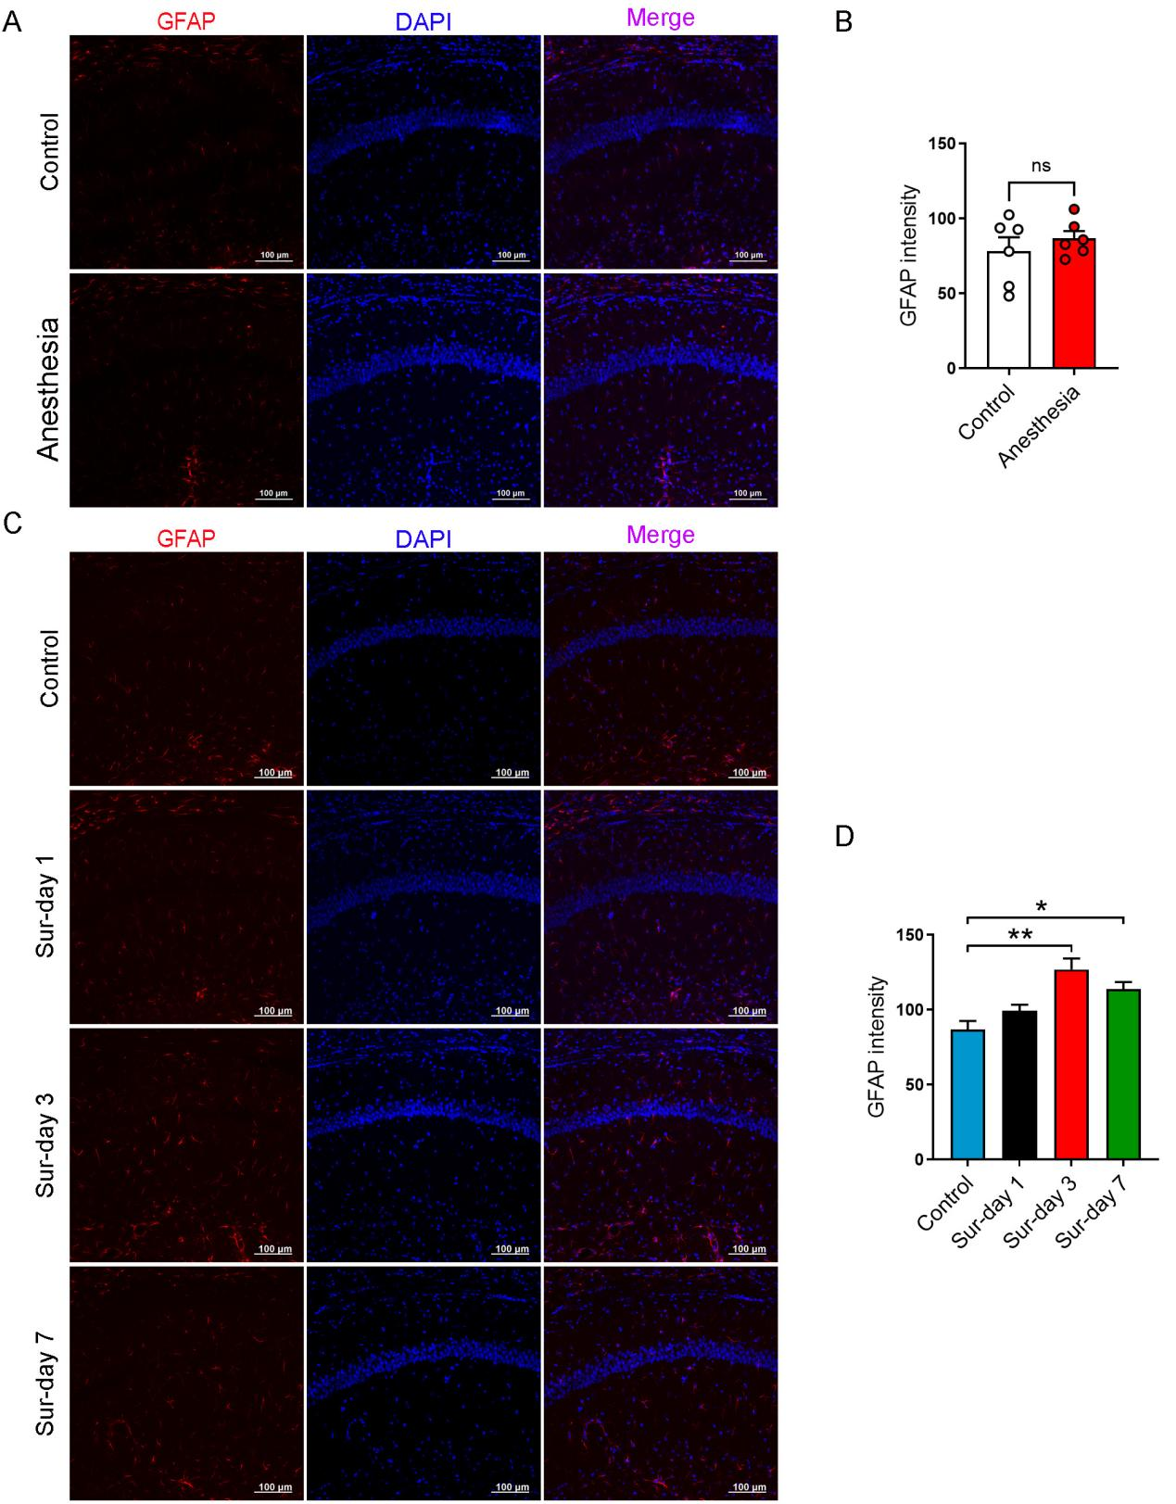
Supplementary Figure 1 Changes in the expression profiles of hippocampal astrocytes in mice following anesthesia alone or post-surgery. (A) Representative confocal images of GFAP in the hippocampal CA1 region following anesthesia. (B) Quantitative analysis of GFAP fluorescence intensity (n = 6 slices from 3 mice/group). (C) Representative confocal images of GFAP in the hippocampal CA1 region following surgery. (D) Quantitative analysis of GFAP fluorescence intensity (n = 6 slices from 3 mice/group). The data are presented as the mean ± SEM for each group. *P < 0.05, **P < 0.01. ns, no significance.

