Fig. S1 Images of control (con) and H/R group cells at 200x magnification. Scale bar = 50 μm. A the con group. B the H/R group.
Fig. S2 The results of Crispr/cas9 screening. A the test result of Aglient 2200. B The quality identification results of the strips were recovered by PCR.
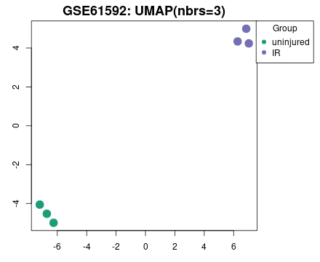
Fig. S3 UMAP visualization of the GSE61592 dataset. Green denotes the uninjured control group, and purple denotes the ischemia-reperfusion (IR) injury group.
Fig. S4 Results from transmission electron microscopy for each group are provided, with red arrows indicating the damaged mitochondria at 15000x magnification. Scale bar = 1μm (n = 4).
Fig. S5 Results from ultrasound images for sham and I/R group are provided (n = 6).

