Supplementary Fig. 1
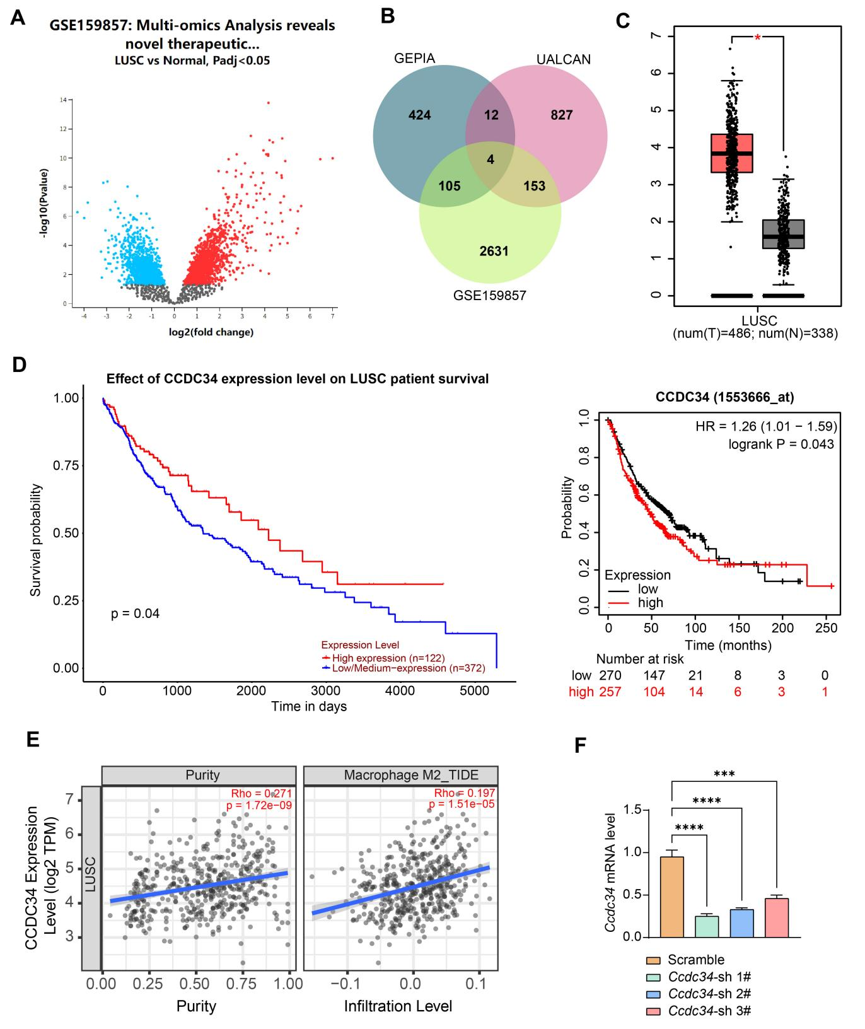
Supplementary Fig. 1 CCDC34 is a novel biomarker in LUSC and is associated with TAM-M2 polarization. A, The volcano plot of differentially expressed genes in tumor tissues and normal tissues of LUSC patients analyzed by the GSE159857 dataset. B, The intersection of significantly elevated differential genes in LUSC downloaded from GEPIA, prognostic markers downloaded from the UALCAN database, and the differentially expressed genes in the GSE159857 dataset. C, Differential expression of CCDC34 in LUSC of the GEPIA database. D, Analysis of the survival of LUSC patients with high or low expression of CCDC34 in the UALCAN database. E, Detection of Ccdc34 expression after knockdown of Ccdc34 in LLC cells by RT-qPCR. F, The correlation between CCDC34 expression and M2 macrophage infiltration in LUSC was analyzed in the TIMER2.0 database. Data are from three independent biological experiments and presented as the mean ± SEM. Statistical significance was assessed using ANOVA. *** p < 0.001, **** p < 0.0001.

Supplementary Fig. 2
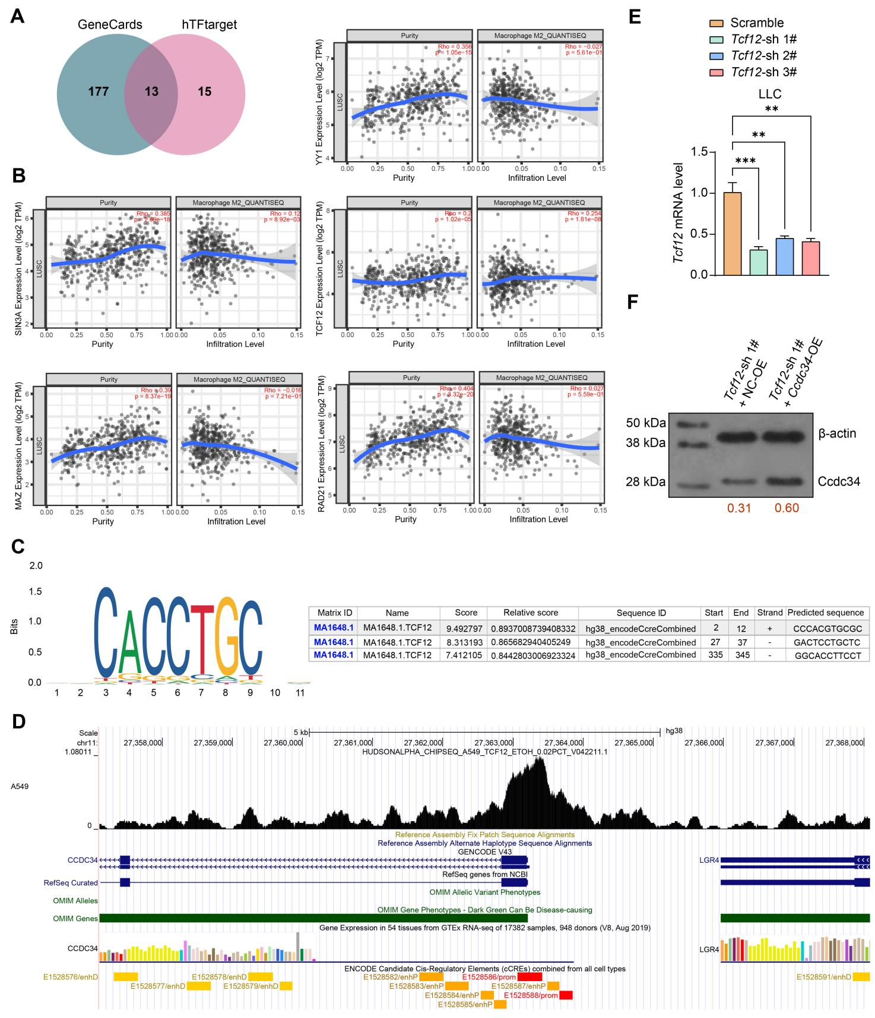
Supplementary Fig. 2 TCF12 is a candidate TF of CCDC34. A, The intersection of TFs regulating CCDC34 in lung tissue downloaded from the hTFtarget database and TFs with binding sites present at the CCDC34 promoter downloaded from GeneCards. B, The correlation between RAD21, MAZ, SIN3A, YY1, and TCF12 expression and M2 macrophage infiltration in LUSC was analyzed in the TIMER database. C, Analysis of TCF12 binding sites to the CCDC34 promoter in the JASPAR database. D, ChIP-seq database analysis of TCF12 binding at the CCDC34 promoter. E, Tcf12 expression in LLC cells infected with shRNAs targeting Tcf12. F, Ccdc34 expression in LLC cells infected with Tcf12-sh 1# + NC-OE or Ccdc34-OE. Data are from three independent biological experiments and presented as the mean ± SEM. Statistical significance was assessed using ANOVA (E). ** p < 0.01, *** p < 0.001.

Supplementary Fig. 3
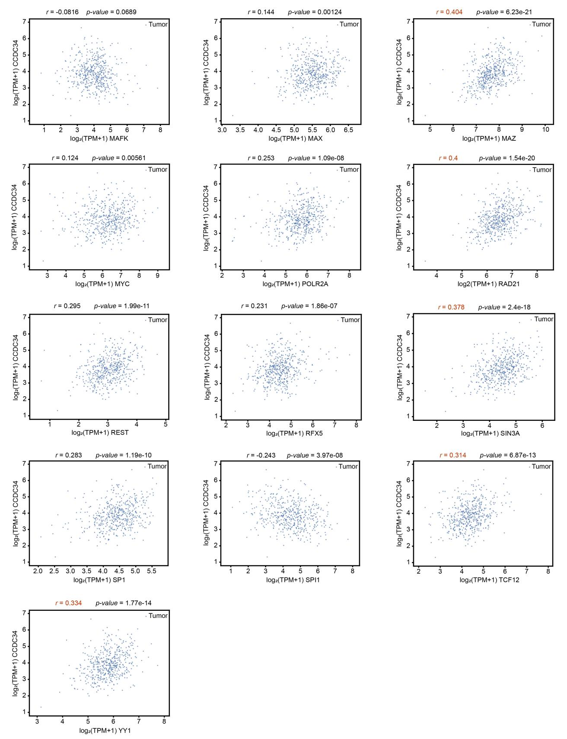
Supplementary Fig. 3 The correlation between the set of transcription factors that regulate CCDC34 and CCDC34 expression in LUSC in the GEPIA database.

