Supplementary Information - Cell Biology and Toxicology

Multiple sevoflurane exposures in early development lead to long-term vascular abnormalities in the hippocampus

Yu Matsumoto^{1,2}, Kazue Hashimoto-Torii^{1,3}, Masaaki Torii^{1,3,*}

¹Center for Neuroscience Research, Children's Research Institute, Children's National Hospital, Washington, DC 20010, USA.
²Department of Anesthesiology & Intensive Care Medicine Graduate School of Medicine, School of Medicine, The University of Osaka, 2-2, Yamadaoka, Suita-city, Osaka 565-0871, Japan.
³Department of Pediatrics, Pharmacology & Physiology, School of Medicine and Health Sciences, The George Washington University, Washington, DC, 20052, USA.

*To whom correspondence may be addressed:
Masaaki Torii
111 Michigan Avenue, N.W., M7631
Washington DC, 20010-2970
Phone: 202-476-4279
Email: mtorii@childrensnational.org

Supplementary Figure
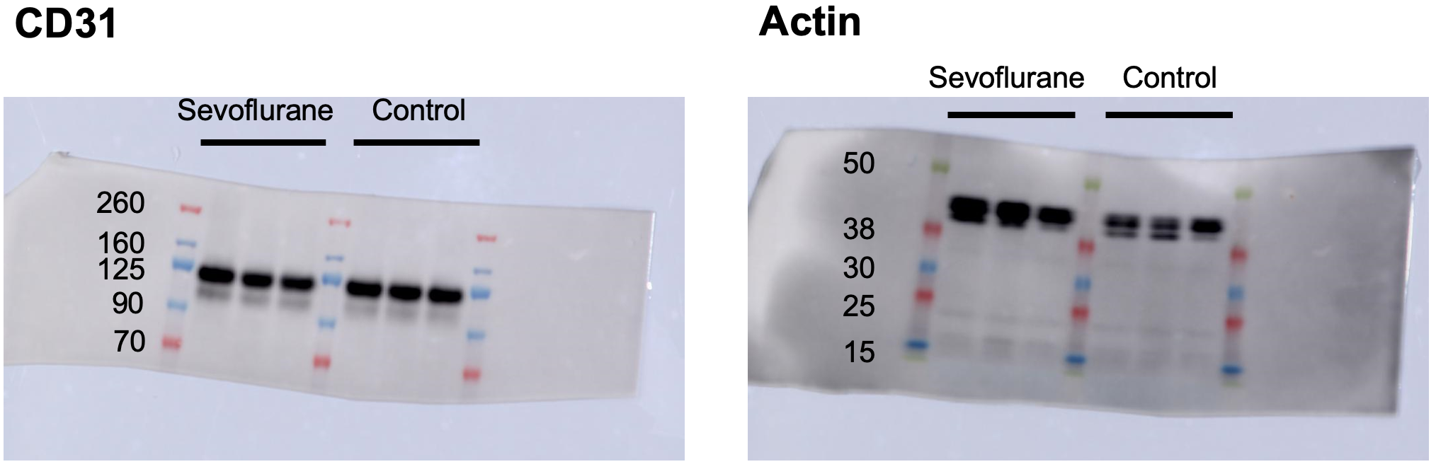
Supplementary Figure 1. Full uncropped gel and blot images for Figure 7b
Full uncropped images of Western blot analysis of CD31 and actin protein levels in BMECs in sevoflurane-exposed and non-exposed cultures.

