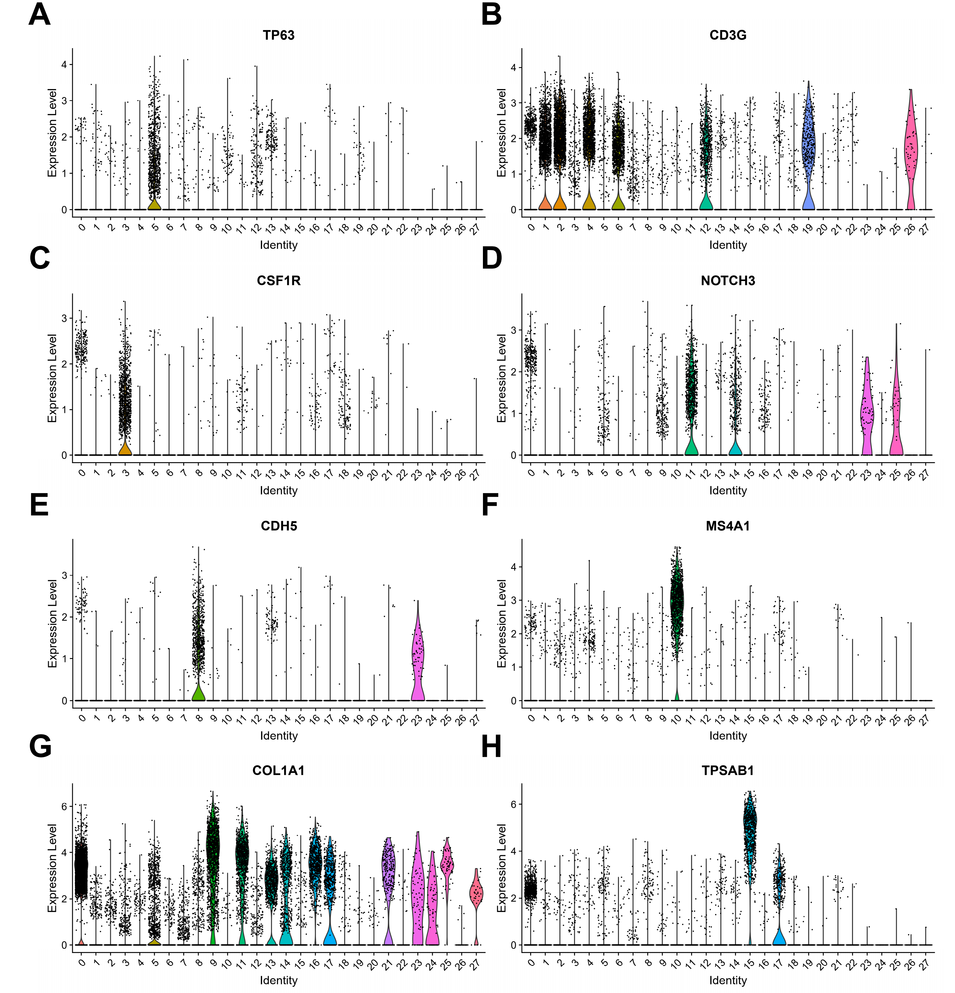
Supplementary Figures
Supplementary Figure. 1 Violin plots of marker genes for 8 annotated cell types in 28 identified cell clusters. (A) Violin plot of tumor cell marker TP63 in 28 identified cell clusters. (B) Violin plot of T cell marker CD3G in 28 identified cell clusters. (C) Violin plot of myeloid cell marker CSF1R in 28 identified cell clusters. (D) Violin plot of myoid cell marker NOTCH3 in 28 identified cell clusters. (E) Violin plot of endothelial cell marker CDH5 in 28 identified cell clusters. (F) Violin plot of B cell marker MS4A1 in 28 identified cell clusters. (G) Violin plot of fibroblast cell marker COL1A1 in 28 identified cell clusters. (H) Violin plot of mast cell marker TPSAB1 in 28 identified cell clusters.
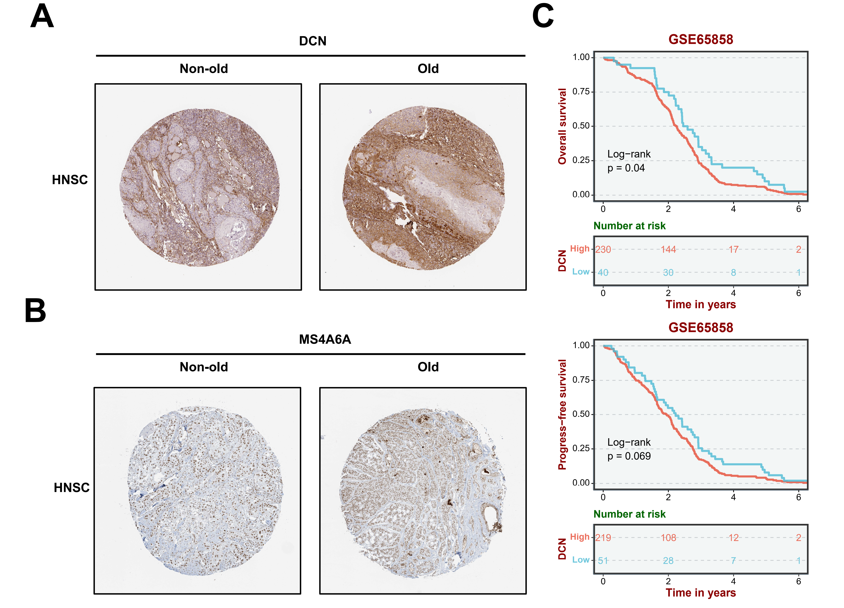
Supplementary Figure. 2 Markers of fibroblast and myeloid cells are highly expressed in the old group of head and neck squamous carcinoma (HNSC) and suggest a poor prognosis. (A) Immunohistochemistry of fibroblast marker DCN indicates significantly high expression in the old group of HNSC. (B) Immunohistochemistry of myeloid cell marker MS4A6A indicates significantly high expression in the old group of HNSC. (C) High expression of the fibroblast marker DCN is associated with reduced overall survival and progression-free survival in HNSC data from GSE65858.

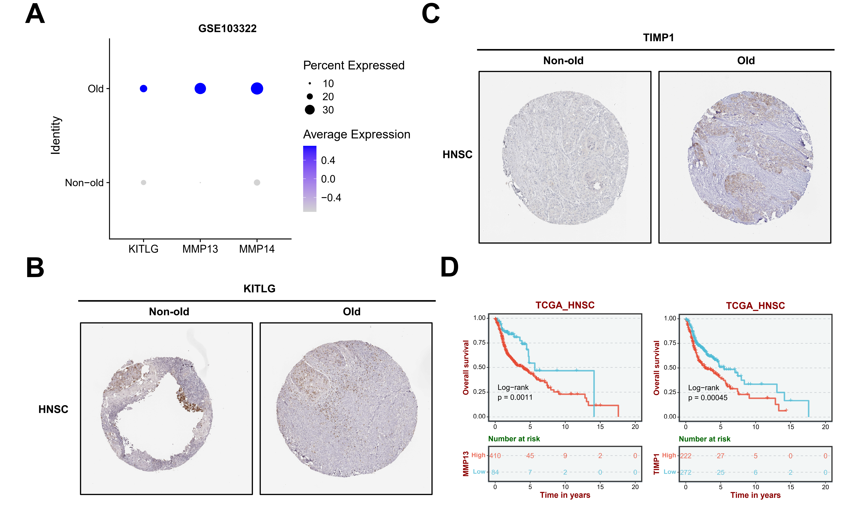
Supplementary Figure. 3 SASP markers are highly expressed in the old group of HNSC and indicate a poor prognosis. (A) Bubble plot of SASP markers KITLG, MMP13, and MMP14 are shown to be significantly higher expressed in the old group of HNSC tumor cells from GSE103322. (B) Immunohistochemistry of KITLG indicates higher expression in the old group of HNSC. (C) Immunohistochemistry of TIMP1 indicates higher expression in the old group of HNSC. (D) High expression of MMP13 and TIMP1 is associated with reduced overall survival in TCGA HNSC data.

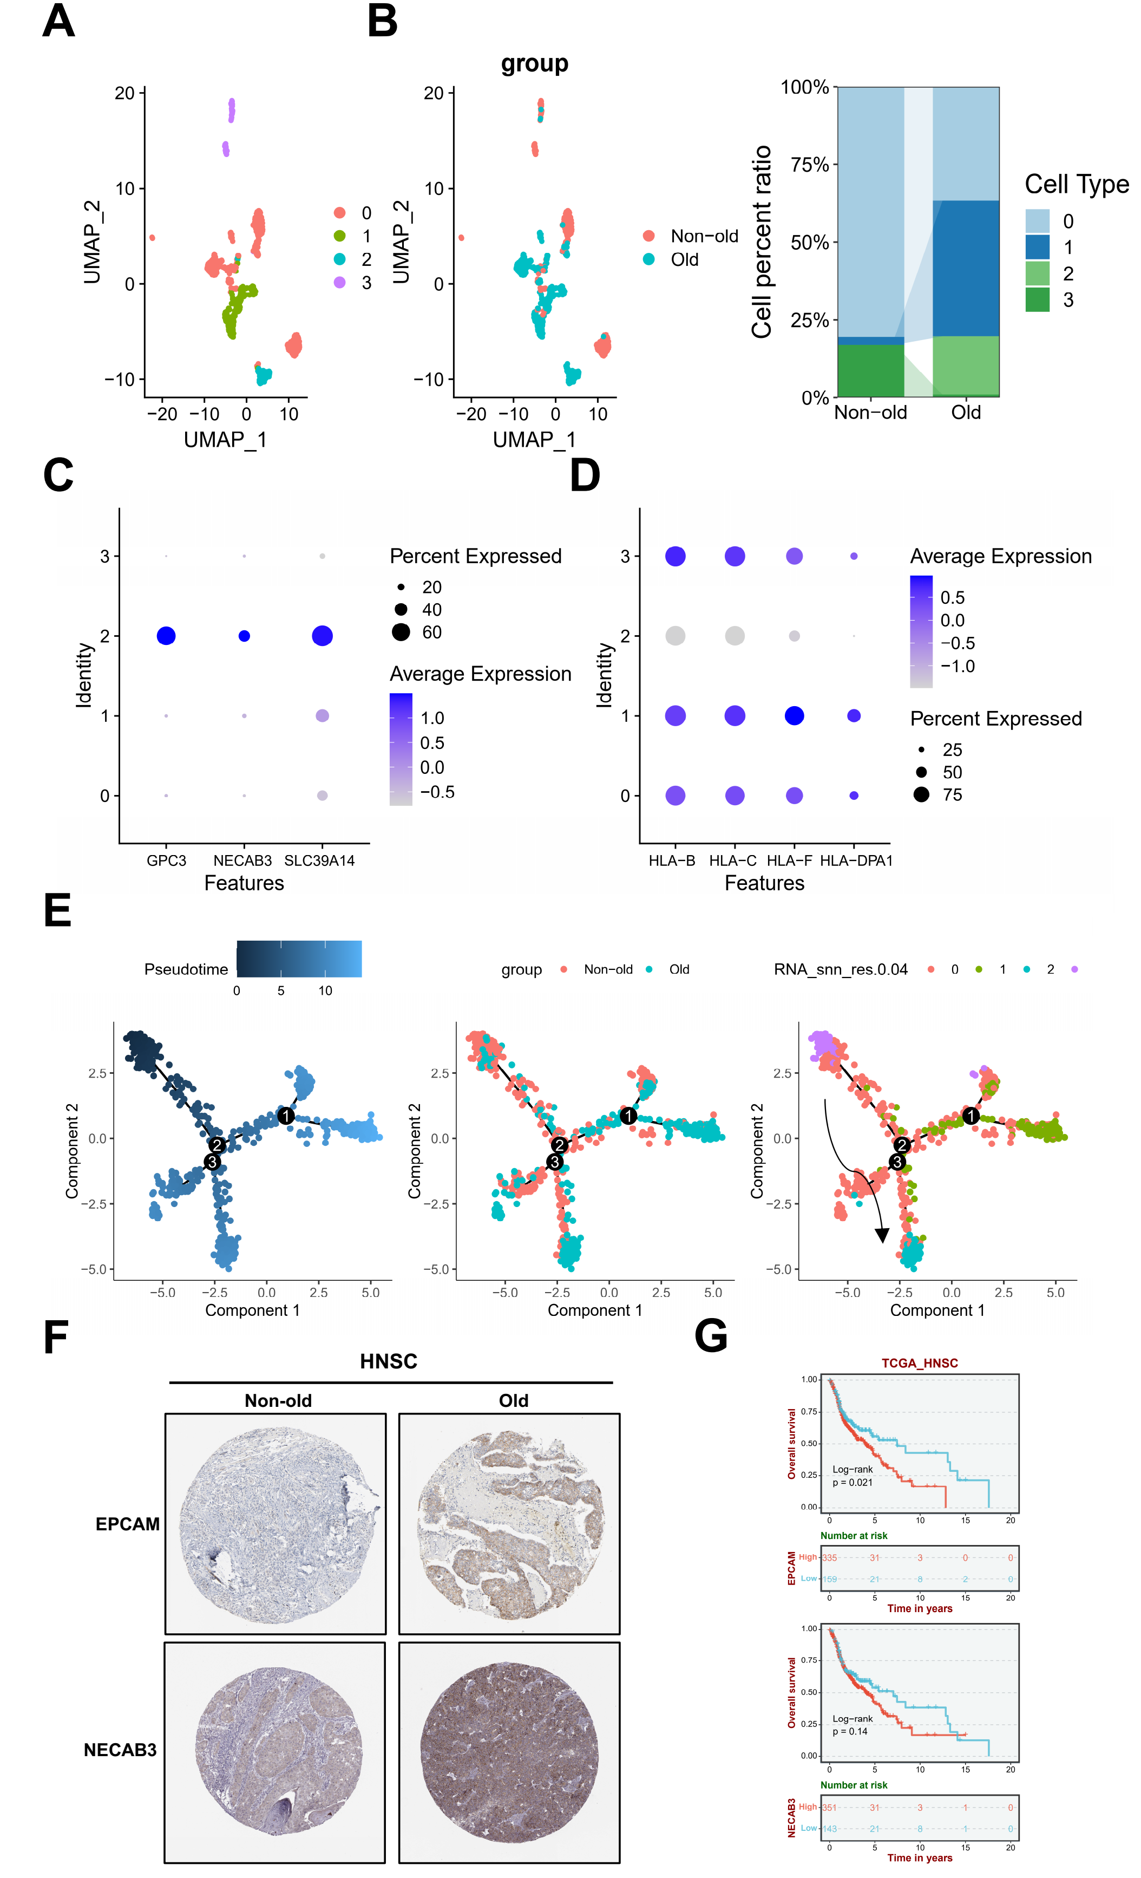
Supplementary Figure. 4 Senescence-associated tumor cell subcluster C2 is also present in elderly patients with head and neck squamous cell carcinoma and is associated with patient prognosis. (A) The UMAP plot shows the distribution of four tumor cell subclusters. (B) The UMAP plot shows the distribution of the non-old and old groups in tumor cells. The barplot shows the percentages of the four cell subclusters in both groups. (C) The GPC3, NECAB3, and SLC39A14 gene expression levels in four tumor cell subclusters. (D) The HLA gene expression levels in four tumor cell subclusters. (E) The pseudotime analysis of four tumor cell subclusters. (F) Immunohistochemistry of cell adhesion marker genes, EPCAM and NECAB3, were highly expressed in the old group of HNSC. (G) Upregulation of the cell adhesion marker genes, EPCAM and NECAB3, is associated with decreased overall survival in TCGA HNSC data.
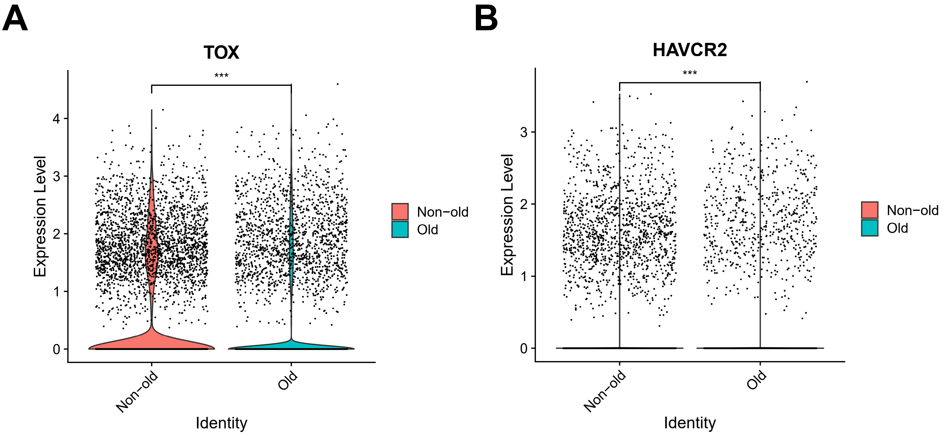
Supplementary Figure. 5 Expression of genes associated with T-cell exhaustion in the two groups. (A) Violin plots to show the expression of exhaustion-related genes TOX in T cells from the two groups. (B) Violin plots to show the expression of exhaustion-related genes HAVCR2 in T cells from the two groups. ***p<0.001.

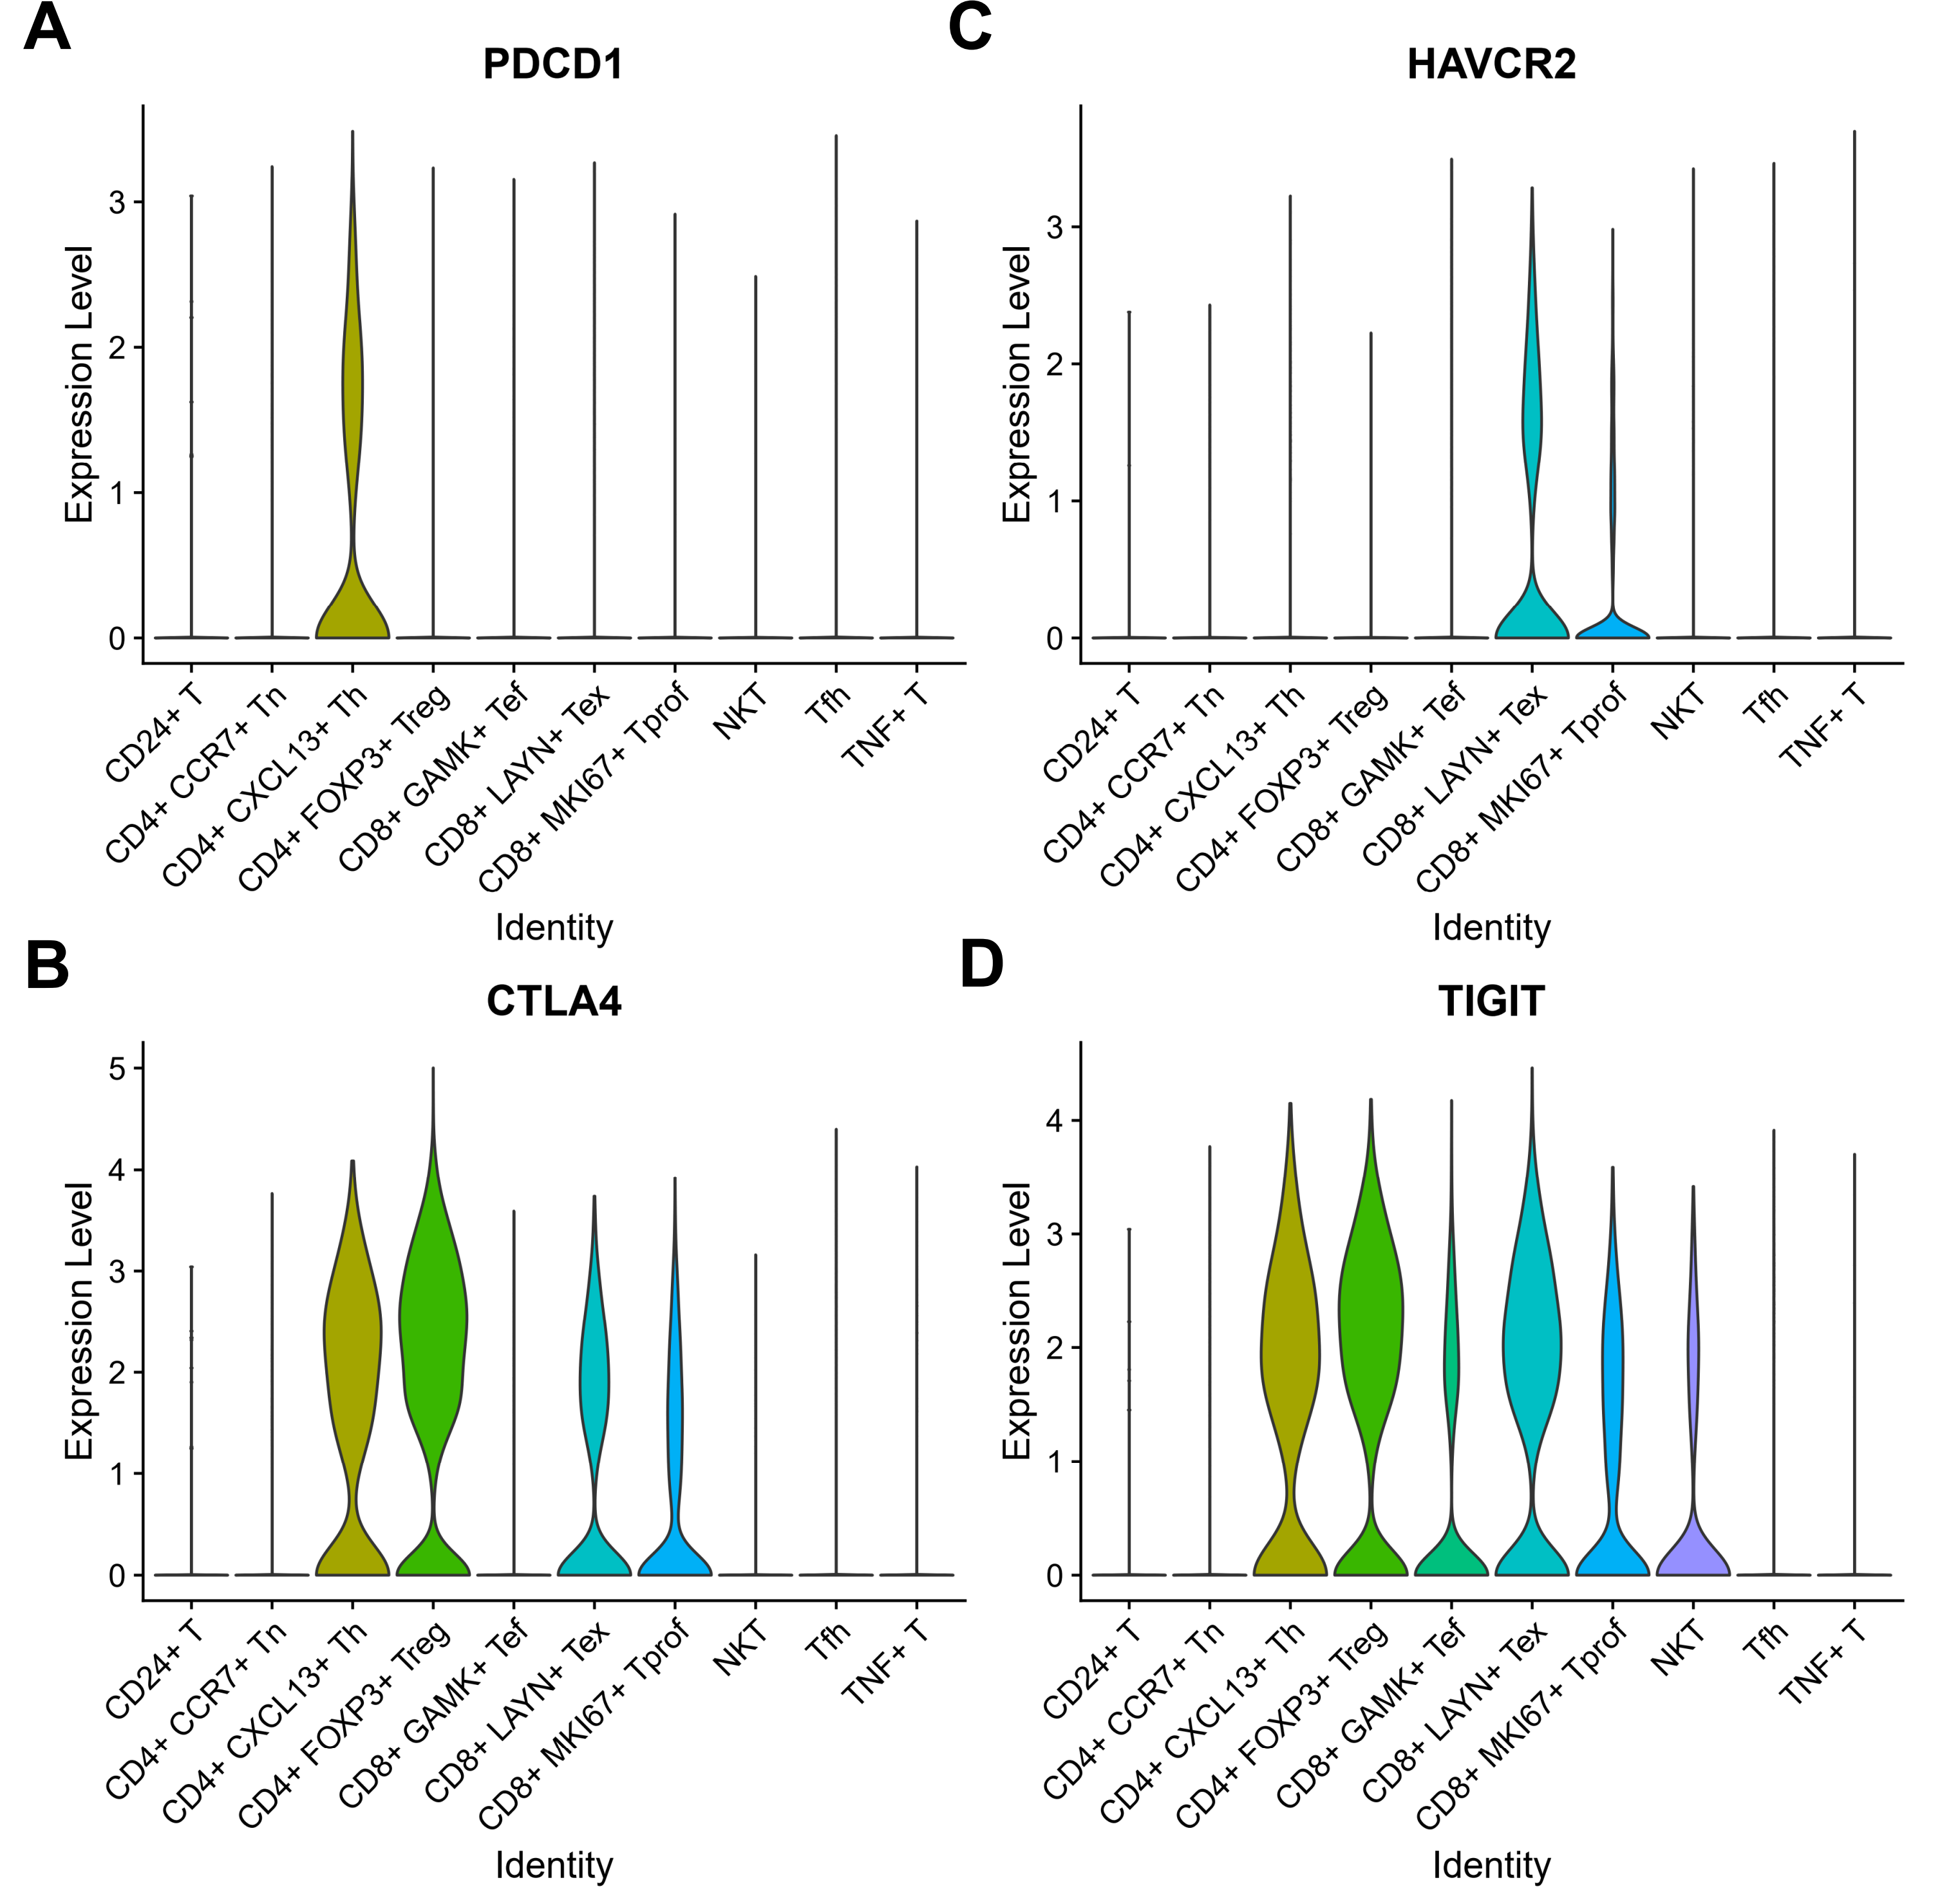
Supplementary Figure. 6 The violin plots show the expression levels of immune checkpoint genes PDCD1 (A), CTLA4 (B), HAVCR2 (C) and TIGIT (D) in each T cell subcluster.

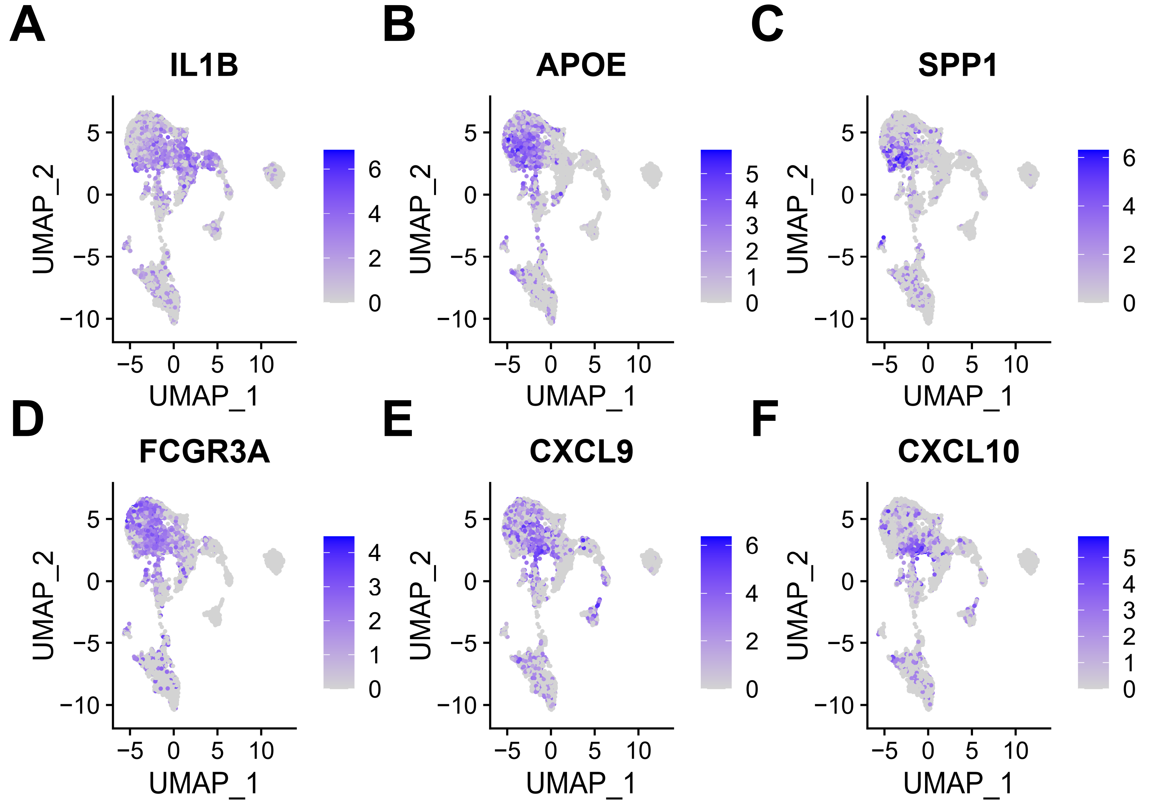
Supplementary Figure. 7 Expression of genes associated with macrophage polarization in myeloid cells. (A-F) UMAP plots to show the expression of these polarization markers (CXCL9/10, IL1B, FCGR3A, APOE, SPP1) in macrophages.
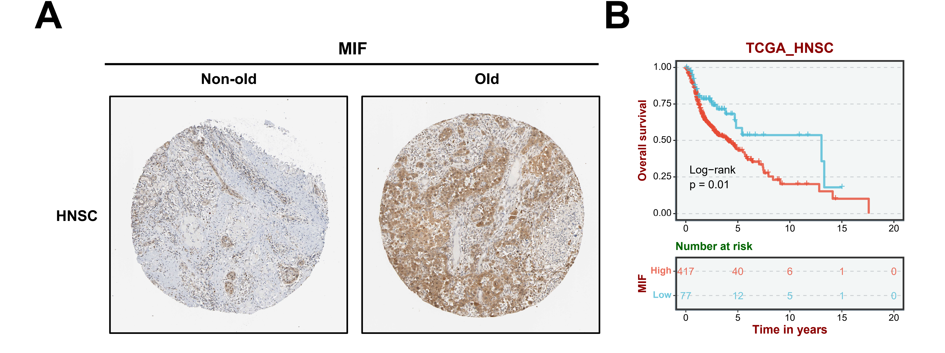
Supplementary Fig. 8 MIF is highly expressed in the old group of HNSC and suggests poor prognosis. (A) Immunohistochemistry of MIF indicates higher expression in the old group of HNSC. (B) High expression of the MIF is associated with reduced overall survival in TCGA HNSC data.

