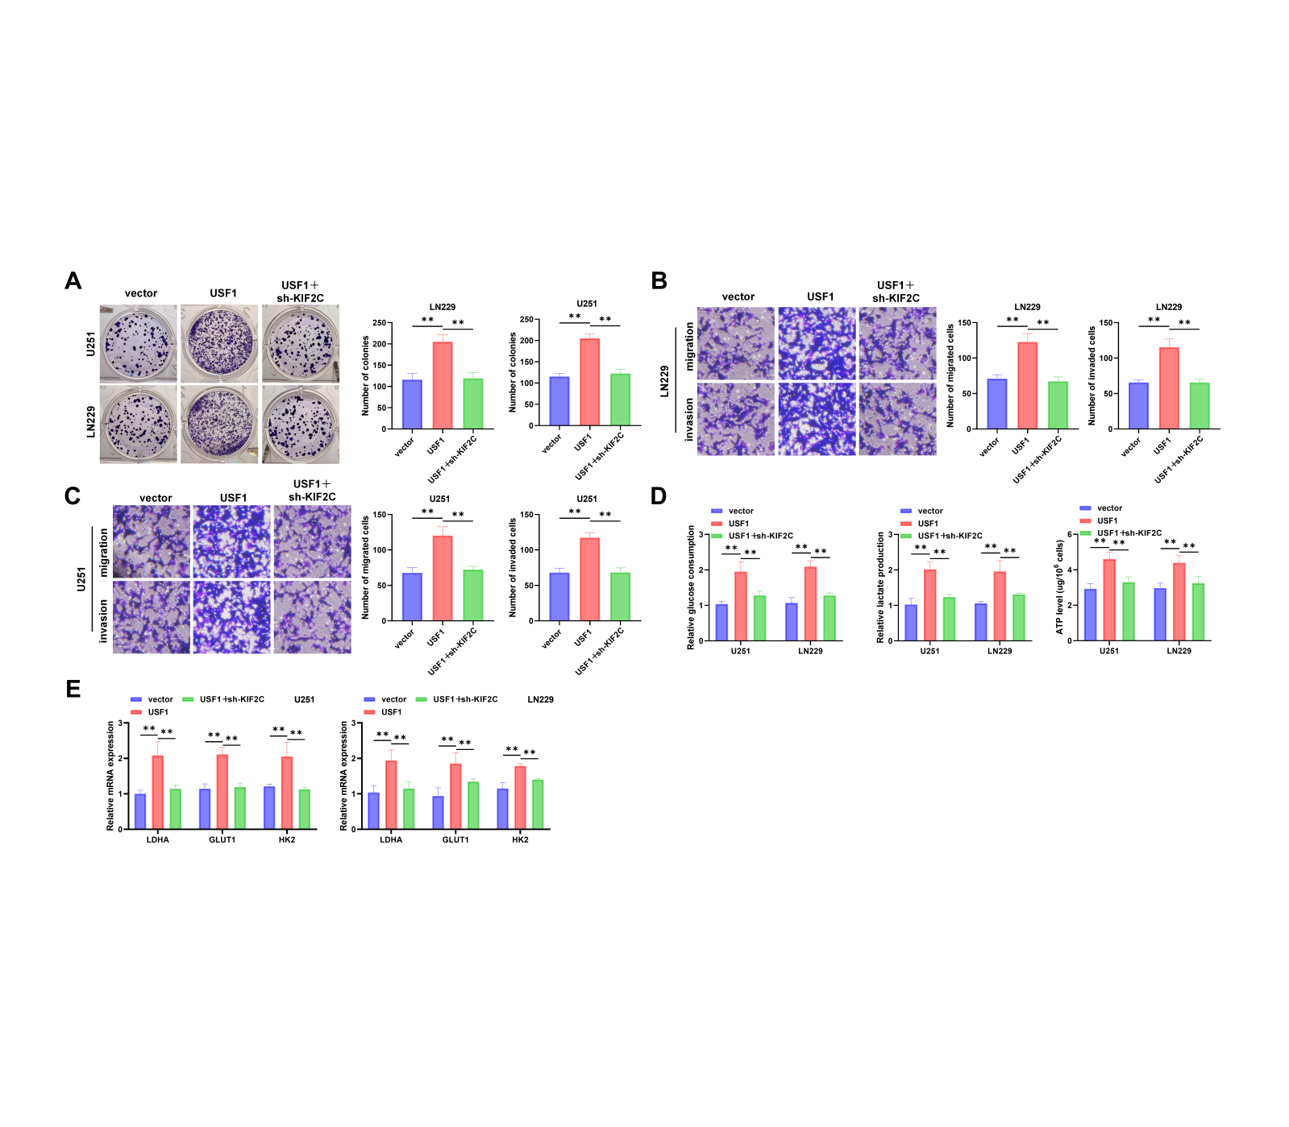
Figure S1. KIF2C knockdown attenuates USF1-induced malignant phenotypes and glycolytic activity. (A) Colony formation assay to measure cell proliferation. (B-C) Transwell migration and invasion assays to measure cell migration and invasion capabilities. (D) Measurement of glycolysis functional parameters, including glucose uptake; lactic acid production; intracellular ATP levels. (E) RT-qPCR analysis of glycolytic gene expression (LDHA, GLUT1, and HK2). Data are presented as mean ± SD from three independent biological replicates, each with triplicate technical repeats. Statistical significance was determined using one-way analysis of variance (ANOVA) followed by Tukey’s post hoc test. **P < 0.01.

