Child & Youth Care Forum
The Mental Health of Young People Entering Custody:
A Systematic Review and Meta-Analysis

Supplementary Materials

Author | Year | Review Date | 1. | 2. | 3. | 4. | 5. | 6. | 7. | 8. | 9. | Category | Verdict
Baetz et al. | 2024 | 11/10/2024 | Y | Y | Y | Y | Y | Y | Y | Y | Y | High | Include
Colins et al. | 2017 | 23/01/2024 | Y | Y | Y | Y | Y | Y | Y | Y | Y | High | Include
Colins, O., Van Damme, L. | 2020 | 23/01/2024 | Y | Y | Y | Y | Y | Y | Y | Y | Y | High | Include
Colins, O., Vermeiren, R. | 2009 | 23/01/2024 | Y | Y | Y | Y | Y | Y | Y | Y | Y | High | Include
Gosden et al. | 2006 | 23/01/2024 | Y | Y | Y | Y | Y | Y | N | Y | Y | High | Include
Harrington et al. | 2005 | 23/01/2024 | Y | Y | Y | Y | Y | Y | Y | Y | Y | High | Include
Kashani et al. | 1980 | 23/01/2024 | Y | Y | Y | N | N | N | N | UC | Y | High | Include
Kelly et al. | 2019 | 23/01/2024 | Y | Y | Y | Y | Y | Y | Y | Y | Y | High | Include
Kerig et al. | 2016 | 23/01/2024 | Y | Y | Y | Y | Y | Y | Y | Y | Y | High | Include
Kerig et al. | 2010 | 23/01/2024 | Y | Y | Y | Y | Y | Y | Y | Y | Y | High | Include
Kerig et al. | 2009 | 23/01/2024 | Y | Y | Y | Y | Y | Y | Y | Y | Y | High | Include
LaBelle et al. | 2024 | 11/20/2024 | Y | Y | Y | Y | Y | Y | N | Y | Y | High | Include
Lederman et al. | 2004 | 23/01/2024 | Y | Y | Y | Y | UC | Y | Y | Y | Y | High | Include
Lennox et al. | 2013 | 23/01/2024 | Y | Y | Y | Y | Y | Y | Y | Y | Y | High | Include
Lennox et al. | 2015 | 23/01/2024 | Y | Y | Y | Y | Y | Y | Y | Y | Y | High | Include
McCarty et al. | 2006 | 23/01/2024 | Y | Y | Y | Y | Y | Y | Y | Y | Y | High | Include
Wasserman, G. | 2011 | 23/01/2024 | Y | Y | Y | N | Y | Y | Y | Y | Y | High | Include
McReynolds et al. | 2008 | 23/01/2024 | Y | Y | Y | Y | Y | Y | Y | Y | Y | High | Include
Mitchell, P., Shaw, J. | 2011 | 23/01/2024 | Y | Y | Y | Y | Y | Y | Y | Y | Y | Moderate | Include
O'Dell et al. | 2023 | 23/01/2024 | Y | Y | Y | Y | Y | Y | Y | Y | Y | Moderate | Include
Ollendick et al. | 1999 | 2/02/2024 | Y | Y | N | Y | Y | Y | Y | Y | Y | Moderate | Include
Pliska et al. | 2000 | 23/01/2024 | N | Y | UC | N | UC | Y | Y | UC | Y | High | Include
Stathis et al. | 2012 | 2/02/2024 | Y | N | UC | Y | N | Y | Y | Y | N | High | Include
Teplin et al. | 2012 | 30/01/2024 | Y | Y | Y | Y | Y | Y | Y | Y | Y | High | Include
Vahl et al. | 2016 | 30/01/2024 | Y | Y | Y | Y | Y | Y | Y | Y | Y | High | Include
VanDamm et al. | 2015 | 30/01/2024 | Y | Y | Y | Y | Y | Y | Y | Y | Y | High | Include
VanDamm et al. | 2014 | 30/01/2024 | Y | Y | Y | Y | Y | Y | Y | Y | Y | High | Include
Van Doorn et al. | 2012 | 2/02/2024 | Y | Y | Y | N | Y | Y | Y | Y | Y | High | Include
Wasserman et al. | 2002 | 2/02/2024 | Y | Y | Y | Y | Y | Y | Y | Y | Y | High | Include
Table 3
Quality Assessment Tables

Results – Subgroup Analysis

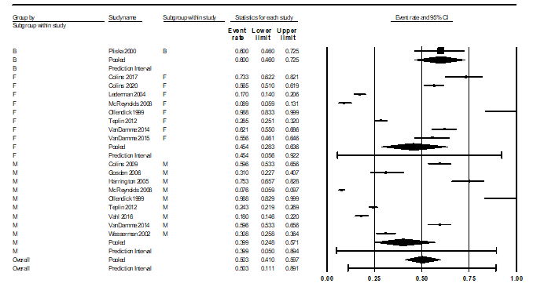
Figure 7
Conduct disorder subgroup analysis plot

Mixed effects analysis
 |  | Effect size and 95% interval |  |  | Prediction Interval |  | Between-study |  | Other heterogeneity statistics
Group | No. Studies | Point Estimate | Lower limit | Upper limit | Lower limit | Upper limit | Tau | TauSq | Q-value | df (Q) | P-value
Females | 8 | 0.454 | 0.283 | 0.636 | 0.056 | 0.922 | 1.014 | 1.027
Males | 9 | 0.399 | 0.248 | 0.571 | 0.063 | 0.868 | 1.015 | 1.031
Total between |  |  |  |  |  |  |  |  | 0.189 | 1 | 0.663
Overall | 17 | 0.424 | 0.307 | 0.551 | 0.080 | 0.862 | 0.966 | 0.934

Table 4
Conduct disorder subgroup analysis

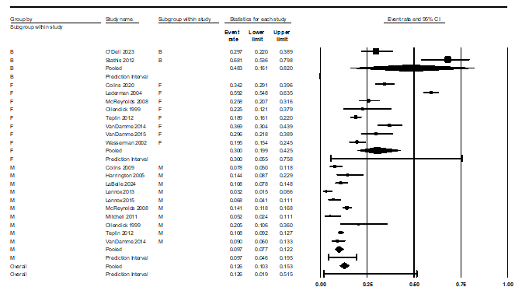
Figure 8
Anxiety disorders subgroup analysis plot

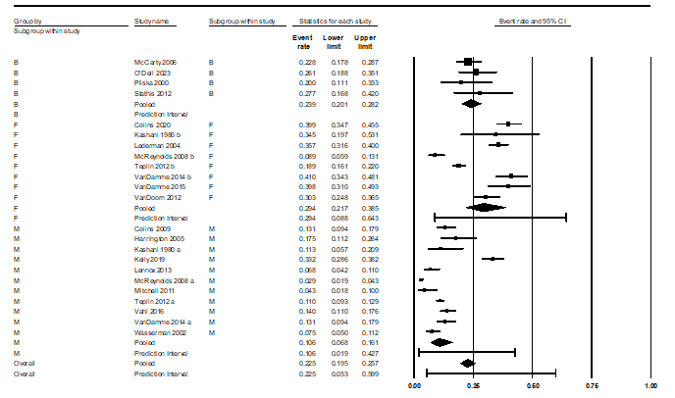
Figure 9
Major depressive disorder subgroup analysis plot

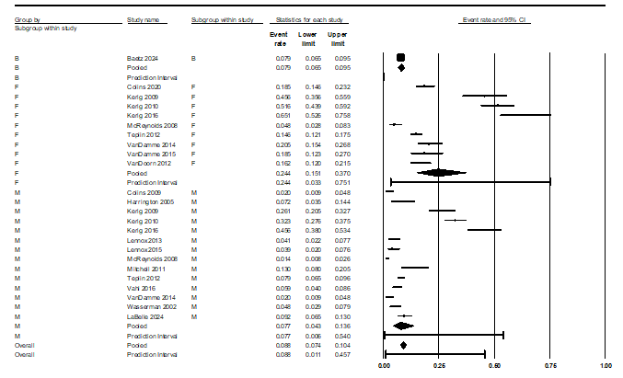
Figure 10
PTSD subgroup analysis plot

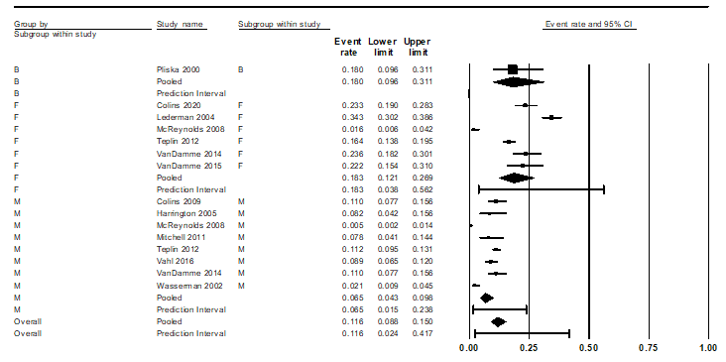
Figure 11
ADHD subgroup analysis plot
Results – Quality Assessment Analysis

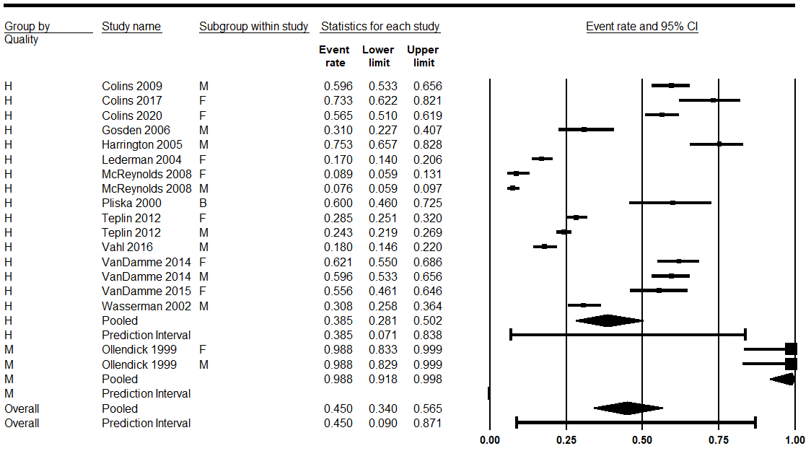
Figure 12
Conduct disorder quality assessment analysis

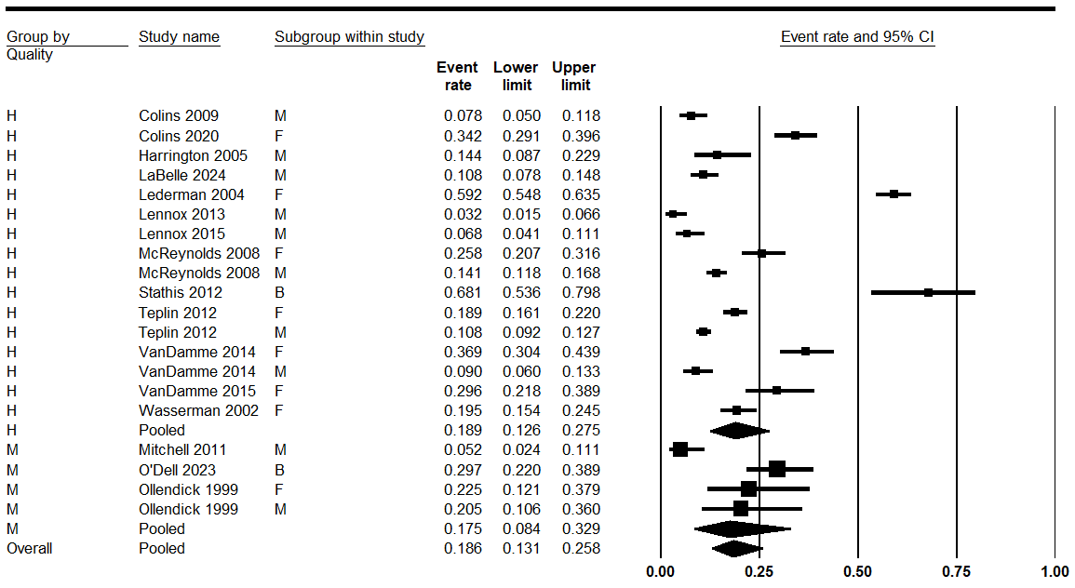
Figure 13
Anxiety disorders quality assessment analysis

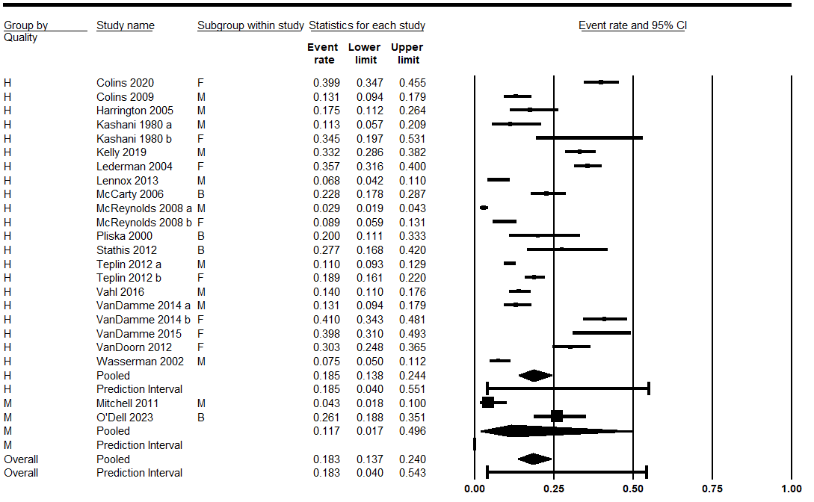
Figure 14
Depression quality assessment analysis

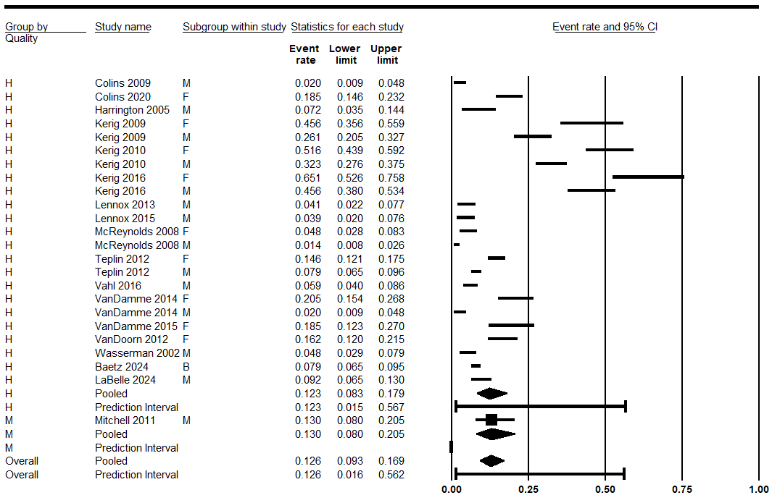
Figure 15
PTSD quality assessment analysis

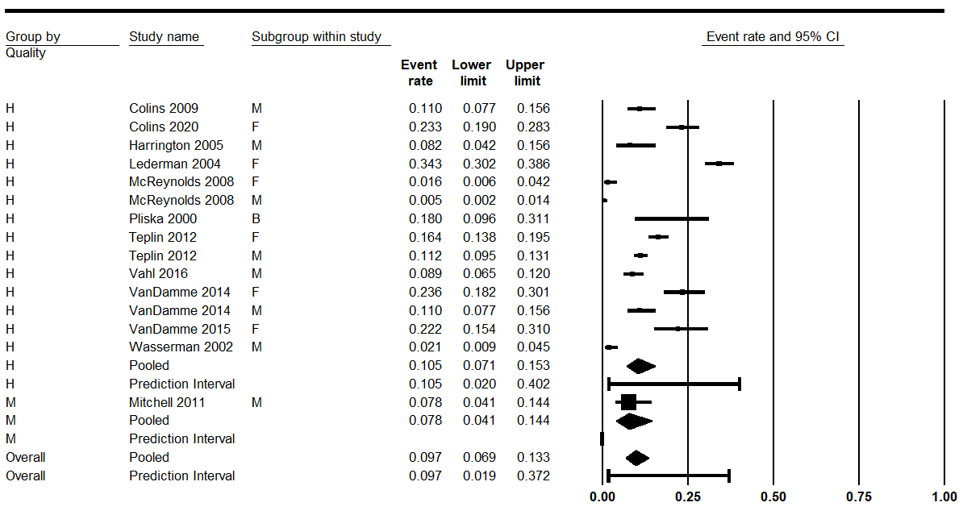
Figure 16
ADHD Quality assessment analysis

Results – Publication Bias

Disorder Type | Fail-Safe N | Egger’s test | Trim and Fill | Adjusted Effect Size
CD | 994 studies needed to nullify observed effect | Intercept = 5.27,  p = 0.07 | Estimated two studies missing | 0.39 [0.28, 0.50] vs 0.43 (observed)
Anxiety Disorders | 6041 studies needed to nullify observed effect | Intercept = -3.27, p = 0.145 | Estimated three studies missing | 0.23 [0.16, 0.31] vs 0.19 (observed)
MDD | 8,734 studies needed to nullify observed effect | Intercept = -3.61,  p = 0.075 | Nil studies missing | Nil difference
PTSD | 2,135 studies needed to nullify observed effect | Intercept = -3.13,  p = 0.15 | Estimated two studies missing | 0.14 [0.10, 0.20] vs 0.12 (observed)
ADHD | 5,512 studies needed to nullify observed effect | Intercept = -5.16  p = 0.01 | Nil studies missing | Nil difference
Table 5
Publication Bias Results

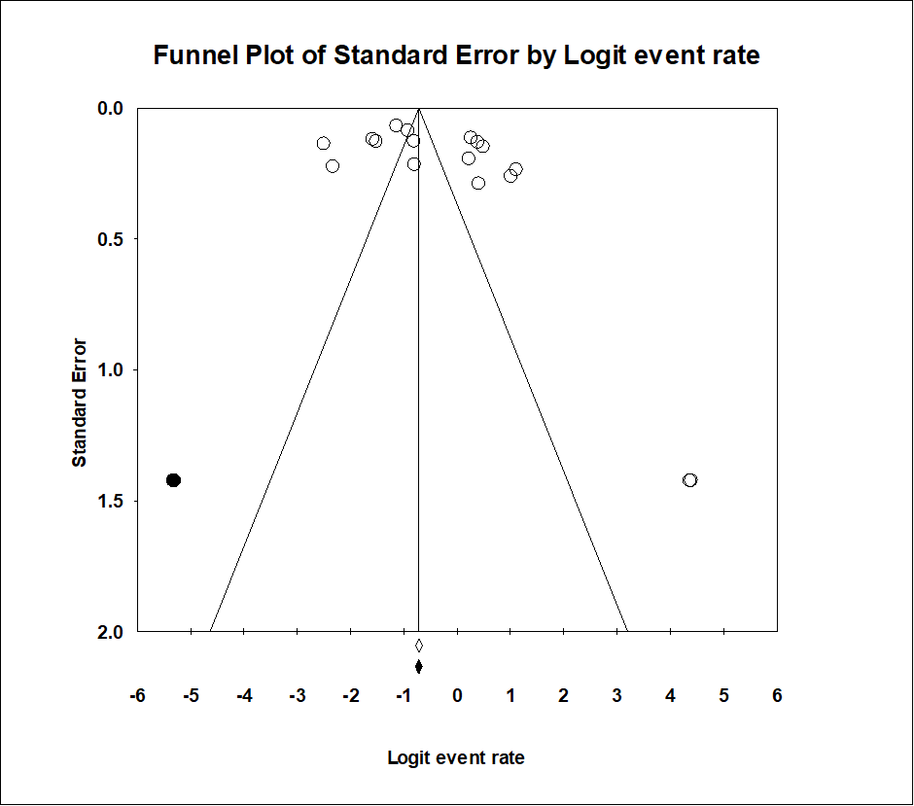
Figure 17
Publication Bias Results for Conduct Disorder
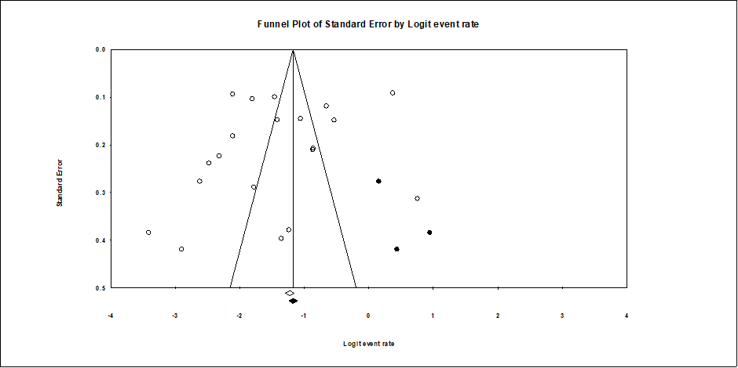
Figure 18
Publication Bias Results for Anxiety Disorders

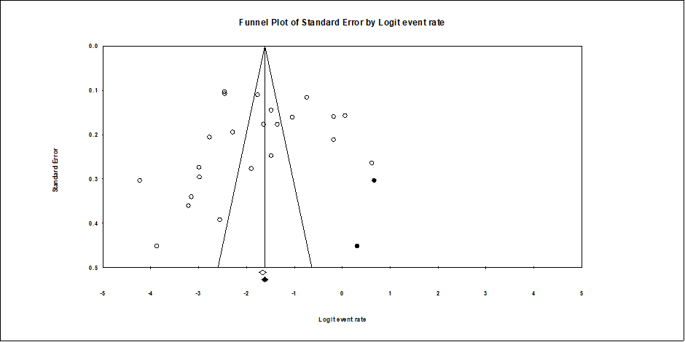
Figure 19
Publication Bias Results for PTSD

