Supporting information for:
The relationship between fibre composition and material properties following periodate oxidation and borohydride reduction of a range of wood-based fibres

Verónica López Durán^{1,2}, Per A. Larsson^{1,2}, Lars Wågberg^{1,2,3}

¹Fibre and Polymer Technology, KTH Royal Institute of Technology, SE-10044 Stockholm, Sweden
² BiMaC Innovation, KTH Royal Institute of Technology, SE-10044, Sweden
³ Wallenberg Wood Science Center, KTH Royal Institute of Technology, SE-10044, Sweden

- Crystallinity index (%) and crystalline width (nm) of fibres:
 |  | Crystallinity index (%) | FWHM | Crystalline width (nm)
Bleached chemical | 0 | 82,8 | 2,0 | 4,1
Bleached chemical | 6 | 76,2 | 2,2 | 3,6
Bleached chemical | 6+1 | 80,6 | 2,1 | 3,9
Bleached chemical | 12 | 61,4 | 2,7 | 3,0
Bleached chemical | 12+1 | 74,6 | 2,2 | 3,7
Dissolving grade | 0 | 82,3 | 1,9 | 4,2
Dissolving grade | 6 | 77,3 | 2,1 | 3,9
Dissolving grade | 6+1 | 80,5 | 2,0 | 4,0
Dissolving grade | 12 | 73,4 | 2,2 | 3,6
Dissolving grade | 12+1 | 81,3 | 2,0 | 4,1
Unbleached chemical | 0 | 79,3 | 2,3 | 3,5
Unbleached chemical | 6 | 70,0 | 2,6 | 3,1
Unbleached chemical | 6+1 | 77,0 | 2,4 | 3,4
Unbleached chemical | 12 | 60,6 | 2,9 | 2,8
Unbleached chemical | 12+1 | 72,5 | 2,5 | 3,3
CTMP fibres | 0 | 78,5 | 2,1 | 3,9
CTMP fibres | 6 | 73,2 | 2,3 | 3,6
CTMP fibres | 6+1 | 77,0 | 2,1 | 3,8
CTMP fibres | 12 | 68,3 | 2,4 | 3,3
CTMP fibres | 12+1 | 73,6 | 2,3 | 3,6
CTMP fibres | 24 | 55,8 | 2,9 | 2,8
CTMP fibres | 24+1 | 63,9 | 2,5 | 3,2

- SEM images:
Sample | Reference | 6 h oxidation | 6 h oxidation and 1 h reduction | 12 h oxidation | 12 h oxidation and 1 h reduction
Bleached chemical | 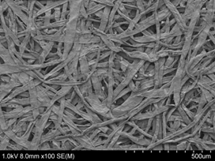
Dissolving grade |  |  | 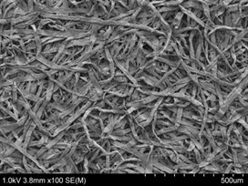 | 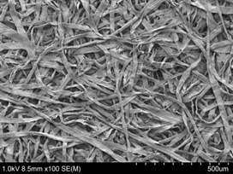 | 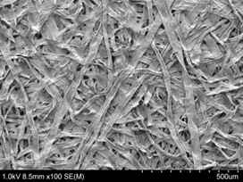
Unbleached chemical | 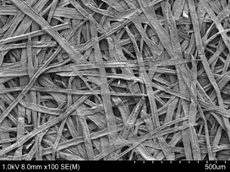 | 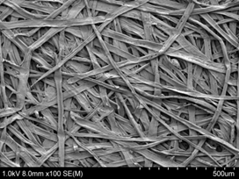 | 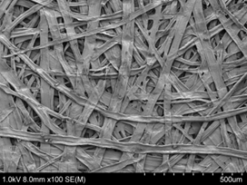 | 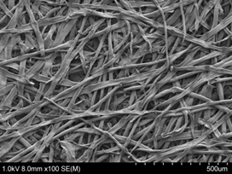 | 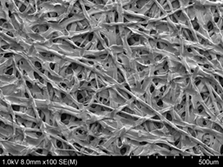

Sample | Reference | 6 h oxidation | 6 h oxidation and 1 h reduction | 12 h oxidation | 12 h oxidation and 1 h reduction
CTMP fibres | 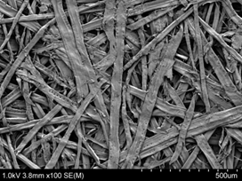 | 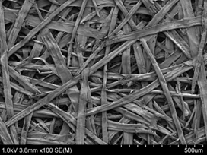 | 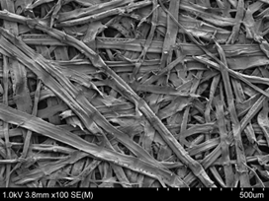 | 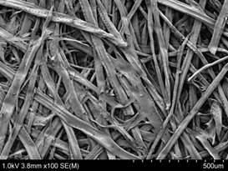 | 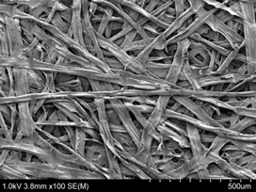
CTMP fibres | 24 h oxidation | 24 h oxidation and 1 h reduction

