Supplemental Information

Drying of a cellulose II gel: effect of physical modification and redispersibility in water

Marco Beaumont,ª Jakob König,ª Martina Opietnik,^{b} Antje Potthast,ª Thomas Rosenau ^{a,c*}

ª University of Natural Resources and Life Sciences Vienna (BOKU), Department of Chemistry, Division of Chemistry of Renewable Resources, Konrad-Lorenz-Strasse 24, A-3430 Tulln, Austria. ^{b}Lenzing AG, Werkstrasse 2, 4860 Lenzing, Austria.
^{b} Lenzing AG, Werkstrasse 2, 4860 Lenzing, Austria
^{c} Johan Gadolin Process Chemistry Centre, Åbo Akademi University,
Porthansgatan 3, Åbo/Turku FI-20500, Finland
Table S1: List of studied additives to increase the redispersibility of oven-dried cellulose II gel. After consideration of the colloidal stability and WRV of the respective redispersed samples, a pre-selection (highlighted in yellow) was chosen for more detailed studies. Literature examples of additives to reduce hornification of other cellulosic materials are listed as well.
Additive | Purity | Supplier | Literature
D-(+)-Glucose |  | Fluka | (Zhang et al. 2004; Müller et al. 2014)
D(+)-Saccharose | ≥ 99.5 % | Roth | (Zhang et al. 2004; Müller et al. 2014)
Alginic acid, sodium salt |  | Sigma-Aldrich
Starch, from potato |  | Sigma-Aldrich
Cellulose acetate |  | Sigma-Aldrich
Urea |  | Sigma-Aldrich
Methyl cellulose |  | Sigma-Aldrich
Carboxymethylcellulose (CMC), DS 0.7 |  | Sigma-Aldrich | (Butchosa and Zhou 2014; Naderi et al. 2015)
CMC, Walocel CRT 2000 Pa, DS 0.82-0.95 |  | DuPont Danisco | (Butchosa and Zhou 2014; Naderi et al. 2015)
CMC, Walocel CRT 30000 Pa, DS 0.82-0.95 |  | DuPont Danisco | (Butchosa and Zhou 2014; Naderi et al. 2015)
Xanthan, GRINDSTED® Xanthan 80 |  | Dow Chemical
Hexadecyltrimethylammoniumbromide | ≥ 98% | Sigma-Aldrich | (Fairman 2014)
Polyethylene glycol 4000 |  | Alfa Aesar | (Müller et al. 2014)
Polyethylene glycol 400 |  | Roth | (Müller et al. 2014)
Li₂SO₄ | ≥ 98.5% | Sigma-Aldrich
Calcium acetate hydrate | ≥ 99% | Sigma-Aldrich
CaCl₂ dihydrate |  | VWR
LiCl |  | VWR
MgCl₂ anhydrous | ≥ 98% | Sigma-Aldrich | (Müller et al. 2014)
Ammonium acetate | ≥ 98% | Sigma-Aldrich
Tween 80 | pure | Sigma-Aldrich
Polyethyleneimine solution | 50 wt% | Sigma-Aldrich
NaCl | ≥ 99.8% | Sigma-Aldrich | (Missoum et al. 2012; Müller et al. 2014)

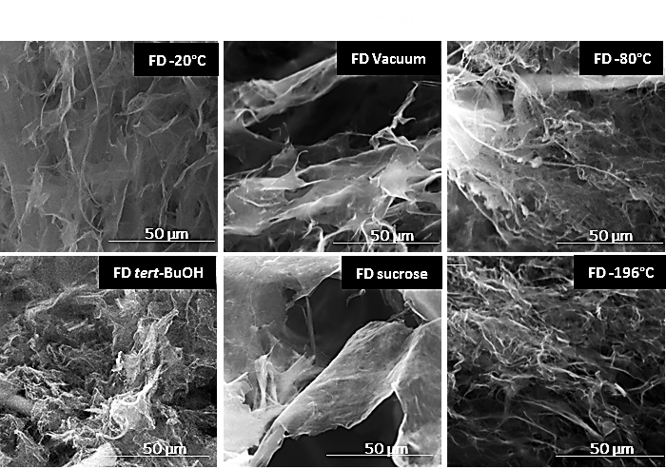
Figure S1: SEM micrographs of CNF cryogels using different freezing conditions.

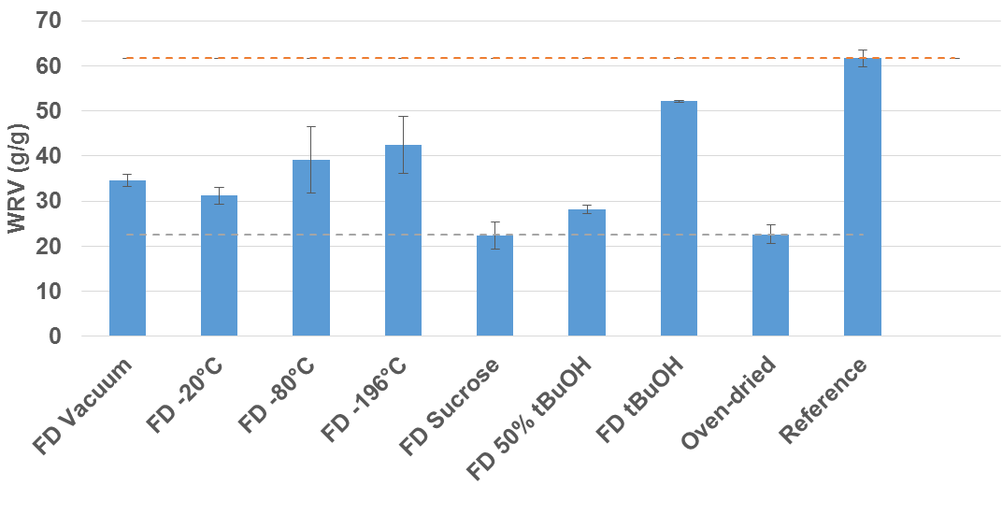
Figure S2: WRV of the redispersed CNF cryogels (1 wt%) in water.

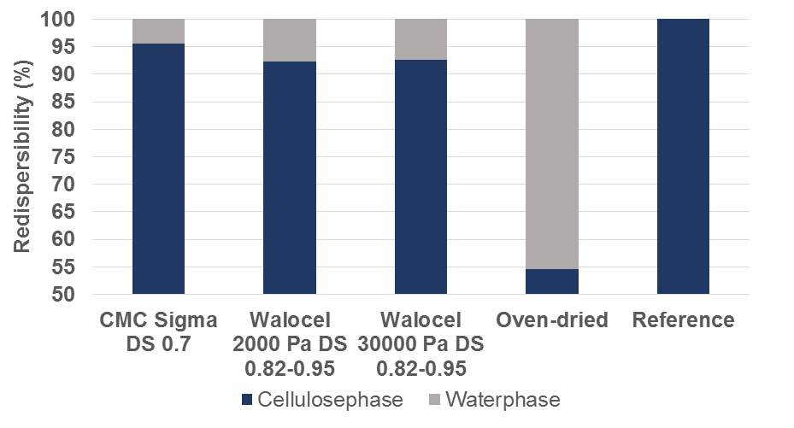
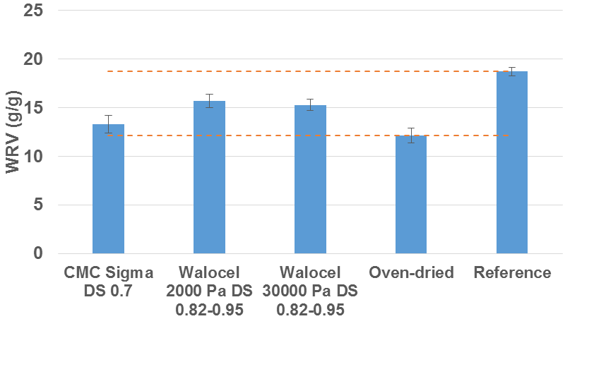
Figure S3: Comparison of CMC of different viscosities and degree of substitutions. Redispersed samples with CMC showed similar colloidal stabilities. But a higher WRV was obtained for CMC with a DS of 0.82-0.95.

Literature
Butchosa N, Zhou Q (2014) Water redispersible cellulose nanofibrils adsorbed with carboxymethyl cellulose. Cellulose 21:4349–4358. doi: 10.1007/s10570-014-0452-7
Fairman EM (2014) Avoiding aggregation during drying and rehydration of nanocellulose. University of Maine
Missoum K, Bras J, Belgacem MN (2012) Water Redispersible Dried Nanofibrillated Cellulose by Adding Sodium Chloride. Biomacromolecules 13:4118–4125. doi: 10.1021/bm301378n
Müller A, Zink M, Hessler N, et al (2014) Bacterial nanocellulose with a shape-memory effect as potential drug delivery system. RSC Adv 4:57173–57184. doi: 10.1039/C4RA09898F
Naderi A, Lindström T, Sundström J, Flodberg G (2015) Can redispersible low-charged nanofibrillated cellulose be produced by the addition of carboxymethyl cellulose? Nord Pulp Pap Res J 30:568–77.
Zhang M, Hubbe MA, Venditti RA, Heitmann JA (2004) Effects of Sugar Addition Before Drying on Wet-Flexibility of Redispersed Kraft Fibers. J Pulp Pap Sci 30:29–34.

