Supporting information

Chemically modified cellulose micro- and nanofibrils as paper-strength additives
Rebecca Hollertz, Verónica López Durán, Per Larsson, Lars Wågberg
Fibre and Polymer Technology, KTH Royal Institute of Technology
rhollert@kth.se, wagberg@kth.se
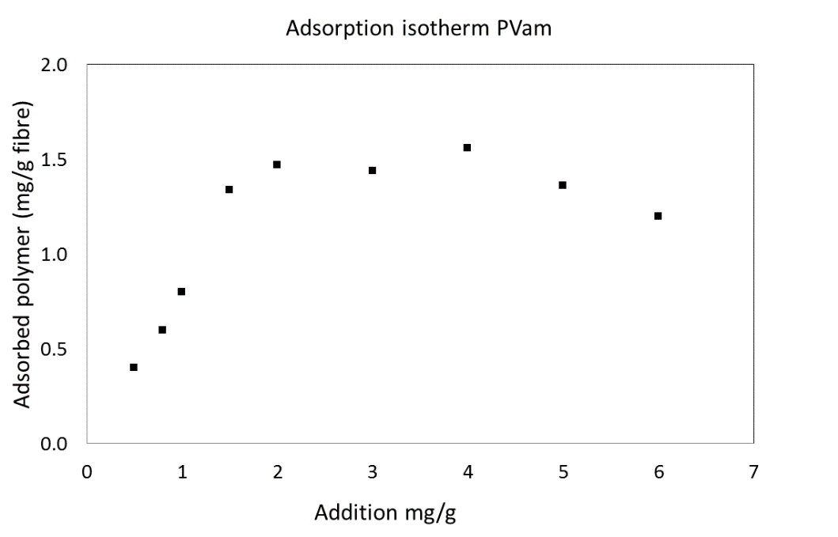

Figure 1. Adsorption isotherm of PVAm; adsorbed versus added amount of polymer in mg/g of wood-fibres.

Figure 2. SEM image of a paper sheet with 2 wt% added kraft MFC, with PVAm. Already at low CNF additions, fibril networks or films could be seen at the fibre joints, partly closing the pore openings formed between the fibres.

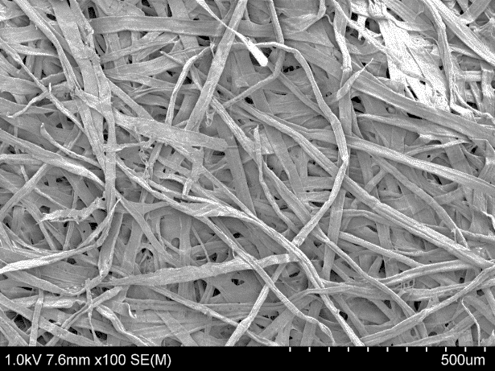
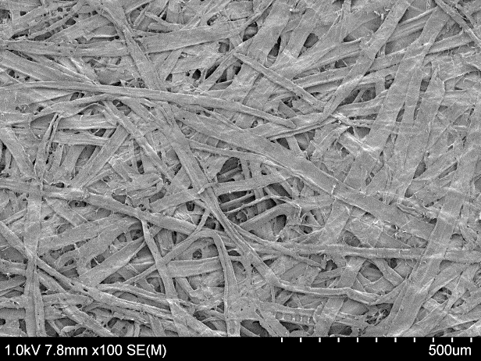

Figure 3. SEM images of paper sheets with 5 wt% added periodate oxidized CNFs without (left) and with (right) PVAm. The film formation as well as the sheet density was higher without PVAm.
Figure 4. Infrared (IR) spectra of CNF films made from the different fibrils and from periodate-oxidised carboxymethylated fibrils with retention aids. The oxidation and the reaction with dopamine was detected with FTIR (with a reduction of the carboxyl peak⁶³ at 1593⁻¹, the appearance of the characteristic peak of dialdehyde cellulose⁸³ at 1740 cm⁻¹ and the appearance of bands attributed to amide carbonyl stretching vibrations⁶³ at 1680-1630 cm⁻¹ for the film with dopamine fibrils). It was also shown that the periodate-oxidised fibrils have reacted further with PVAm (N-H deformation vibrations⁷⁵ were detected at 1555 cm⁻¹) but not with pDADMAC.

