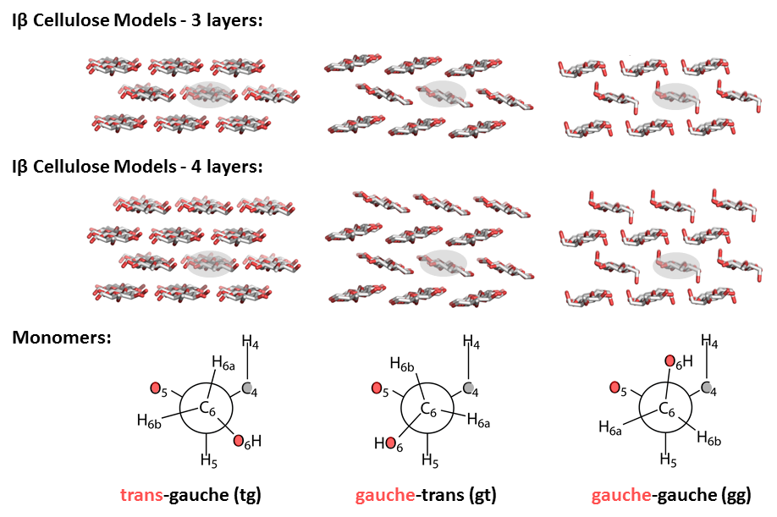
Supplementary Fig. 1 The 3-layer cellulose Iβ model and 4-layer model with three different conformations of the C6 exocyclic group (tg, gt and gg, respectively). Each model was produced to be three chains wide, four or three layers high and four monomer units in length, The smaller 3-layer models were produced in order to test the sensitivity of calculated NMR chemical shifts to the size of cellulose models. The calculated NMR chemical shifts of middle two glucan units in the shaded regions were compared.

Supplementary Table 1 Calculated δ¹³C using 3-layer models and 4-layer models (ppm)
 | 3-layer cellulose Iβ models |  |  |  |  |  | 4-layer cellulose Iβ models
 | C1 | C2 | C3 | C4 | C5 | C6 | C1 | C2 | C3 | C4 | C5 | C6
gg | 100.9 | 72.8 | 72.6 | 77.8 | 71.8 | 59.8 | 100.9 | 72.9 | 72.6 | 77.9 | 71.8 | 59.8
gg | 100.7 | 73.0 | 72.6 | 77.7 | 71.5 | 59.7 | 100.7 | 72.9 | 72.7 | 77.8 | 71.4 | 59.7
gt | 99.2 | 73.3 | 71.9 | 83.3 | 71.2 | 60.7 | 99.0 | 73.3 | 72.0 | 83.5 | 71.0 | 60.7
gt | 98.9 | 73.5 | 71.9 | 83.2 | 71.1 | 60.6 | 98.9 | 73.5 | 72.0 | 83.1 | 71.1 | 60.7
tg | 105.1 | 69.4 | 71.6 | 86.0 | 71.6 | 64.2 | 105.1 | 69.5 | 71.7 | 86.0 | 71.7 | 64.3
tg | 104.9 | 69.7 | 71.9 | 86.2 | 71.4 | 64.1 | 105.1 | 69.7 | 72.0 | 86.2 | 71.6 | 64.3

Supplementary Fig. 2 Nomenclature of the dihedral angles understudied in the cellulose tetramer model. The glycosidic linkage dihedral angles Ψ: C1′-O-C4-C5, Φ: O5′-C1′-O-C4. The dihedral angle χ3: C2-C3-O3-HO3, and χ2: C1′-C2′-O2′-HO2′.

Supplementary Table 2 Calculated δ¹³C and the standard deviation of surface cellulose in water (ppm)
 | C1 | C2 | C3 | C4 | C5 | C6
tg(s) | 103.0 ±1.3 | 68.7 ±0.6 | 71.1 ±1.0 | 85.8 ±1.7 | 69.7 ±1.1 | 64.4 ±1.2
GT(s) | 101.7 ±2.7 | 70.9 ±1.3 | 71.4 ±1.1 | 83.6 ±2.0 | 71.2 ±1.4 | 60.7 ±1.1
GG(s) | 100.8 ±1.4 | 71.1 ±1.1 | 70.8 ±1.8 | 78.3 ±2.2 | 71.8 ±1.3 | 60.4 ±1.1
tg(s) – tg(i) | -1.0 ±0.8 | -0.9 ±0.6 | -1.1 ±1.1 | 0.1 ±1.6 | -1.2 ±0.8 | 0.1 ±1.2
GT(s) – GT(i) | -0.4 ±1.4 | -1.2 ±1.0 | -0.6 ±1.0 | -0.6 ±1.9 | -0.6 ±1.1 | -0.6 ±1.4
GG(s) – GG(i) | -1.1 ±1.4 | -1.0 ±1.1 | -0.9 ±1.3 | -0.5 ±2.1 | -0.9 ±0.8 | -0.8 ±1.4
Note: (i) represents the signals from interior cellulose whereas (s) represents signals from glucose on the surface of cellulose microfibril model (4x3x4 cluster).

Supplementary Table 3 Calculated δ¹³C and the standard deviation of surface cellulose in vacuum (ppm)
 | C1 | C2 | C3 | C4 | C5 | C6
tg(s) | 105.1 ±1.5 | 70.2 ±1.0 | 72.3 ±0.8 | 87.2 ±1.7 | 70.8 ±1.1 | 65.1 ±1.0
gt(s) | 103.7 ±2.8 | 72.4 ±1.2 | 73.1 ±1.5 | 85.4 ±2.8 | 72.8 ±1.6 | 62.0 ±1.0
gg(s) | 102.8 ±1.3 | 72.3 ±1.0 | 72.2 ±1.4 | 79.1 ±1.4 | 73.3 ±1.2 | 60.4 ±1.1
tg(s) – tg(i) | 1.1 ±1.2 | 0.6 ±1.2 | 0.1 ±0.9 | 1.5 ±1.7 | -0.1 ±0.9 | 0.8 ±1.0
gt(s) – gt(i) | 1.6 ±1.7 | 0.3 ±1.1 | 1.1 ±1.5 | 1.2 ±2.7 | 1.0 ±1.5 | 0.7 ±0.9
gg(s) – gg(i) | 0.9 ±1.1 | 0.2 ±1.0 | 0.5 ±0.8 | 0.3 ±1.1 | 0.6 ±0.8 | -0.2 ±1.2
Note: (i) represents the signals from interior cellulose whereas (s) represents signals from glucose on the surface of cellulose microfibril model (4x3x4 cluster).
Supplementary Table 4 Calculated relative δ¹³C4 values (for gg conformation) when rotating Ψ Φ angles (ppm)
Φ | Ψ | -183 | -173 | -163 | -153 | -143 | -133 | -123
-63 | -7.6 | -5.4 | -3.8 | -3.3 | -4.2 | -5.5 | -7.1
-73 | -7.7 | -5.5 | -3.6 | -2.3 | -2.3 | -3.1 | -4.6
-83 | -8.0 | -5.7 | -3.4 | -1.7 | -0.8 | -0.9 | -2.1
-93 | -8.7 | -6.2 | -3.7 | -1.6 | 0.0 | 0.4 | -0.1
-103 | -9.7 | -7.2 | -4.5 | -2.1 | 0.1 | 0.9 | 1.1
-113 | -10.9 | -8.5 | -6.0 | -3.3 | -0.9 | 0.5 | 1.4
-123 | -11.7 | -9.7 | -7.5 | -4.9 | -2.4 | -0.7 | 0.6

Supplementary Table 5 Calculated relative δ¹³C4 values (for gt conformation) when rotating Ψ Φ angles (ppm)
Φ | Ψ | -183 | -173 | -163 | -153 | -143 | -133 | -123
-63 | -8.3 | -6.0 | -4.1 | -3.8 | -4.6 | -6.4 | -8.2
-73 | -8.6 | -6.1 | -3.8 | -2.7 | -2.7 | -3.8 | -5.4
-83 | -9.1 | -6.4 | -3.7 | -1.8 | -1.1 | -1.3 | -2.5
-93 | -10.0 | -7.1 | -4.2 | -1.4 | 0.0 | 0.5 | -0.2
-103 | -11.0 | -8.2 | -5.0 | -2.0 | 0.0 | 1.3 | 1.3
-113 | -12.1 | -9.5 | -6.4 | -3.2 | -0.9 | 1.0 | 1.8
-123 | -13.0 | -10.8 | -8.0 | -5.0 | -2.5 | -0.2 | 1.3

Supplementary Table 6 Calculated relative δ¹³C values (for tg conformation) when rotating Ψ Φ angles (ppm)
δ¹³C1′
Φ | Ψ | -183 | -173 | -163 | -153 | -143 | -133 | -123
-63 | -6.6 | -6.1 | -6.0 | -5.7 | -5.3 | -4.8 | -5.1
-73 | -5.5 | -4.9 | -4.7 | -4.3 | -3.5 | -3.1 | -3.1
-83 | -5.7 | -4.7 | -3.8 | -2.6 | -1.7 | -0.8 | -0.6
-93 | -5.7 | -4.0 | -2.6 | -1.3 | 0.0 | 1.0 | 0.8
-103 | -6.1 | -4.1 | -2.2 | -0.5 | 1.3 | 2.5 | 1.2
-113 | -5.9 | -4.8 | -2.6 | -0.5 | 1.5 | 2.9 | 2.0
-123 | -7.1 | -5.7 | -3.4 | -1.3 | -0.2 | 0.8 | 3.7

δ¹³C2′
Φ | Ψ | -183 | -173 | -163 | -153 | -143 | -133 | -123
-63 | 1.5 | 1.6 | 1.0 | 0.9 | 0.8 | 0.6 | 0.6
-73 | 0.9 | 0.9 | 0.5 | 0.3 | 0.2 | 0.1 | 0.1
-83 | -0.1 | -0.1 | -0.1 | -0.1 | 0.0 | 0.1 | 0.1
-93 | 0.2 | 0.1 | 0.0 | 0.0 | 0.0 | 0.0 | 0.0
-103 | 0.6 | 0.5 | 0.4 | 0.3 | 0.0 | -0.2 | -0.3
-113 | 1.7 | 1.4 | 1.1 | 0.8 | 0.2 | -0.6 | -6.0
-123 | 2.5 | 2.1 | 1.9 | 1.4 | 2.7 | 0.9 | -1.9
δ¹³C3′
Φ | Ψ | -183 | -173 | -163 | -153 | -143 | -133 | -123
-63 | -0.8 | -0.4 | -0.1 | 0.0 | -0.2 | 0.3 | 0.4
-73 | -0.4 | -0.3 | -0.3 | -0.1 | -0.1 | 0.4 | 0.5
-83 | -0.6 | -0.6 | -0.4 | -0.3 | 0.0 | 0.1 | -0.6
-93 | -0.6 | -0.6 | -0.4 | -0.2 | 0.0 | 0.0 | -0.3
-103 | -0.5 | -0.6 | -0.5 | -0.3 | -0.1 | 0.4 | 0.9
-113 | -0.2 | -0.4 | -0.5 | -0.5 | -0.1 | 0.9 | -2.8
-123 | -0.3 | -0.5 | -0.5 | -0.5 | -0.3 | 1.8 | 6.1
δ¹³C4′
Φ | Ψ | -183 | -173 | -163 | -153 | -143 | -133 | -123
-63 | 1.4 | 1.6 | 1.1 | 0.7 | 0.3 | 0.1 | 0.1
-73 | 0.9 | 1.1 | 0.4 | 0.3 | 0.1 | 0.1 | 0.0
-83 | 0.3 | 0.2 | 0.1 | 0.1 | 0.0 | 0.2 | 0.1
-93 | 0.4 | 0.3 | 0.1 | 0.1 | 0.0 | 0.2 | 0.3
-103 | 0.4 | 0.3 | 0.2 | 0.3 | 0.2 | 0.4 | 0.5
-113 | 0.8 | 0.6 | 0.6 | 0.4 | 0.4 | 0.3 | -0.4
-123 | 0.8 | 0.4 | 0.5 | 0.5 | 0.0 | 0.5 | -0.1

δ¹³C5′
Φ | Ψ | -183 | -173 | -163 | -153 | -143 | -133 | -123
-63 | -0.4 | -1.0 | -0.9 | -1.1 | -0.4 | 0.2 | 0.2
-73 | -0.4 | -0.6 | -1.7 | -0.9 | -0.3 | 0.1 | 0.3
-83 | -1.1 | -1.4 | -1.2 | -0.7 | -0.2 | 0.2 | 0.4
-93 | -0.7 | -0.9 | -0.7 | -0.5 | 0.0 | 0.3 | 0.4
-103 | 0.2 | -0.1 | -0.2 | 0.0 | 0.2 | 0.4 | 0.4
-113 | 0.3 | 0.3 | 0.2 | 0.3 | 0.4 | 0.6 | 2.8
-123 | 0.4 | 0.8 | 0.6 | 0.6 | 1.0 | 0.7 | 0.8

δ¹³C6′
Φ | Ψ | -183 | -173 | -163 | -153 | -143 | -133 | -123
-63 | -0.7 | -1.5 | -1.1 | -1.3 | -1.1 | -0.6 | -0.2
-73 | -0.1 | -0.5 | -1.0 | -1.4 | -1.0 | -0.5 | -0.2
-83 | 0.0 | -0.5 | -0.8 | -0.8 | -0.6 | -0.1 | -0.1
-93 | 0.3 | 0.1 | 0.0 | -0.1 | 0.0 | 0.2 | 0.1
-103 | 0.4 | 0.3 | 0.3 | 0.4 | 0.4 | 0.4 | 0.3
-113 | 0.6 | 0.4 | 0.4 | 0.3 | 0.5 | 0.5 | -1.1
-123 | 0.5 | 0.3 | 0.3 | 0.3 | -0.1 | 0.4 | 0.0
δ¹³C1
Φ | Ψ | -183 | -173 | -163 | -153 | -143 | -133 | -123
-63 | -0.5 | -0.4 | -0.7 | 0.3 | 0.0 | -0.2 | -0.4
-73 | -0.5 | -0.5 | 0.4 | 0.3 | 0.0 | -0.2 | -0.3
-83 | 0.4 | 0.4 | 0.3 | 0.2 | 0.0 | -0.2 | -0.5
-93 | 0.3 | 0.3 | 0.2 | 0.1 | 0.0 | -0.2 | -0.4
-103 | 0.2 | 0.2 | 0.1 | 0.1 | 0.0 | -0.1 | -0.3
-113 | -0.7 | 0.1 | 0.1 | 0.1 | 0.0 | -0.1 | 4.5
-123 | -0.7 | 0.1 | 0.1 | 0.1 | -0.9 | -0.1 | -0.4
δ¹³C2
Φ | Ψ | -183 | -173 | -163 | -153 | -143 | -133 | -123
-63 | 0.9 | 4.1 | 2.0 | -0.3 | -0.1 | 0.5 | 0.8
-73 | 0.8 | 0.8 | -0.1 | -0.3 | 0.0 | 0.4 | 0.7
-83 | -0.5 | -0.4 | -0.3 | -0.1 | 0.1 | 0.4 | 0.5
-93 | -0.5 | -0.6 | -0.4 | -0.2 | 0.0 | 0.3 | 0.5
-103 | -0.5 | -0.7 | -0.6 | -0.4 | -0.2 | 0.1 | 0.4
-113 | 0.7 | -0.7 | -0.7 | -0.5 | -0.3 | -0.1 | -0.1
-123 | 0.6 | -0.5 | -0.7 | -0.6 | -1.0 | -0.2 | 0.3

δ¹³C3
Φ | Ψ | -183 | -173 | -163 | -153 | -143 | -133 | -123
-63 | -1.2 | -1.8 | 0.1 | -1.4 | -1.3 | -1.1 | -1.0
-73 | -1.3 | -1.6 | -1.0 | -1.3 | -1.1 | -0.9 | -0.9
-83 | -0.1 | -0.7 | -0.8 | -0.8 | -0.7 | -0.6 | -0.5
-93 | 1.1 | 0.7 | 0.4 | 0.2 | 0.0 | -0.2 | -0.2
-103 | 2.4 | 2.0 | 1.6 | 1.2 | 0.8 | 0.3 | 0.2
-113 | 1.7 | 3.2 | 2.7 | 2.1 | 1.5 | 0.9 | 5.1
-123 | 2.2 | 4.0 | 3.6 | 2.8 | 1.3 | 1.6 | 0.9

δ¹³C4
Φ | Ψ | -183 | -173 | -163 | -153 | -143 | -133 | -123
-63 | -8.1 | -4.8 | -5.3 | -3.8 | -3.8 | -5.0 | -6.7
-73 | -7.4 | -6.1 | -4.2 | -2.1 | -1.7 | -2.5 | -3.9
-83 | -7.7 | -5.1 | -2.9 | -1.2 | -0.4 | -0.4 | -1.0
-93 | -8.3 | -5.7 | -3.4 | -1.3 | 0.0 | 0.7 | 0.9
-103 | -9.1 | -6.6 | -4.3 | -2.1 | -0.4 | 0.8 | 1.8
-113 | -9.3 | -7.7 | -5.7 | -3.5 | -1.6 | -0.1 | -4.5
-123 | -9.5 | -8.8 | -6.9 | -5.1 | 1.0 | -1.2 | 0.9
δ¹³C5
Φ | Ψ | -183 | -173 | -163 | -153 | -143 | -133 | -123
-63 | 0.8 | 0.1 | 0.7 | 0.3 | 0.1 | 0.2 | 0.4
-73 | 0.7 | 0.5 | 0.5 | 0.1 | 0.0 | 0.0 | 0.1
-83 | 0.9 | 0.6 | 0.3 | 0.1 | 0.0 | -0.3 | 0.6
-93 | 1.0 | 0.6 | 0.4 | 0.2 | 0.0 | -0.4 | 0.3
-103 | 1.1 | 0.7 | 0.5 | 0.3 | 0.1 | -0.4 | 0.1
-113 | 1.1 | 0.9 | 0.6 | 0.4 | 0.3 | -0.5 | 14.4
-123 | 1.1 | 1.0 | 0.7 | 0.6 | -0.6 | 1.8 | 2.5
δ¹³C6
Φ | Ψ | -183 | -173 | -163 | -153 | -143 | -133 | -123
-63 | 0.8 | 1.1 | 0.9 | 1.0 | 1.0 | 0.9 | 0.7
-73 | 0.9 | 0.9 | 1.0 | 0.9 | 0.9 | 0.7 | 0.5
-83 | 0.9 | 0.9 | 0.8 | 0.7 | 0.6 | 0.3 | -1.4
-93 | 0.9 | 0.8 | 0.7 | 0.4 | 0.0 | -0.2 | -1.9
-103 | 0.9 | 0.8 | 0.5 | 0.0 | -0.8 | -1.1 | -1.7
-113 | 0.9 | 0.8 | 0.4 | -0.4 | -1.4 | -2.1 | -2.2
-123 | 0.9 | 0.9 | 0.5 | -0.5 | -1.9 | -1.0 | -1.8

Supplementary Table 7 Relative potential energies (for tg conformation) when rotating Ψ Φ angles (kJ/mol)
Φ | Ψ | -183 | -173 | -163 | -153 | -143 | -133 | -123
-63 | 235.8 | 351.3 | 133.9 | 98.1 | 44.3 | 16.1 | 9.6
-73 | 73.6 | 84.9 | 96.4 | 58.1 | 23.3 | 6.6 | 3.8
-83 | 43.4 | 42.9 | 35.8 | 20.7 | 9.1 | 6.4 | 13.3
-93 | 32.5 | 20.9 | 12.1 | 3.4 | 3.7 | 26.2 | 64.7
-103 | 39.8 | 21.3 | 8.5 | 0.0 | 8.8 | 70.2 | 190.4
-113 | 40.6 | 34.0 | 17.3 | 5.2 | 15.1 | 115.9 | 297.7
-123 | 50.6 | 48.7 | 29.6 | 13.8 | 48.8 | 86.2 | 347.5

A B
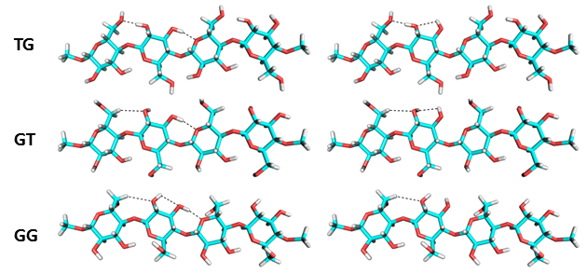
Supplementary Fig. 3 Different conformations at C6 changed the position of HO2. Hence the H-bond between O3 and O2 was allowed in tg (first row) and gt (second row) conformation. In gg conformation, O3 cannot form a H-bond with O2. Structures in column A correspond to the global minimum of the energy profiles in Figure 4. Structures in column B correspond to the local minimum of the energy profiles in Figure 4.

Supplementary Fig. 4 δ¹³C1′ (black dots) decreased as the distance (blue circles) between H1′ and HO2′ increased. δ¹³C1′ was downfield shifted (~2-3 ppm) to the maximum when H1′- HO2′ was at minimum. Whereas, δ¹³C1′ was upfield shifted (~1-2 ppm) to the minimum when H1′- HO2′ was at maximum.

A B

C D

Supplementary Fig. 5 Summary of the effects of different conformation of exocyclic groups at C6, Water and Gas on (A)¹³C1, (B)¹³C2, (C)¹³C3, and (D)¹³C5 NMR chemical shift. (i) represents the signals from interior cellulose whereas (s) represents signals from glucose on the surface of cellulose microfibril model. The horizontal error bars are the standard error.

