Tailoring Flame-Retardancy and Strength of Papers via Layer-by-Layer Treatment of Cellulose Fibers
Oruç Köklükaya*, †, Federico Carosio‡ and Lars Wågberg^{*, †, ᵮ}
†Fiber and Polymer Technology, KTH Royal Institute of Technology,
Teknikringen 56, SE-100 44 Stockholm, Sweden
‡Dipartimento di Scienza Applicata e Tecnologia, Politecnico di Torino, Alessandria Site
Viale Teresa Michel 5, 15121, Alessandria, Italy
^{ᵮ}Wallenberg Wood Science Center, KTH Royal Institute of Technology,
SE-100 44 Stockholm, Sweden

Corresponding authors:
Oruҫ Köklükaya
ORCID ID 0000-0001-9856-6536
E-mail: oruc@kth.se
Phone: +46-8-790 82 96

Lars Wågberg
ORCID ID 0000-0001-8622-0386
E-mail: wagberg@kth.se
Phone: +46-8-790 82 94

Supplementary material
Fig. S 1 The density of papers prepared from untreated and LbL-treated fibers

Fig. S 2 Nitrogen analysis calibration curves for a) low molecular mass PEI and b) high molecular mass PEI

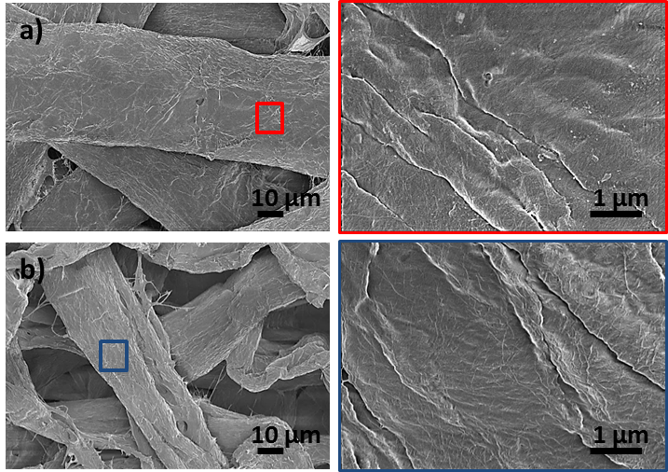
Fig. S 3 SEM images of a) cellulose fibers and b) carboxymethylated fiber and corresponding high magnification images.
Table S 1 The average roughness value (Rq) of PEI/SHMP thin films deposited on model cellulose and CM-cellulose surfaces as a function of bilayer number
Sample | Model cellulose surface roughness [nm] | Model CM-cellulose surface roughness [nm]
Reference | 8.5 ± 0.4 | 8.0 ± 0.1
LM_{w}-PEI/SHMP-3.5BL | 8.0 ± 0.0 | 11.8 ± 2.0
HM_{w}-PEI/SHMP-3.5BL | 8.7 ± 0.3 | 25.5 ± 0.8

