Supplementary Information for the article:

Preparation and evaluation of high-lignin content cellulose nanofibrils from eucalyptus pulp

Martha Herrera¹, Kasinee Thitiwutthisakul², Xuan Yang¹,

Pim-on Rujitanaroj^{2*}, Ramiro Rojas^{1*}, and Lars Berglund¹

¹Department of Fibre and Polymer Technology and Wallenberg Wood Science Center, KTH Royal Institute of Technology, SE-100 44 Stockholm, SWEDEN
²Product and Technology Development Center, SCG Packaging Public Company Limited, Ban Pong, Ratchaburi 70110, THAILAND
*e-mail and telephone number: ramiro@kth.se; +46 8-790 8106
*e-mail and telephone number: pimonruj@scg.co.th; (+66)-32-339-800

Methods

Morphology of the fibers
Never-dried samples of the eucalyptus pulps were taken through the oxidation and microfluidization process and diluted using distilled water. A drop of each suspension was observed through an optical microscope at 10X magnification.

Results

Effect of the process steps on the LCNF fiber structure
Figure S1 shows the LCNF original eucalyptus pulp fibers and the changes occurred during the pretreatment, 4-AT-mediated oxidation and microfluidization steps.
In Fig. S1 (A) single eucalyptus fibers can be observed, after the pretreatment (Fig. S1 B) the fibers keep size and shape, however, after the 4-AT- mediated oxidation (Fig. S1 C) the fibers seem shorter and finer. In the final microfluidization step (Fig. S1 D) very short and fine fiber with some agglomerations can be observed.

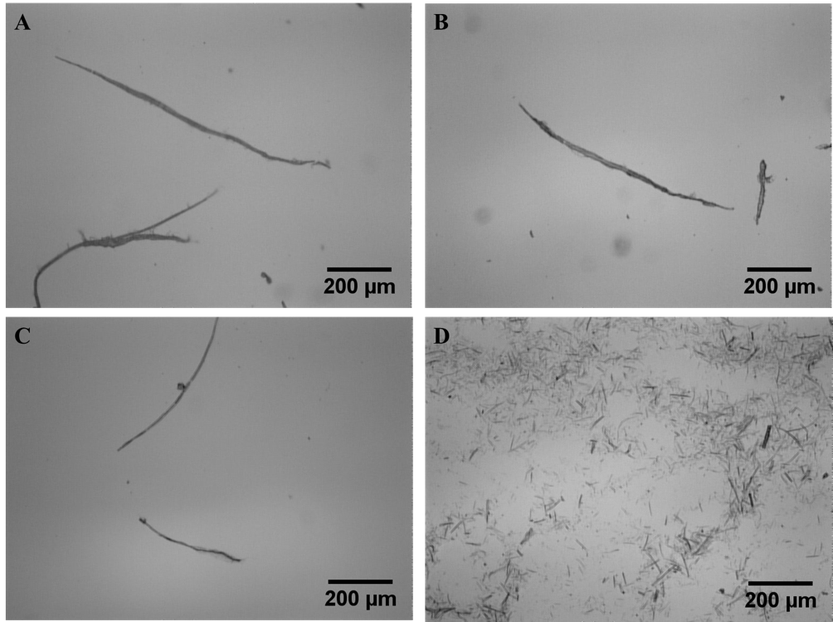
Figure S1: Optical microscopy images of eucalyptus pulp (A), pretreated pulp (B), 4-AT oxidized pulp (C), and last microfluidization step at 12,400 kPa (D) at 10X magnification.

Oxidation and microfluidization effect on fiber suspensions
Figure S2 shows how as received eucalyptus pulp, the 4-AT-mediated oxidized pulp and microfluidized pulps changed in appearance during the isolation process. The original pulp fibers (Fig. S2 A), became more liquid and fluid after the pretreatments and 4-AT mediated oxidation steps (Fig. S2B), but it was after the homogenization (Figs. S2 C and D) that an increase in the viscosity can be appreciated.
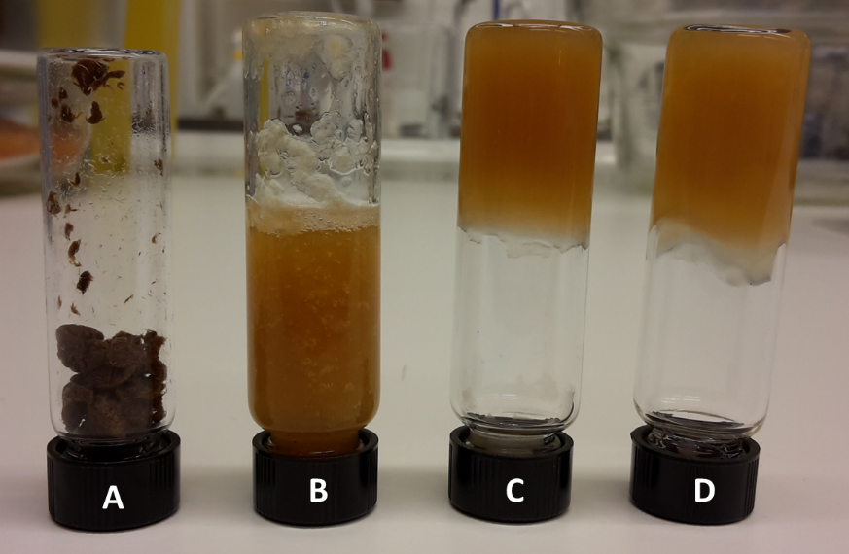
Figure S2: Eucalyptus pulp (A), 4-AT oxidized pulp (B), suspension after the last microfluidization step at 5,500 kPa (C), and last microfluidization step at 12,400 kPa (D).

