Direct sulfation of cellulose fibers using a reactive deep eutectic solvent to produce highly charged cellulose nanofibers
Juho Antti Sirviö,* Jonne Ukkola, Henrikki Liimatainen

Fibre and Particle Engineering Research Unit, University of Oulu, P.O. Box 4300, 90014 Oulu, Finland E-mail: juho.sirvio@oulu.fi
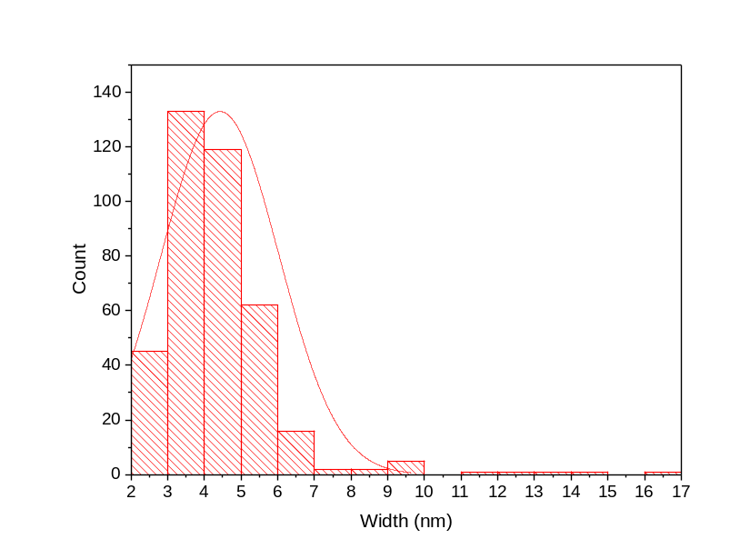
Figure S1. The size distribution of SCNF calculated from TEM image

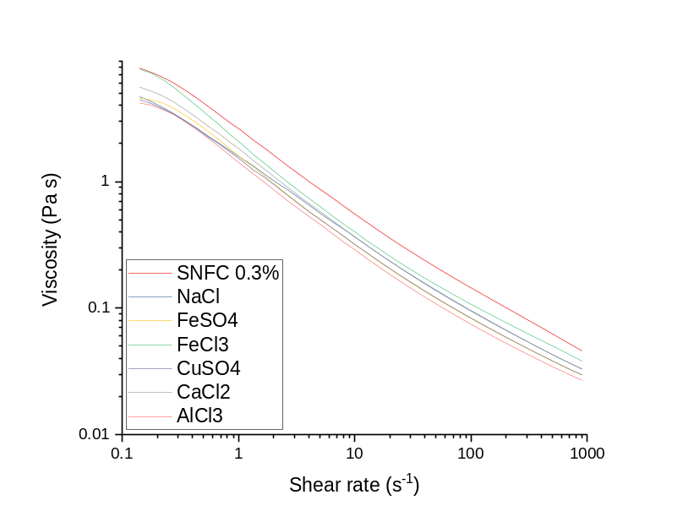

Figure S2. Viscosities of the SCNFs 0.3% solutions in the presence of various metal salts (1 mM) as a function of shear rate (0.1-1000 s⁻¹).

Table S2. Viscosities of the SCNFs 0.3% solutions in the presence of various metal salts (1 mM) at shear rate of 1 s⁻¹ and ration between viscosities with and without the presence of metal salts.
 | Viscosity (Pa s) | Viscosityª/Viscosity^{b}
SCNF 0.3% | 2.52
NaCl | 1.52 | 0.6
CaCl2 | 1.75 | 0.7
AlCl3 | 1.35 | 0.8
FeCl3 | 1.98 | 0.8
FeSO4 | 1.52 | 0.6
CuSO4 | 1.46 | 0.6
ª = Viscosity of 0.3% SCNF solution in presence of 1 mM salt
^{b} = Viscosity of 0.3% solution without addition of salt

