Supplementary Information
Supplementary Figure 1: Ink penetration assay by measuring grey scale intensity.

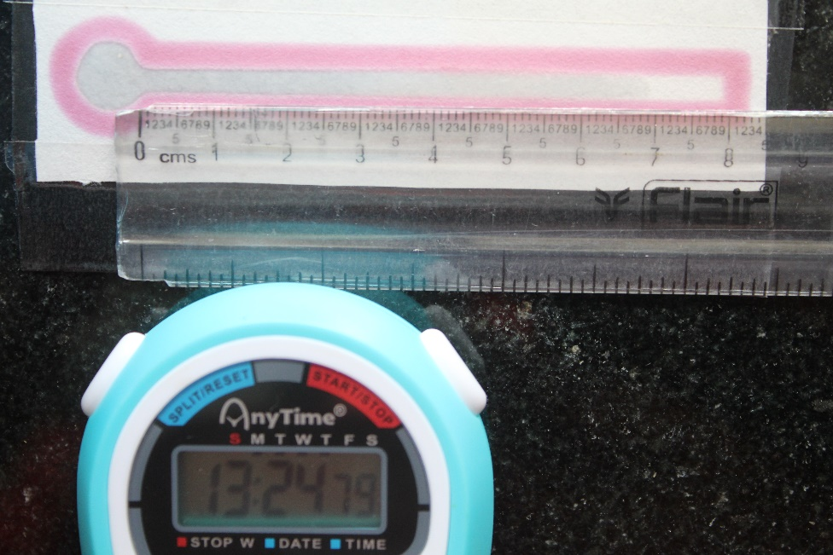

Supplementary Figure 2: Penetration length of water.

Supplementary Figure 3: Bulk colorimetric assay using L-proline-naphthylamide (a) Without Candida albicans (No colour) (b) With Candida albicans (Pink colour).
Supplementary Figure 4: Cost analysis for paper-based colorimetric test.

Fabrication of Paper-based devices
Existing Method | Our Method
Xerox colorQube  Cost: 599 - 2499 $ | Paraffin-based printer  Cost: 25$

Detection of Candida albicans
Existing Methods | Our Method
BacTALERT, Culture & VITEK system  Cost: 15$ | Paper-based device with PRO substrate  Cost: 0.22$

