Title

Development and mining of a database of historic European paper properties

Authors
Matija Strlič, Yun Liu, Dirk Lichtblau, Gerrit De Bruin, Barry Knight, Thea Winther, Irena Kralj Cigić, Richard G. Brereton

Supplementary Material
Spearman’s correlation coefficients have been calculated to account to possible non-linear relationships between data. Tables. S.1-4 present the coefficients on pairwise sets of variables. Tabs. S.5-8 present the number of samples used for the calculation of the corresponding coefficients. Figs. S.1-41 present scatterplots for pairs of variables where ρ² > 0.25. All the plots are colour coded as follows: blue for bleached, red for gelatin and green for groundwood.

Table S.1: Spearman’s correlation coefficients on pairwise sets of variables for all samples.
 | dat | lig | pH | dp | MW | ash | Al | car | ros | pro | grm | TS
dat | 1 | 0.1598 | 0.1802 | 0.4525 | 0.4183 | -0.0172 | -0.0847 | -0.2568 | -0.2125 | -0.4072 | 0.0764 | 0.3013
lig |  | 1 | -0.4717 | -0.3145 | -0.2405 | 0.4969 | 0.1023 | 0.5325 | 0.5054 | -0.5563 | -0.3594 | -0.4224
pH |  |  | 1 | 0.6209 | 0.4547 | -0.2505 | -0.2466 | -0.5942 | -0.461 | 0.2188 | 0.1842 | 0.3802
dp |  |  |  | 1 | 0.7805 | -0.3712 | -0.3710 | -0.7606 | -0.5066 | 0.1936 | -0.0643 | 0.6130
MW |  |  |  |  | 1 | -0.2915 | -0.2859 | -0.5690 | -0.4387 | 0.1501 | 0.0172 | 0.3132
ash |  |  |  |  |  | 1 | 0.1729 | 0.3675 | 0.4957 | -0.5427 | 0.0887 | -0.1985
Al |  |  |  |  |  |  | 1 | 0.2978 | 0.4020 | -0.1148 | 0.0623 | -0.0146
car |  |  |  |  |  |  |  | 1 | 0.5934 | -0.4442 | -0.1471 | -0.4257
ros |  |  |  |  |  |  |  |  | 1 | -0.5331 | -0.1369 | -0.2077
pro |  |  |  |  |  |  |  |  |  | 1 | 0.0971 | 0.2347
grm |  |  |  |  |  |  |  |  |  |  | 1 | 0.5326
TS |  |  |  |  |  |  |  |  |  |  |  | 1

Table S.2: Spearman’s correlation coefficients on pairwise sets of variables for all bleached samples.
 | dat | lig | pH | dp | MW | ash | Al | car | ros | pro | grm | TS
dat | 1 | 0.0372 | 0.3655 | 0.6832 | 0.6239 | -0.1296 | -0.1296 | -0.5615 | -0.3656 | NaN | 0.065 | 0.5504
lig |  | 1 | -0.3082 | -0.1396 | -0.0686 | 0.2775 | 0.2024 | 0.1548 | 0.2934 | NaN | 0.0001 | -0.1353
pH |  |  | 1 | 0.6049 | 0.4406 | -0.1904 | -0.2750 | -0.5534 | -0.5213 | NaN | -0.0663 | 0.3736
dp |  |  |  | 1 | 0.7468 | -0.3448 | -0.2775 | -0.7151 | -0.4744 | NaN | -0.0821 | 0.5742
MW |  |  |  |  | 1 | -0.2243 | -0.1367 | -0.6268 | -0.4111 | NaN | 0.0222 | 0.3566
ash |  |  |  |  |  | 1 | 0.0912 | 0.1557 | 0.2275 | NaN | 0.1300 | -0.1558
Al |  |  |  |  |  |  | 1 | 0.3363 | 0.3367 | NaN | 0.0006 | -0.1328
car |  |  |  |  |  |  |  | 1 | 0.5239 | NaN | 0.1016 | -0.3567
ros |  |  |  |  |  |  |  |  | 1 | NaN | 0.0209 | -0.1373
pro |  |  |  |  |  |  |  |  |  | NaN | NaN | NaN
grm |  |  |  |  |  |  |  |  |  |  | 1 | 0.4123
TS |  |  |  |  |  |  |  |  |  |  |  | 1

Table S.3: Spearman’s correlation coefficients on pairwise sets of variables for gelatine samples.
 | dat | lig | pH | dp | MW | ash | Al | car | ros | pro | grm | TS
dat | 1 | 0.0668 | -0.5858 | -0.4108 | -0.0933 | 0.0805 | 0.6306 | 0.2525 | 0.3164 | -0.0868 | 0.0490 | -0.2994
lig |  | 1 | -0.1568 | -0.1955 | -0.1644 | -0.1582 | -0.0275 | 0.0797 | 0.2618 | -0.0172 | -0.2199 | -0.4688
pH |  |  | 1 | 0.5230 | 0.2300 | 0.0811 | -0.2563 | -0.2587 | -0.5029 | -0.1563 | 0.5263 | -0.1085
dp |  |  |  | 1 | 0.7820 | 0.1054 | -0.3056 | -0.6154 | -0.2944 | -0.0138 | -0.0572 | 0.3429
MW |  |  |  |  | 1 | 0.0238 | -0.3461 | -0.6252 | -0.0173 | 0.0783 | -0.1681 | 0.6321
ash |  |  |  |  |  | 1 | 0.1968 | -0.0251 | -0.0356 | -0.0815 | 0.0614 | 0.5128
Al |  |  |  |  |  |  | 1 | 0.1623 | -0.0143 | 0.4330 | -0.3446 | 0.2000
car |  |  |  |  |  |  |  | 1 | 0.0131 | -0.2776 | 0.3033 | -0.2460
ros |  |  |  |  |  |  |  |  | 1 | 0.0999 | -0.4290 | 0.0255
pro |  |  |  |  |  |  |  |  |  | 1 | -0.1807 | 0.5623
grm |  |  |  |  |  |  |  |  |  |  | 1 | 0.5385
TS |  |  |  |  |  |  |  |  |  |  |  | 1

Table S.4: Spearman’s correlation coefficients on pairwise sets of variables for groundwood samples.
 | dat | lig | pH | dp | MW | ash | Al | car | ros | pro | grm | TS
dat | 1 | 0.1678 | 0.0308 | 0.0714 | 0.2663 | -0.1791 | -0.1952 | -0.1917 | -0.4722 | -0.1444 | -0.0459 | 0.0958
lig |  | 1 | -0.3471 | -0.5714 | 0.1826 | -0.2613 | -0.3094 | 0.2102 | -0.2844 | -0.0278 | -0.3466 | -0.274
pH |  |  | 1 | -0.3571 | 0.2981 | 0.1343 | -0.0718 | -0.4842 | -0.0632 | -0.0515 | 0.1042 | 0.3099
dp |  |  |  | 1 | -0.0357 | 0.1190 | 0.6905 | 0.0476 | 0.2381 | NaN | 0.4000 | 0.5000
MW |  |  |  |  | 1 | -0.1538 | -0.3788 | -0.2933 | -0.3798 | -0.1450 | -0.1586 | 0.1297
ash |  |  |  |  |  | 1 | 0.0195 | -0.1671 | 0.0587 | -0.1089 | 0.3584 | 0.0211
Al |  |  |  |  |  |  | 1 | 0.1353 | 0.4802 | 0.0811 | 0.1695 | -0.0228
car |  |  |  |  |  |  |  | 1 | 0.1697 | 0.1025 | -0.1223 | -0.2942
ros |  |  |  |  |  |  |  |  | 1 | 0.1100 | -0.0319 | -0.0955
pro |  |  |  |  |  |  |  |  |  | 1 | -0.1148 | NaN
grm |  |  |  |  |  |  |  |  |  |  | 1 | 0.5924
TS |  |  |  |  |  |  |  |  |  |  |  | 1

Table S.5: Number of samples used in the Spearman’s correlation analysis on pairwise sets of variables for all samples.
 | dat | lig | pH | dp | MW | ash | Al | car | ros | pro | grm | TS
dat | 597 | 467 | 593 | 332 | 518 | 573 | 566 | 587 | 585 | 597 | 444 | 300
lig |  | 556 | 553 | 300 | 462 | 543 | 534 | 553 | 550 | 534 | 389 | 266
pH |  |  | 725 | 443 | 616 | 699 | 693 | 713 | 711 | 695 | 499 | 330
dp |  |  |  | 446 | 375 | 427 | 424 | 441 | 438 | 428 | 254 | 175
MW |  |  |  |  | 616 | 598 | 589 | 609 | 609 | 588 | 442 | 287
ash |  |  |  |  |  | 702 | 678 | 697 | 694 | 673 | 482 | 322
Al |  |  |  |  |  |  | 697 | 691 | 687 | 668 | 483 | 316
car |  |  |  |  |  |  |  | 717 | 708 | 688 | 494 | 326
ros |  |  |  |  |  |  |  |  | 715 | 686 | 495 | 328
pro |  |  |  |  |  |  |  |  |  | 699 | 481 | 316
grm |  |  |  |  |  |  |  |  |  |  | 501 | 311
TS |  |  |  |  |  |  |  |  |  |  |  | 330

Table S.6: Number of samples used in the Spearman’s correlation analysis on pairwise sets of variables for bleached samples.
 | dat | lig | pH | dp | MW | ash | Al | car | ros | pro | grm | TS
dat | 301 | 195 | 299 | 281 | 269 | 285 | 279 | 295 | 292 | NaN | 205 | 147
lig |  | 208 | 207 | 195 | 186 | 201 | 192 | 205 | 203 | NaN | 134 | 98
pH |  |  | 321 | 301 | 289 | 305 | 299 | 314 | 311 | NaN | 215 | 154
dp |  |  |  | 303 | 274 | 287 | 284 | 300 | 295 | NaN | 210 | 151
MW |  |  |  |  | 289 | 275 | 268 | 284 | 284 | NaN | 199 | 140
ash |  |  |  |  |  | 306 | 287 | 302 | 300 | NaN | 205 | 149
Al |  |  |  |  |  |  | 301 | 296 | 293 | NaN | 206 | 147
car |  |  |  |  |  |  |  | 316 | 309 | NaN | 213 | 152
ros |  |  |  |  |  |  |  |  | 313 | NaN | 212 | 153
pro |  |  |  |  |  |  |  |  |  | NaN | NaN | NaN
grm |  |  |  |  |  |  |  |  |  |  | 216 | 149
TS |  |  |  |  |  |  |  |  |  |  |  | 154

Table S.7: Number of samples used in the Spearman’s correlation analysis on pairwise sets of variables for gelatine samples.
 | dat | lig | pH | dp | MW | ash | Al | car | ros | pro | grm | TS
dat | 46 | 40 | 46 | 44 | 34 | 43 | 43 | 44 | 46 | 46 | 12 | 8
lig |  | 98 | 98 | 97 | 60 | 97 | 97 | 98 | 98 | 98 | 23 | 20
pH |  |  | 137 | 135 | 96 | 134 | 134 | 135 | 137 | 137 | 40 | 21
dp |  |  |  | 135 | 94 | 132 | 132 | 133 | 135 | 135 | 40 | 21
MW |  |  |  |  | 96 | 95 | 95 | 95 | 96 | 96 | 33 | 15
ash |  |  |  |  |  | 134 | 134 | 134 | 134 | 134 | 38 | 20
Al |  |  |  |  |  |  | 134 | 134 | 134 | 134 | 38 | 20
car |  |  |  |  |  |  |  | 135 | 135 | 135 | 38 | 20
ros |  |  |  |  |  |  |  |  | 137 | 137 | 40 | 21
pro |  |  |  |  |  |  |  |  |  | 137 | 40 | 21
grm |  |  |  |  |  |  |  |  |  |  | 40 | 13
TS |  |  |  |  |  |  |  |  |  |  |  | 21

Table S.8: Number of samples used in the Spearman’s correlation analysis on pairwise sets of variables for groundwood samples.
 | dat | lig | pH | dp | MW | ash | Al | car | ros | pro | grm | TS
dat | 250 | 232 | 248 | 7 | 215 | 245 | 244 | 248 | 247 | 250 | 227 | 145
lig |  | 250 | 248 | 8 | 216 | 245 | 245 | 250 | 249 | 238 | 232 | 148
pH |  |  | 267 | 7 | 231 | 260 | 260 | 264 | 263 | 254 | 244 | 155
dp |  |  |  | 8 | 7 | 8 | 8 | 8 | 8 | NaN | 4 | 3
MW |  |  |  |  | 231 | 228 | 226 | 230 | 229 | 219 | 210 | 132
ash |  |  |  |  |  | 262 | 257 | 261 | 260 | 250 | 239 | 153
Al |  |  |  |  |  |  | 262 | 261 | 260 | 250 | 239 | 149
car |  |  |  |  |  |  |  | 266 | 264 | 254 | 243 | 154
ros |  |  |  |  |  |  |  |  | 265 | 253 | 243 | 154
pro |  |  |  |  |  |  |  |  |  | 256 | 233 | NaN
grm |  |  |  |  |  |  |  |  |  |  | 245 | 149
TS |  |  |  |  |  |  |  |  |  |  |  | 155

Figure S.1 | 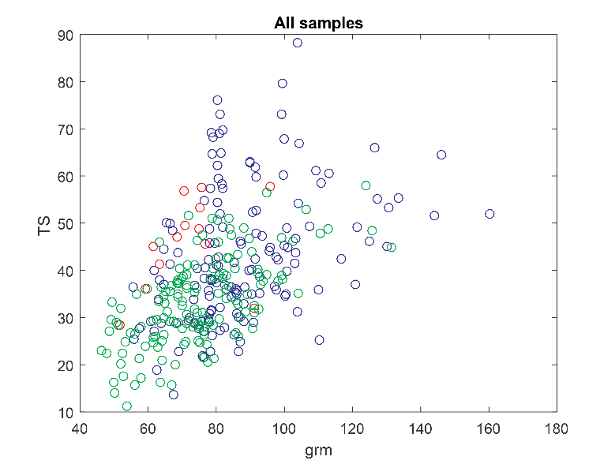
Figure S.2 | 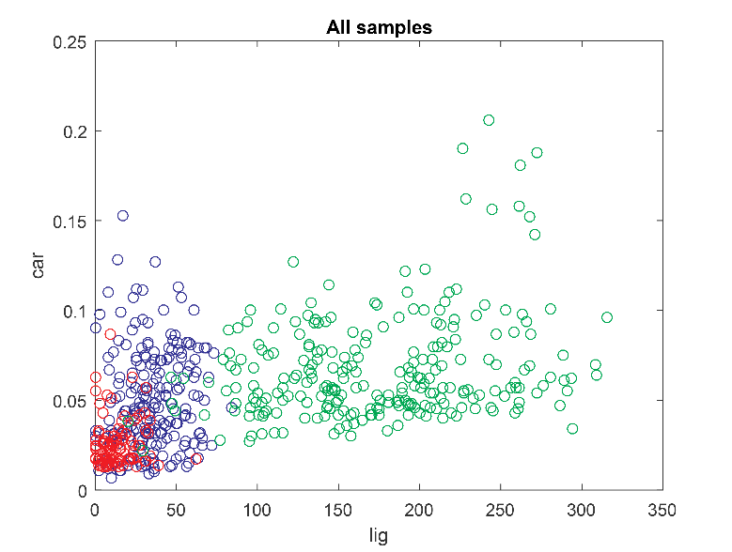
Figure S.3 | 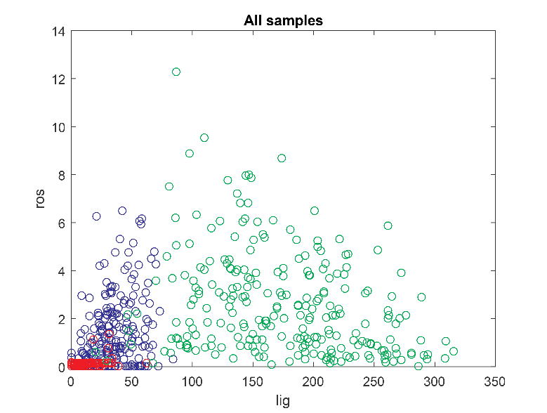
Figure S.4 | 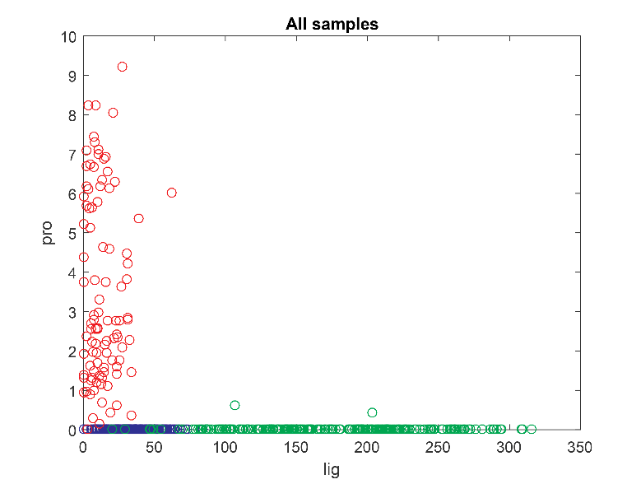
Figure S.5 | 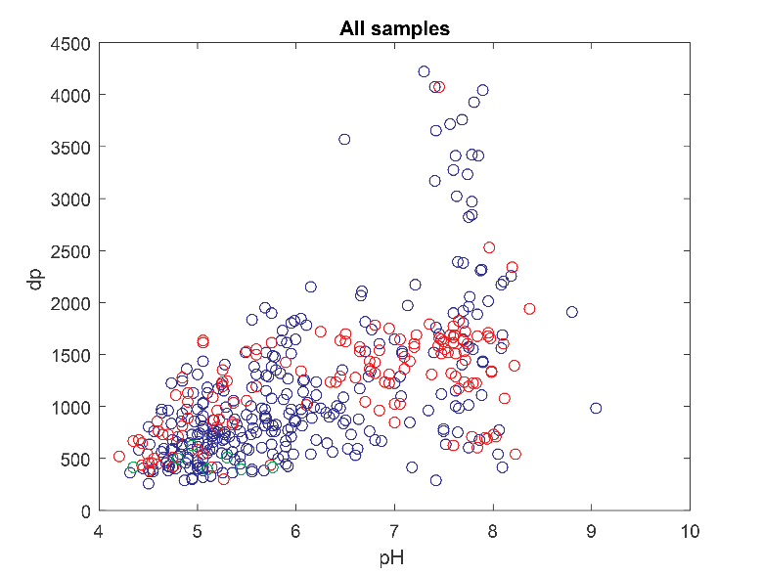
Figure S.6 | 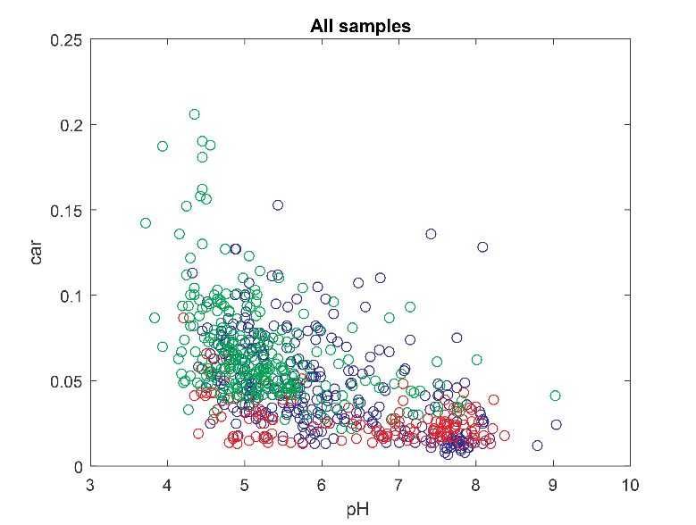
Figure S.7 | 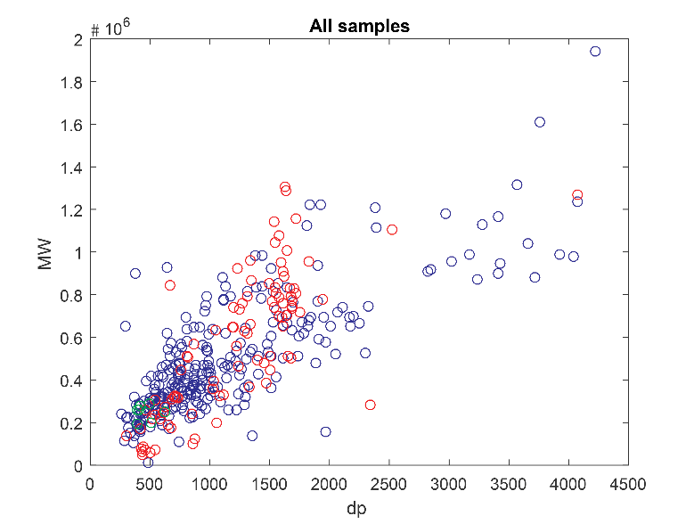
Figure S.8 | 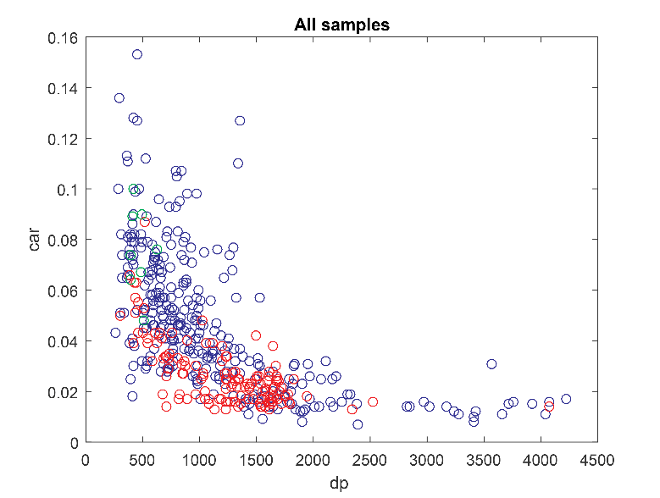
Figure S.9 | 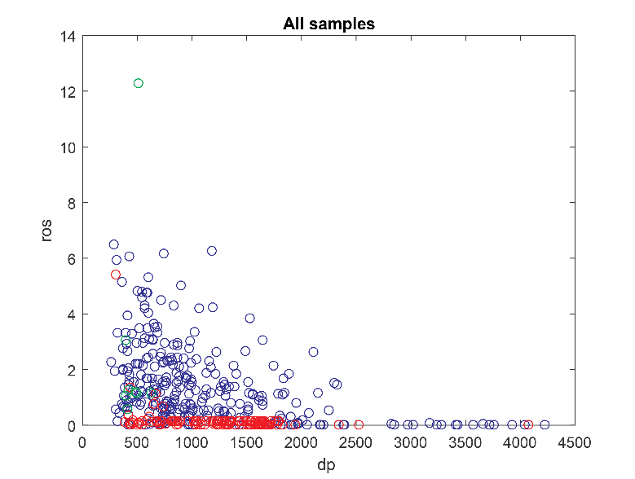
Figure S.10 | 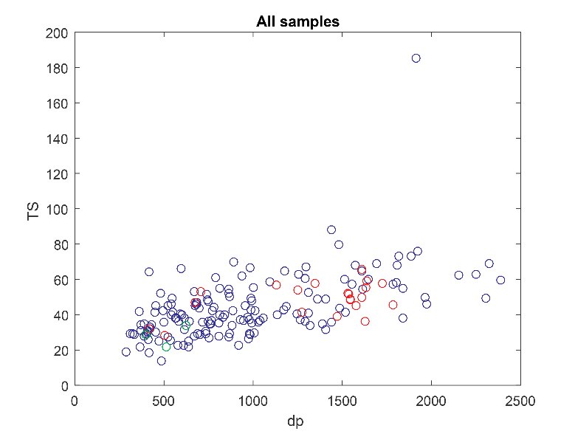
Figure S.11 | 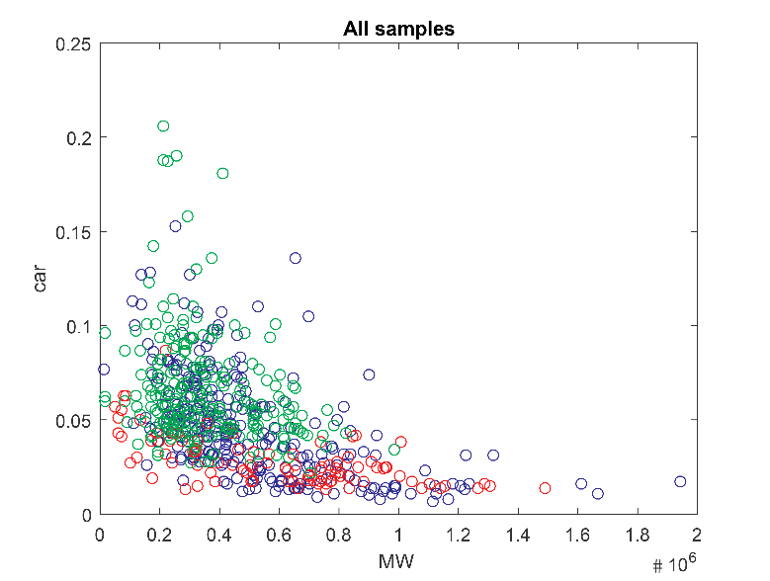
Figure S.12 | 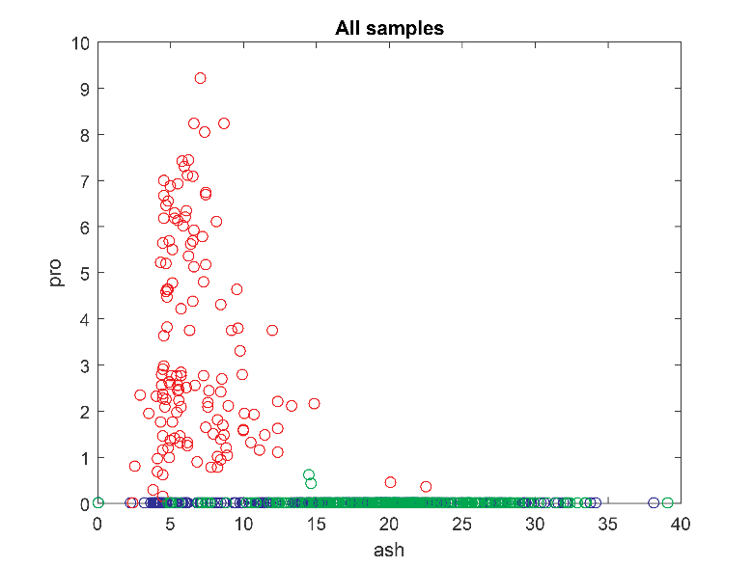
Figure S.13 | 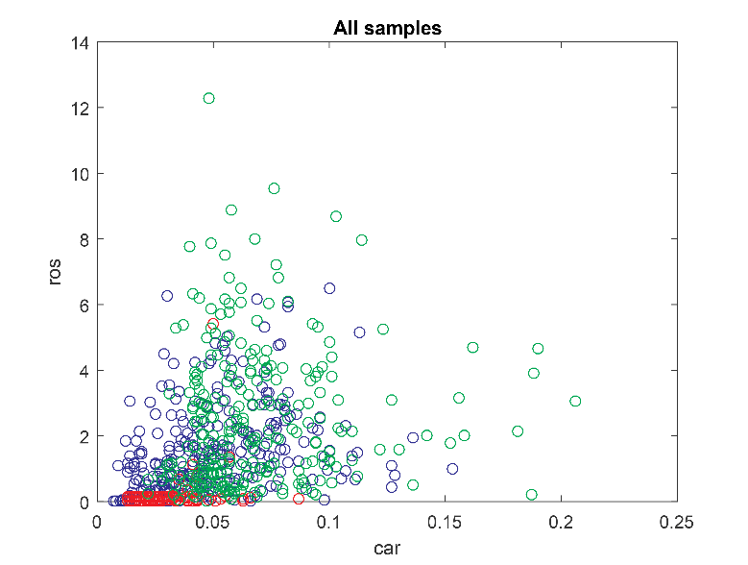
Figure S.14 | 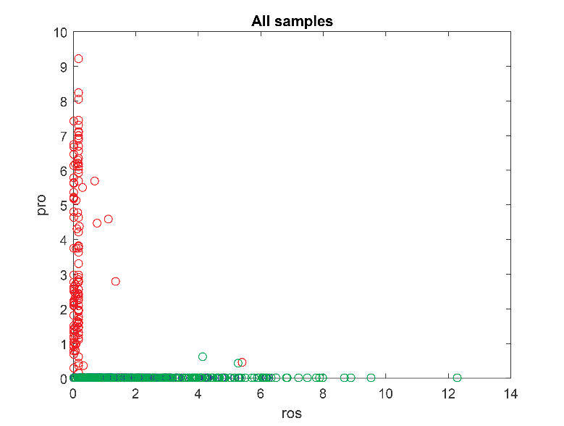
Figure S.15 | 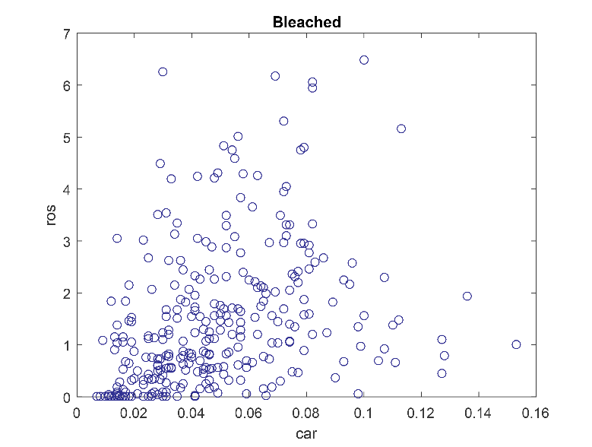
Figure S.16 | 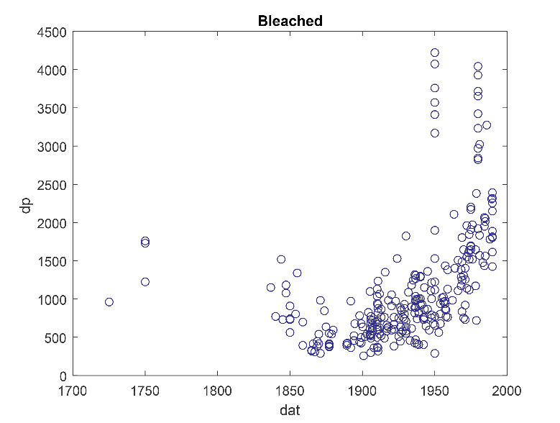
Figure S.17 | 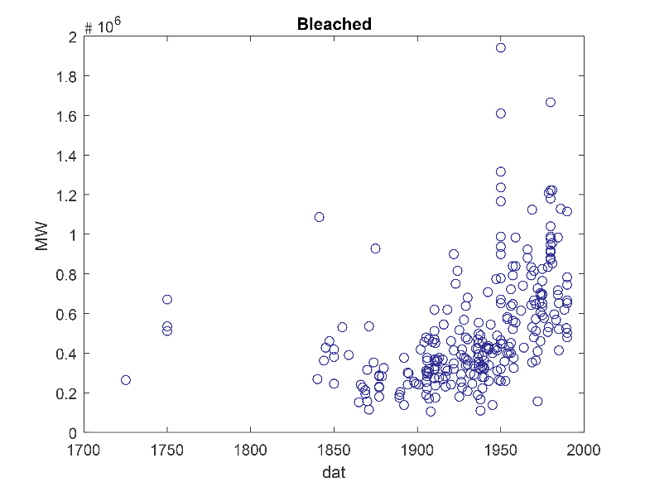
Figure S.18 | 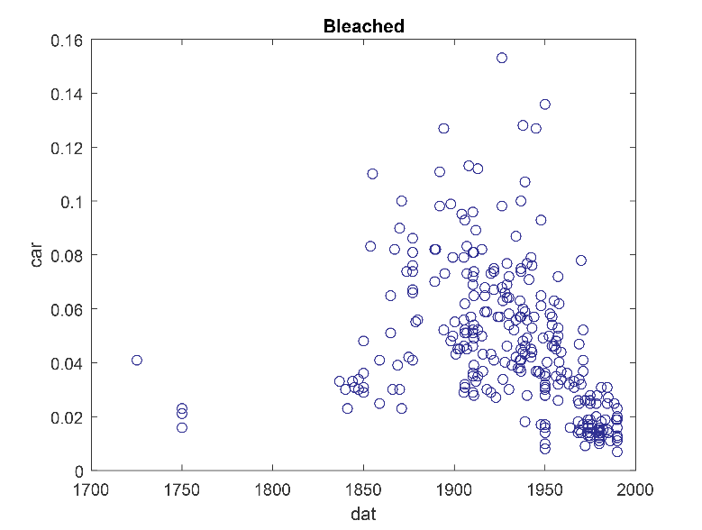
Figure S.19 | 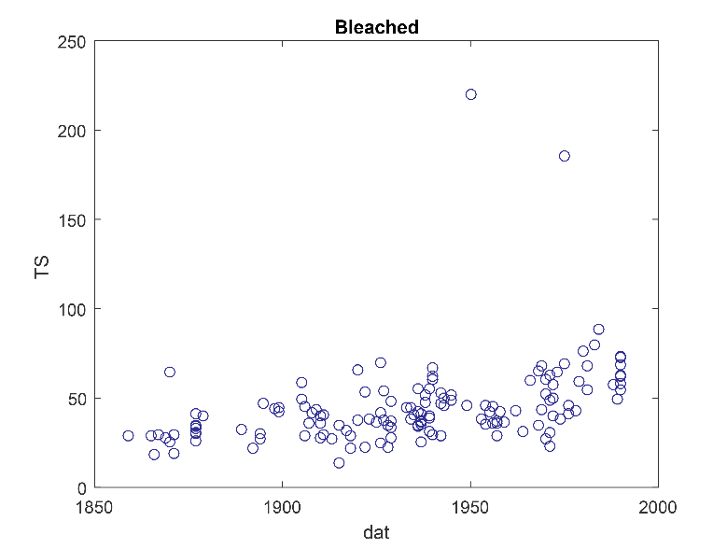
Figure S.20 | 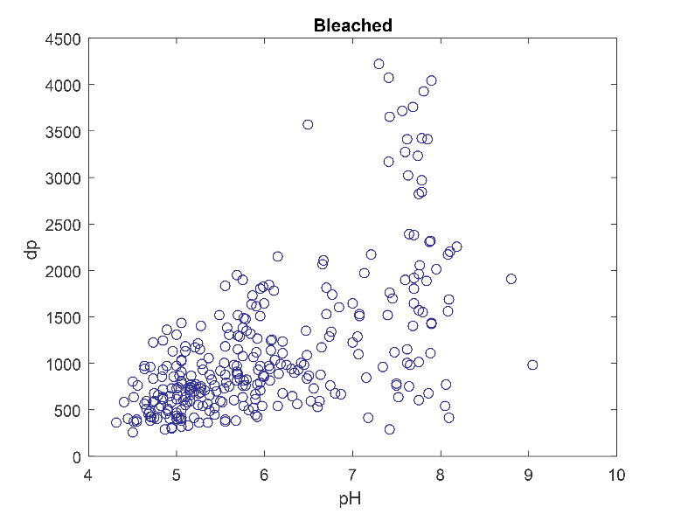
Figure S.21 | 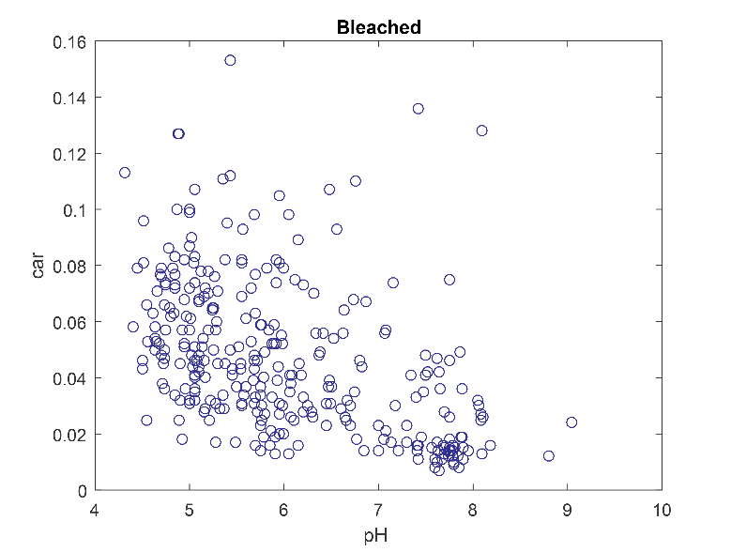
Figure S.22 | 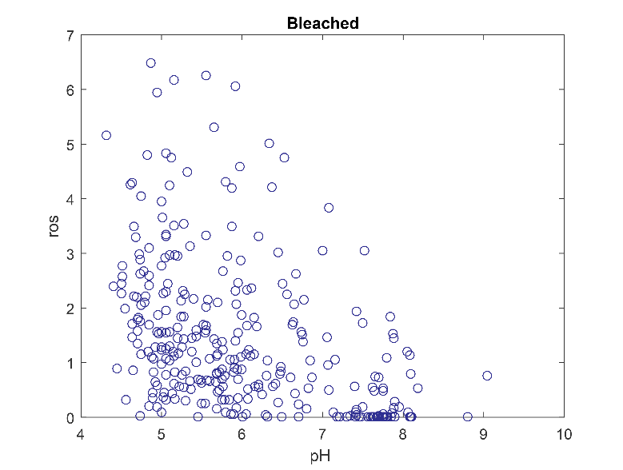
Figure S.23 | 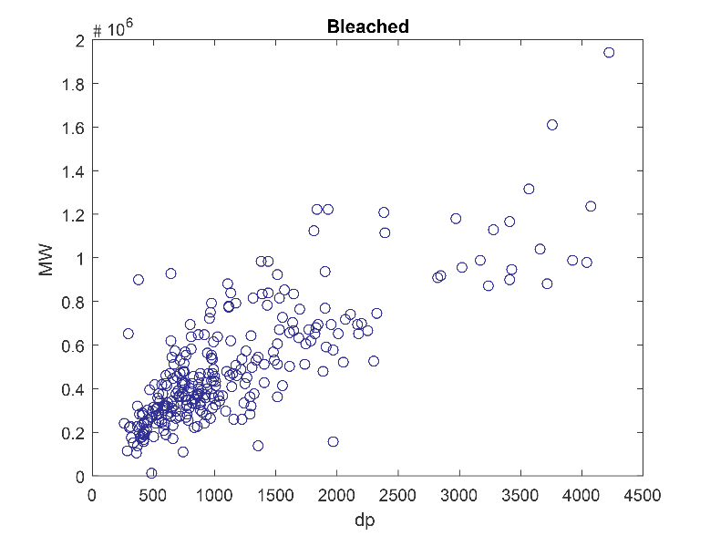
Figure S.24 | 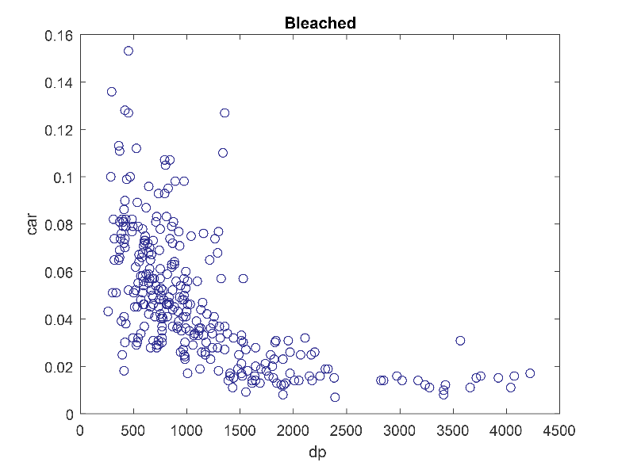
Figure S.25 | 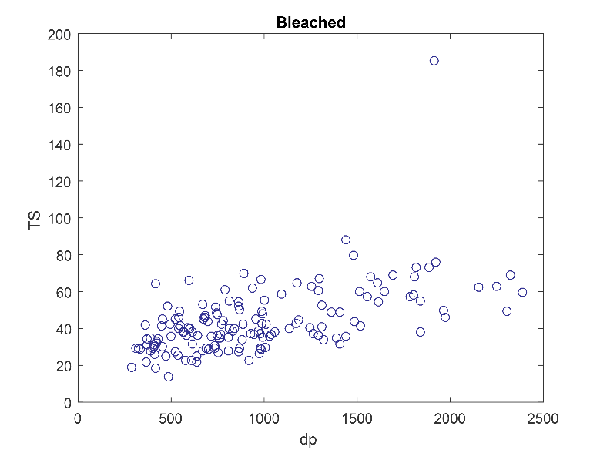
Figure S.26 | 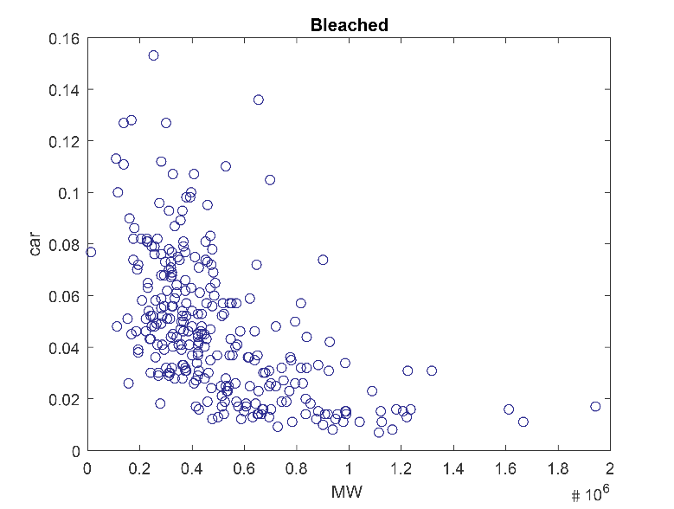
Figure S.27 | 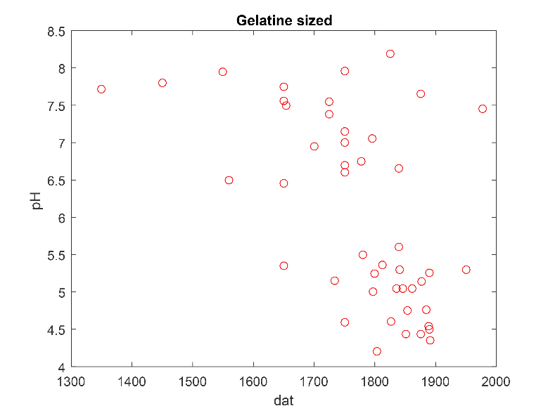
Figure S.28 | 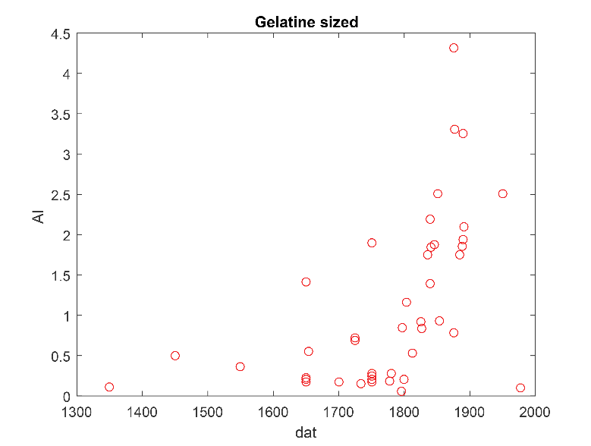
Figure S.29 | 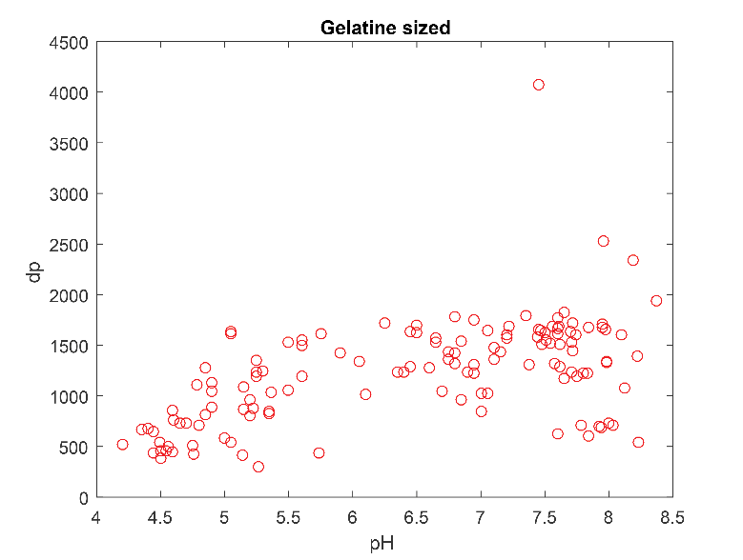
Figure S.30 | 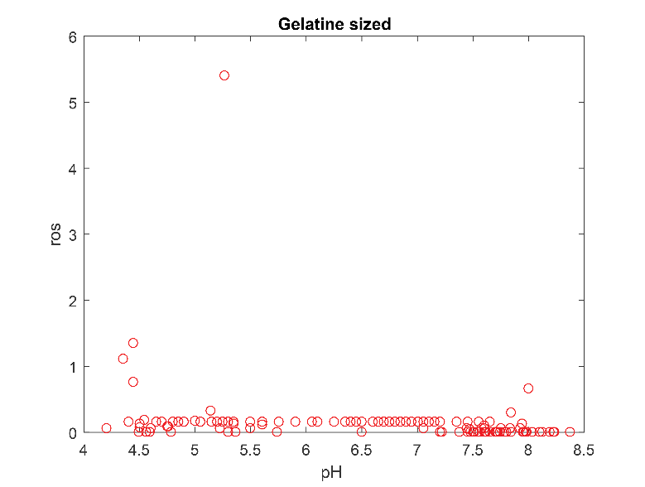
Figure S.31 | 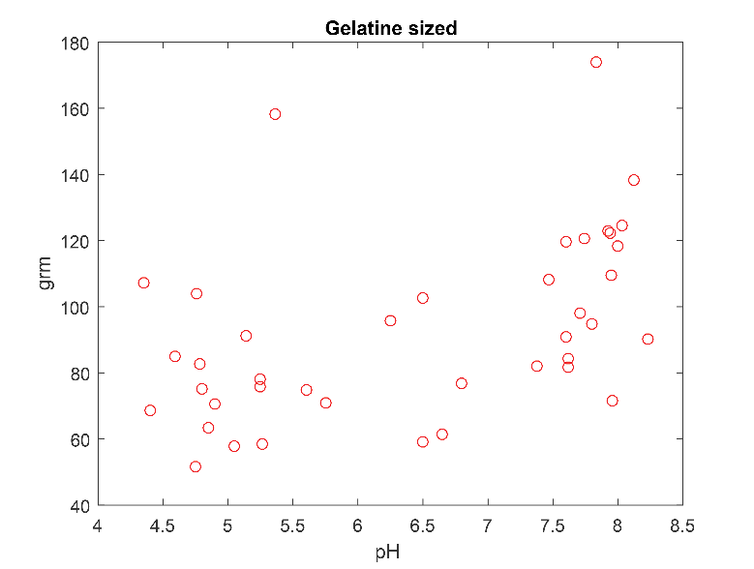
Figure S.32 | 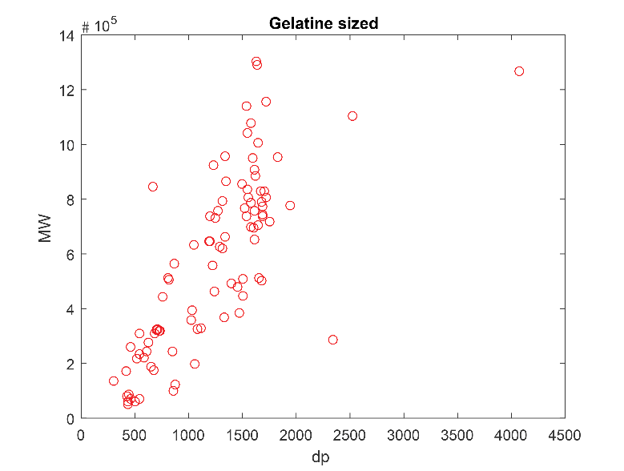
Figure S.33 | 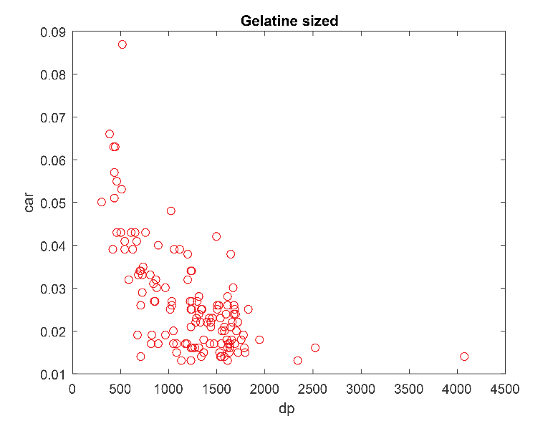
Figure S.34 | 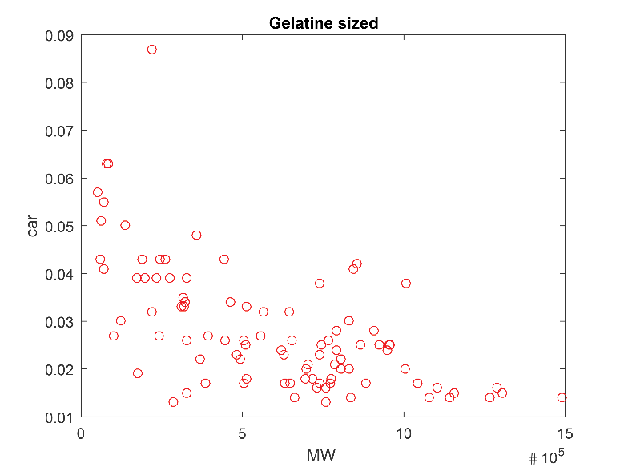
Figure S.35 | 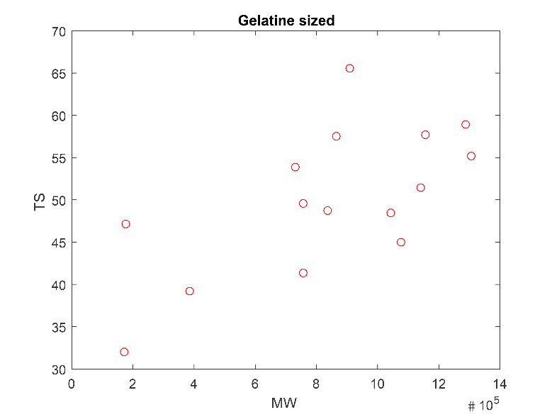
Figure S.36 | 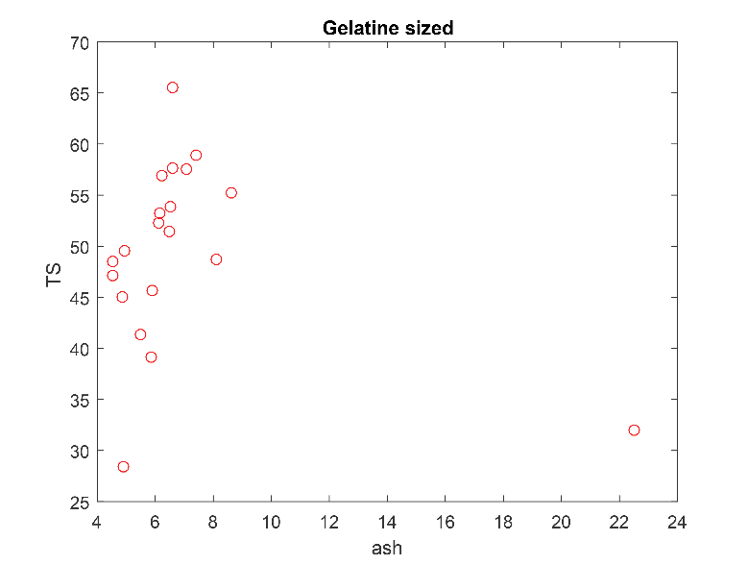
Figure S.37 | 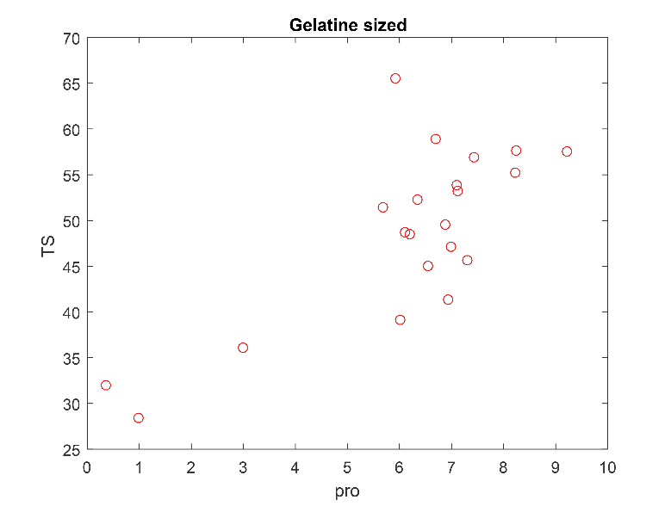
Figure S.38 | 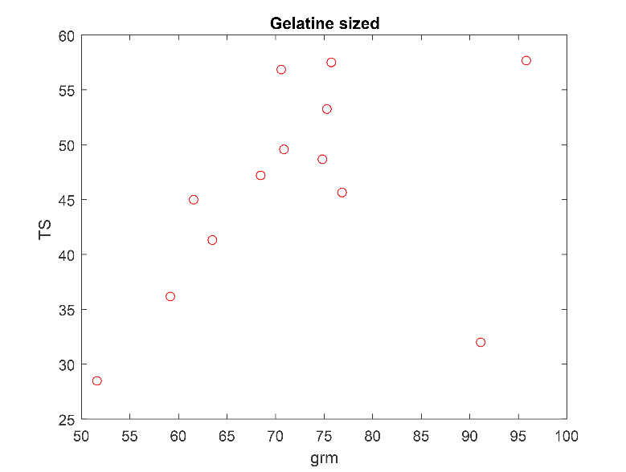
Figure S.39 | 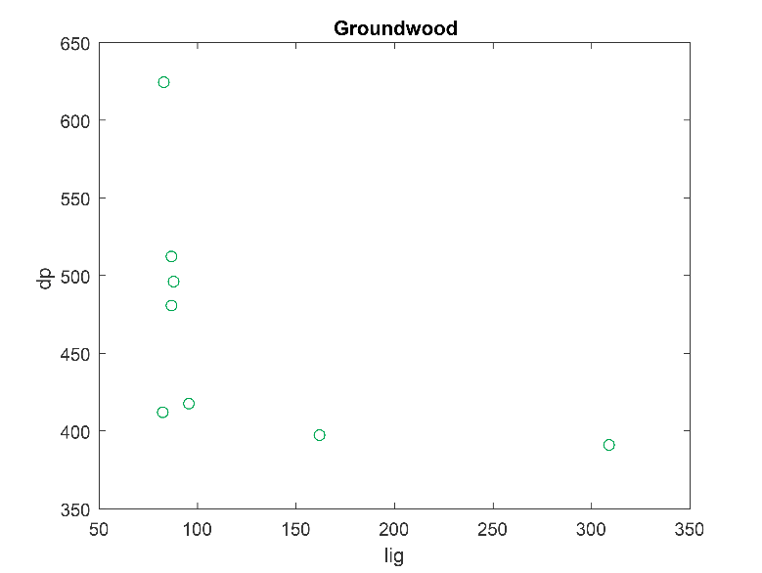
Figure S.40 | 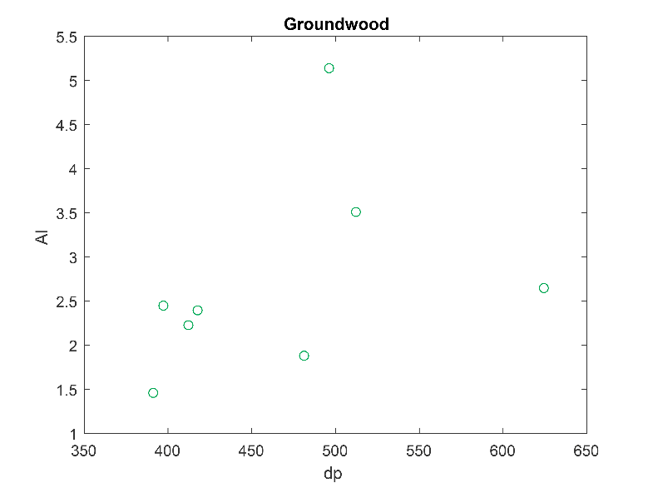
Figure S.41 | 