Supplementary
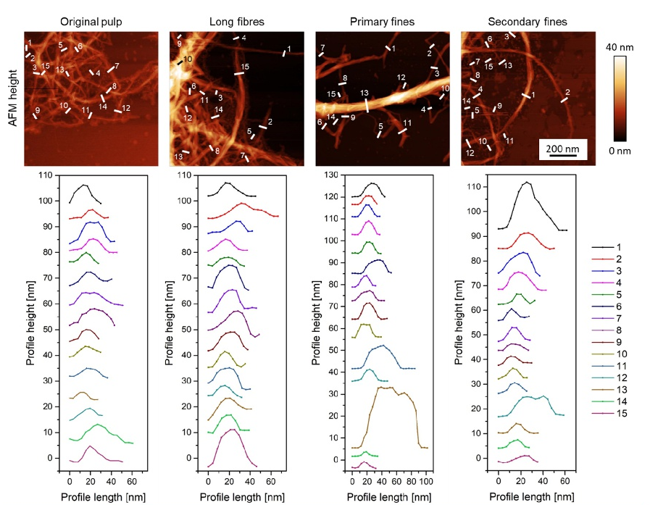
Figure 7 – AFM height images showed the nano-structure of the different pulp and fine sections (top row). 15 profiles of each AFM height image were extracted with Gwyddion software and revealed the size distributions of the fibres/fines (bottom row).

