Supporting information

Superbase-Based Protic Ionic Liquids for Cellulose Filament Spinning
Sherif Elsayed, Michael Hummel, Daisuke Sawada, Chamseddine Guizani, Marja Rissanen and Herbert Sixta

Department of Bioproducts and Biosystems, Aalto University, P.O. Box 16300, FI-00076 Aalto, Finland.

E-mail: sherif.elsayed@aalto.fi, michael.hummel@aalto.fi, daisuke.sawada@aalto.fi, chamseddine.guizani@aalto.fi, marja.rissaned@aalto.fi, herbert.sixta@aalto.fi.

Contents
X-ray diffraction 2
Rheological properties 2
Tensile properties 5

Number of pages: 05
Number of figures: 03
Number of tables: 02

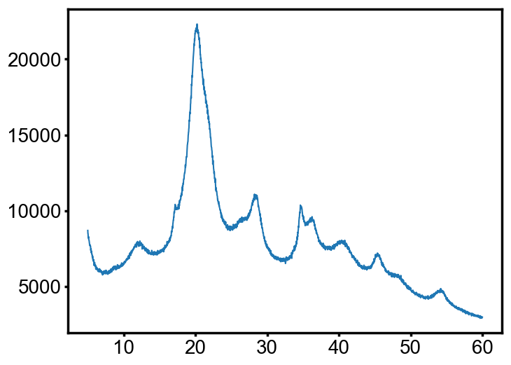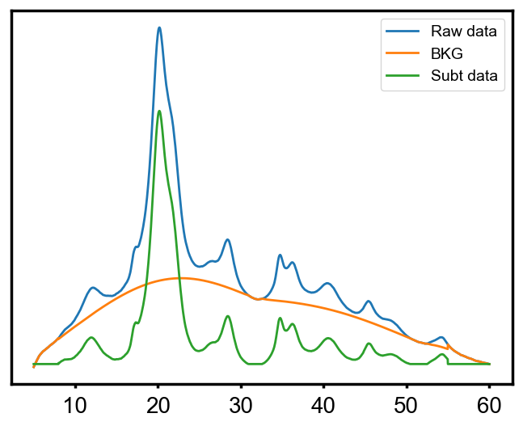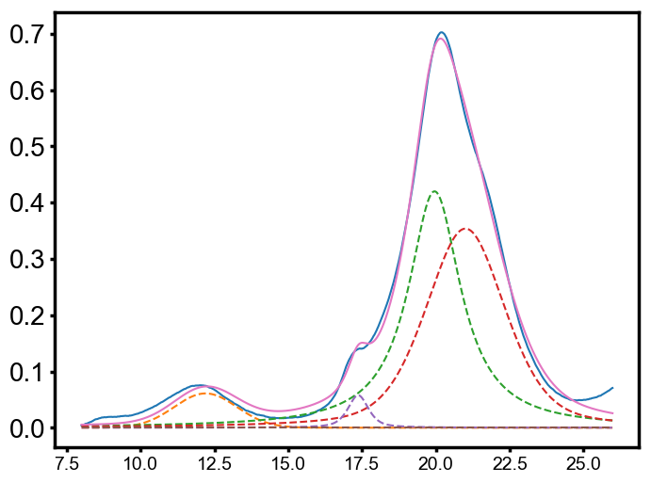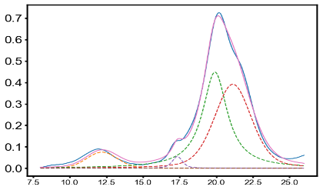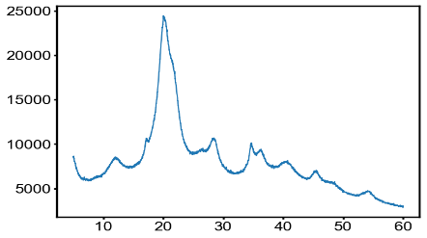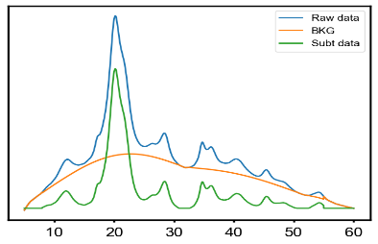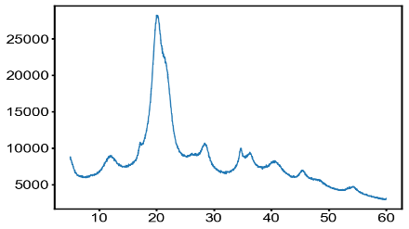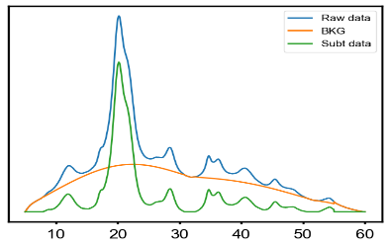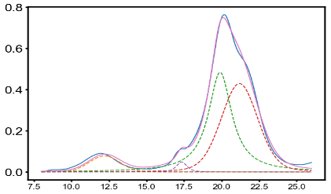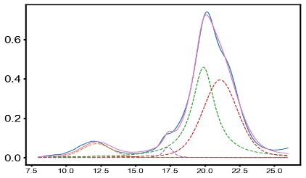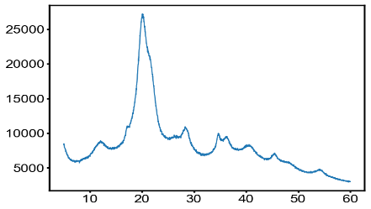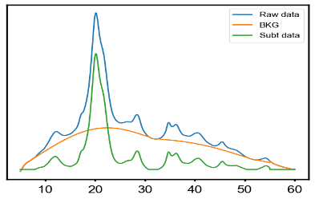X-ray diffraction
NMMO - fibers
[DBNH]OAc - fibers
[DBUH]OAc - fibers
a
b
c
Fig. S1 X-ray diffraction patterns of the fibers at DR 12 a. Raw scattering profiles from 5° to 60° 2θ b. Amorphous scattering c. Fittings of corrected profiles showing the crystalline peaks
[mTBDH]OAc - fibers
(1-10)
(002)
(020)
(110)
Intensity (a.u.)
Intensity (a.u.)
Intensity (a.u.)
Intensity (a.u.)
Intensity (a.u.)
Intensity (a.u.)
Intensity (a.u.)
Intensity (a.u.)
Corrected data for empty scattering
Amorphous BKG
Subtracted data

Corrected data for empty scattering
Amorphous BKG
Subtracted data

Corrected data for empty scattering
Amorphous BKG
Subtracted data
Corrected data for empty scattering
Amorphous BKG
Subtracted data

2θ (°)
2θ (°)

Table S1 Crystal width of the equatorial lattice of the measured fibers
Draw ratio | NMMO | [DBNH]OAc | [DBUH]OAc | [mTBD]OAc
Draw ratio | Crystal width (${CW}_{hkl}$), Å
2 | 30.0 | 34.8 | 35.5 | 35.0
5 | 32.0 | 34.7 | 34.2 | 35.2
12 | 33.5 | 34.9 | 35.6 | 35.2

Rheological properties
Fig. S2 shows a higher zero-shear viscosity for the NMMO and [DBUH]OAc solutions followed by the [mTBDH]OAc solution, while [DBNH]OAc solution depicted the lowest zero shear viscosity.
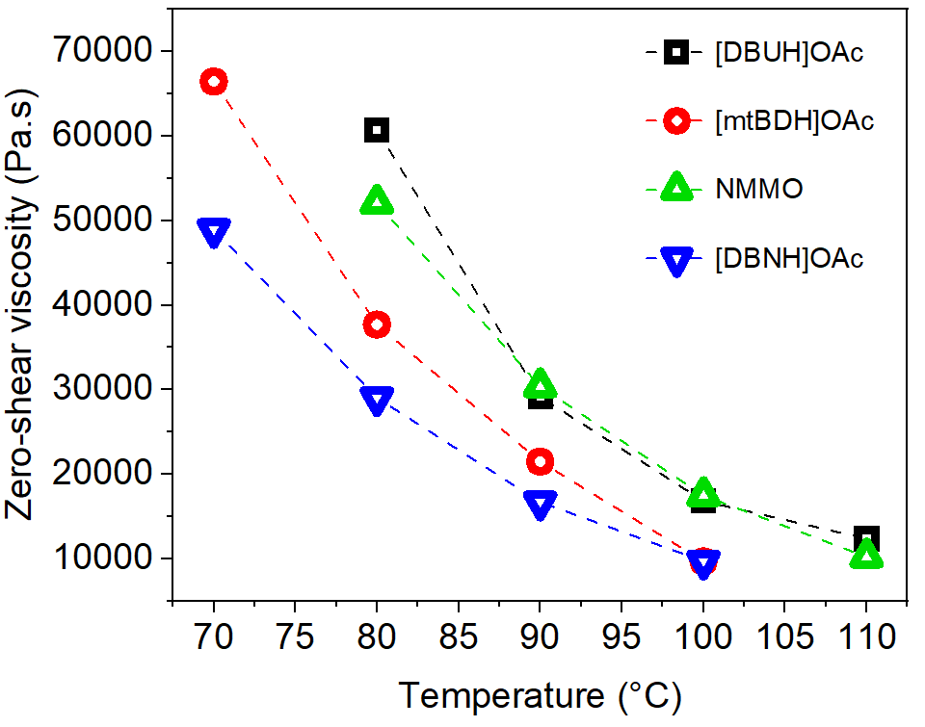
Fig. S2 Zero-shear viscosity (η₀) of the NMMO, [DBUH]OAc, [mTBDH]OAc and [DBNH]OAc cellulose solutions at different measured temperatures

Table S2 Zero-shear viscosity (η₀). cross-over points (COP) and angular frequencies for the cellulose solutions at different measured temperatures
[DBUH]OAc |  |  |  | [mTBD]OAc
Temperature | η₀ | Angular frequency | COP | Temperature | η₀ | Angular frequency | COP
°C | Pa.s | 1/s | Pa | °C | Pa.s | 1/s | Pa
80 | 60800 | 0.27 | 3500 | 85 | 28400 | 0.83 | 3900
85 | 40800 | 0.47 | 3600 | 70 | 66500 | 0.26 | 4100
90 | 29100 | 0.72 | 3700 | 80 | 37700 | 0.59 | 3800
95 | 21900 | 1.02 | 3600 | 85 | 28400 | 0.83 | 3900
100 | 16800 | 1.38 | 3600 | 90 | 21500 | 1.14 | 3900
105 | 13400 | 1.81 | 3700 | 95 | 16300 | 1.56 | 4000
110 | 12400 | 2.26 | 3800 | 105 | 9700 | 2.76 | 4100
NMMO |  |  |  | [DBNH]OAc
Temperature | η₀ | Angular frequency | COP | Temperature | η₀ | Angular frequency | COP
°C | Pa.s | 1/s | Pa | °C | Pa.s | 1/s | Pa
80 | 52100 | 0.43 | 4100 | 70 | 49000 | 0.4 | 3500
90 | 30400 | 0.86 | 4400 | 80 | 29000 | 0.8 | 3800
95 | 22800 | 1.17 | 4400 | 90 | 16700 | 1.46 | 3800
100 | 17500 | 1.58 | 4500 | 100 | 9700 | 2.65 | 3900
105 | 13500 | 2.08 | 4500
110 | 10200 | 2.78 | 4500
115 | 8200 | 3.61 | 4600
[emim]OAc
Temperature | η₀ | Angular frequency | COP
°C | Pa.s | 1/s | Pa
40 | 42700 | 0.35 | 2800
45 | 31700 | 0.51 | 2800
50 | 22500 | 0.75 | 2800
55 | 15700 | 1.13 | 2900
60 | 11000 | 1.68 | 2900
65 | 7900 | 2.45 | 3000
70 | 5600 | 3.49 | 3100
80 | 4100 | 4.90 | 3100
85 | 3000 | 6.80 | 3200
90 | 2100 | 9.60 | 3200
95 | 1500 | 13.73 | 3300
105 | 1126 | 19.45 | 3363

Tensile properties
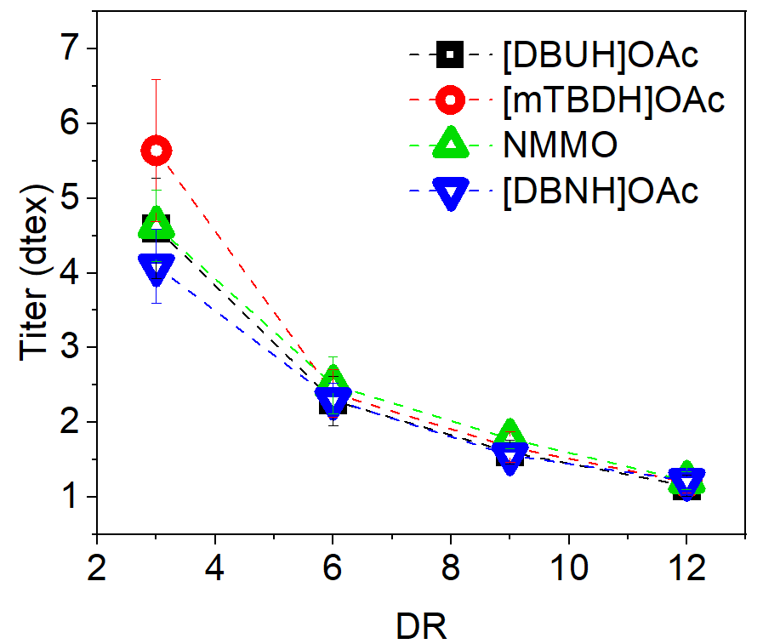
The development of the fiber titers as they are stretched from DR 3 to 12 is depicted in Fig. S3. One can observe that upon increasing DR the diameter of the fibers spun from different solvents (illustrated as titer) reached similar values in the range of 1.2 – 1.3 dtex at DR 12.
Fig. S3 Titer of the fibers spun from NMMO, [DBUH]OAc, [mTBDH]OAc and [DBNH]OAc

