Support information to “Moisture induced straining of the cellulosic microfibril”

Lennart Salmén, Jasna S. Stevanic, Claes Holmqvist and Shun Yu

RISE Bioeconomy and Health Box 5604, SE-11486 Stockholm, Sweden: e-mail lsalmen@kth.se
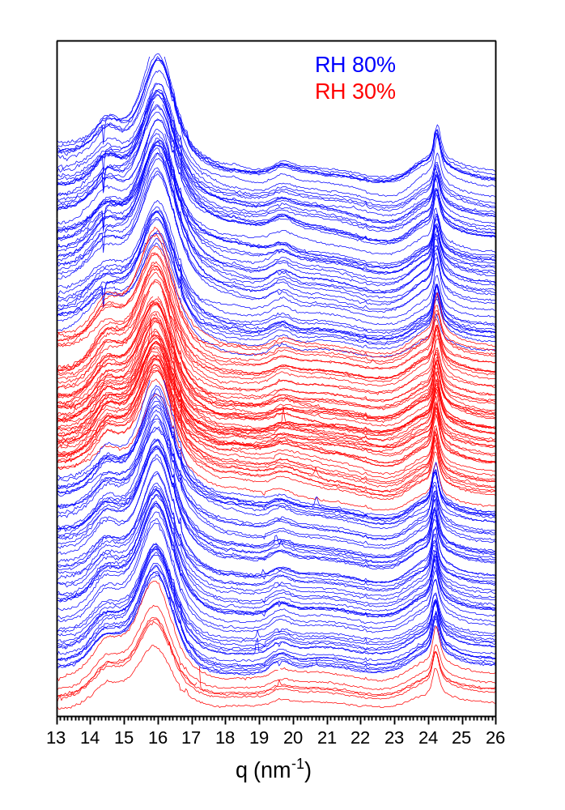
S.Figure 1. Raw data of 1D integrated WAXS profiles. The scattering line profiles are listed from bottom to top following increasing sequence number. Data collected at nominal RH values of 30% and RH 80% are color-coded in red and blue, respectively.
S.Figure 2. Raw data of azimuthal profile of (200) peak. The line profiles are listed from bottom to top following increasing sequence number. Data collected at nominal RH values of 30% and RH 80% are color-coded in red and blue, respectively.

