The experimental curves were deconvoluted using WAXSFIT program.
Linear function was used to set the base line and Cauchy-Gauss function was applied to approximate an amorphous halo and crystalline peaks.
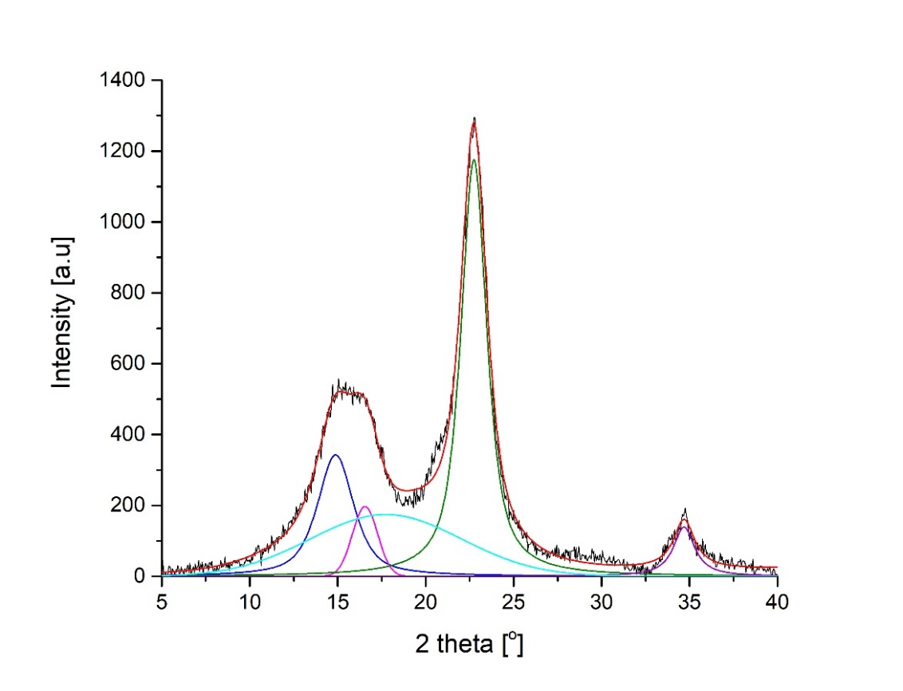
Fig. 1. Deconvolution of XRD curve for C I

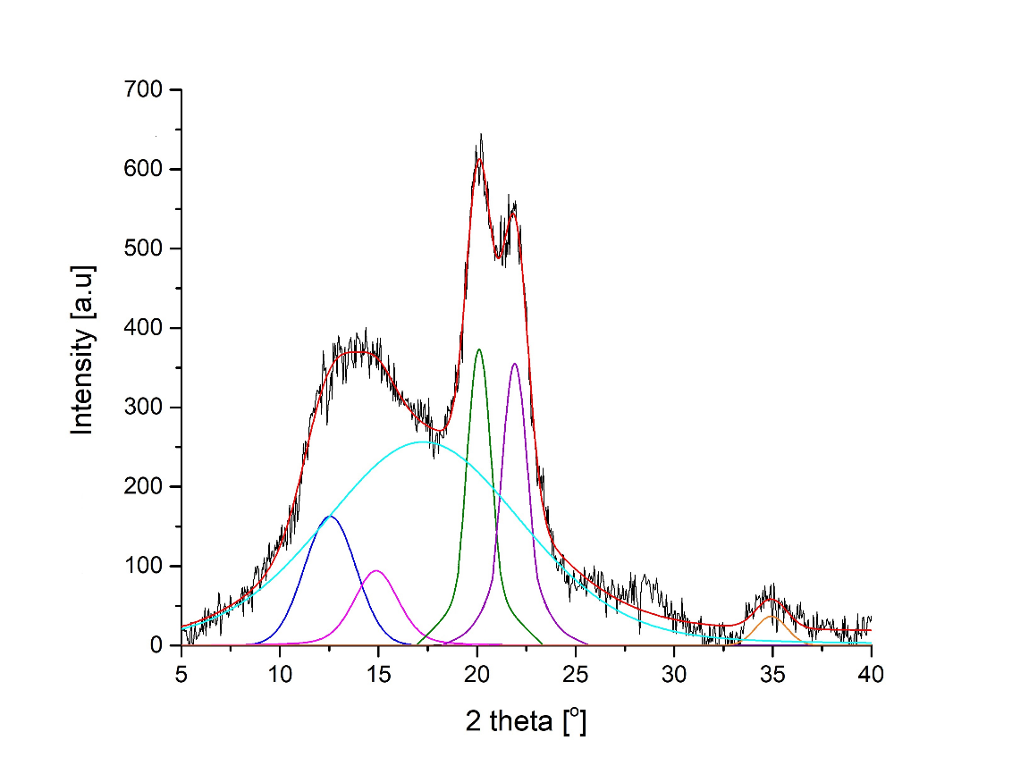
Fig. 2. Deconvolution of XRD curve for C II

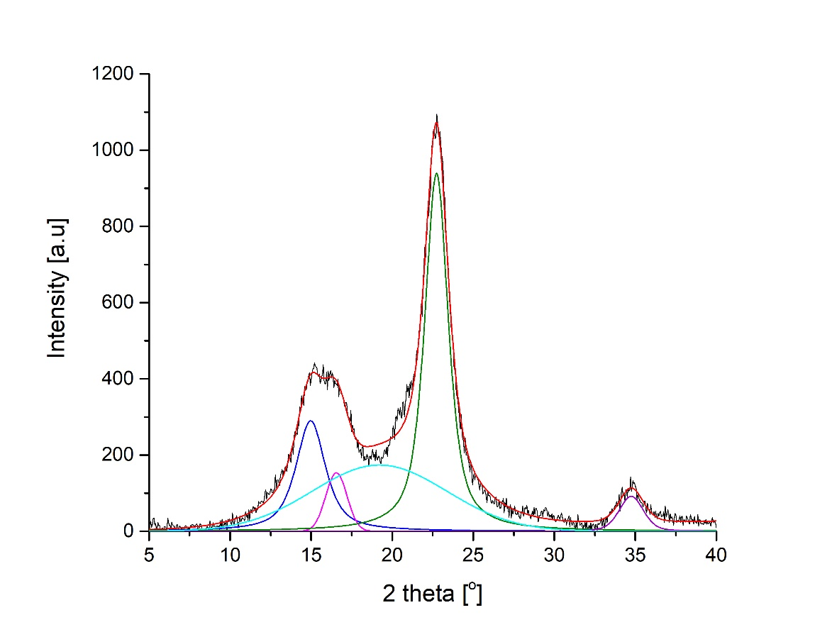
Fig. 3. Deconvolution of XRD curve for CNC I

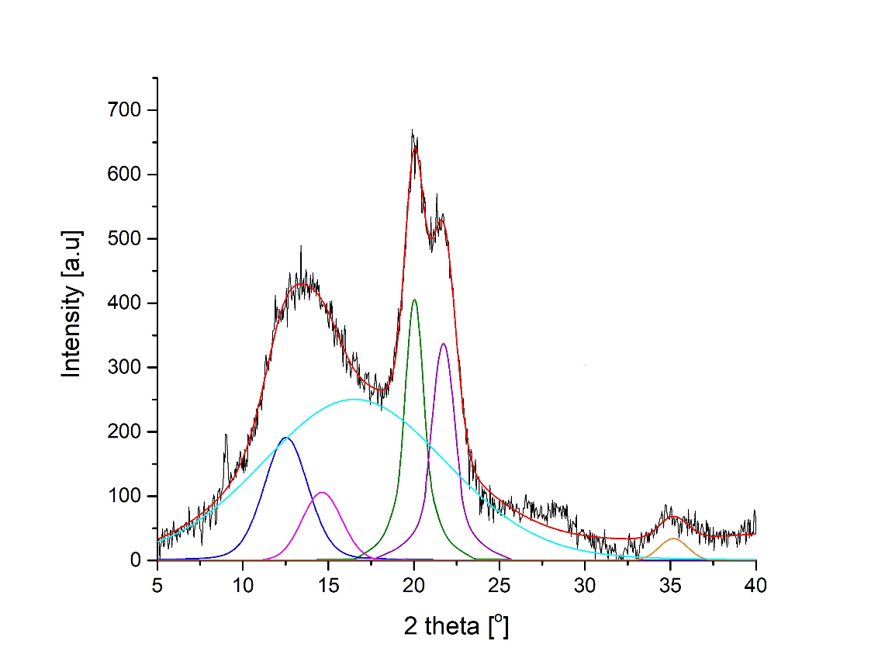
Fig. 4. Deconvolution of XRD curve for CNC II

