Supporting Information -
Rice straw and energy reeds fiber reinforced phenol formaldehyde resin hybrid polymeric composites
K. M. Faridul Hasan^{1,}*, Péter György Horváth¹, Miklós Bak¹, Le Duong Hung Anh ^{1,2,3,4}, Zsuzsanna Mária Mucsi¹ and Tibor Alpár^{1,}*
¹Simonyi Károly Faculty of Engineering, University of Sopron, Sopron, Hungary
²Innovation centre, University of Sopron, Sopron, Hungary
³Department of Engineering Mechanics, Faculty of Applied Science, Ho Chi Minh City University of Technology (HCMUT), 268 Ly Thuong Kiet Street, District 10, Ho Chi Minh City, Vietnam
⁴Vietnam National University Ho Chi Minh City, Linh Trung Ward, Thu Duc District, Ho Chi Minh City, Vietnam

Contents:
Fig. S1 Size distribution of rice straw and energy reeds fiber (a and b) and pressure versus time used for biocomposites production (c)
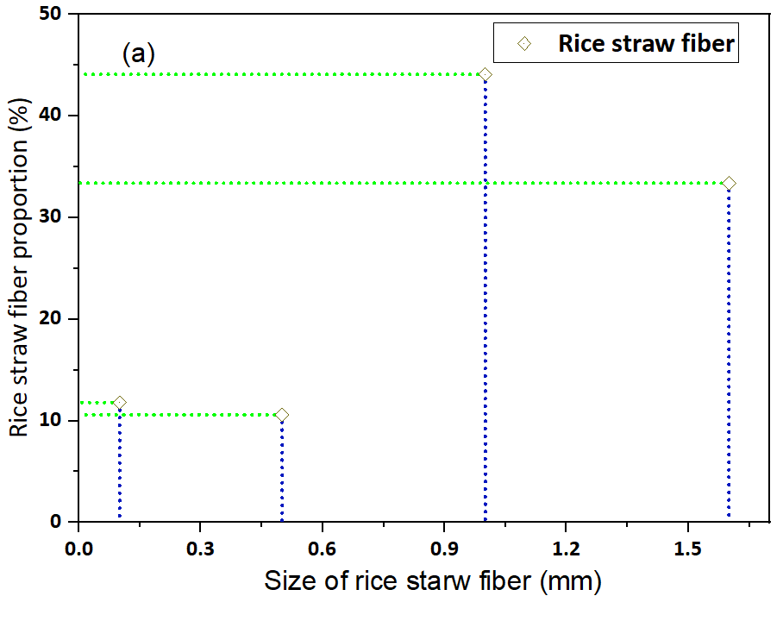 | 