Supplementary Materials
of
Spinneret geometry modulates the mechanical properties of man-made cellulose fibers
Kaniz Moriam^{[a]}, Daisuke Sawada^{[a]}, Kaarlo Nieminen^{[a]}, Yibo Ma^{[a]}, Marja Rissanen^{[a]}, Nicole Nygren^{[a]}, Chamseddine Guizani^{[a]}, Michael Hummel^{[a]}, Herbert Sixta^{[a]}*
*corresponding author
[a] Department of Bioproducts and Biosystems
School of Chemical Engineering
Aalto University
P.O Box 16300, Espoo, FI-00076 Aalto, Finland
Emails: most.moriam@aalto.fi ; daisuke.sawada@aalto.fi ; kaarlo.nieminen@aalto.fi ;
yibo.ma@aalto.fi; marja.rissanen@aalto.fi; nicole.nygren@aalto.fi ;chamseddine.guizani@aalto.fi;
michael.hummel@aalto.fi

Corresponding Author’s E-mail: herbert.sixta@aalto.fi

Table of contents
Spinneret geometries……………………………………………………………………………………………S2
Numerical simulation data………………………………………………………………………………………S2
Spinnabilities of cellulose solutions…………………………………………………………………………… S4
Spinning parameters…………………………………………………………………………………………… S4
Contour plots……………………………………………………………………………………………………S5
Fiber morphologies……………………………………………………………………………………………...S6
Mechanical properties of fibers…………………………………………………………………………………S7

Number of pages: 09
Number of tables: 03
Number of figures: 08

Spinneret geometries

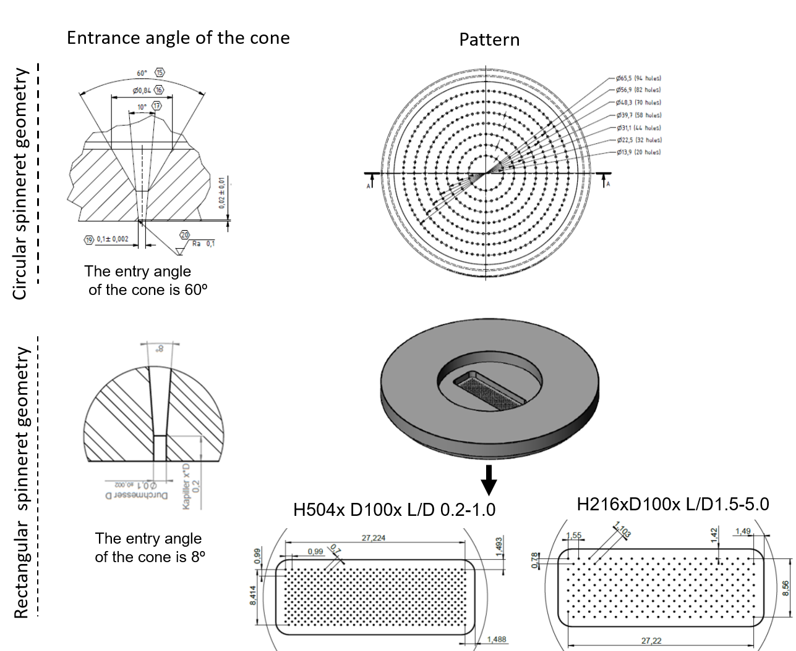
Fig. S1 The circular and rectangular geometries of the spinnerets

Numerical simulation data
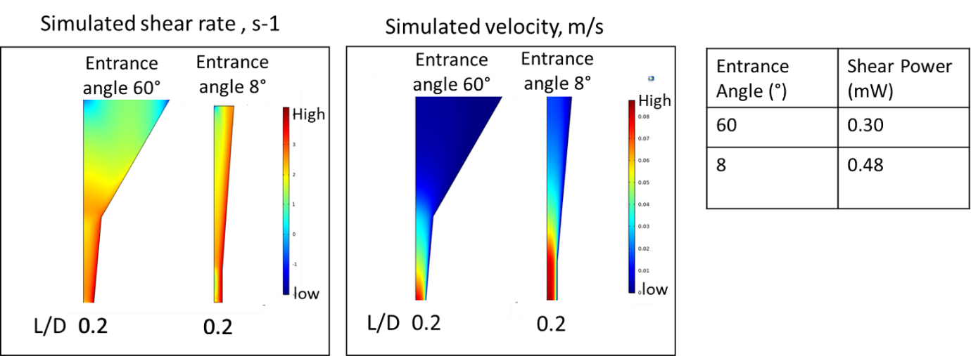
Fig. S2 The simulated shear rate and velocity as well as the shear power of cellulose solution inside the D100 spinneret capillary having entrance angle 8°and 60°.

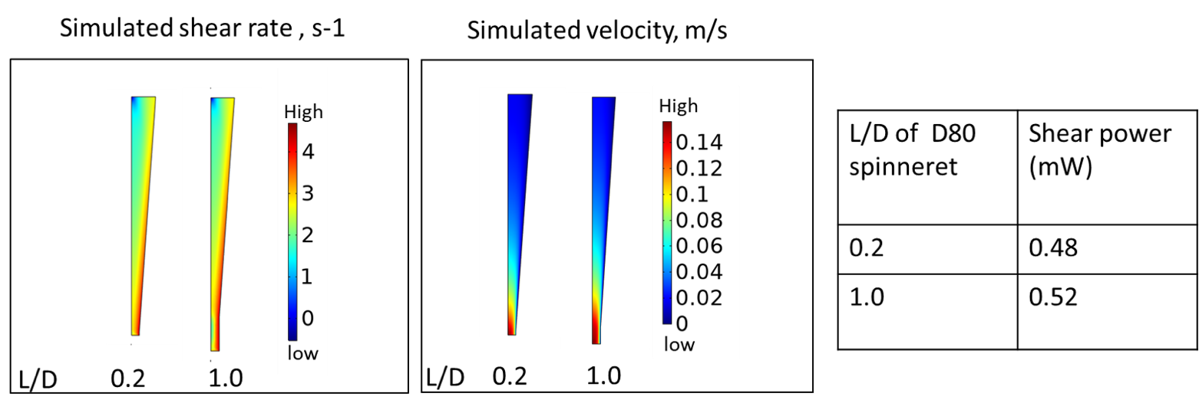
Fig. S3 The simulated shear rate and velocity as well as the shear power of cellulose solution inside the spinneret capillary having diameter 80 micrometer (L/D 0.2 and 1.0). Pulp and solvent: 13 wt% STG in [DBNH][OAc].

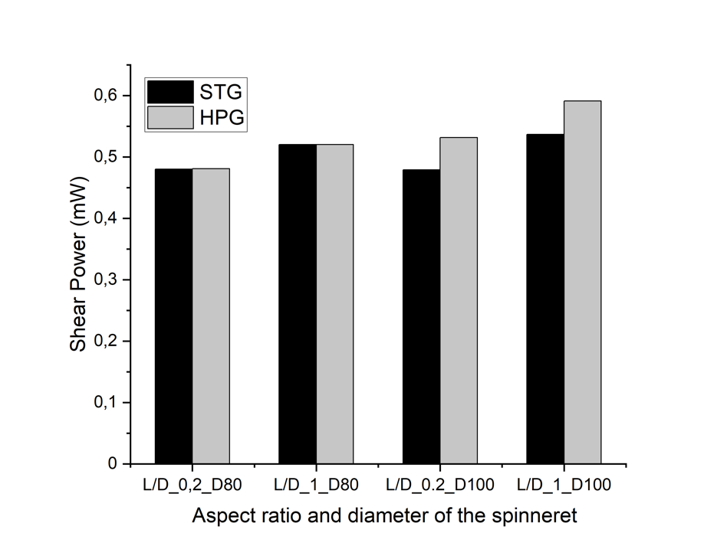
Fig. S4 the shear power of STG and HPG solutions inside the D100 (L/D 0.2 and 1.0) and D80 (L/D 0.2 and 1.0) spinnerets. Pulp concentration in solvent: 13 wt% in [DBNH][OAc].

Spinnabilities of cellulose solutions

Table S1 The spinnabilities of the cellulose solution using different spinneret geometries.
Spinnability | Draw ratio  (100 µm hole containing spinnerets) | Draw ratio  (80 µm hole containing spinnerets) | Minimum Titer achieved (dtex) | Spinnerets
Excellent | >14-18 | >8 | T<1 | 216x100x1.5; 216x100x2.0; 216x100x4.0; 216x100x5.0; 504x100x1.0; 216x80x0.2; 216x80x1.0;  504x80x1.0
Good | 8-14 | 6-8 | 1.8- 1.2 | 400x100x0.2;  504x100x0.2
Poor | 2-8 | <5 | >2

Spinning parameters

Table S2 Process parameters during spinning with STG pulp (13 wt% cellulose concentration) using different spinneret geometries
No of holes | hole density  (holes/cm2) | hole distribution &  entrance angle | Hole diameter  (µm) | L/D | Spinning pressure  (bar) | Spinning  temperature  °C | Zero shear Viscosity  Pa.s | Angular frequency at COP, s⁻¹ | G’=G’’ (COP)  Pa | Extrusion velocity  m/min
H216 | 95 | Rectangular geometry.  entrance angle: 8° | 100 | 1.5 | 50 | 75 | 34000 | 0.57 | 3736 | 6.5
H216 | 95 | Rectangular geometry.  entrance angle: 8° | 100 | 2 | 50-59 | 70-72 | 33000 | 0,71 | 4306 | 6.5/6.8
H216 | 95 | Rectangular geometry.  entrance angle: 8° | 100 | 4 | 60-64 | 75 | 34000 | 0.84 | 4065 | 4.3
H216 | 95 | Rectangular geometry.  entrance angle: 8° | 100 | 5 | 59-60 | 76-77 | 24500 | 0.77 | 4197 | 4.3/4.7
H504 | 221 | Rectangular geometry.  entrance angle: 8° | 100 | 0.2 | 50-54 | 68-70 | 33000 | 0.36 | 4036 | 4.8
H504 | 221 | Rectangular geometry.  entrance angle: 8° | 100 | 1 | 60-63 | 63-65 | 48000 | 0.40 | 4378 | 4.8/4.3
H216 | 95 | Rectangular geometry.  entrance angle: 8° | 80 | 0.2 | 65-67 | 77-78 | 25000 | 0,68 | 3968 | 6.5/5.9
H216 | 95 | Rectangular geometry.  entrance angle: 8° | 80 | 1 | 64-65 | 75-80 | 21000 | 1 | 4066 | 7.5
H504 | 95 | Rectangular geometry.  entrance angle: 8° | 80 | 1 | 64-65 | 75-80 | 21000 | 0.83 | 4050 | 6.5/5.9
H200 | 58 | Circular geometry  entrance angle:60° | 100 | 0.2 | 30-32 | 75 | 34000 | 0.90 | 3828 | 4.8

Contour plots
The calculation and visualization of XYZ Contour plots were performed by the Origin Software. Delaunay Triangulation was used to compute and draw the contour lines.

L/D ratio of the spinnerets: effect on toughness and tenacity

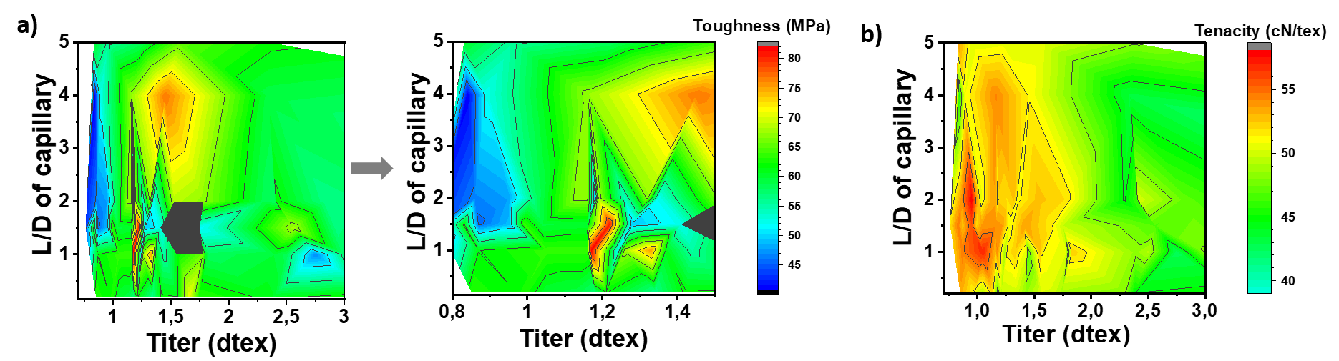
Fig. S5 The contour plot presenting the effect of L/D ratio of different spinnerets to achieve a) highest toughness and b) highest tenacity at certain titer. Pulp and solvent: 13 wt% STG in [DBNH][OAc].

Hole diameter of the spinnerets: effect on tenacity

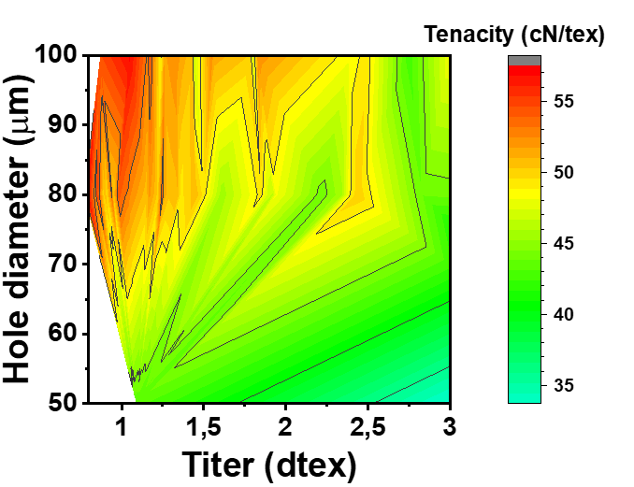
Fig. S6 The effect of spinneret hole diameter in achieving highest toughness. Pulp and solvent: 13 wt% STG in [DBNH][OAc]

Fiber morphologies

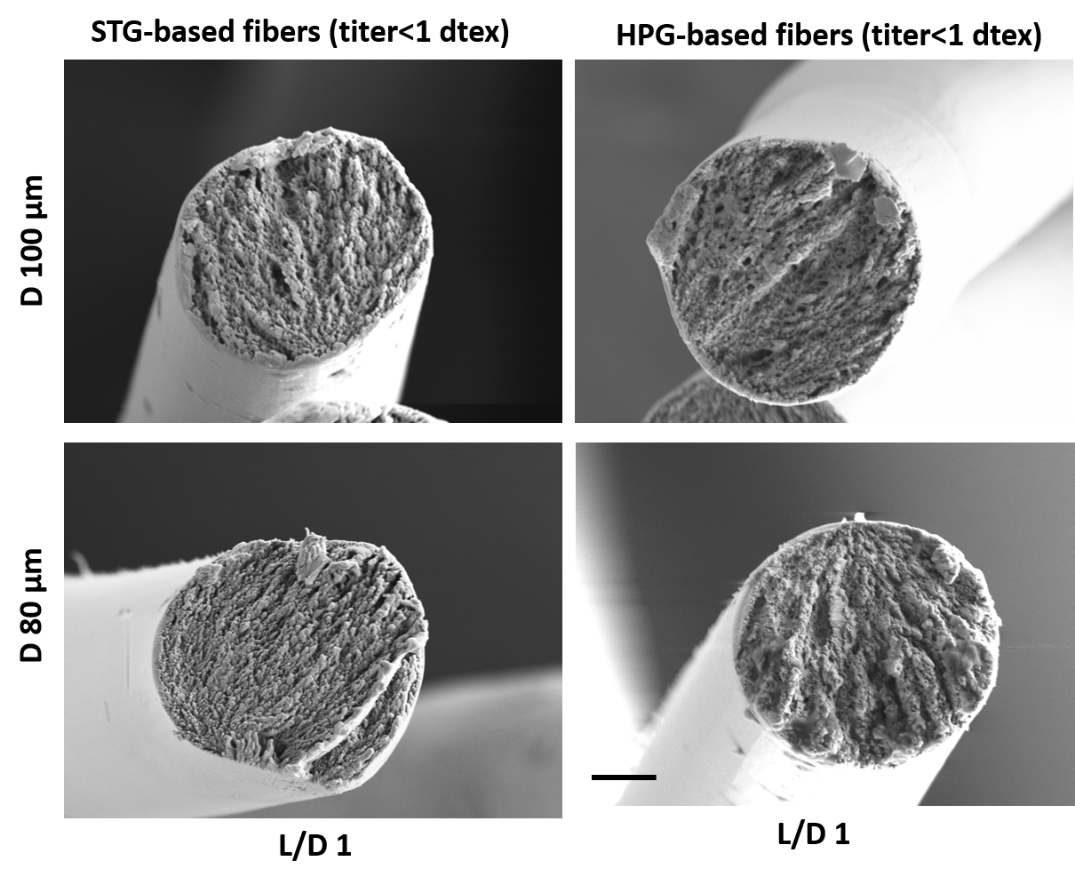
Fig. S7 The morphologies of the micro-fiber fiber cross section of the STG and HPG based fiber prodced using D100 and D80 spinnerets having L/D 1. Pulp concentration in solvent: 13 wt% in [DBNH][OAc]

Mechanical Properties of the fibers

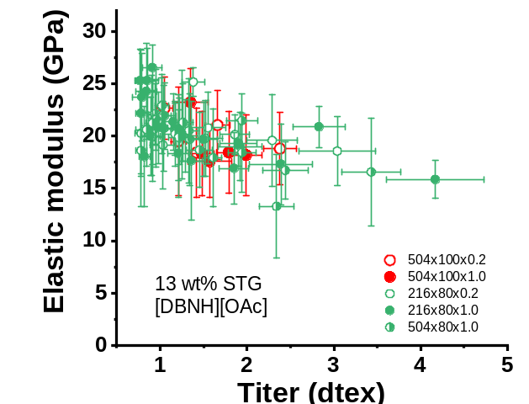

Fig. S8 Elastic modulus vs linear density for various spinnerets: 504x100x0.2; 504x100x1.0; 216x80x0.2; 216x80x1.0; 504x80x1.0. Pulp and solvent: 13 wt% STG in [DBNH][OAc]

Table S3 Mechanical properties of the fibers in condition state spun using different spinneret geometries and different pulps
Spinneret name/ pulp/solvent | DR | Fiber properties in cond. state |  |  |  |  | CRI (%) | CW(Å)
Spinneret name/ pulp/solvent | DR | Linear density (dtex) | Tenacity (cN/tex) | Elongation (%) | elastic modulus (GPa) | Toughness (MPa)
D216x100x1.5 | 6 | 2.56±0.47 | 46.82± 2.53 | 15.07±1.93 | 20.02±2.71 | 67.96±10.65
STG 13 wt%in [DBNH][OAc] | 8 | 1.75±0.19 | 49.71± 3.38 | 11.65±1.55 | 20.42±3.47 | 51.46±9.80 | 35.6 | 34.6
 | 12 | 1.19±0.09 | 53.80± 2.83 | 13.82±1.37 | 22.20±2.89 | 70.35±10.76 | 35.3 | 34.6
 | 15 | 0.97±0.07 | 53.99± 3.41 | 10.95±1.37 | 24.61±2.87 | 56.21±8.96
 | 18 | 0.80±0.07 | 53.26±4.16 | 10.94±1.27 | 25.74±2.50 | 52.66±10.17
H216xD100x2 | 4 | 4.57±0.55 | 41.90± 2.71 | 14.09±1.40 | 15.37±4.28 | 54.69±9.86
STG 13 wt%in [DBNH][OAc] | 6 | 2.37±0.24 | 46.98± 3.75 | 12.73±1.64 | 19.04±2.59 | 59.62±11.62
 | 8 | 1.57±0.20 | 51.46± 3.53 | 12.94±1.66 | 20.41±2.94 | 59.56±10.69 | 34 | 34.3
 | 10 | 1.40±0.14 | 52.29±3.64 | 12.82±1.38 | 19.41±3.54 | 61.40±10.62
 | 12 | 1.16±0.11 | 52.56±3.65 | 13.55±1.75 | 22.62±2.87 | 66.87±11.41 | 36.7 | 36.2
 | 15 | 0.98±0.09 | 55.26± 2.43 | 11.10±1.26 | 20.79±2.32 | 52.00±8.27
 | 18 | 0.86±0.07 | 53.97± 4.50 | 9.89±1.30 | 25.12±3.48 | 46.57±10.91
H216xD100x4 | 6 | 2.34±0.38 | 43.33±3.34 | 14.46±1.49 | 18.49±3.15 | 59.21±8.82
STG 13 wt%in [DBNH][OAc] | 9 | 1.45±0.21 | 51.26±3.73 | 16.09±1.62 | 16.35±4.93 | 76.78±11.83 | 35 | 34.2
 | 12 | 1.16±0.10 | 54.28±2.43 | 11.94±1.60 | 22.22±4.89 | 67.29±10.20 | 34 | 33.4
 | 18 | 0.84±0.16 | 45.56±8.81 | 10.17±1.29 | 19.97±4.41 | 40.98±1332
H216xD100x5 | 6 | 2.37±0.14 | 48.12±2.76 | 14.11±1.57 | 15.64±4.15 | 61.84±9.99
STG 13 wt%in [DBNH][OAc] | 9 | 1.57±0.09 | 50.42± 2.63 | 14.04±1.34 | 20.49±3.19 | 65.36±9.61 | 34 | 34.3
 | 12 | 1.23±0.14 | 50.55± 3.57 | 13.07±1.43 | 16.62±4.52 | 58.22±10.83 | 34 | 33.4
 | 15 | 0.96±0.09 | 50.28± 5.02 | 12.55±1.69 | 18.06±5.67 | 55.65± 11.55
 | 18 | 0.83±0.08 | 53.61± 2.86 | 12.65±1.28 | 20.09±4.20 | 60.21±8.63
H504XD100x0.2 | 6 | 2.38±0.19 | 44.64± 4.43 | 14.17±2.39 | 18.80±3.43 | 60.66±17.56
STG 13 wt%in [DBNH][OAc] | 9 | 1.66±0.14 | 50.04± 3.50 | 14.88±1.52 | 21.04±3.31 | 70.82±10.95 | 34 | 34.3
 | 10 | 1.42±0.09 | 48.38± 3.46 | 13.93±2.03 | 18.42±4.29 | 61.80±12.72
 | 12 | 1.21±0.09 | 50.94± 2.36 | 14.47±1.74 | 19.49±5.18 | 68.46±10.83 | 36 | 35.3
 | 13 | 1.05±0.09 | 49.08± 5.76 | 12.95±2.76 | 22.65±2.98 | 59.96±18.02
H504XD100x1 | 4 | 2.88±0.34 | 45.39± 5.53 | 12.89±2.02 | 15.02±2.95 | 52.19±13.60
STG 13 wt%in [DBNH][OAc] | 6 | 2.45±0.21 | 48.80± 3.42 | 13.32±1.56 | 14.78±3.37 | 59.05±11.16
 | 8 | 1.80±0.14 | 49.81± 3.38 | 13.99±1.68 | 16.37±4.06 | 61.58±11.92
 | 10 | 1.44±0.13 | 51.46± 3.58 | 13.74±1.43 | 19.84±2.6 | 64.35±11.44
 | 12 | 1.27±0.12 | 52.80± 2.57 | 14.80±1.32 | 20.57±4.02 | 71.46±8.83 | 36 | 36
 | 17 | 0.87±0.10 | 54.54± 2.94 | 12.68±1.48 | 21.12±4.34 | 61.34±10.50
H216xD80x0.2 | 4 | 2.67±0.37 | 45.74±4.03 | 14.43±1.69 | 19.08±3.84 | 58.30±10.68
STG 13 wt%in [DBNH][OAc] | 6 | 1.54±0.20 | 50.04±4.20 | 12.16±1.85 | 20.28±3.53 | 59.89±14.29
 | 9 | 1.03±0.15 | 51.34± 3.90 | 13.91±1.75 | 19.15±4.18 | 64.96±9.53 | 35.6 | 35.2
 | 10.4 | 0.91±0.12 | 50.22± 6.26 | 12.69±2.66 | 19.92±4.26 | 58.98±7.95 | 36.1 | 36.4
 | 12 | 0.78±0.07 | 50.87± 7.52 | 11.24±2.74 | 20.27±3.91 | 54.32±11.10
H216xD80x1 | 4 | 2.31±0.27 | 46.38± 4.27 | 13.28±1.82 | 17.31±3.86 | 59.47±10.65
STG 13 wt%in [DBNH][OAc] | 5 | 1.89±0.21 | 47.55± 3.16 | 12.93±1.50 | 18.4±2.98 | 56.52±10.09
 | 7 | 1.33±0.13 | 49.85± 3.09 | 12.04±1.38 | 18.83±4.57 | 53.04±9.61
 | 7.5 | 1.25±0.12 | 51.54± 3.21 | 12.21±1.23 | 20.36±4.04 | 56.74±9.07 | 35.6 | 35.6
 | 9 | 1.02±0.11 | 53.27± 4.02 | 12.68±1.45 | 21.16±3.55 | 61.61±11.30
 | 12 | 0.80±0.10 | 55.31± 4.78 | 10.52±1.33 | 23.38±4.92 | 51.19±10.77
H504xD80x1 | 4 | 2.39±0.23 | 47.96± 2.70 | 13.75±1.34 | 15.00±3.84 | 56.75±9.39
STG 13 wt%in [DBNH][OAc] | 5 | 1.94±0.17 | 48.27± 3.40 | 12.32±1.27 | 19.95±3.16 | 59.07±11.61
 | 6 | 1.61±0.10 | 45.55± 7.16 | 10.79±2.23 | 17.93±4.70 | 44.50±15.67
 | 7 | 1.30±0.12 | 51.15± 3.71 | 12.07±1.21 | 20.50±4.07 | 55.93±9.90
 | 7.5 | 1.20±0.10 | 51.94± 3.50 | 13.29±1.47 | 20.26±4.03 | 61.92±9.75 | 35 | 34.8
 | 9 | 1.02±0.10 | 53.29± 2.64 | 11.75±1.46 | 22.42±3.33 | 56.30±9.83 | 35 | 35
 | 10 | 0.95±0.09 | 52.69± 5.03 | 11.31±1.66 | 21.91±3.78 | 53.27±11.85
 | 12 | 0.78±0.06 | 53.87± 2.95 | 13.27±1.17 | 18.62±5.34 | 63.42±9.16
Spinneret name/pulp | DR | Linear density (dtex) | Tenacity (cN/tex) | Elongation (%) | elastic modulus (GPa) | Toughness (MPa)
H504XD100x1 | 4 | 2.33±0.2 | 54.29±3.31 | 11.83±1.11 | 23.39±2.15 | 58.53±9.41
HPG 13 wt%in [DBNH][OAc] | 8 | 1.75±0.18 | 58.62±3.49 | 13.86±1.32 | 24.68±2.4 | 75.36±12.24
 | 9 | 1.71±0.18 | 59.00±1.38 | 15.48±0.77 | 16.77±6.16 | 79.95±6.09
 | 10 | 1.47±0.16 | 59.60±2.38 | 14.82±0.89 | 25.26±3.92 | 80.62±6.8
 | 10.5 | 1.35±0.07 | 60.29±2.29 | 16.44±1.11 | 24.65±3.17 | 93.4±9.01 | 36.1 | 36.4
 | 11 | 1.33±0.14 | 57.79±2.38 | 14.24±1.09 | 24.05±2.36 | 77.24±6.88
 | 12 | 1.22±0.12 | 55.46±4.94 | 13.63±1.94 | 23.99±1.57 | 72.86±11.17 | 35.7 | 34.5
H216XD80x1 | 4 | 2.12±0.22 | 56.58±2.62 | 13.04±0.72 | 15.62±4.64 | 64.31±6.25
HPG 13 wt%in [DBNH][OAc] | 5 | 1.72±0.17 | 55.31±5.65 | 11.83±1.99 | 23.22±3.06 | 66.27±10.94
 | 6 | 1.41±0.15 | 57.21±3.86 | 12.9±1.71 | 23.42±2.5 | 67.43±14.58
 | 6.5 | 1.42±0.14 | 57.28±5.8 | 12.56±2.43 | 24.35±2.39 | 75.24±16.82
 | 7 | 1.27±0.11 | 61.21±1.49 | 14.47±1.01 | 26.72±2.24 | 82.73±8.09 | 36 | 35.8
 | 7.5 | 1.17±0.08 | 63.37±2.6 | 11.66±0.64 | 25.35±3.73 | 67.77±3.96
 | 8 | 1.2±0.09 | 55.88±6.06 | 11.27±2.09 | 23.9±2.45 | 57.57±16.42 | 36 | 36

Rheology measurement of 15 wt% HPG- and STG-cellulose solution

Table S4 Rheological properties of 15 wt% HPG- and STG-cellulose solution at spinning temperature

Pulp | Pulp consistency | Spinning temperature (°C) | Zero shear viscosity  (Pa s) | Dynamic modulus at COP (Pa) | Angular frequency at COP (s⁻¹)
STG | 15 | 77 | 55000 | 4180 | 0.53
HPG | 15 | 80 | 80000 | 5030 | 0.28

