Supplementary Materials for
Enzymatic synthesis of cellulose in space: gravity is a crucial factor for building cellulose II gel structure

Tomohiro Kuga¹, Naoki Sunagawa¹ and Kiyohiko Igarashi^{1,2*}

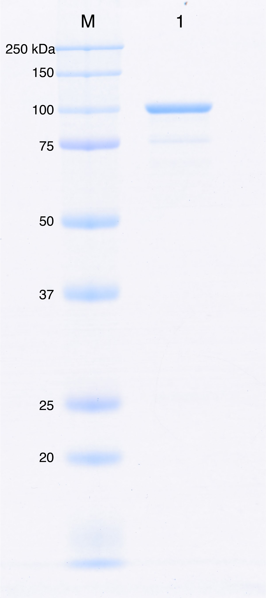
Supplementary Fig. 1. SDS-PAGE of Δcys-CtCDP. Lane M, molecular weight marker; Lane 1, Δcys-CtCDP after two-step purifications.

