Protocol for characterizing the molar mass distribution and oxidized functionality profiles of aged transformer papers by gel permeation chromatography (GPC)
Paul Jusner¹, Florian Bausch¹, Sonja Schiehser¹, Elisabeth Schwaiger², Antje Potthast¹, Thomas Rosenau^{1,3}
¹ Department of Chemistry, Institute of Chemistry of Renewable Resources, University of Natural Resources and Life Sciences Vienna (BOKU), Konrad-Lorenz-Straße 24, A-3430 Tulln, Austria
² Mondi Frantschach GmbH, Frantschach 5, A-9413 St. Gertraud, Austria
³ Johan Gadolin Process Chemistry Centre, Åbo Akademi University, Porthansgatan 3, FI-20500 Åbo/Turku, Finland

Supplementary information
Table of content
Figures p. 2
Tables p. 4
Literature p. 5

List of figures
Figure S1 p. 2
Figure S2 p. 2
Figure S3 p. 2
Figure S4 p. 3
Figure S5 p. 3

List of tables
Table S1 p. 4
Table S2 p. 4
Table S3 p. 4
Table S4 p. 5
Table S5 p. 5

Figures
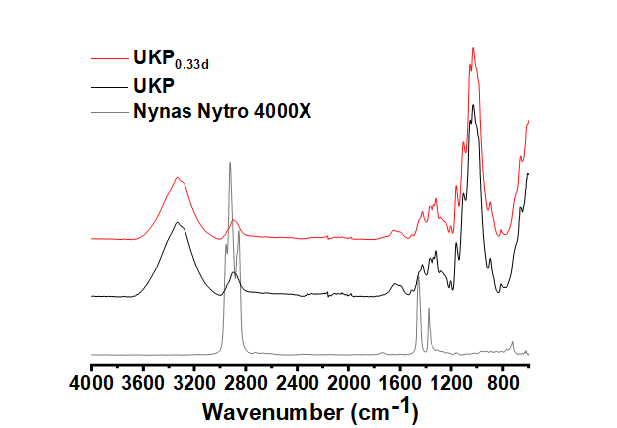
Figure S1: FTIR spectra of Nynas Nytro 4000X transformer oil (Nynas AB, Sweden), of unbleached Kraft pulp prior to ageing (UKP), and of an aged sample (UKP_{0.33d}) after extraction with heptane.

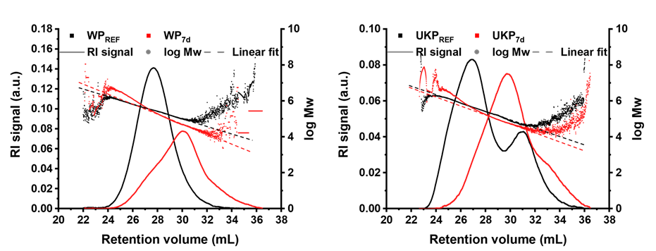
Figure S2: Examples for linear fitting of the raw data to calulate the molar mass parameters (M_{n}, M_{w}, M_{z}, and Đ_{M}) in GRAMS/AI 7.0. In some measurements, WP_{7d} and UKP_{7d} exhibited a slight deviation from the linear relationship between the retention volume and the molar mass in the high molar mass range.

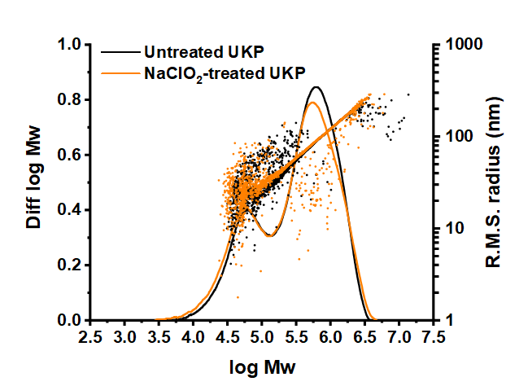
Figure S3: Effect of NaClO₂-treatment on the MMD and the polymer conformation in solution of UKP.

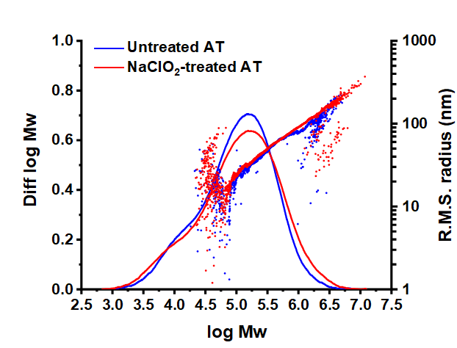
Figure S4: Effect of NaClO₂-treatment on the MMD and the polymer conformation in solution of laboratory-aged transformer board (AT) samples. The untreated AT sample did not dissolve completely and showed a tendency towards polymer agglomeration. Transformer oil residues were extracted from all aged samples prior to sample dissolution.

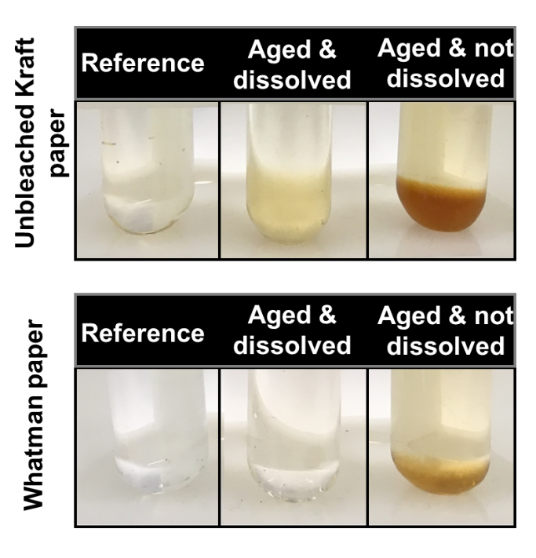
Figure S5: Examples of successful dissolution and of insufficient sample dissolution with the DMAc/LiCl/EIC system.
Tables
Table S1: Effect of NaClO₂ treatment on crystallinity and low molecular weight carbohydrate composition of UKP samples before ageing.
 | UKP untreated | UKP NaClO₂-treated
CI from s.s. ¹³C NMR (a.u.)* | 0.66 | 0.57
Arabinose (µg/mg)§ | 8.48 ± 0.03 | 6.13 ± 0.01
Xylose (µg/mg)§ | 38.85 ± 0.33 | 35.93 ± 0.51
Mannose (µg/mg)§ | 19.14 ± 0.44 | 19.34 ± 0.04
Galactose (µg/mg)§ | 4.30 ± 0.06 | 3.82 ± 0.08
Glucose (µg/mg)§ | 26.59 ± 0.29 | 28.34 ± 0.05
* derived from C4 signal deconvolution of solid state ¹³C CP/MAS NMR spectra according to Zuckerstätter et al. (2013), not considering the hemicellulose contributor; § obtained by acidic methanolysis followed by gas chromatography according to Sundberg et al. (1999) and Becker et al. (2021) (analysis was performed in duplicate).

Table S2: Effect of NaClO₂ treatment on crystallinity and low molecular weight carbohydrate composition of laboratory aged transformer board (AT) samples manufactured of UKP. Transformer oil residues were extracted from all aged samples prior to sample dissolution.
 | AT untreated | AT NaClO₂-treated
CI from s.s. ¹³C NMR (a.u.)* | 0.61 | 0.55
Arabinose (µg/mg)§ | 5.62 ± 0.07 | 5.16 ± 0.09
Xylose (µg/mg) § | 38.6 ± 0.17 | 36.24 ± 0.24
Mannose (µg/mg)§ | 21.5 ± 0.05 | 20.75 ± 0.14
Galactose (µg/mg)§ | 3.42 ± 0.00 | 3.28 ± 0.01
Glucose (µg/mg)§ | 33.43 ± 0.20 | 35.11 ± 0.13
* derived from C4 signal deconvolution of solid state ¹³C CP/MAS NMR spectra according to Zuckerstätter et al. (2013), not considering the hemicellulose contributor; § obtained by acidic methanolysis followed by gas chromatography according to Sundberg et al. (1999) and Becker et al. (2021) (analysis was performed in duplicate).

Table S3: Low molar mass carbohydrate composition of UPK sample series obtained by acidic methanolysis followed by gas chromatography according to Sundberg et al. (1999) and Becker et al. (2021) (analysis was performed in duplicate).
Days at 170°C | Glc (µg/mg) | Xyl (µg/mg) | Man (µg/mg) | Ara (µg/mg) | Gal (µg/mg)
0 | 28.34 ± 0.05 | 35.93 ± 0.51 | 19.34 ± 0.04 | 6.13 ± 0.01 | 3.82 ± 0.08
0.33 | 33.13 ± 0.31 | 33.32 ± 0.31 | 20.05 ± 0.08 | 4.71 ± 0.21 | 3.15 ± 0.04
1 | 36.39 ± 0.12 | 30.93 ± 0.24 | 19.80 ± 0.16 | 3.72 ± 0.00 | 2.78 ± 0.05
2 | 38.29 ± 0.66 | 27.75 ± 0.42 | 18.75 ± 0.07 | 2.89 ± 0.32 | 2.38 ± 0.01
3 | 39.81 ± 0.52 | 25.50 ± 0.37 | 18.37 ± 0.55 | 2.45 ± 0.31 | 2.17 ± 0.03
4 | 40.51 ± 0.59 | 23.92 ± 0.56 | 17.59 ± 0.80 | 1.94 ± 0.12 | 1.99 ± 0.12
7 | 41.97 ± 1.54 | 18.04 ± 0.05 | 14.78 ± 0.04 | 1.14 ± 0.02 | 1.36 ± 0.03
10 | 42.55 ± 0.49 | 15.13 ± 0.04 | 13.48 ± 0.03 | 0.87 ± 0.05 | 1.09 ± 0.02
14 | 41.71 ± 0.25 | 11.00 ± 0.62 | 10.26 ± 0.50 | 0.48 ± 0.67 | 0.27 ± 0.39

Table S4: M_{n}, M_{w}, M_{z}, and Đ_{M} throughout accelerated ageing at 170 °C derived from WP MMDs (n = 4).
Days at 170 °C | M_{n} (kg/mol) | M_{w} (kg/mol) | M_{z} (kg/mol) | Đ_{M} (a.u.)
0 | 244.7 ± 10.7 | 401.6 ± 9.6 | 600.9 ± 35.4 | 1.6
0.33 | 60.2 ± 5.5 | 194.4 ± 5.8 | 502.1 ± 35.2 | 3.1
1 | 33.9 ± 1.8 | 119.8 ± 6.9 | 409.4 ± 68.8 | 3.5
2 | 23.0 ± 1.2 | 94.9 ± 3.3 | 420.5 ± 70.1 | 4.2
3 | 24.2 ± 1.7 | 112.2 ± 20.3 | 499.9 ± 260.7 | 5.0
7 | 33.5 ± 2.4 | 355.3 ± 92.0 | 2183.3 ± 534.6 | 12.1

Table S5: M_{n}, M_{w}, M_{z}, and Đ_{M} throughout accelerated ageing at 170 °C derived from UKP MMDs (n = 4).
Days at 170 °C | M_{n} (kg/mol) | M_{w} (kg/mol) | M_{z} (kg/mol) | Đ_{M} (a.u.)
0 | 96.4 ± 11.0 | 552.6 ± 50.0 | 1214.5 ± 107.6 | 5.6
0.33 | 41.0 ± 4.3 | 290.3 ± 27.6 | 1007.9 ± 185.1 | 6.2
1 | 28.0 ± 4.0 | 247.9 ± 8.0 | 925.4 ± 141.3 | 8.1
2 | 25.5 ± 2.5 | 266.9 ± 21.7 | 1260.0 ± 123.6 | 9.1
3 | 25.9 ± 1.8 | 282.5 ± 41.3 | 1348.5 ± 308.9 | 9.5
4 | 24.7 ± 3.3 | 257.7 ± 9.6 | 1204.6 ± 263.3 | 9.4
7 | 22.4 ± 2.4 | 229.7 ± 30.9 | 1342.5 ± 163.5 | 9.9

Literature

Becker M, Ahn K, Bacher M, Xu C, Sundberg A, Willför S, Rosenau T, Potthast A (2021) Comparative hydrolysis analysis of cellulose samples and aspects of its application in conservation science. Cellulose 28:8719-8734.
Sundberg A, Sundberg K, Lillandt C, Holmhom B (1996) Determination of hemicelluloses and pectins in wood and pulp fibres by acid methanolysis and gas chromatography. Nord Pulp Pap Res J 11:216-219.
Zuckerstätter G, Terinte N, Sixta H, Schuster K C (2013) Novel insight into cellulose supramolecular structure through 13C CP-MAS NMR spectroscopy and paramagnetic relaxation enhancement. Carbohydr Polym 93:122-128.

