Supplementary information
Hybrid films from cellulose nanomaterials - properties and defined optical patterns
Ilona Leppänen^{a*}, Ari Hokkanen^{b}, Monika Österberg^{c}, Mika Vähä-Nissiª, Ali Harlinª, Hannes Orelmaª
ªBiomass processing and products, VTT Technical Research Centre of Finland Ltd., FI-02044 Espoo, Finland
^{b}Microelectronics, VTT Technical Research Centre of Finland Ltd., FI-02044 Espoo, Finland
^{c}Aalto university, School of Chemical Engineering, Department of Bioproducts and Biosystems, Espoo, Finland
* Corresponding author: Ilona Leppänen (email: ilona.leppanen@vtt.fi, ORCID: 0000-0003-1807-3411)

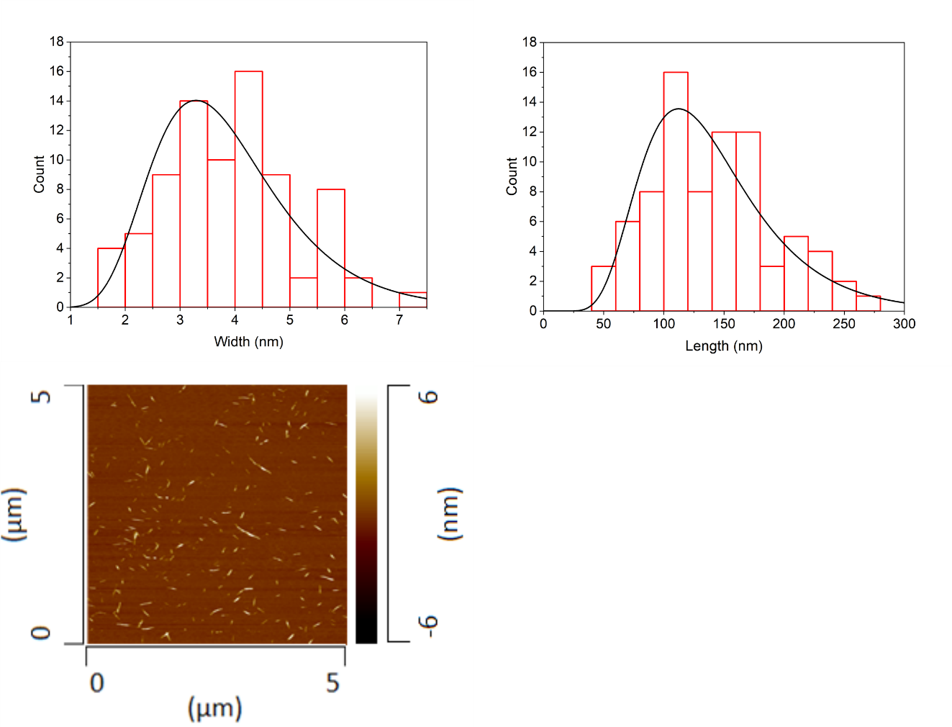
Fig. S1 Width (left) and length (right) distribution histograms of Celluforce CNCs obtained by measuring the width and length of the crystals from two independent AFM images (example image below the histograms) using the MountainSPIP9 software. The surfaces were prepared by spincoating (Laurell WS-400BZ-6NPP/LITE, 3000 rpm/1.5 min) a dilute dispersion (0.0025 wt%) of CNCs onto SiO₂ crystals covered with an polyethylenimine anchoring layer. The imaging was performed using a NanoTA AFM+ instrument (Anasys Instruments, Bruker, MA, USA) and the images were recorded in tapping mode in air with scan rate of 0.5 Hz using silicon cantilevers (Applied Nanostructures Inc., Santa Clara, CA, USA). The damping ratio was around 0.7-0.85 Hz. An average of 80 individual crystals were analyzed.

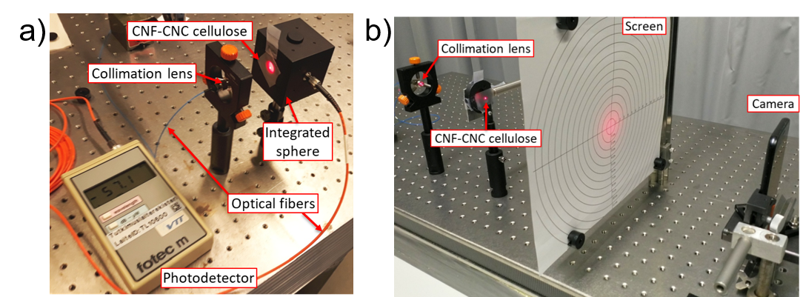
Fig. S2 Measurement setups for a) Haze value and b) forward scattering angle

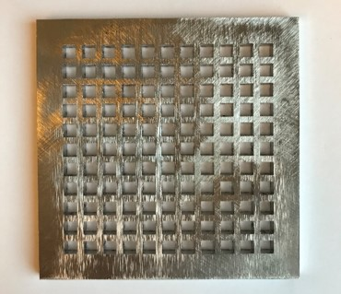
Fig. S3 Metal plate with specific patterning. Size of the plate is 10 cm x 10 cm and each small square is 5 mm x 5 mm
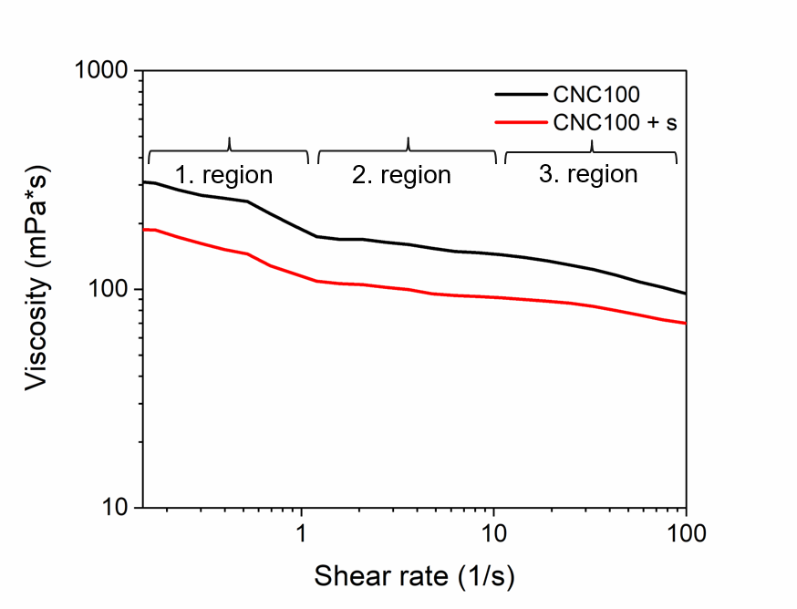
Fig. S4 Viscosity profile of CNCs showing the typical three-region behavior of liquid crystals.

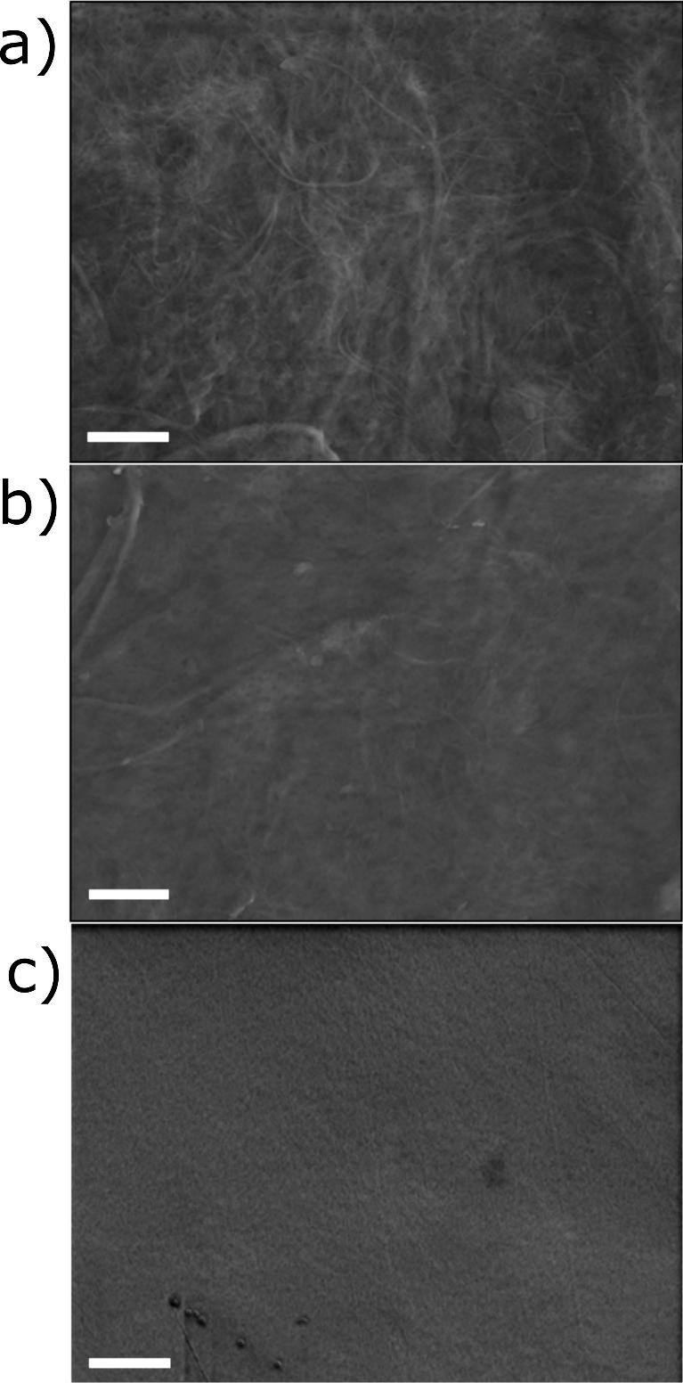
Fig. S5 SEM images of CNF/CNC hybrid films with sorbitol. a) CNF100 + s b) CNF50CNC50 +s and c) CNC100 + s. All SEM images are 7500 x and the scale bar is 2 µm

Fig. S6 Backward scattering and absorption of CNF/CNC films with and without sorbitol (+ S indicates samples with sorbitol)

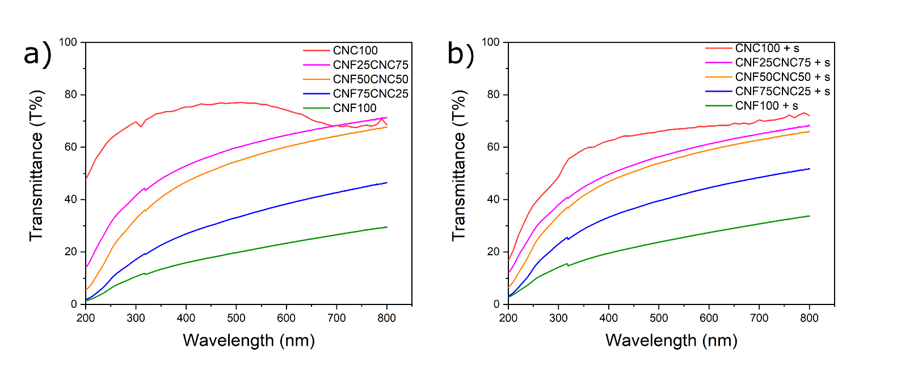
Fig. S7 Transmittance of CNF/CNC hybrid films without sorbitol (a) with sorbitol (b). Film thicknesses for samples in a) starting from CNC100 downwards are 35 µm, 25 µm, 32 µm, 32 µm and 28 µm respectively and for b) starting from CNC100 + s downwards are 70 µm, 32 µm, 39 µm, 35 µm and 20 µm

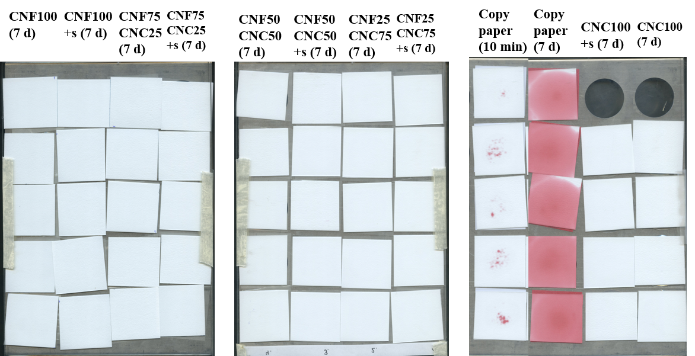
Fig. S8 Grease barrier results after 7 days. No grease permeation through the films onto the blotting paper was visible after 7 days for the CNF/CNC films. Copy paper was the reference material and grease permeated through the paper onto the blotting paper already after 10 minutes.

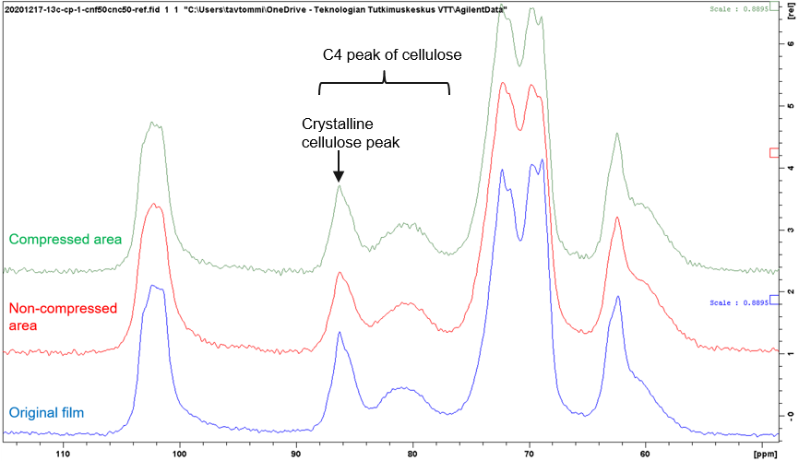
Fig. S9 ¹³C NMR spectrum of NMMO treated CNF50CNC50 + s film and the original CNF50CNC50 + s film.

Table S1 Comparison of mechanical properties of CNF100 film made on a polypropylene film versus a petri dish
Sample | Tensile strength (MPa) | Young's modulus (GPa) | Strain at break (%)
CNF100 | 147 ± 33 | 5.9 ± 0.4 | 9.5 ± 4.5
CNF100 (petri dish) | 168 ± 19 | 9.3 ± 1.3 | 5.6 ± 1.3

