SUPPLEMENTARY INFORMATION
Anisotropic Wood-Water Interactions Determined by Gravimetric Vapor Sorption Experiments
Antoni Sánchez-Ferrer*, Max Engelhardt, Klaus Richter
Technical University of Munich, School of Life Sciences, Chair of Wood Science, D-80797 Munich, Germany
Antoni Sánchez-Ferrer*: orcid.org/0000-0002-1041-0324; email: sanchez@hfm.tum.de
Max Engelhardt: orcid.org/0000-0002-9781-7476; email: engelhardt@hfm.tum.de
Klaus Richter: orcid.org/0000-0002-6583-0254; email: richter@hfm.tum.de

Figure SI-1. The three wood orthotropic directions in beech disk samples 3
Figure SI-2. 3D printed DVT cub 3
Figure SI-3. DVS adsorption/desorption experiment for disk1-L (DSE model) 4
Figure SI-4. DVS adsorption/desorption experiment for disk2-R (DSE model) 5
Figure SI-5. DVS adsorption/desorption experiment for disk3-T (DSE model) 6
Figure SI-6. DVS adsorption/desorption experiment for disk1-L (RP model) 7
Figure SI-7. DVS adsorption/desorption experiment for disk2-R (RP model) 8
Figure SI-8. DVS adsorption/desorption experiment for disk3-T (RP model) 9
Figure SI-9. Kinetic constant and diffusion coefficient 10
Figure SI-10. Diffusion coefficient comparison between DSE, RP and SSE models 11
Figure SI-11. Relative directional kinetic constant and relative directional diffusion coefficient 12
Figure SI-12. Moisture sorption isotherms (GAB* and SSO model) 13
Figure SI-13. Sorption coefficient 14
Figure SI-14. DVT experiments (exponential-linear model) 16
Figure SI-15. DVT experiments (linear model) 17
Figure SI-16. Permeability, diffusion and sorption coefficients, and transmission rate values 20
Figure SI-17. Relative directional permeability and diffusion coefficients 21
Figure SI-18. Transmission rate values 22
Table SI-1. DSE fitting parameters, kinetic constant and diffusion coefficient for disk1-L 4
Table SI-2. DSE fitting parameters, kinetic constant and diffusion coefficient for disk2-R 5
Table SI-3. DSE fitting parameters, kinetic constant and diffusion coefficient for disk3-T 6
Table SI-4. RP fitting parameters, kinetic constant and diffusion coefficient for disk1-L 7
Table SI-5. RP fitting parameters, kinetic constant and diffusion coefficient for disk2-R 8
Table SI-6. RP fitting parameters, kinetic constant and diffusion coefficient for disk3-T 9
Table SI-7. GAB* and SSO fitting parameters, and sorption sites molar concentration 13
Table SI-8. Sorption coefficient from MSI 15
Table SI-9. DVT fitting parameters and coefficients for disk1-L 18
Table SI-10. DVT fitting parameters and coefficients for disk2-R 18
Table SI-11. DVT fitting parameters and coefficients for disk3-T 19

a)  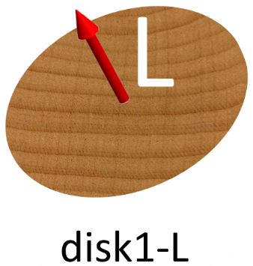 | b)  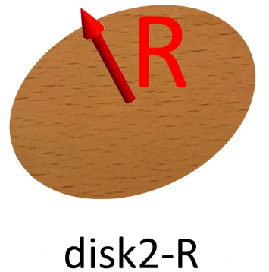 | c)  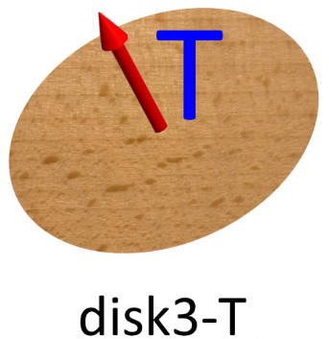

Figure SI-1. Beech disks with the three wood orthotropic directions perpendicular to the disk plane: a) disk1-L – longitudinal -, b) disk2-R – radial - and c) disk3-T - tangential.

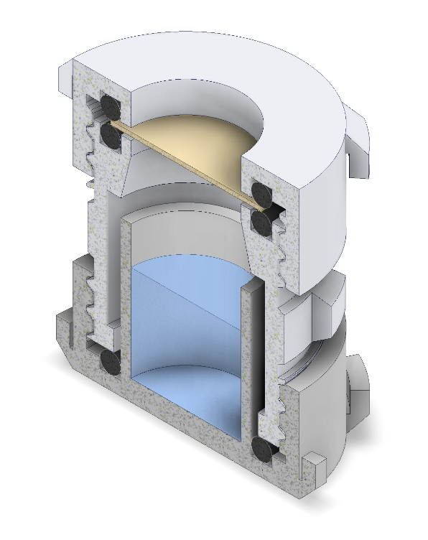
Figure SI-2. Cross-section along the cylindrical axis of the 3D-printed DVT cup. The upper component is used to attach the wood sample between two O-ring seals while the bottom component is used either as a water reservoir or as a drying agent container.

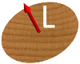
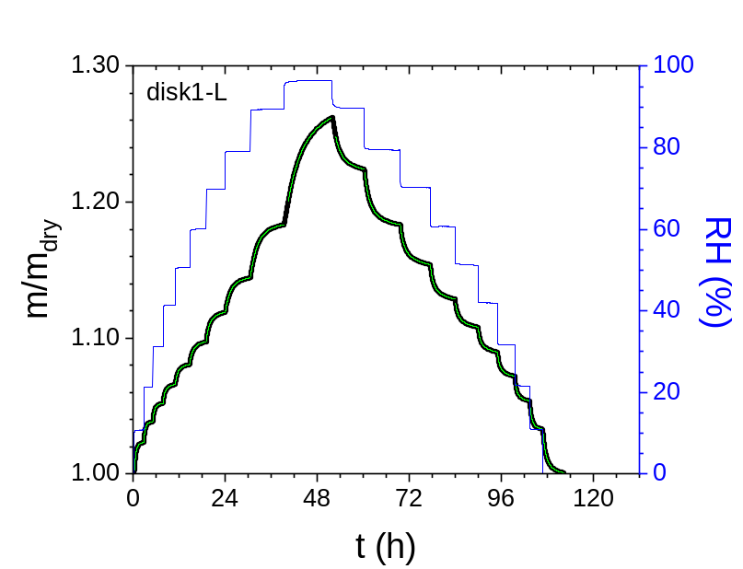
Figure SI-3. DVS adsorption/desorption experiment for the disk1-L. The green lines are the fitting curves following the double stretched exponential (DSE) model.

Table SI-1. Double stretched exponential fitting parameters ((m/m_{dry})_{eq}, A₁, A₂, τ₁, τ₂, β₁, β₂) and the equivalent lifetime (τ), stretched exponential factor (β) and kinetic constant (k), and the diffusion coefficient (D) for each adsorption/desorption step in the DVS experiment for the disk1-L.
RH  [%] | (m/m_{dry})_{eq} | A₁ | A₂ | τ₁  [min] | τ₂  [min] | β₁ | β₂ | τ  [min] | β | k  [s⁻¹] | D  [m²/s] | R
10.82 | 1.0234 | -0.01913 | -0.00139 | 23.96 | 106.9 | 1.052 | 1.210 | 26.42 | 0.893 | 6.31E-04 | 1.37E-10 | 0.9996
21.31 | 1.0388 | -0.01041 | -0.00492 | 16.88 | 54.52 | 1.037 | 1.069 | 23.82 | 0.771 | 7.00E-04 | 1.52E-10 | 0.9996
31.21 | 1.0525 | -0.00771 | -0.00584 | 16.86 | 62.65 | 0.954 | 0.982 | 29.89 | 0.729 | 5.58E-04 | 1.21E-10 | 0.9999
41.34 | 1.0665 | -0.00729 | -0.00663 | 19.72 | 76.72 | 0.896 | 0.937 | 38.69 | 0.715 | 4.31E-04 | 9.35E-11 | 0.9998
50.61 | 1.0813 | -0.00650 | -0.00852 | 22.50 | 83.26 | 0.851 | 0.897 | 49.32 | 0.731 | 3.38E-04 | 7.34E-11 | 0.9999
60.11 | 1.0988 | -0.00809 | -0.00889 | 44.30 | 115.3 | 0.877 | 0.745 | 68.57 | 0.650 | 2.43E-04 | 5.28E-11 | 0.9996
69.81 | 1.1199 | -0.00389 | -0.01824 | 50.41 | 76.22 | 1.363 | 0.757 | 66.99 | 0.734 | 2.49E-04 | 5.41E-11 | 0.9998
79.16 | 1.1456 | -0.00366 | -0.02231 | 69.84 | 103.0 | 1.490 | 0.786 | 93.09 | 0.765 | 1.79E-04 | 3.90E-11 | 0.9999
89.45 | 1.1860 | -0.01406 | -0.02662 | 96.41 | 180.3 | 1.240 | 0.777 | 131.9 | 0.714 | 1.26E-04 | 2.75E-11 | 0.9994
96.52 | 1.2735 | -0.03053 | -0.04221 | 155.3 | 516.8 | 1.021 | 1.031 | 323.3 | 0.830 | 5.15E-05 | 1.12E-11 | 0.9998
89.75 | 1.2211 | 0.01459 | 0.01263 | 71.18 | 317.5 | 0.992 | 1.055 | 150.6 | 0.747 | 1.11E-04 | 2.41E-11 | 0.9992
79.42 | 1.1786 | 0.02516 | 0.01801 | 70.01 | 390.4 | 0.961 | 0.836 | 136.2 | 0.576 | 1.22E-04 | 2.66E-11 | 0.9995
70.19 | 1.1514 | 0.01418 | 0.01685 | 49.92 | 223.1 | 0.869 | 0.810 | 113.2 | 0.636 | 1.47E-04 | 3.20E-11 | 0.9998
60.66 | 1.1254 | 0.01615 | 0.01193 | 42.55 | 282.8 | 0.838 | 0.851 | 98.23 | 0.578 | 1.70E-04 | 3.69E-11 | 0.9991
51.21 | 1.1055 | 0.00980 | 0.01041 | 40.53 | 239.2 | 0.831 | 0.845 | 108.0 | 0.625 | 1.54E-04 | 3.35E-11 | 0.9992
41.85 | 1.0883 | 0.00767 | 0.01106 | 21.77 | 130.6 | 0.865 | 0.857 | 68.76 | 0.661 | 2.42E-04 | 5.26E-11 | 0.9990
31.61 | 1.0709 | 0.00824 | 0.00969 | 20.38 | 108.0 | 0.888 | 0.884 | 53.36 | 0.665 | 3.12E-04 | 6.78E-11 | 0.9992
21.57 | 1.0530 | 0.01026 | 0.00820 | 20.95 | 95.47 | 0.912 | 0.927 | 41.83 | 0.670 | 3.98E-04 | 8.64E-11 | 0.9997
10.83 | 1.0322 | 0.01402 | 0.00673 | 25.56 | 84.39 | 0.941 | 0.918 | 35.60 | 0.694 | 4.68E-04 | 1.01E-10 | 0.9992
0.00 | 1.0000 | 0.01726 | 0.01537 | 32.99 | 119.2 | 0.983 | 1.001 | 61.36 | 0.756 | 2.72E-04 | 5.88E-11 | 0.9998

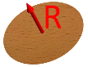
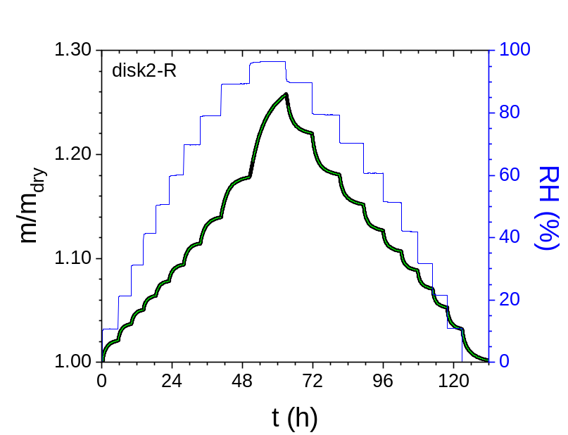
Figure SI-4. DVS adsorption/desorption experiment for the disk2-R. The green lines are the fitting curves following the double stretched exponential (DSE) model.

Table SI-2. Double stretched exponential fitting parameters ((m/m_{dry})_{eq}, A₁, A₂, τ₁, τ₂, β₁, β₂) and the equivalent lifetime (τ), stretched exponential factor (β) and kinetic constant (k), and the diffusion coefficient (D) for each adsorption/desorption step in the DVS experiment for the disk2-R.
RH  [%] | (m/m_{dry})_{eq} | A₁ | A₂ | τ₁  [min] | τ₂  [min] | β₁ | β₂ | τ  [min] | β | k  [s⁻¹] | D  [m²/s] | R
10.70 | 1.0221 | -0.00407 | -0.01669 | 21.30 | 106.1 | 0.975 | 0.918 | 83.90 | 0.823 | 1.99E-04 | 3.92E-11 | 0.9997
21.25 | 1.0378 | -0.00145 | -0.01504 | 14.72 | 80.55 | 1.051 | 0.872 | 72.75 | 0.832 | 2.29E-04 | 4.55E-11 | 0.9999
31.17 | 1.0514 | -0.00141 | -0.01273 | 15.62 | 78.65 | 0.950 | 0.882 | 70.26 | 0.838 | 2.37E-04 | 4.73E-11 | 0.9999
41.29 | 1.0649 | -0.00063 | -0.01345 | 13.79 | 75.08 | 1.147 | 0.849 | 71.29 | 0.829 | 2.34E-04 | 4.70E-11 | 1.0000
50.56 | 1.0790 | -0.00128 | -0.01317 | 16.30 | 83.94 | 0.885 | 0.885 | 76.13 | 0.846 | 2.19E-04 | 4.43E-11 | 1.0000
60.11 | 1.0955 | -0.00552 | -0.01158 | 57.24 | 115.5 | 0.907 | 0.792 | 89.34 | 0.739 | 1.87E-04 | 3.80E-11 | 0.9999
69.74 | 1.1159 | -0.00424 | -0.01736 | 63.85 | 106.6 | 1.183 | 0.775 | 91.76 | 0.745 | 1.82E-04 | 3.73E-11 | 0.9998
79.04 | 1.1409 | -0.00119 | -0.02486 | 93.01 | 120.2 | 1.130 | 0.844 | 116.6 | 0.836 | 1.43E-04 | 2.98E-11 | 1.0000
89.36 | 1.1832 | -0.01962 | -0.02273 | 113.8 | 326.0 | 1.174 | 0.715 | 171.5 | 0.596 | 9.72E-05 | 2.07E-11 | 0.9994
96.50 | 1.2705 | -0.0356 | -0.04154 | 166.4 | 584.9 | 1.007 | 1.308 | 370.2 | 0.997 | 4.50E-05 | 9.80E-12 | 0.9992
89.66 | 1.2178 | 0.01415 | 0.01496 | 72.38 | 273.8 | 0.998 | 1.008 | 148.1 | 0.768 | 1.13E-04 | 2.40E-11 | 0.9997
79.40 | 1.1775 | 0.01877 | 0.02226 | 72.73 | 241.9 | 1.003 | 0.800 | 130.9 | 0.651 | 1.27E-04 | 2.65E-11 | 0.9999
70.17 | 1.1493 | 0.01333 | 0.01736 | 56.51 | 221.7 | 0.887 | 0.803 | 121.3 | 0.650 | 1.37E-04 | 2.83E-11 | 0.9999
60.68 | 1.1251 | 0.01008 | 0.01646 | 36.35 | 158.7 | 0.881 | 0.844 | 94.27 | 0.689 | 1.77E-04 | 3.60E-11 | 0.9997
51.21 | 1.1047 | 0.00708 | 0.01318 | 37.35 | 177.9 | 0.869 | 0.827 | 108.7 | 0.682 | 1.53E-04 | 3.10E-11 | 0.9996
41.88 | 1.0871 | 0.00724 | 0.01183 | 27.76 | 143.3 | 0.871 | 0.884 | 83.76 | 0.707 | 1.99E-04 | 4.00E-11 | 0.9994
31.59 | 1.0698 | 0.00690 | 0.01127 | 26.53 | 123.6 | 0.887 | 0.896 | 73.98 | 0.723 | 2.25E-04 | 4.50E-11 | 0.9995
21.52 | 1.0517 | 0.00699 | 0.01167 | 27.86 | 113.8 | 0.891 | 0.906 | 71.01 | 0.744 | 2.35E-04 | 4.66E-11 | 0.9997
10.82 | 1.0310 | 0.00600 | 0.01530 | 27.43 | 102.9 | 0.905 | 0.896 | 74.28 | 0.780 | 2.24E-04 | 4.43E-11 | 0.9998
0.00 | 0.9993 | 0.00871 | 0.02382 | 43.26 | 208.7 | 0.923 | 0.852 | 146.1 | 0.733 | 1.14E-04 | 2.24E-11 | 0.9996

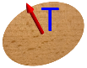
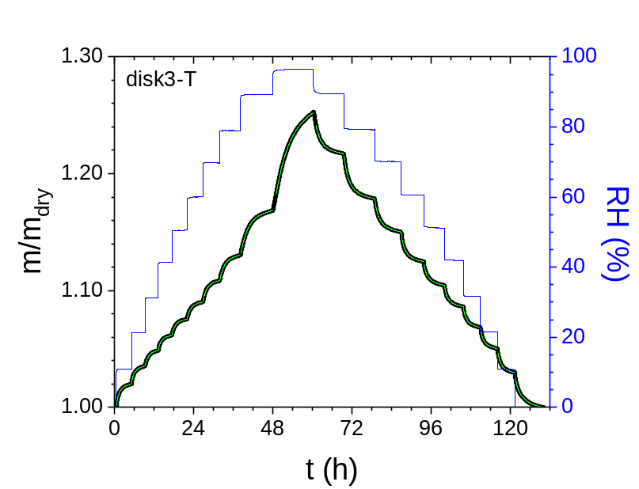
Figure SI-5. DVS adsorption/desorption experiment for the disk3-T. The green lines are the fitting curves following the double stretched exponential (DSE) model.

Table SI-3. Double stretched exponential fitting parameters ((m/m_{dry})_{eq}, A₁, A₂, τ₁, τ₂, β₁, β₂) and the equivalent lifetime (τ), stretched exponential factor (β) and kinetic constant (k), and the diffusion coefficient (D) for each adsorption/desorption step in the DVS experiment for the disk3-T.
RH  [%] | (m/m_{dry})_{eq} | A₁ | A₂ | τ₁  [min] | τ₂  [min] | β₁ | β₂ | τ  [min] | β | k  [s⁻¹] | D  [m²/s] | R
10.80 | 1.0208 | -0.00527 | -0.01418 | 22.94 | 88.91 | 0.944 | 0.939 | 65.27 | 0.816 | 2.55E-04 | 5.49E-11 | 0.9998
21.31 | 1.0361 | -0.00233 | -0.01332 | 15.24 | 76.61 | 0.995 | 0.884 | 64.14 | 0.815 | 2.60E-04 | 5.64E-11 | 0.9999
31.19 | 1.0494 | -0.00158 | -0.01208 | 14.27 | 74.78 | 0.976 | 0.872 | 65.28 | 0.820 | 2.55E-04 | 5.59E-11 | 0.9999
41.29 | 1.0625 | -0.00161 | -0.01224 | 15.48 | 78.86 | 0.948 | 0.867 | 68.85 | 0.816 | 2.42E-04 | 5.35E-11 | 0.9999
50.56 | 1.0766 | -0.00545 | -0.00885 | 44.91 | 112.0 | 0.822 | 0.847 | 79.89 | 0.759 | 2.09E-04 | 4.66E-11 | 1.0000
60.13 | 1.0918 | -0.01161 | -0.00436 | 71.83 | 179.4 | 0.823 | 0.793 | 87.68 | 0.690 | 1.90E-04 | 4.29E-11 | 0.9990
69.72 | 1.1102 | -0.01578 | -0.00394 | 68.36 | 268.8 | 0.858 | 0.878 | 82.71 | 0.641 | 2.02E-04 | 4.62E-11 | 0.9977
78.90 | 1.1319 | -0.00348 | -0.01970 | 72.25 | 123.1 | 1.194 | 0.794 | 109.6 | 0.768 | 1.52E-04 | 3.55E-11 | 0.9999
89.20 | 1.1748 | -0.01905 | -0.02448 | 114.0 | 391.8 | 1.134 | 0.723 | 200.9 | 0.587 | 8.30E-05 | 2.00E-11 | 0.9999
96.50 | 1.2636 | -0.05602 | -0.02556 | 203.0 | 694.2 | 1.037 | 1.537 | 329.7 | 0.971 | 5.06E-05 | 1.25E-11 | 0.9990
89.48 | 1.2132 | 0.01649 | 0.01195 | 78.48 | 445.8 | 0.982 | 1.034 | 172.1 | 0.675 | 9.68E-05 | 2.33E-11 | 0.9983
79.21 | 1.1743 | 0.02184 | 0.01931 | 70.81 | 333.1 | 0.958 | 0.813 | 139.4 | 0.601 | 1.20E-04 | 2.80E-11 | 0.9997
70.09 | 1.1440 | 0.02165 | 0.01264 | 68.72 | 654.3 | 0.828 | 0.895 | 167.3 | 0.535 | 9.96E-05 | 2.28E-11 | 0.9975
60.63 | 1.1230 | 0.01206 | 0.01486 | 37.15 | 175.8 | 0.864 | 0.879 | 92.56 | 0.681 | 1.80E-04 | 4.07E-11 | 0.9996
51.18 | 1.1028 | 0.00685 | 0.01334 | 31.78 | 162.7 | 0.846 | 0.870 | 102.4 | 0.718 | 1.63E-04 | 3.64E-11 | 0.9995
41.85 | 1.0847 | 0.00676 | 0.01231 | 26.58 | 142.1 | 0.870 | 0.870 | 85.85 | 0.705 | 1.94E-04 | 4.29E-11 | 0.9994
31.57 | 1.0672 | 0.00668 | 0.01150 | 26.81 | 128.7 | 0.872 | 0.889 | 78.22 | 0.721 | 2.13E-04 | 4.67E-11 | 0.9995
21.48 | 1.0493 | 0.00663 | 0.01214 | 27.14 | 114.2 | 0.872 | 0.889 | 73.08 | 0.739 | 2.28E-04 | 4.95E-11 | 0.9997
10.77 | 1.0287 | 0.00606 | 0.01500 | 25.85 | 107.5 | 0.887 | 0.901 | 76.15 | 0.776 | 2.19E-04 | 4.70E-11 | 0.9998
0.00 | 0.9977 | 0.00994 | 0.02156 | 41.74 | 207.7 | 0.888 | 0.890 | 136.7 | 0.743 | 1.22E-04 | 2.59E-11 | 0.9995

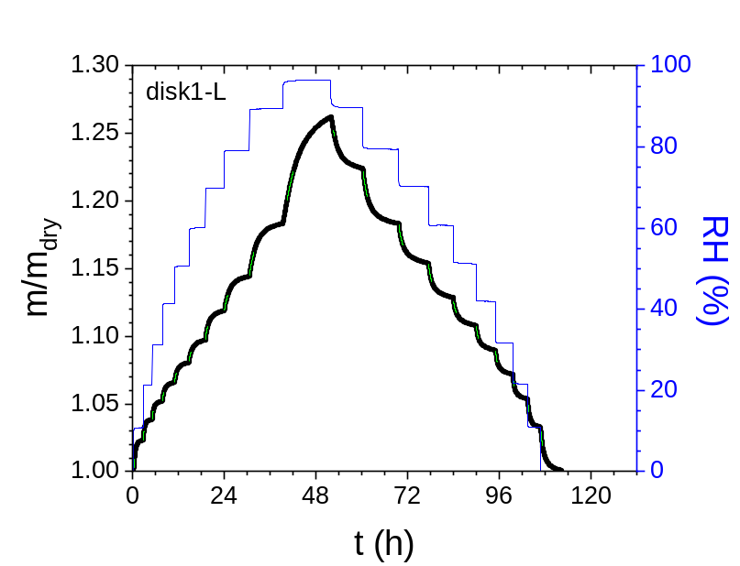
Figure SI-6. DVS adsorption/desorption experiment for the disk1-L. The green lines are the fitting curves following the Ritger-Peppas (RP) model.

Table SI-4. Ritger-Peppas fitting parameters ((m/m_{dry})_{eq}, τ_{rp}, n_{rp}), the corresponding kinetic constant (k_{rp}) and diffusion parameter (D_{rp}), the equivalent kinetic constant (k’), and diffusion coefficient (D’) for each adsorption/desorption step in the DVS experiment for the disk1-L.
RH  [%] | (m/m_{dry})_{eq} | τ_{rp}  [min] | k_{rp}  [s⁻¹] | n | D_{rp}  [m²/s] | k’  [s⁻¹] | β' | D’  [m²/s]
10.82 | 1.0234 | 35.36 | 4.71E-04 | 0.930 | 1.02E-10 | 6.62E-04 | 1.068 | 1.43E-10
21.31 | 1.0388 | 32.90 | 5.07E-04 | 0.886 | 1.10E-10 | 7.23E-04 | 1.018 | 1.57E-10
31.21 | 1.0525 | 40.02 | 4.16E-04 | 0.813 | 9.03E-11 | 6.15E-04 | 0.937 | 1.33E-10
41.34 | 1.0665 | 53.79 | 3.10E-04 | 0.753 | 6.73E-11 | 4.73E-04 | 0.870 | 1.03E-10
50.61 | 1.0813 | 72.10 | 2.31E-04 | 0.711 | 5.02E-11 | 3.63E-04 | 0.823 | 7.88E-11
60.11 | 1.0988 | 105.74 | 1.58E-04 | 0.703 | 3.43E-11 | 2.49E-04 | 0.814 | 5.40E-11
69.81 | 1.1199 | 110.97 | 1.50E-04 | 0.718 | 3.27E-11 | 2.35E-04 | 0.830 | 5.10E-11
79.16 | 1.1456 | 151.22 | 1.10E-04 | 0.736 | 2.40E-11 | 1.70E-04 | 0.850 | 3.70E-11
89.45 | 1.1860 | 203.46 | 8.19E-05 | 0.803 | 1.78E-11 | 1.22E-04 | 0.926 | 2.65E-11
96.52 | 1.2735 | 377.2 | 4.42E-05 | 0.903 | 9.63E-12 | 6.27E-05 | 1.037 | 1.37E-11
89.75 | 1.2211 | 133.4 | 1.25E-04 | 0.951 | 2.72E-11 | 1.74E-04 | 1.091 | 3.79E-11
79.42 | 1.1786 | 183.42 | 9.09E-05 | 0.766 | 1.98E-11 | 1.38E-04 | 0.884 | 3.00E-11
70.19 | 1.1514 | 179.15 | 9.30E-05 | 0.660 | 2.02E-11 | 1.52E-04 | 0.766 | 3.30E-11
60.66 | 1.1254 | 143.24 | 1.16E-04 | 0.658 | 2.53E-11 | 1.90E-04 | 0.763 | 4.13E-11
51.21 | 1.1055 | 147.05 | 1.13E-04 | 0.672 | 2.46E-11 | 1.83E-04 | 0.779 | 3.98E-11
41.85 | 1.0883 | 98.56 | 1.69E-04 | 0.657 | 3.67E-11 | 2.76E-04 | 0.763 | 6.00E-11
31.61 | 1.0709 | 71.20 | 2.34E-04 | 0.714 | 5.08E-11 | 3.67E-04 | 0.826 | 7.95E-11
21.57 | 1.0530 | 57.43 | 2.90E-04 | 0.753 | 6.29E-11 | 4.43E-04 | 0.870 | 9.61E-11
10.83 | 1.0322 | 51.87 | 3.21E-04 | 0.800 | 6.96E-11 | 4.78E-04 | 0.923 | 1.03E-10
0.00 | 1.0000 | 83.73 | 1.99E-04 | 0.815 | 4.31E-11 | 2.94E-04 | 0.939 | 6.36E-11

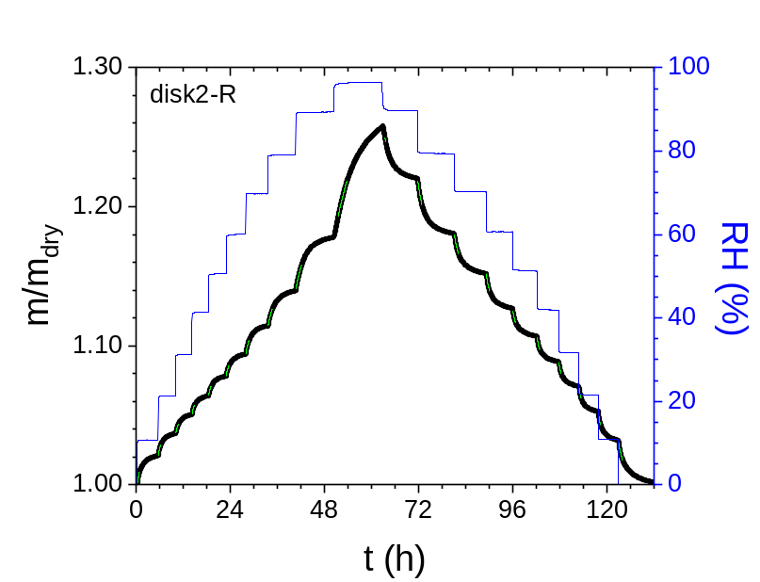
Figure SI-7. DVS adsorption/desorption experiment for the disk2-R. The green lines are the fitting curves following the Ritger-Peppas (RP) model.

Table SI-5. Ritger-Peppas fitting parameters ((m/m_{dry})_{eq}, τ_{rp}, n_{rp}), the corresponding kinetic constant (k_{rp}) and diffusion parameter (D_{rp}), the equivalent kinetic constant (k’), and diffusion coefficient (D’) for each adsorption/desorption step in the DVS experiment for the disk2-R.
RH  [%] | (m/m_{dry})_{eq} | τ_{rp}  [min] | k_{rp}  [s⁻¹] | n | D_{rp}  [m²/s] | k’  [s⁻¹] | β' | D’  [m²/s]
10.70 | 1.0221 | 108.7 | 1.53E-04 | 0.767 | 3.03E-11 | 2.32E-04 | 0.886 | 4.58E-11
21.25 | 1.0378 | 110.3 | 1.51E-04 | 0.716 | 3.00E-11 | 2.36E-04 | 0.829 | 4.69E-11
31.17 | 1.0514 | 106.7 | 1.56E-04 | 0.720 | 3.12E-11 | 2.44E-04 | 0.833 | 4.86E-11
41.29 | 1.0649 | 110.9 | 1.50E-04 | 0.712 | 3.02E-11 | 2.36E-04 | 0.824 | 4.73E-11
50.56 | 1.0790 | 118.1 | 1.41E-04 | 0.715 | 2.85E-11 | 2.21E-04 | 0.827 | 4.46E-11
60.11 | 1.0955 | 143.2 | 1.16E-04 | 0.705 | 2.37E-11 | 1.83E-04 | 0.816 | 3.74E-11
69.74 | 1.1159 | 149.1 | 1.12E-04 | 0.722 | 2.30E-11 | 1.74E-04 | 0.835 | 3.58E-11
79.04 | 1.1409 | 189.7 | 8.79E-05 | 0.740 | 1.83E-11 | 1.35E-04 | 0.855 | 2.82E-11
89.36 | 1.1832 | 252.8 | 6.59E-05 | 0.815 | 1.40E-11 | 9.73E-05 | 0.939 | 2.07E-11
96.50 | 1.2705 | 459.4 | 3.63E-05 | 0.890 | 7.90E-12 | 5.17E-05 | 1.023 | 1.13E-11
89.66 | 1.2178 | 129.9 | 1.28E-04 | 0.974 | 2.73E-11 | 1.77E-04 | 1.116 | 3.78E-11
79.40 | 1.1775 | 186.7 | 8.93E-05 | 0.773 | 1.86E-11 | 1.35E-04 | 0.892 | 2.81E-11
70.17 | 1.1493 | 185.4 | 8.99E-05 | 0.687 | 1.85E-11 | 1.44E-04 | 0.795 | 2.95E-11
60.68 | 1.1251 | 141.9 | 1.17E-04 | 0.681 | 2.39E-11 | 1.88E-04 | 0.789 | 3.84E-11
51.21 | 1.1047 | 147.3 | 1.13E-04 | 0.697 | 2.29E-11 | 1.79E-04 | 0.807 | 3.62E-11
41.88 | 1.0871 | 122.6 | 1.36E-04 | 0.674 | 2.73E-11 | 2.19E-04 | 0.781 | 4.40E-11
31.59 | 1.0698 | 105.1 | 1.59E-04 | 0.704 | 3.16E-11 | 2.50E-04 | 0.815 | 4.99E-11
21.52 | 1.0517 | 102.1 | 1.63E-04 | 0.720 | 3.24E-11 | 2.55E-04 | 0.833 | 5.06E-11
10.82 | 1.0310 | 108.2 | 1.54E-04 | 0.728 | 3.04E-11 | 2.39E-04 | 0.842 | 4.72E-11
0.00 | 0.9993 | 203.6 | 8.19E-05 | 0.705 | 1.61E-11 | 1.29E-04 | 0.816 | 2.53E-11

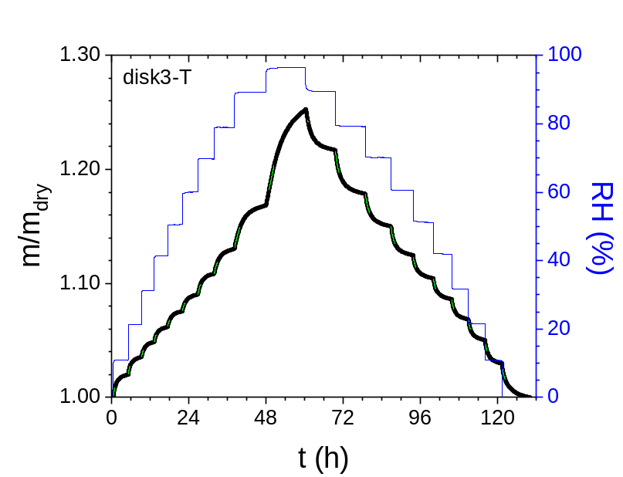
Figure SI-8. DVS adsorption/desorption experiment for the disk3-T. The green lines are the fitting curves following the Ritger-Peppas (RP) model.

Table SI-6. Ritger-Peppas fitting parameters ((m/m_{dry})_{eq}, τ_{rp}, n_{rp}), the corresponding kinetic constant (k_{rp}) and diffusion parameter (D_{rp}), the equivalent kinetic constant (k’), and diffusion coefficient (D’) for each adsorption/desorption step in the DVS experiment for the disk3-T.
RH  [%] | (m/m_{dry})_{eq} | τ_{rp}  [min] | k_{rp}  [s⁻¹] | n | D_{rp}  [m²/s] | k’  [s⁻¹] | β' | D’  [m²/s]
10.80 | 1.0208 | 84.79 | 1.97E-04 | 0.791 | 4.22E-11 | 2.94E-04 | 0.912 | 6.31E-11
21.31 | 1.0361 | 91.61 | 1.82E-04 | 0.729 | 3.95E-11 | 2.82E-04 | 0.843 | 6.12E-11
31.19 | 1.0494 | 96.56 | 1.73E-04 | 0.717 | 3.78E-11 | 2.70E-04 | 0.829 | 5.90E-11
41.29 | 1.0625 | 105.7 | 1.58E-04 | 0.702 | 3.48E-11 | 2.49E-04 | 0.813 | 5.50E-11
50.56 | 1.0766 | 123.7 | 1.35E-04 | 0.702 | 3.01E-11 | 2.13E-04 | 0.813 | 4.75E-11
60.13 | 1.0918 | 145.0 | 1.15E-04 | 0.690 | 2.60E-11 | 1.83E-04 | 0.799 | 4.14E-11
69.72 | 1.1102 | 139.2 | 1.20E-04 | 0.712 | 2.74E-11 | 1.88E-04 | 0.823 | 4.30E-11
78.90 | 1.1319 | 176.9 | 9.42E-05 | 0.723 | 2.20E-11 | 1.47E-04 | 0.836 | 3.43E-11
89.20 | 1.1748 | 281.4 | 5.92E-05 | 0.797 | 1.43E-11 | 8.82E-05 | 0.919 | 2.12E-11
96.50 | 1.2636 | 386.1 | 4.32E-05 | 0.937 | 1.07E-11 | 6.04E-05 | 1.076 | 1.50E-11
89.48 | 1.2132 | 129.9 | 1.28E-04 | 0.977 | 3.09E-11 | 1.77E-04 | 1.120 | 4.27E-11
79.21 | 1.1743 | 197.4 | 8.44E-05 | 0.745 | 1.97E-11 | 1.30E-04 | 0.860 | 3.03E-11
70.09 | 1.1440 | 243.5 | 6.85E-05 | 0.630 | 1.57E-11 | 1.14E-04 | 0.732 | 2.63E-11
60.63 | 1.1230 | 158.4 | 1.05E-04 | 0.632 | 2.38E-11 | 1.76E-04 | 0.734 | 3.97E-11
51.18 | 1.1028 | 154.5 | 1.08E-04 | 0.658 | 2.41E-11 | 1.76E-04 | 0.764 | 3.93E-11
41.85 | 1.0847 | 122.2 | 1.36E-04 | 0.677 | 3.02E-11 | 2.19E-04 | 0.784 | 4.85E-11
31.57 | 1.0672 | 110.2 | 1.51E-04 | 0.698 | 3.31E-11 | 2.40E-04 | 0.808 | 5.25E-11
21.48 | 1.0493 | 106.7 | 1.56E-04 | 0.702 | 3.39E-11 | 2.47E-04 | 0.813 | 5.35E-11
10.77 | 1.0287 | 109.4 | 1.52E-04 | 0.720 | 3.27E-11 | 2.38E-04 | 0.832 | 5.10E-11
0.00 | 0.9977 | 190.2 | 8.76E-05 | 0.703 | 1.86E-11 | 1.38E-04 | 0.814 | 2.94E-11

a)  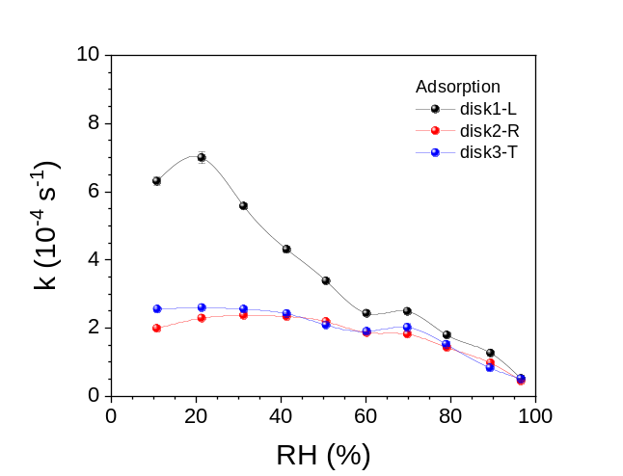 | b)  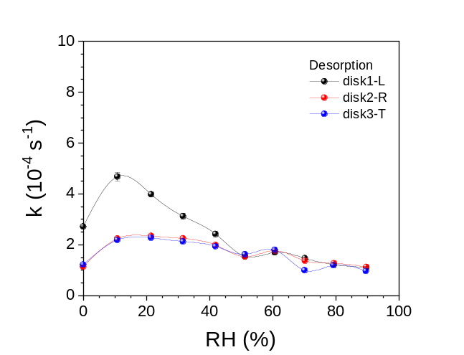
c)  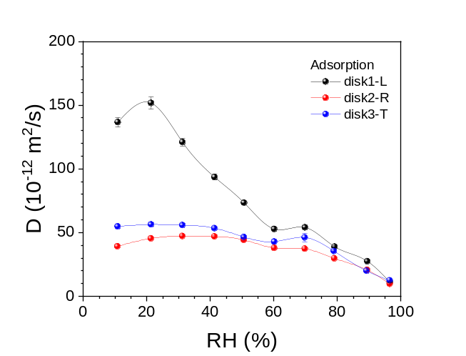 | d)  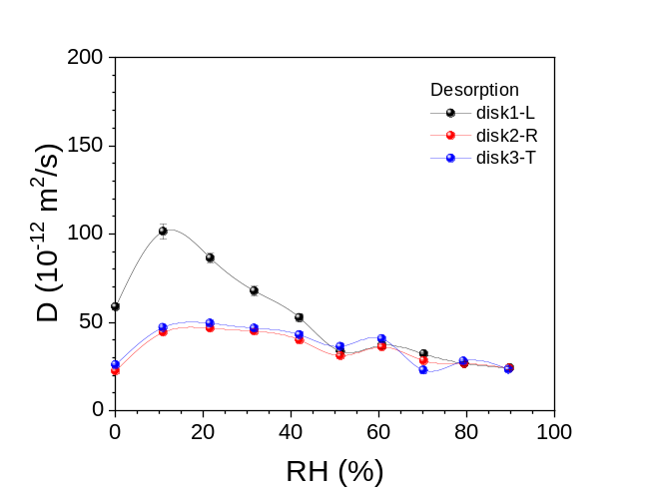

Figure SI-9. a) Adsorption and b) desorption kinetic constant (k), and c) adsorption and d) desorption diffusion coefficient (D) using the DSE model for the three beech disks: disk1-L, disk2-R and disk3-T.

a)
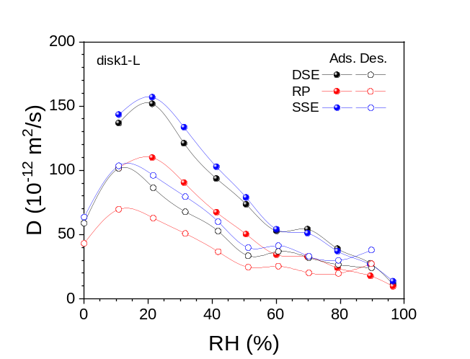
b)
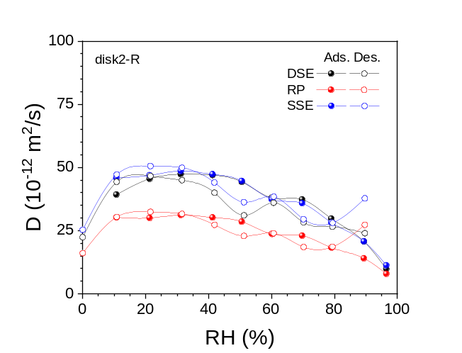
c)
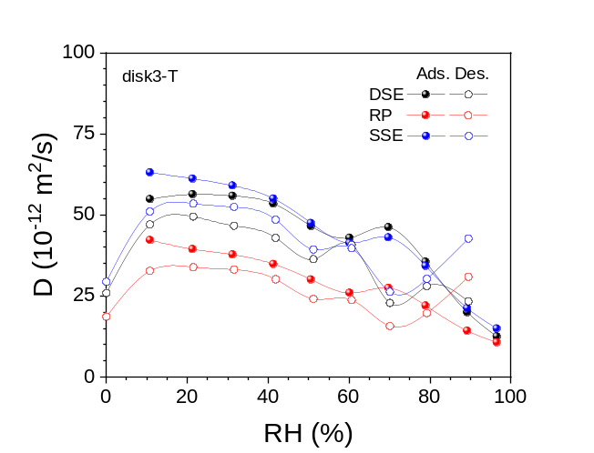

Figure SI-10. Adsorption/desorption diffusion coefficient (D) as a function of the relative humidity for the three beech disks: a) disk1-L, b) disk-R, and c) disk3-T, using the double stretched exponential (DSE) model, the Ritger-Peppas (RP) model and the equivalent to the single stretched exponential function (SSE) from the Ritger-Peppas model.

a)  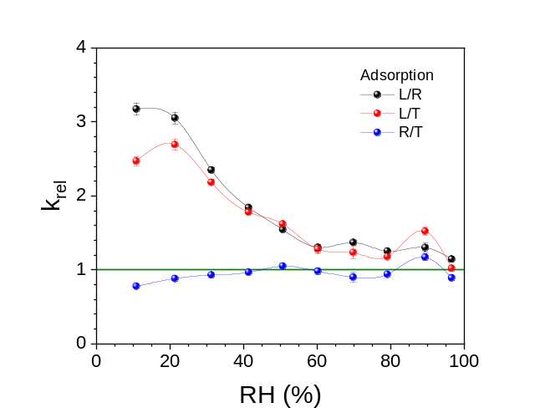 | 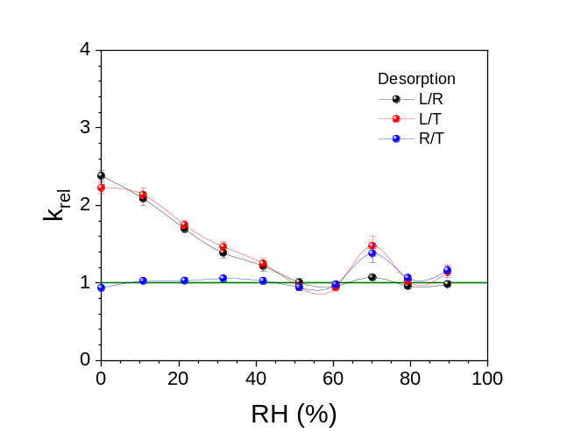
b)  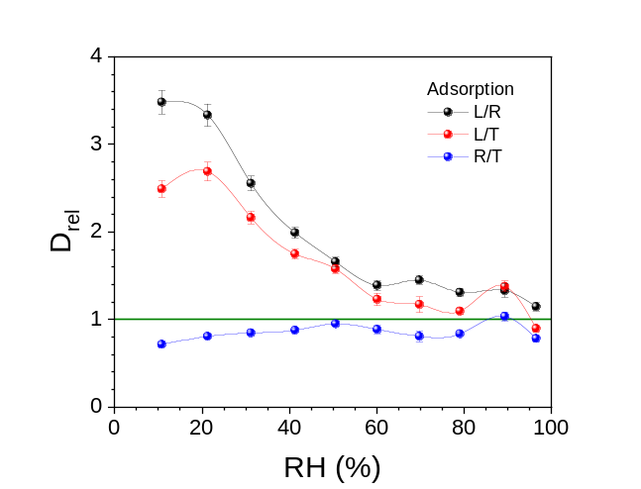 | 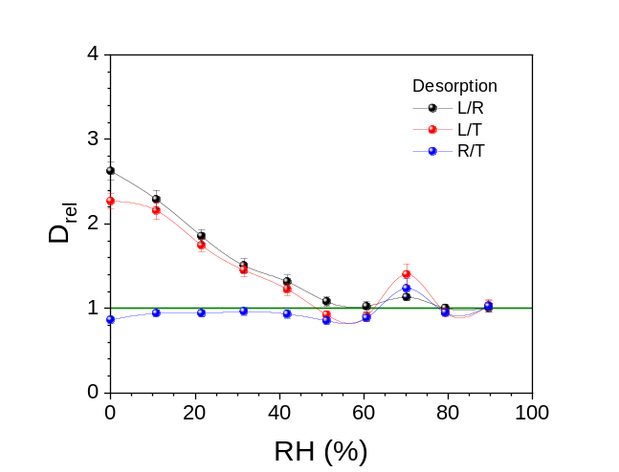

Figure SI-11. a) Adsorption and c) desorption relative directional kinetic constant (k_{rel}: L/R, L/T and R/T), and c) adsorption and d) desorption relative directional diffusion coefficient (D_{rel}: L/R, L/T and R/T) for the three beech disks: disk1-L, disk2-R and disk3-T.

a)  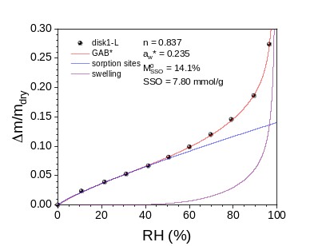 | b)  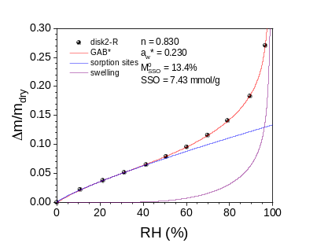 | c)  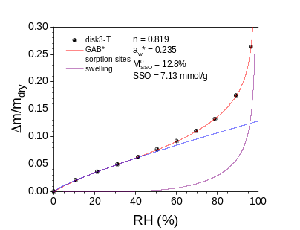
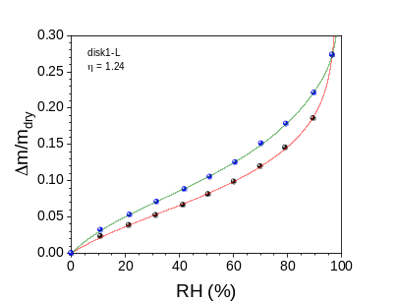 | 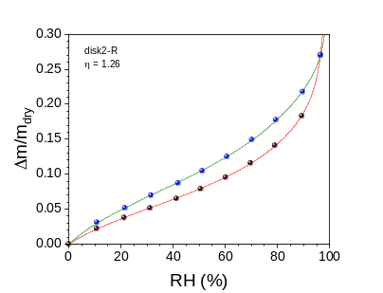 | 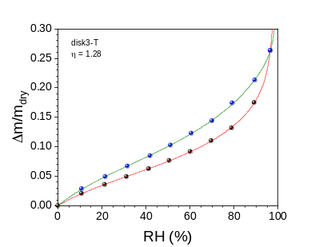

Figure SI-12. (Top) Moisture adsorption isotherm, fitting of the data following the GAB* model (0 ≤ a_{w} ≤ 0.99), and deconvolution following the SSO model (bound water, blue; non-bound water violet). (Bottom) Both the moisture adsorption (red) and desorption (green) isotherms and the corresponding hysteresis factor η for the three beech disks: a) disk1-L (η = 1.24), b) disk2-R (η = 1.26), and c) disk3-T (η = 1.28).

Table SI-7. GAB* fitting parameters (M₀, C, K and N), the SSO fitting parameters: exponent (n), the maximum bound water moisture capacity (M_{SSO}⁰), and the sorption sites molar concentration (SSO) for the three beech disks.
 | M₀ | C | K | N | n | M_{SSO}⁰ | SSO  [mmol/g]
disk1-L | 0.0773 | 4.47 | 0.670 | 0.00447 | 0.837 | 0.141 | 7.80
disk2-R | 0.0712 | 4.76 | 0.692 | 0.00407 | 0.830 | 0.134 | 7.43
disk3-T | 0.0695 | 4.76 | 0.677 | 0.00484 | 0.819 | 0.128 | 7.13

a)
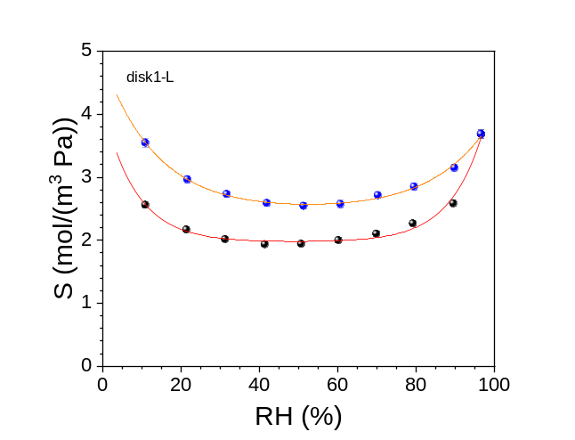
b)
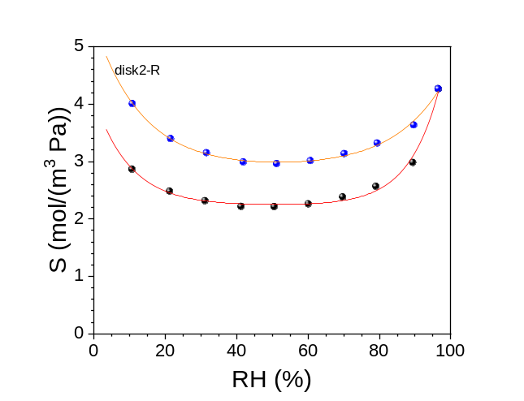
c)
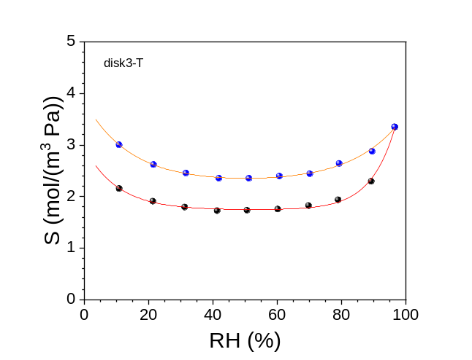

Figure SI-13. Sorption coefficient (S) profile in the adsorption (red curve) and desorption (orange curve) process for the three beech disks: a) disk1-L, b) disk2-R, and c) disk3-T.

Table SI-8. Sorption coefficient (S) calculated from the moisture sorption isotherms for the three beech disks: disk1-L, disk2-R, and disk3-T.
disk1-L |  | disk2-R |  | disk3-T
RH (%) | S [mol/(m³ Pa)] | RH (%) | S [mol/(m³ Pa)] | RH (%) | S [mol/(m³ Pa)]
10.8 | 2.57 | 10.7 | 2.87 | 10.8 | 2.18
21.3 | 2.18 | 21.3 | 2.48 | 21.3 | 1.94
31.2 | 2.03 | 31.2 | 2.32 | 31.2 | 1.82
41.3 | 1.95 | 41.3 | 2.22 | 41.3 | 1.75
50.6 | 1.95 | 50.6 | 2.21 | 50.6 | 1.76
60.1 | 2.01 | 60.1 | 2.26 | 60.1 | 1.78
69.8 | 2.11 | 69.7 | 2.38 | 69.7 | 1.85
79.2 | 2.28 | 79.0 | 2.57 | 78.9 | 1.96
89.5 | 2.60 | 89.4 | 2.98 | 89.2 | 2.32
96.5 | 3.70 | 96.5 | 4.27 | 96.5 | 3.39
89.8 | 3.17 | 89.7 | 3.63 | 89.5 | 2.92
79.4 | 2.86 | 79.4 | 3.32 | 79.2 | 2.68
70.2 | 2.73 | 70.2 | 3.14 | 70.1 | 2.47
60.7 | 2.59 | 60.7 | 3.01 | 60.6 | 2.43
51.2 | 2.56 | 51.2 | 2.96 | 51.2 | 2.39
41.9 | 2.60 | 41.9 | 2.99 | 41.9 | 2.38
31.6 | 2.75 | 31.6 | 3.15 | 31.6 | 2.49
21.6 | 2.98 | 21.5 | 3.40 | 21.5 | 2.66
10.8 | 3.57 | 10.8 | 4.01 | 10.8 | 3.04

a)  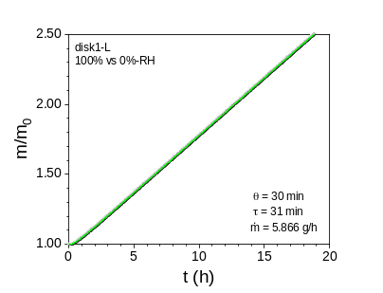 | 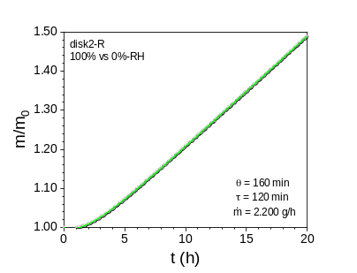 | 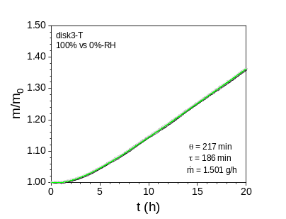
b)  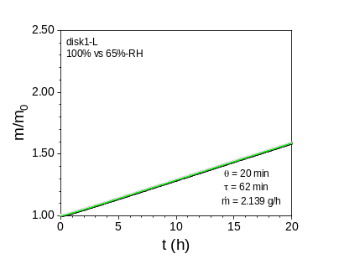 | 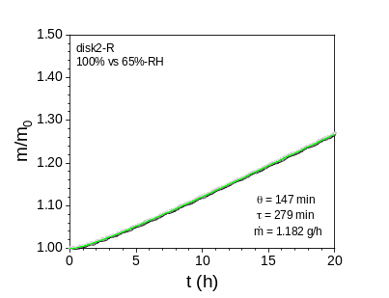 | 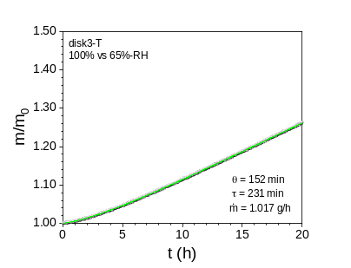
c)  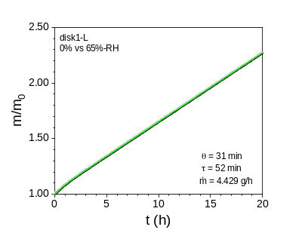 | 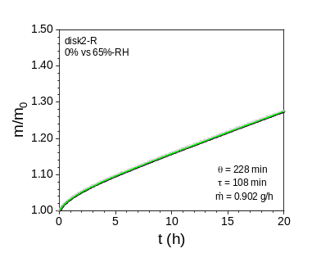 | 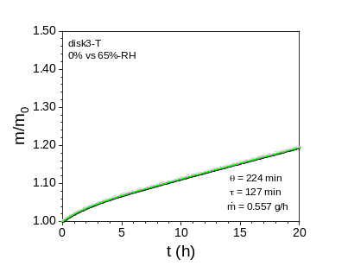
d)  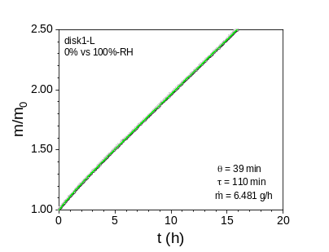 | 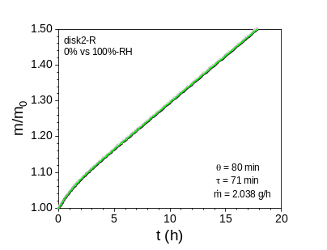 | 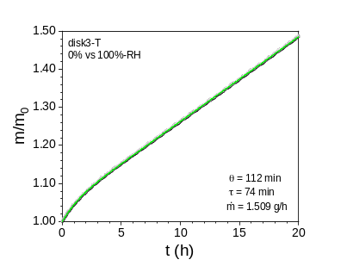

Figure SI-14. Moisture transmission experiments on the three beech disks under different conditions: inner RH-value of 100% against outer RH-value of a) 0% and b) 65%; inner RH-value of 0% against outer RH-value of c) 65% and d) 100%. The lines are the fits to the experimental data using the exponential-linear fitting function (Eq. 4).

a)  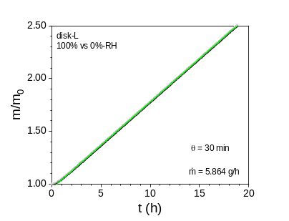 | 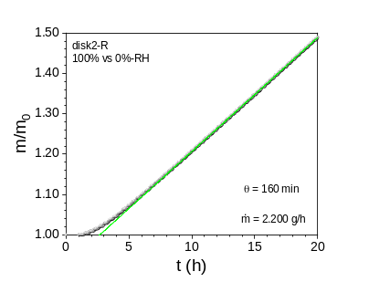 | 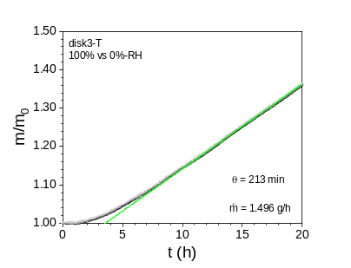
b)  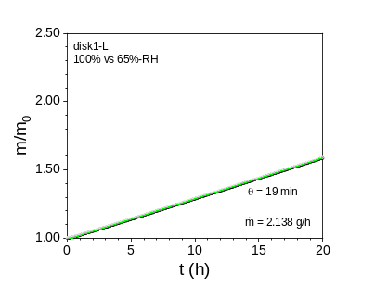 | 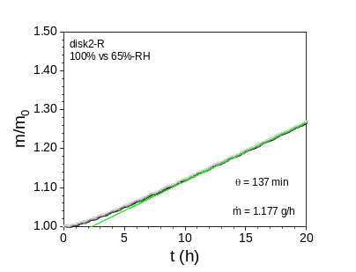 | 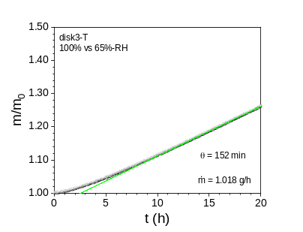
c)  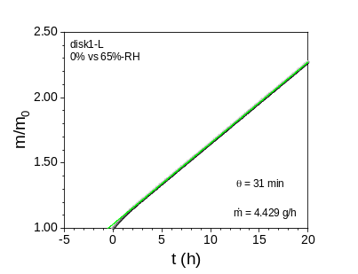 | 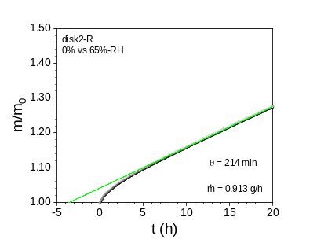 | 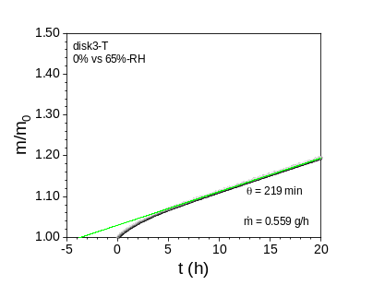
d)  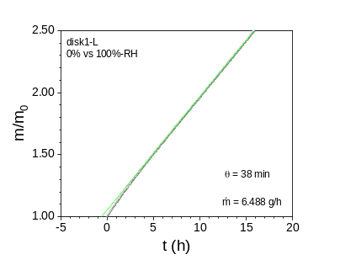 | 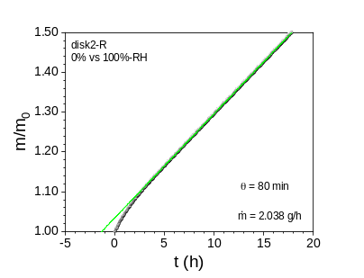 | 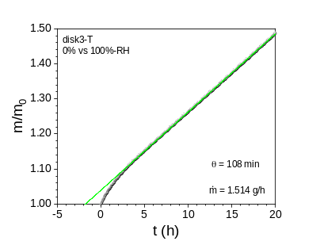

Figure SI-15. Moisture transmission experiments on the three beech disks under different conditions: inner RH-value of 100% against outer RH-value of a) 0% and b) 65%; inner RH-value of 0% against outer RH-value of c) 65% and d) 100%. The lines are linear fits to the experimental data in the linear regime.

Table SI-9. Permeability coefficient (P), transmission rate (TR), mass rate ($\dot{m}$), diffusion coefficient (D_{θ}, D_{τ}, D_{MSI}), sorption coefficient (S_{θ}, S_{τ}, S_{MSI}), lagtime (θ), lifetime (τ), stretched exponential factor (β), and moisture capacity (M_{w}) at different relative humidity conditions for the disk1-L.
 | 100% vs 0%-RH | 100% vs 65%-RH | 0% vs 65%-RH | 0% vs 100%-RH
Δp [Pa] | 2862 | 1002 | 1860 | 2862
P [mol/(m s Pa)] | (3.66 ± 0.04) 10⁻¹⁰ | (3.87 ± 0.04) 10⁻¹⁰ | (4.38 ± 0.04) 10⁻¹⁰ | (4.04 ± 0.04) 10⁻¹⁰
TR [mol/(m² s)] | (9.95 ± 0.02) 10⁻⁴ | (3.69 ± 0.01) 10⁻⁴ | (7.76 ± 0.01) 10⁻⁴ | (11.00 ± 0.02) 10⁻⁴
$\dot{m}$ [mol/s] | (9.044 ± 0.001) 10⁻⁸ | (3.298 ± 0.001) 10⁻⁸ | (6.829 ± 0.001) 10⁻⁸ | (9.993 ± 0.001) 10⁻⁸
D_{θ} [m²/s] | (1.01 ± 0.02) 10⁻¹⁰ | (1.54 ± 0.10) 10⁻¹⁰ | (0.97 ± 0.03) 10⁻¹⁰ | (0.78 ± 0.03) 10⁻¹⁰
D_{τ} [m²/s] | (4.72 ± 0.10) 10⁻¹⁰ | (2.32 ± 0.20) 10⁻¹⁰ | (2.79 ± 0.10) 10⁻¹⁰ | (1.32 ± 0.10) 10⁻¹⁰
D_{MSI} [m²/s] | (1.6 ± 0.1) 10⁻¹⁰ | (1.6 ± 0.1) 10⁻¹⁰ | (2.0 ± 0.2) 10⁻¹⁰ | (1.8 ± 0.1) 10⁻¹⁰
S_{θ} [mol/(m³ Pa)] | 3.6 ± 0.1 | 2.5 ± 0.2 | 4.5 ± 0.1 | 5.2 ± 0.2
S_{τ} [mol/(m³ Pa)] | 0.77 ± 0.03 | 1.7 ± 0.1 | 1.57 ± 0.05 | 3.1 ± 0.1
S_{MSI} [mol/(m³ Pa)] | 2.25 ± 0.05 | 2.39 ± 0.05 | 2.16 ± 0.04 | 2.25 ± 0.05
θ [min] | 30 ± 1 | 20 ± 1 | 31 ± 1 | 39 ± 1
τ [min] | 31 ± 1 | 62 ± 5 | 52 ± 1 | 110 ± 3
β | 0.80 ± 0.02 | 0.72 ± 0.06 | 1.14 ± 0.04 | 0.90 ± 0.03
M_{w} (%) | 4.2 ± 0.1 | 1.0 ± 0.1 | 3.2 ± 0.1 | 5.9 ± 0.2
Area (%) | 8.4 | 1.0 | 3.6 | 8.4

Table SI-10. Permeability coefficient (P), transmission rate (TR), mass rate ($\dot{m}$), diffusion coefficient (D_{θ}, D_{τ}, D_{MSI}), sorption coefficient (S_{θ}, S_{τ}, S_{MSI}), lagtime (θ), lifetime (τ), stretched exponential factor (β), and moisture capacity (M_{w}) at different relative humidity conditions for the disk2-R.
 | 100% vs 0%-RH | 100% vs 65%-RH | 0% vs 65%-RH | 0% vs 100%-RH
Δp [Pa] | 2862 | 1002 | 1860 | 2862
P [mol/(m s Pa)] | (1.35 ± 0.01) 10⁻¹⁰ | (2.08 ± 0.02) 10⁻¹⁰ | (8.59 ± 0.09) 10⁻¹¹ | (1.25 ± 0.01) 10⁻¹⁰
TR [mol/(m² s)] | (3.80 ± 0.01) 10⁻⁴ | (2.06 ± 0.01) 10⁻⁴ | (1.59 ± 0.01) 10⁻⁴ | (3.52 ± 0.01) 10⁻⁴
$\dot{m}$ [mol/s] | (3.393 ± 0.002) 10⁻⁸ | (1.823 ± 0.001) 10⁻⁸ | (1.391 ± 0.001) 10⁻⁸ | (3.142 ± 0.001) 10⁻⁸
D_{θ} [m²/s] | (1.80 ± 0.04) 10⁻¹¹ | (1.94 ± 0.05) 10⁻¹¹ | (1.23 ± 0.03) 10⁻¹¹ | (3.59 ± 0.08) 10⁻¹¹
D_{τ} [m²/s] | (1.13 ± 0.02) 10⁻¹⁰ | (4.81 ± 0.01) 10⁻¹¹ | (1.22 ± 0.03) 10⁻¹⁰ | (1.90 ± 0.04) 10⁻¹⁰
D_{MSI} [m²/s] | (5.3 ± 0.3) 10⁻¹¹ | (7.6 ± 0.4) 10⁻¹¹ | (3.5 ± 0.2) 10⁻¹¹ | (4.9 ± 0.2) 10⁻¹¹
S_{θ} [mol/(m³ Pa)] | 7.5 ± 0.2 | 10.7 ± 0.3 | 7.0 ± 0.2 | 3.5 ± 0.1
S_{τ} [mol/(m³ Pa)] | 1.19 ± 0.03 | 4.3 ± 0.1 | 0.70 ± 0.02 | 0.66 ± 0.02
S_{MSI} [mol/(m³ Pa)] | 2.56 ± 0.03 | 2.73 ± 0.03 | 2.44 ± 0.03 | 2.56 ± 0.03
θ [min] | 160 ± 1 | 147 ± 2 | 228 ± 2 | 80 ± 1
τ [min] | 120 ± 1 | 279 ± 5 | 108 ± 1 | 71 ± 1
β | 0.96 ± 0.01 | 0.74 ± 0.01 | 0.74 ± 0.01 | 1.05 ± 0.02
M_{w} (%) | 7.5 ± 0.1 | 3.7 ± 0.1 | 4.4 ± 0.1 | 3.5 ± 0.1
Area (%) | 8.2 | 4.8 | 3.5 | 8.2

Table SI-11. Permeability coefficient (P), transmission rate (TR), mass rate ($\dot{m}$), diffusion coefficient (D_{θ}, D_{τ}, D_{MSI}), sorption coefficient (S_{θ}, S_{τ}, S_{MSI}), lagtime (θ), lifetime (τ), stretched exponential factor (β), and moisture capacity (M_{w}) at different relative humidity conditions for the disk3-T.
 | 100% vs 0%-RH | 100% vs 65%-RH | 0% vs 65%-RH | 0% vs 100%-RH
Δp [Pa] | 2862 | 1002 | 1860 | 2862
P [mol/(m s Pa)] | (0.98 ± 0.01) 10⁻¹⁰ | (1.89 ± 0.02) 10⁻¹⁰ | (5.57 ± 0.05) 10⁻¹¹ | (0.99 ± 0.01) 10⁻¹⁰
TR [mol/(m² s)] | (2.62 ± 0.01) 10⁻⁴ | (1.79 ± 0.01) 10⁻⁴ | (0.99 ± 0.01) 10⁻⁴ | (2.63 ± 0.01) 10⁻⁴
$\dot{m}$ [mol/s] | (2.315 ± 0.002) 10⁻⁸ | (1.568 ± 0.002) 10⁻⁸ | (0.859 ± 0.001) 10⁻⁸ | (2.327 ± 0.001) 10⁻⁸
D_{θ} [m²/s] | (1.47 ± 0.03) 10⁻¹¹ | (2.05 ± 0.04) 10⁻¹¹ | (1.37 ± 0.03) 10⁻¹¹ | (2.86 ± 0.06) 10⁻¹¹
D_{τ} [m²/s] | (8.10 ± 0.20) 10⁻¹¹ | (6.38 ± 0.20) 10⁻¹¹ | (1.13 ± 0.02) 10⁻¹⁰ | (2.04 ± 0.05) 10⁻¹⁰
D_{MSI} [m²/s] | (5.0 ± 0.2) 10⁻¹¹ | (9.0 ± 0.4) 10⁻¹¹ | (3.0 ± 0.1) 10⁻¹¹ | (5.0 ± 0.2) 10⁻¹¹
S_{θ} [mol/(m³ Pa)] | 6.7 ± 0.1 | 9.2 ± 0.2 | 4.1 ± 0.1 | 3.4 ± 0.1
S_{τ} [mol/(m³ Pa)] | 1.21 ± 0.03 | 3.0 ± 0.1 | 0.49 ± 0.01 | 0.48 ± 0.01
S_{MSI} [mol/(m³ Pa)] | 1.96 ± 0.02 | 2.10 ± 0.03 | 1.88 ± 0.02 | 1.96 ± 0.02
θ [min] | 217 ± 1 | 152 ± 1 | 224 ± 2 | 112 ± 1
τ [min] | 186 ± 1 | 231 ± 4 | 127 ± 1 | 74 ± 1
β | 1.02 ± 0.01 | 1.00 ± 0.01 | 0.94 ± 0.01 | 1.06 ± 0.02
M_{w} (%) | 8.0 ± 0.1 | 3.8 ± 0.1 | 3.1 ± 0.1 | 4.1 ± 0.1
Area (%) | 7.9 | 4.5 | 3.3 | 7.9

a)  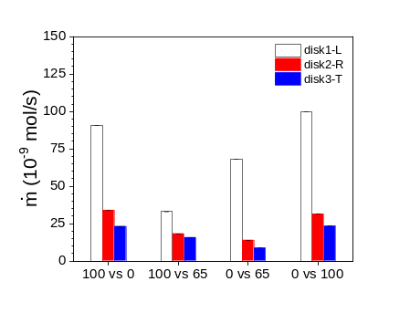 | b)  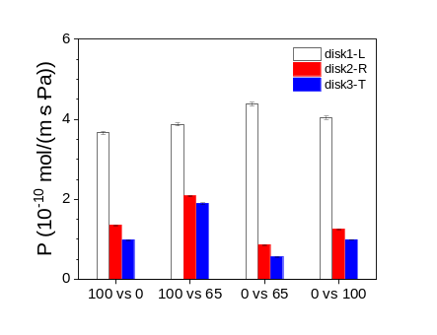 | c)  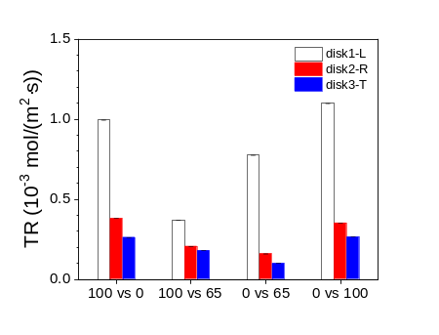
d)  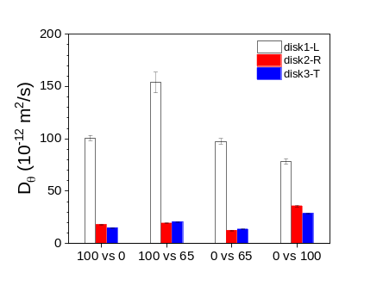 | e)  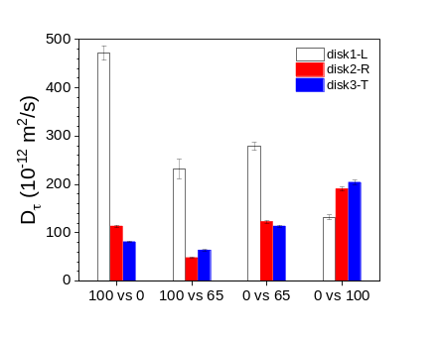 | f)  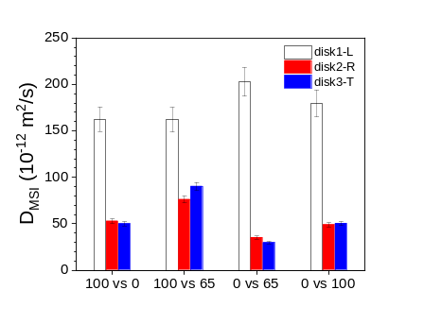
g)  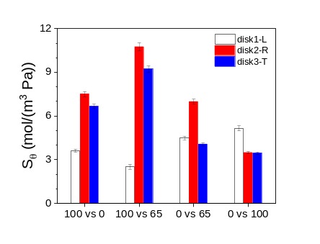 | h)  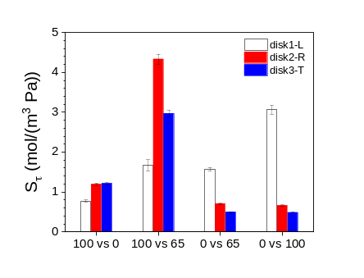 | i)  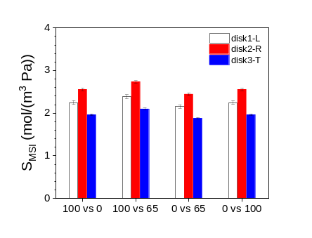
j)  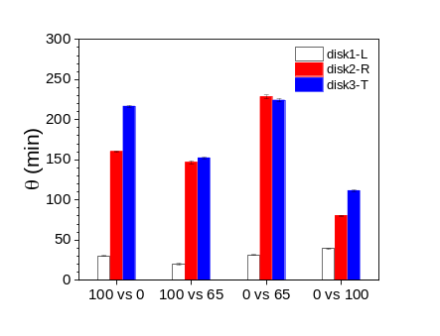 | k)  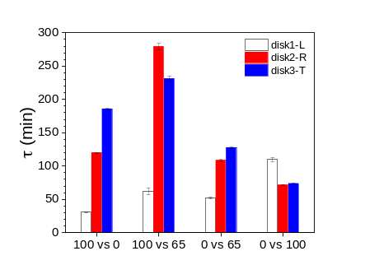 | l)  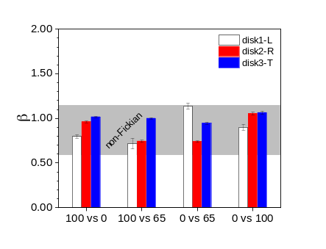

Figure SI-16. a) Mass rate ($\dot{m}$), b) transmission rate (TR), c) permeability coefficient (P), d,e,f) diffusion coefficient (D_{θ}, D_{τ}, D_{MSI}), g,h,i) sorption coefficient (S_{θ}, S_{τ}, S_{MSI}), j) lagtime (θ), k) lifetime (τ), and l) stretched exponential factor (β) for the three beech disks with the moisture transmission parallel to the longitudinal (L), radial (R), and tangential (T) direction at different relative humidity conditions. Note: in the x-axis, the first value refers to the inner RH-value (cup) and the second one to the outer RH-value (gas flow).

a)
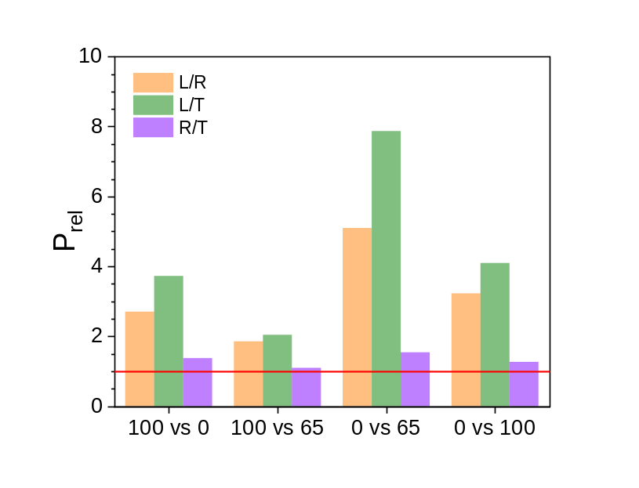
b)
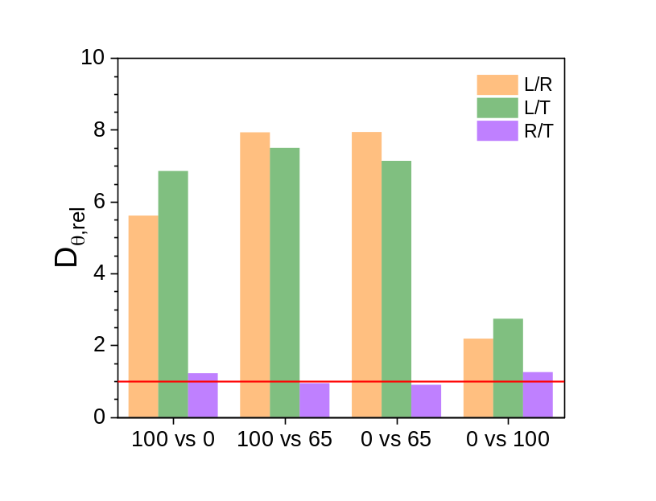
c)
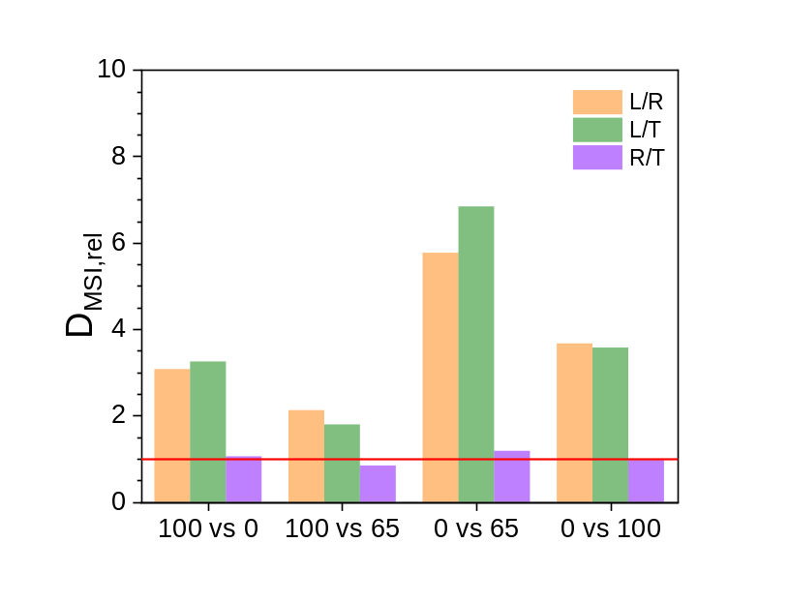

Figure SI-17. a) Relative directional permeability coefficient (P_{rel}: L/R, L/T and R/T), b) relative directional diffusion coefficient obtained from the lagtime value θ (D_{θ}: L/R, L/T and R/T), and c) relative diffusion coefficient obtained from the moisture sorption isotherms (D_{MSI}: L/R, L/T and R/T) at different relative humidity conditions for the three beech disks: disk1-L, disk2-R and disk3-T. Note: in the x-axis, the first value refers to the inner RH-value (cup) and the second one to the outer RH-value (gas flow).

a)
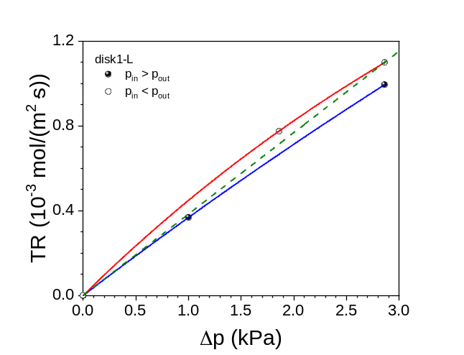
b)
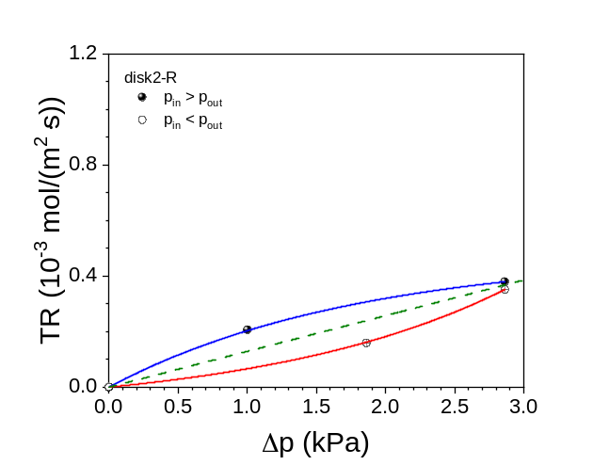
c)
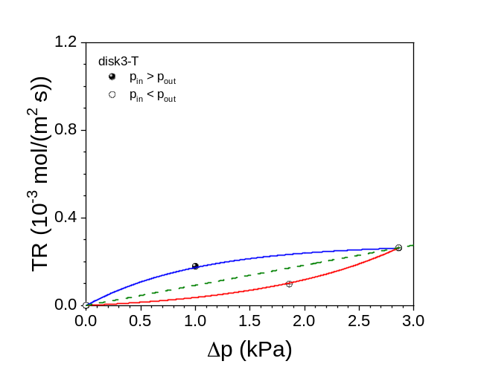

Figure SI-18. Transmission rate (TR) as a function of the vapor pressure difference at different relative humidity conditions for the three beech disks: disk1-L, disk2-R and disk3-T. Note: the green curve is representing the theoretical linear behavior.

