Supplementary material

Table S1 Characterization of the prepared CNF samples
CNF type | Mec | Enz | T55 | Cat
Dry content (%) | 0.74 | 0.94 | 0.90 | 0.71
Degree of fibrillation (%) | 6.5 | 16.6 | 49.3 | 31.1
Degree of polymerization | 2287 | 960 | 381 | 1213
DS (mmol g⁻¹) | ---- | ---- | 0.74 | 0.41
Zeta potential (mV) | –14±4 | –18±2 | –42±10 | +40±3
Hydrodynamic diameter (nm) | 861±151 | 436±49 | 381±19 | 536±34
Fibril diameter (nm) | ---- | 20 - 80 | 5 - 40 | ----

Table S2 Mechanical properties (maximum force at break and elongation at break) of films prepared by filtration + hot pressing with CNFs and minerals (basis weight of 40 g m⁻²)
Film | F_{max} (N) | Elongation at break (%)
Mec CNF | 71.5±4.9 | 10.5±1.7
Mec CNF + 20% SEP | 44.4±3.4 | 4.3±0.6
Mec CNF + 10% SEP + 10% Kao | 50.7±5.3 | 7.0±0.9
Mec CNF + 20% SEP, pH 3 | 42.6±2.6 | 6.2±1.1
Mec CNF + 10% SEP + 10% Kao, pH3 | 41.2±6.3 | 5.6±1.4
Enz CNF | 51.9±5.2 | 5.0±0.7
Enz CNF + 20% SEP | 38.6±2.4 | 3.2±0.1
Enz CNF + 10% SEP + 10% Kao | 40.1±0.2 | 5.7±0.4
Enz CNF + 20% SEP, pH 3 | 37.6±1.3 | 4.7±0.7
Enz CNF + 10% SEP + 10% Kao, pH3 | 37.0±3.8 | 3.8±0.4
T55 CNF | 25.6±13.5 | 2.0±1.3
T55 CNF + 20% SEP | 36.9±4.1 | 4.7±1.1
T55 CNF + 10% SEP + 10% Kao | 37.2±3.3 | 3.9±1.0
T55 CNF + 20% SEP, pH 3 | 30.2±6.5 | 2.9±1.2
T55 CNF + 10% SEP + 10% Kao, pH3 | 37.7±2.8 | 4.2±1.2
Cat CNF | 60.9±4.5 | 18.5±1.7
Cat CNF + 20% SEP | 51.3±6.6 | 19.9±2.6
Cat CNF + 10% SEP + 10% Kao | 55.3±6.4 | 17.7±1.4
Measurements were made at 23 ºC and 50% RH

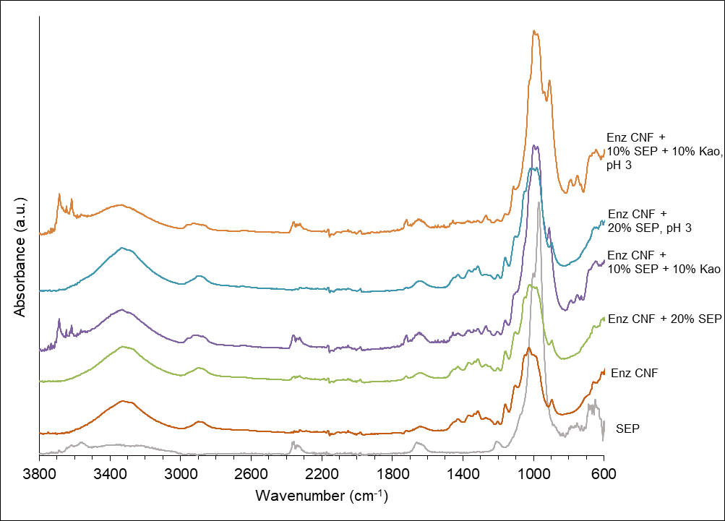

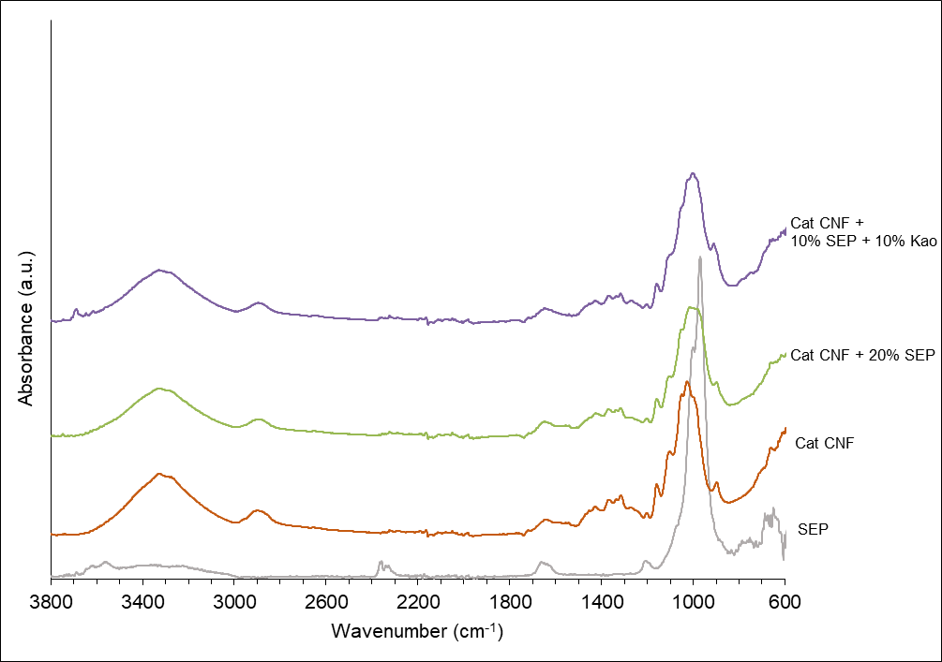
Figure S1 FTIR spectra of series of films of Enz CNF and Cat CNF with minerals

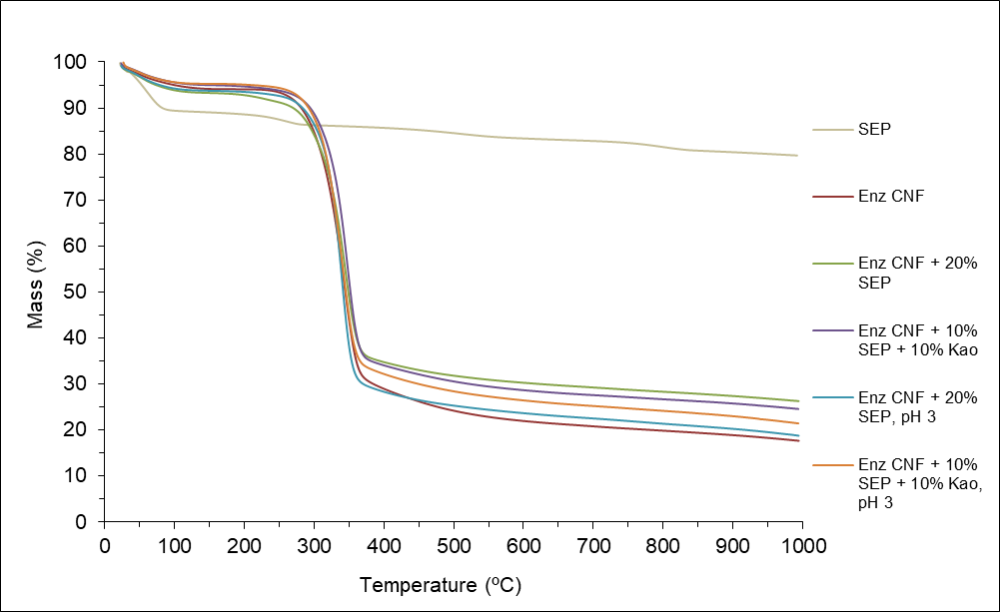

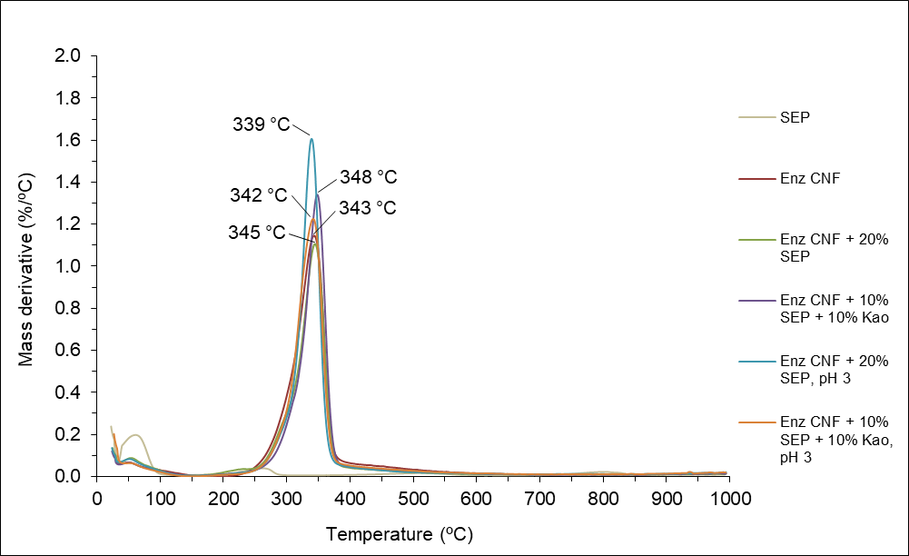

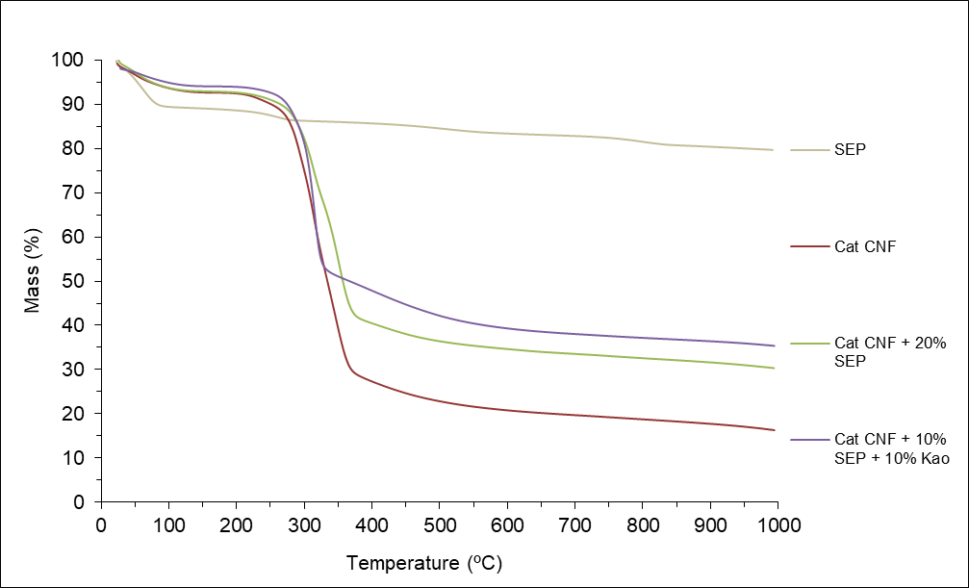

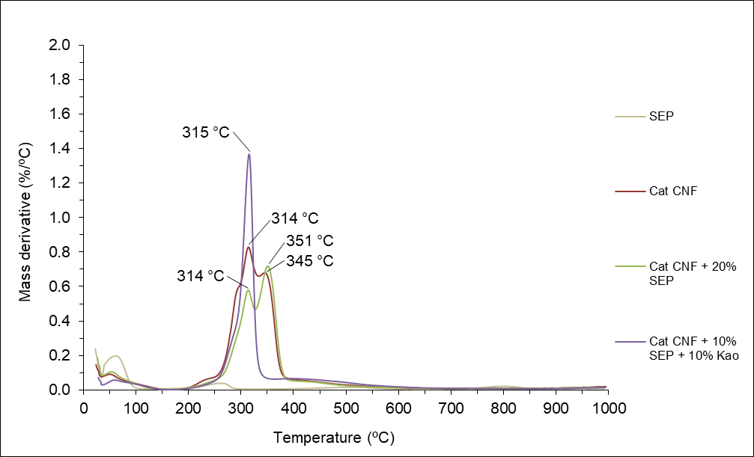
Figure S2 Thermograms and derivative curves for the Enz CNF and Cat CNF-based composite films

