Supplements
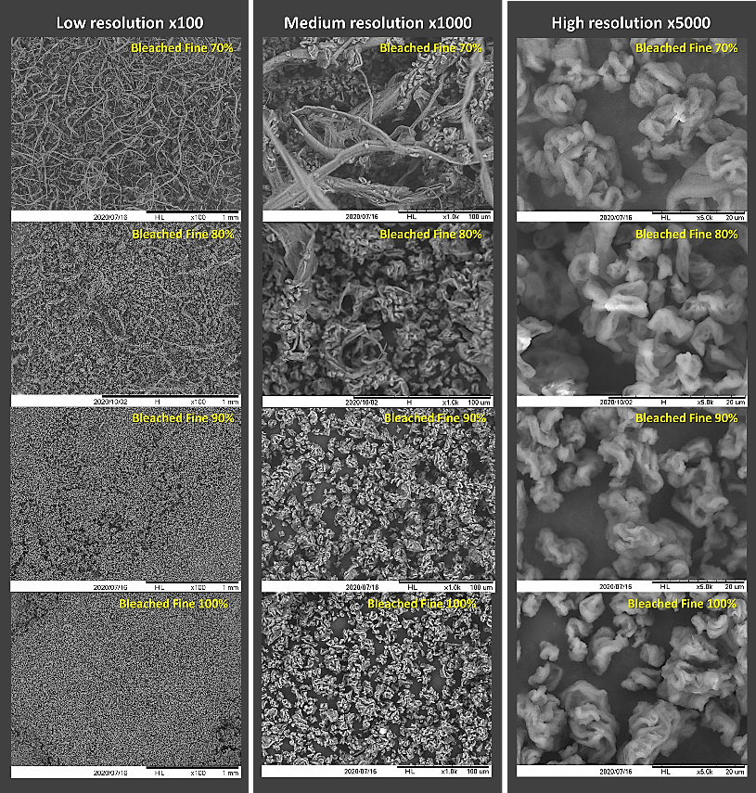
Fig. 18 SEM micrographs of cellulose nanofibrils with different fine levels of their suspensions dried by UMaine's pilot spray dryer

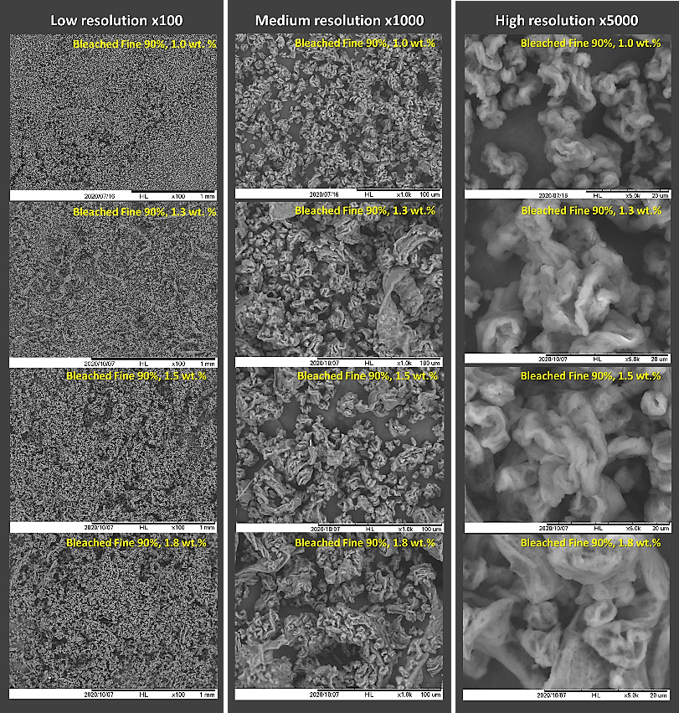
Fig. 19 SEM micrographs of cellulose nanofibrils with different solid contents of their suspensions dried by UMaine's pilot spray dryer
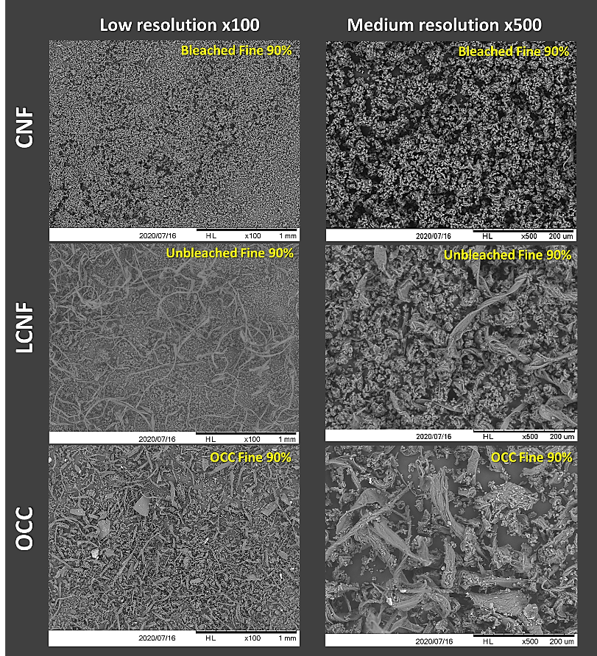
Fig. 20 SEM micrographs of cellulose nanofibrils from different resources (CNF, LCNF, and OCC) dried by UMaine's pilot spray dryer

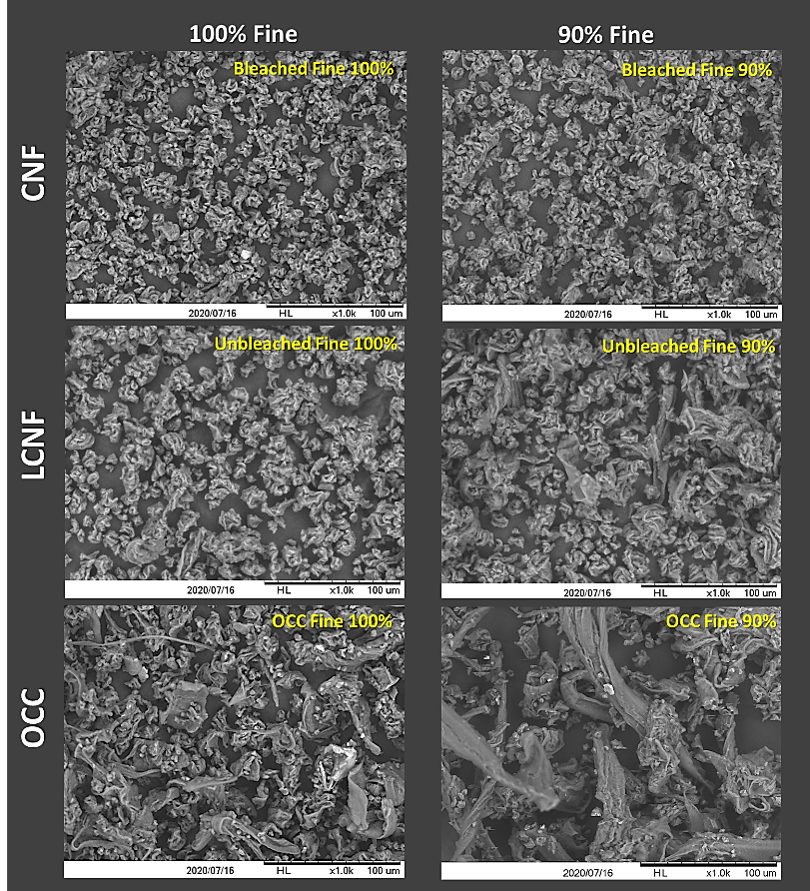
Fig. 21 SEM micrographs of cellulose nanofibrils from different fine levels and resources dried by UMaine's pilot spray dryer

