Supporting information for
Properties of quaternized and cross-linked hydroxyethylcellulose composite films
Ivan Šimkovic^{a, *}· Filip Gucmann^{b} · Edmund Dobročka^{b} · Jaroslav Filip^{c} · Michal Hricovíniª · Viera Dujničª · Raniero Mendichi^{d} · Alberto Giacometti Schieroni^{e} · Daniele Piovani^{e} · Stefania Zappia^{e} · Miloš Hricovíniª
ªInstitute of Chemistry, Slovak Academy of Sciences, 845 38 Bratislava, Slovakia
^{b}Institute of Electrical Engineering, Slovak Academy of Sciences, Dúbravská cesta 9, 84104 Bratislava, Slovakia
^{c}Department of Environmental Protection Engineering, Tomáš Baťa University in Zlín, Faculty of Technology, Czechia
^{d}Expert Analysis, Molecular and Rheological Characterization Complex Polymers
Via Roma 7, 20067 Tribiano, Milan, Italy
^{e}Instituto di Scienze e Tecnologie Chimiche "G. Natta", Via A. Corti 12, 20133 Milan, Italy

Correspondence: Ivan Šimkovic (e-mail: chemsimk@savba.sk); ORCID: 0000-0003-4107-1529

Contents
Fig. S1. Hypothetical structures of HEC, CHEC, QHEC and QCHEC.
Table S1. NMR data in D₂O.
Fig. S2. ¹H-NMR spectrum of HEC.
Fig. S3. COSY spectrum of HEC.
Fig. S4. TOCSY spectrum of HEC.
Fig. S5. HSQC-TOCSY spectrum of HEC.
Fig. S6. HMBC spectrum of HEC.
Fig. S7. ¹³C-NMR spectrum of HEC.
Fig. S8. ¹H-NMR spectrum of CHEC.
Fig. S9. COSY spectrum of CHEC.
Fig. S10. TOCSY spectrum of CHEC.
Fig. S11. HSQC-TOCSY spectrum of CHEC.
Fig. S12. HMBC spectrum of CHEC.
Fig. S13. ¹³C-NMR spectrum of CHEC.
Fig. S14. ¹H-NMR spectrum of QHEC.
Fig. S15. COSY spectrum of QHEC.
Fig. S16. HSQC-TOCSY spectrum of QHEC.
Fig. S17. HMBC spectrum of QHEC.
Fig. S18. ¹³C-NMR spectrum of QHEC.
Fig. S19. ¹H-NMR spectrum of QCHEC.
Fig. S20. COSY spectrum of QCHEC.
Fig. S21. TOCSY spectrum of QCHEC.
Fig. S22. HSQC-TOCSY spectrum of QCHEC.
Fig. S23. HMBC spectrum of QCHEC.
Fig. S24. ¹³C-NMR spectrum of QCHEC.
Table S2. TG/DTG/DTA data of films in air environment.
Electrochemical measurements
Fig. S25. Cyclic voltammograms of SPE electrodes modified by HEC, CHEC, QCHEC, and QHEC.
Fig. S26. Cyclic voltammograms of SPE electrodes modified by HEC, CHEC, QCHEC, and QHEC including the stirring of the solution on the electrode surface.
HEC

CHEC
QHEC

QCHEC
Fig. S1. Hypothetical structures of HEC, CHEC, QHEC, and QCHEC (R and R₁ represent the rest of individual cellulose derivatives and x and y are numbers specifying ethyl multiplicities on different positions of the derivatives. They only demonstrate the possibilities of HEC modification.

Table S1. NMR data of HEC derivatives in D₂O [ppm].
Unit H₁/C₁ H₂/C₂ H₃/C₃ H₄/C₄ H₅/C₅ H₆/C₆
Uª 4.55/104.98 3.11/85.36 3.49/85.94 3.78/78.77 3.36/75.84 3.81, 3.99/62.81
HEC^{b} 4.49/104.98 3.18/85.07 3.67/81.41 3.67/76.57 3.59/77.65 3.76, 3.79/72.91
CHECª 4.56/104.48 3.51/84.89 3.23/84.28 3.83/78.77 3.35/75.89 3.81, 3.98/65.38
CHEC^{b} 4.98/104.81 3.99/83.71 3.92/82.71 3.51/84.89 3.57/76.90 3.76, 4.19/74.22
CHEC^{c} 4.56/104.46 3.89/73.20 3.93/73.13 3.12/84.41 2.96/83.36 3.68, 4.30/63.39
QHECª 4.56/104.82 3.37/75.83 3.50/73.94 3.70/81.11 3.55/84.92 3.75, 4.13/63.25
QHEC^{b} 4.54/104.98 3.73/81.11 3.48/75.34 3.86/79.21 3.48/84.89 3.67, 3.91/65.45
QHEC^{d} 4.75/103.94 3.73/81.11 3.48/75.34 3.86/79.21 3.48/84.89 3.67, 3.91/65.45
QCHECª 4.42/101.07 3.36/76.00 3.27/84.19 3.12/84.37 3.27/84.19 3.82, 3.93/62.52
QCHECe 4.75/104.37 3.78/76.46 3.67/76.83 3.36/75.84 3.53/84.96 3.58, 4.11/67.64
Key: ªUnsubstituted cellulose units; ^{b}HEC units; ^{c}CHEC units; ^{d}QHEC units; ^{e}QCHEC units.

Fig. S2. ¹H NMR spectrum of HEC.

Fig. S3. COSY spectrum of HEC.
Fig. S4. TOCSY spectrum of HEC.
Fig. S5. HSQC-TOCSY spectrum of HEC.
Fig. S6. HMBC spectrum of HEC.
Fig. S7. ¹³C-NMR spectrum of HEC.
Fig. S8. ¹H-NMR spectrum of CHEC in D₂O.
Fig. S9. COSY spectrum of CHEC.
Fig. S10. TOCSY spectrum of CHEC.
Fig. S11. HSQC-TOCSY spectrum of CHEC.
Fig. S12. HMBC spectrum of CHEC.
Fig. S13. ¹³C NMR spectrum of CHEC.
Fig. S14. ¹H-NMR spectrum of QHEC.
Fig. S15. COSY spectrum of QHEC.
Fig. S16. HSQC-TOCSY spectrum of QHEC.
Fig. S17. HMBC spectrum of QHEC.
Fig. S18. ¹³C-NMR spectrum of QHEC.
Fig. S19. ¹H-NMR spectrum of QCHEC.
Fig. S20. COSY spectrum of QCHEC.
Fig S21. TOCSY spectrum of QCHEC.
Fig. S22. HSQC-TOCSY spectrum of QCHEC.
Fig. S23. HMBC spectrum of QCHEC.
Fig. S24. ¹³C NMR spectrum of QCHEC.
Table S2. TG/DTG/DTA data of films measured in air environment.
Sample OTª Residue [%] at [°C]
[°C] 105 200 300 400 500
HEC 222 91 85 51 39 31
QHEC 141 93 92 65 21 11
CHEC 142 94 88 79 24 11
QCHEC 162 97 88 57 37 31
--------------------------------------------------------------------------------------------------------------------
ªOnset temperatures in air environment.

Electrochemical measurements
Aqueous solutions of all polysaccharide derivatives were drop-casted on the surface of screen-printed electrodes (SPE), which were assessed by cyclic voltammetry immediately after drying and forming of a polysaccharide film. Voltammetric response towards 5 mM ferricyanide in 0.1M supporting electrolyte (KCl) was recorded with results shown in Fig. S26. To evaluate the results, it should be considered that the observed voltammetric peak height is dependent on i) diffusion of ferricyanide molecules to the surface of the electrode and ii) their redox transformation. While the latter process is known to be sufficiently fast, the diffusion is supposed to be the major factor determining the voltammetric peak heights. The diffusion rate of molecules through the hydrogel layer is dependent mostly on the hydrogel layer thickness, its conductivity and electrostatic charge. Given these facts, it can be predicted that electrode coated with HEC, which is non-conductive and highly soluble, will exhibit low voltammetric peaks in the initial CV scans (Uria at al., 2020; Oltolani et al., 2018). Indeed, voltammograms shown in the Fig. S26 confirmed very low voltammetric response of HEC-coated electrode. It was also shown that the redox peak heights gradually increased with consequent scanning, confirming that thickness of the insulating HEC layer is decreasing as it dissolves. Two peaks were observed in cyclic voltammograms of HEC, i.e., one at 131 mV related to “unrestrained” ferricyanide and the other, very broad one at 311 mV, most probably reflecting the hindrance of ferricyanide redox reaction caused by HEC on the electrodes.
For CHEC, graduated emergence of two peaks was also observed suggesting similar behavior of HEC and CHEC in terms of hindering diffusion of ferricyanide to the electrode surface. However, faradaic currents observed at CHEC-coated electrode were higher (76.4 μA for anodic peak of 10th CV scan) than for HEC (43.6 μA for anodic peak of 10th CV scan). While FTIR could not show significant difference in chemical composition between HEC and CHEC that could be ascribed to electrostatic hindrance of ferricyanide molecules, the observed increased should be explained in terms of different organization of molecules. This is supported by SEC-MALS analysis, as well as by the AFM measurement.
Expected further increase in faradaic current was observed for QHEC (anodic peak height of 115 μA, at 10th CV scan) and QCHEC (anodic peak height of 152 μA, at 10th CV scan) where the strong influence of positively charged quaternary amines introduced by the quaternization process plays important role. The faradaic current increase was accompanied with a decrease in separation of the large broad peaks, as well as with their shift to less positive potential. It should be noted that the small peaks attributed to slowly-diffused ferricyanide exhibited different behavior. For better understanding, cyclic voltammograms were also acquired in gently stirred solution on the electrode surface using pipette. It can be anticipated that under such condition’s mass transportation effects like slow diffusion and partial dissolving of films can be suppressed. The resulting CVs shown in Fig. S27 confirmed that differences between consequent voltammograms were significantly smaller. This measurement also confirmed the characteristic features of CVs observed previously (without the stirring of solution on the electrode), i.e., a portion of ferricyanide molecules undergoes a “direct” redox transformation on electrode surface while major process is hindered redox transformation of ferricyanide displayed as large and broad peak at more positive potential. The only exception was the electrode coated with QCHEC film where only one set of redox peaks was observed, suggesting that the redox process was not hindered by this polysaccharide. Since QHEC contained practically the same amount of nitrogen as QCHEC, the achieved results could not be attributed to higher/lower degree of HEC quaternization. Supposedly, the more important phenomenon is assembling of individual polymer chains; the cross-linked polymer having less degrees of freedom affecting the resulting assembling. It can also be expected, that assembling where positively charged quaternary amines are exposed in such a way that results in facilitation of ferricyanide redox transformation, such as in case of QHEC, are likely prevented in cases of some other HEC derivatives at scan rate of 100 mV s⁻¹.
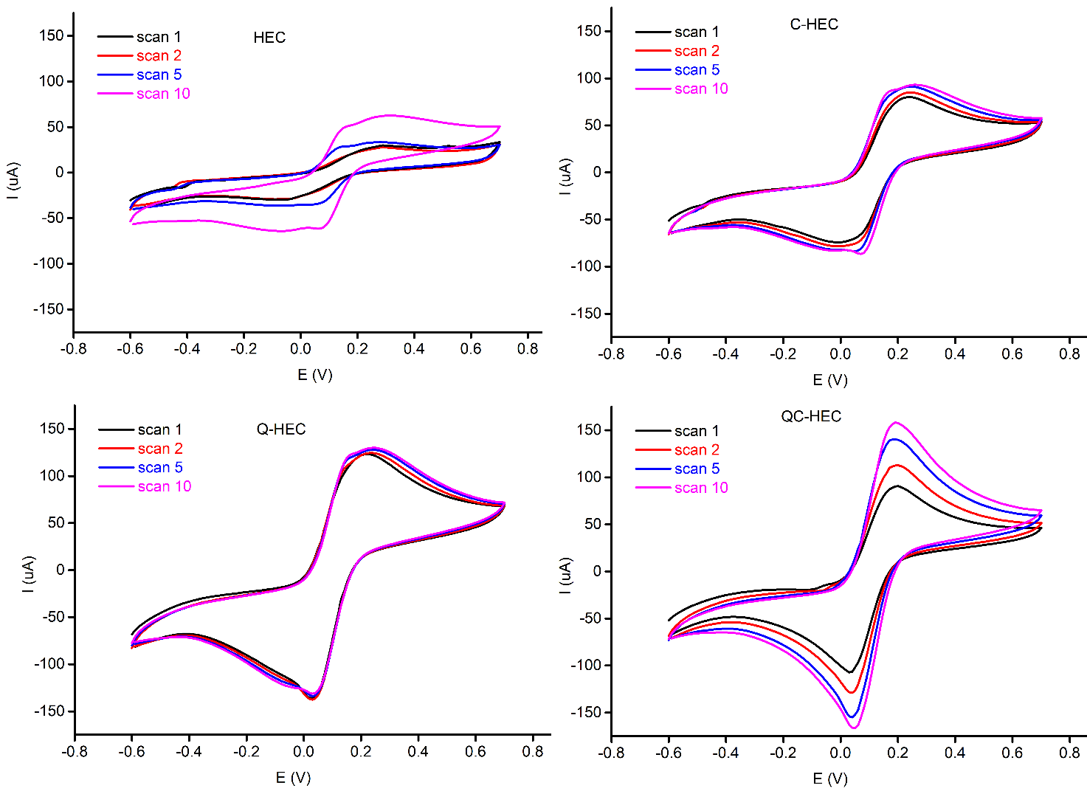
Fig. S25. Cyclic voltammograms of SPE electrodes modified by HEC, CHEC, QCHEC, and QHEC. First (black), second (red), fifth (blue), and tenth (magenta) scans are shown. Acquired with 100 μL of 0.1M KCl with 5 mM of ferricyanide at scan rate of 100 mV s⁻¹.
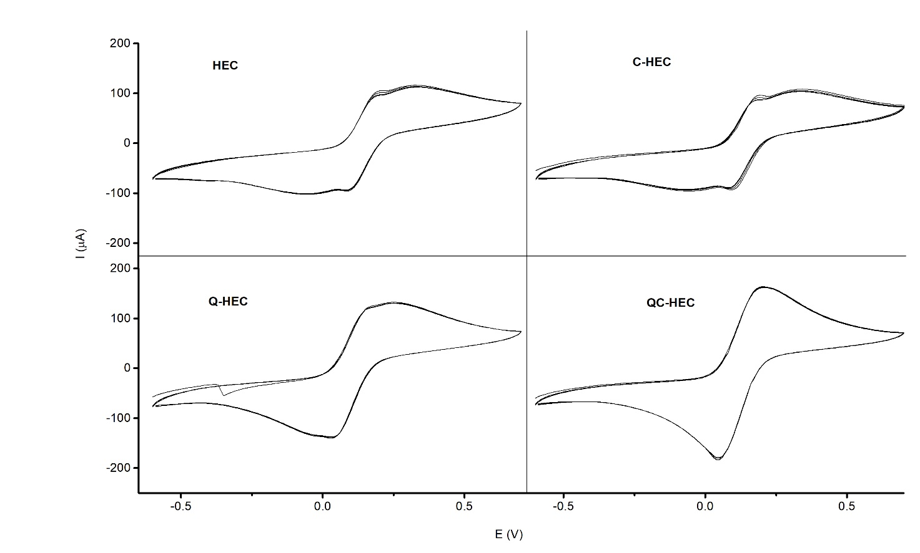
Fig. S26. Cyclic voltammograms of SPE electrodes modified by HEC, CHEC, QCHEC, and QHEC including the stirring of the solution on the electrode surface. First, second, fifth, and tenth scans are shown. Acquired with 100 μL of 0.1M KCl with 5 mM of ferricyanide at scan rate of 100 mV s⁻¹.

References
Uria N, Fiset E., Pellitero MA, Muñoz FX, Rabaey K, del Campo FJ (2020) Immobilisation of electrochemically active bacteria on screen-printed electrodes for rapid in situ toxicity biosensing. Eviron Sci Ecotechnol 3:100053 https://doi.org/10.1016/j.ese.2020.100053
Ortolani TS, Pereira TS, Assumpcao HMT, Vicentini FC, de Oliveira GG, Janegitz BC (2019) Electrochemical sensing of purines guanine and adenine using single-walled carbon nanohorns and nanocellulose. Electrochim Acta 298:893-900. https://doi.org/10.1016/j.electacta.2018.12.114
Fan LH, Peng M, Zhou XY, Wu H, Hu J, Xie WG, Liu SH (2014) Modification of carboxymethyl cellulose grafted with collagen peptide and its antioxidant activity. Carbohydr Polym 112:32–38.
Şen F, Kahraman MV (2018) Preparation and characterization of hybrid cationic hydroxyethyl cellulose/sodium alginate polyelectrolyte antimicrobial films. Polym Adv Technol 29:1895-1901. https://doi.org/10.1002/pat.4298

