Supporting Information

On the negative effect of trace amounts of 1,3-dialkylimidazolium ionic liquids in analytical samples from biorefinery research, and a recommended protocol for their removal

Anna F. Lehrhofer,^{1#} Yuko Yoneda,^{1,2#} Ivan Melikhov,¹ Stefan Böhmdorfer,¹ Antje Potthast,¹ Herwig Schottenberger,³ Thomas Rosenau^{1,4*}

¹ Department of Chemistry, Institute of Chemistry of Renewable Resources, University of Natural Resources and Life Sciences Vienna (BOKU), Konrad-Lorenz-Straße 24, A-3430 Tulln, Austria
² Shizuoka University, College of Agriculture, Academic Institute, Shizuoka University, Ohya 836, Suruga-ku, Shizuoka, 422-8529 Japan
³ Faculty of Chemistry and Pharmacy, University of Innsbruck, 6020 Innsbruck, Austria
⁴ Faculty of Science and Engineering, Laboratory of Natural Materials Technology, Åbo Akademi University, Porthansgatan 3, 20500 Åbo/Turku, Finland

1-Ethyl-3-methyl-1,3-dihydro-2-imidazolinethione (3).
-dried 1-methyl-3-ethylimidazolium chloride (1.01 g, 6.89 mmol, 1.0 equiv.), sulfur (0.234 g, 7.30 mmol, 1.06 equiv.), and K₂CO₃ (1.14 g, 8.26 mmol, 1.2 equiv.) were mixed, flushed with Ar and refluxed in anhydrous MeOH (10 mL) for 3 h. The yellow suspension was cooled to RT, the solvent was removed in vacuo and 10 mL of H₂O deion. were added. The suspension was briefly heated to refluxing temperature to fully dissolve impurities, cooled to RT, acidified with 10 mL 1M HCl and extracted with 3 x 20 mL EtOAc. The combined organic layers were washed with 2 x 20 mL 1M HCl and 20 mL brine, dried over MgSO₄ and concentrated in vacuo. The product was obtained as a yellow oil (0.678 g; 69 %). ¹H NMR (400 MHz, DMSO-d₆): δ 7.15 (d, 1H, J = 2.4), 7.12 (d, 1H, J = 2.4), 3.95 (q, 2H, J = 7.3), 3.45 (s, 3H), 1.21 (t, 3H, J = 7.3) ppm. ¹³C NMR (100 MHz, DMSO-d₆): δ 160.9, 118.3, 116.5, 41.9, 34.3, 14.1 ppm. FTIR ν = 3157, 3131, 3187, 2959, 2931, 2874, 1567, 1458, 1413, 1398, 1357, 1328, 1264, 1222, 1166, 1088, 954, 735, 709, 672 cm⁻¹. HRMS (LC ESI-QToF-MS): m/z = 143.0636 (calcd. 143.0643 for C₆H₁₁N₂S, [M+H]⁺).
 | ¹H (DMSO) | ¹³C (DMSO) | ¹⁵N (DMSO) (extr. from ¹H-¹⁵N HMBC)
1 | - | - | -207.6
2 |  | 160.9
3 | - | - | -221.4
4 | 7.12 (d, 1H, J = 2.4) | 118.3
5 | 7.15 (d, 1H, J = 2.4) | 116.5
6 | 3.45 (s, 3H) | 34.3
7 | 3.95 (q, 2H, J =7.3) | 41.9
8 | 1.21 (t, 3H, J =7.3) | 14.1

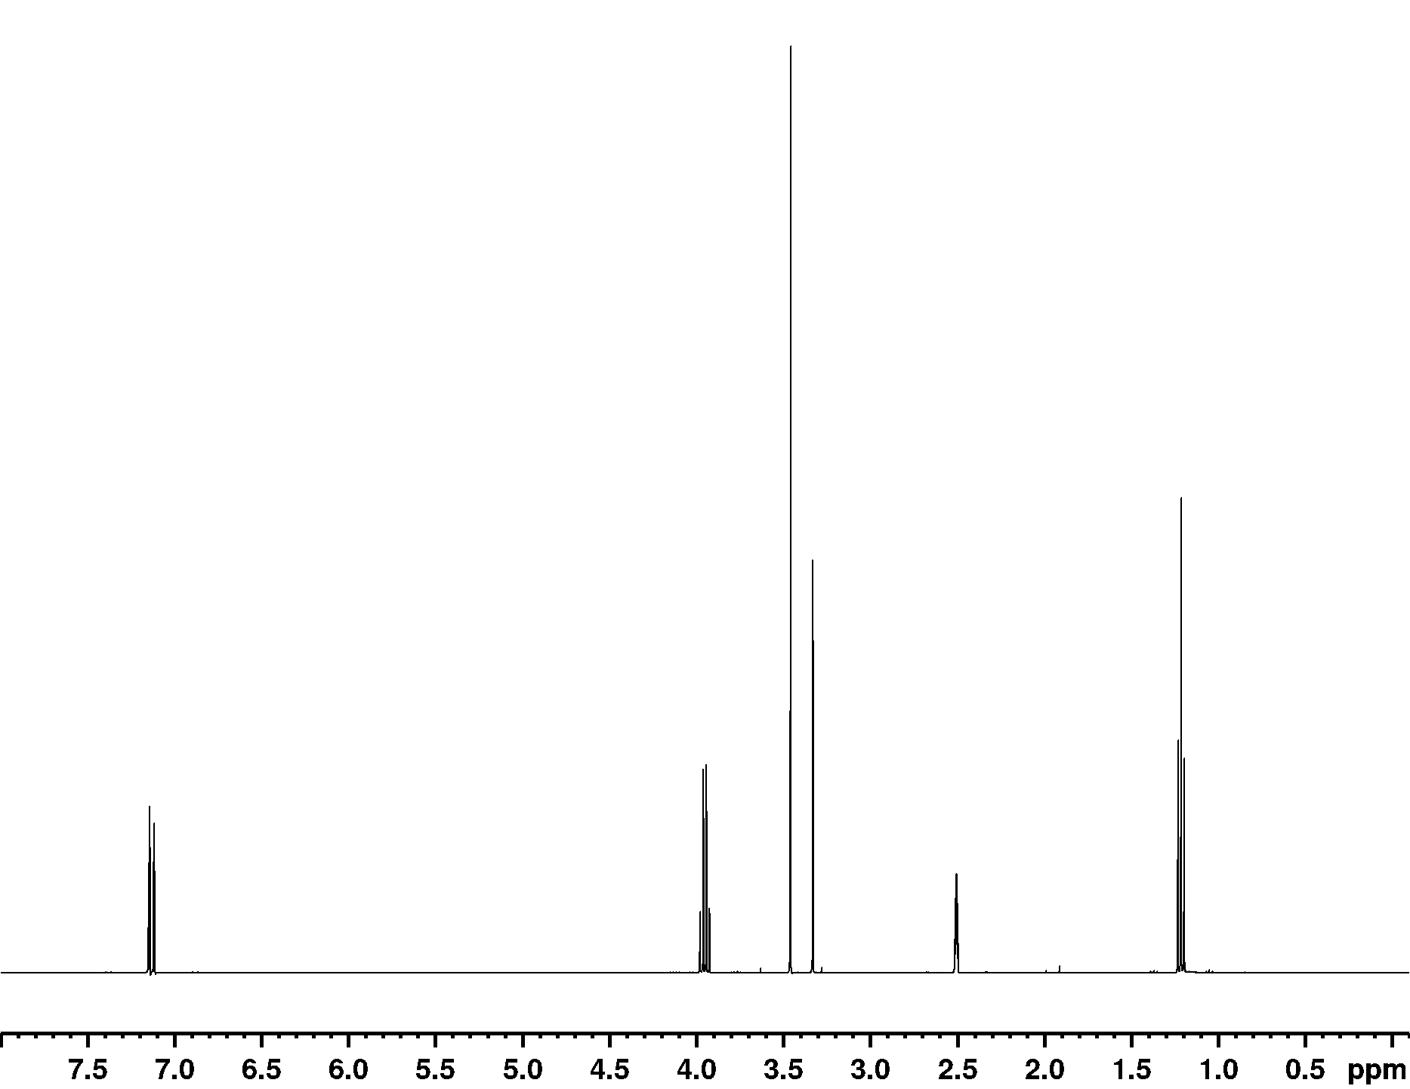
¹H NMR spectrum of 3

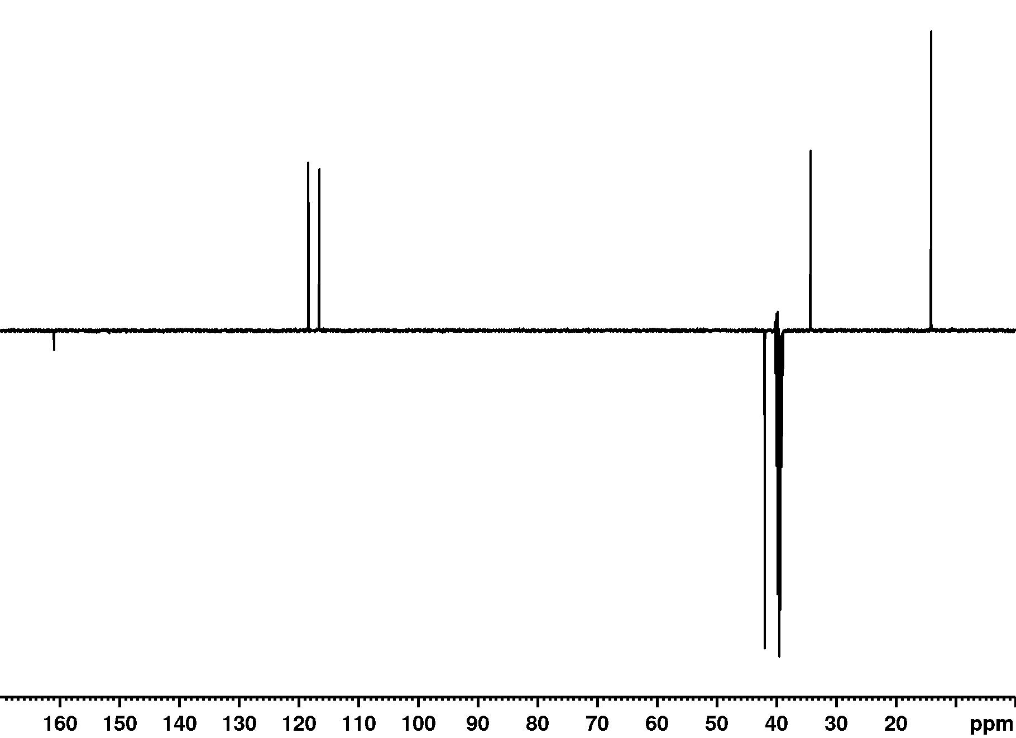
¹³C NMR spectrum of 3
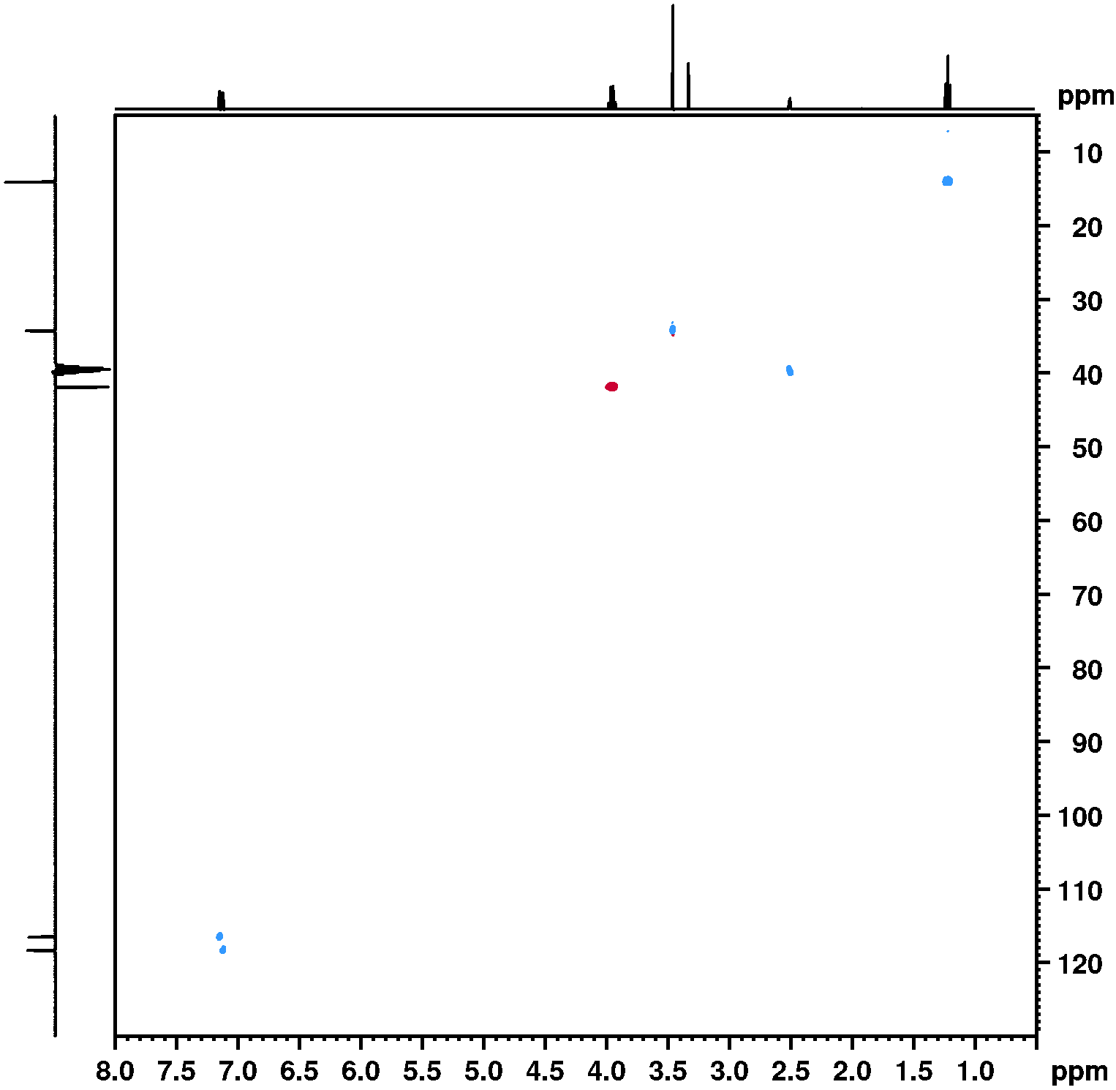
¹H - ¹³C HSQC NMR spectrum of 3

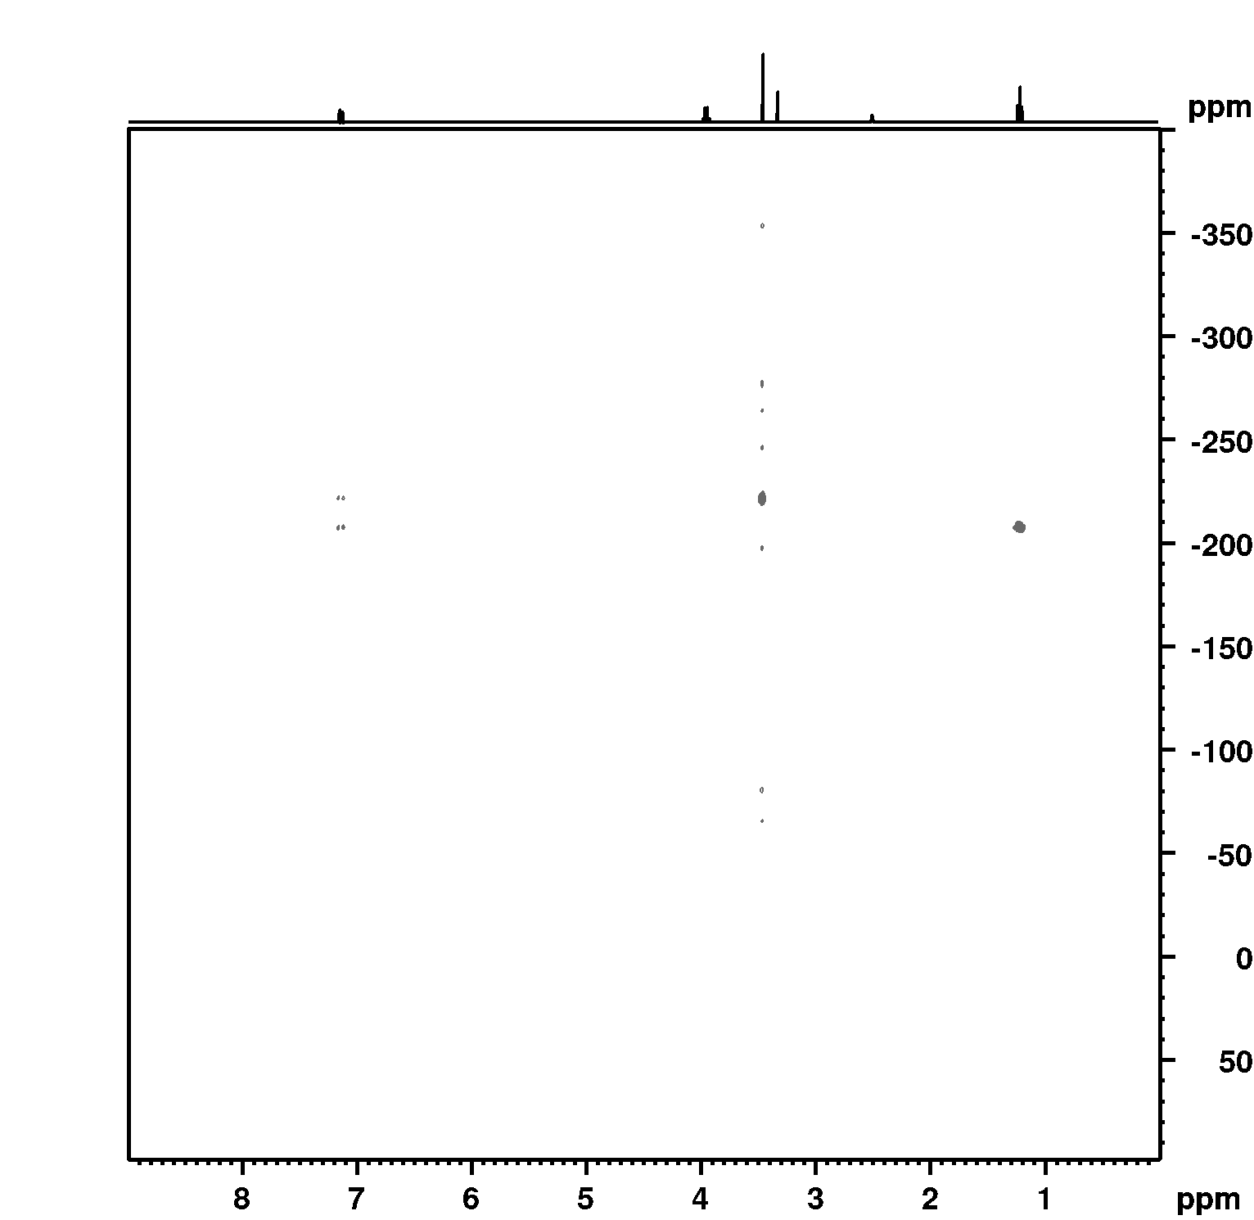
¹H – ¹⁵N HMBC NMR spectrum of 3
1-Butyl-3-methyl-1,3-dihydro-2-imidazolinethione (4).
Vacuum-dried 1-methyl-3-butylimidazolium chloride (1.00 g, 5.72 mmol, 1.0 equiv.), sulfur (0.191 g, 5.95 mmol, 1.04 equiv.), and K₂CO₃ (0.999 g, 6.87 mmol, 1.2 equiv.) were mixed, flushed with Ar and refluxed in anhydrous MeOH (9 mL) for 3 h. The yellow suspension was cooled to RT, the solvent was removed in vacuo and 10 mL of H₂O deion. were added. The biphasic suspension was briefly heated to refluxing temperature to fully dissolve impurities, cooled to RT and extracted with 3 x 20 mL EtOAc. The combined organic layers were washed with 2 x 20 mL 1M HCl and 20 mL brine, dried over MgSO₄ and concentrated in vacuo. The product was obtained as a yellow oil (0.799 g; 82 %). ¹H NMR (400 MHz, DMSO-d₆): δ 7.13 (d, 1H, J = 2.4), 7.11 (d, 1H, J = 2.4), 3.92 (q, 2H, J = 7.4), 3.45 (s, 3H), 1.64 (m, 2H), 1.26 (m, 2H), 0.89 (t, 3H, J = 7.3) ppm. ¹³C NMR (100 MHz, DMSO-d₆): δ 161.3, 118.2, 117.1, 46.6, 34.4, 30.4, 19.2, 13.6 ppm. ATR FTIR: ν = 3157, 3131, 3187, 2959, 2931, 2874, 1567, 1458, 1413, 1398, 1357, 1328, 1264, 1222, 1166, 1088, 954, 794, 735, 709, 672 cm−1. HRMS (LC ESI-QToF-MS): m/z = 171.0941 (calcd. 171.0956 for C₈H₁₅N₂S, [M+H]⁺).
Microanalysis for C₈H₁₄N₂S: calcd. C 56.43, H 8.29, N 16.45, S 18.83; found C 56.51, H 8.14, N 16.54, S 18.85.
 | ¹H (DMSO) | ¹³C (DMSO) | ¹⁵N (DMSO) (extr. from ¹H-¹⁵N HMBC)
1 | - | - | -209.87
2 |  | 161.3
3 | - | - | -221.21
4 | 7.11 (d, 1H, J = 2.4) | 118.2
5 | 7.13 (d, 1H, J = 2.4) | 117.1
6 | 3.45 (s, 3H) | 34.4
7 | 3.92 (q, 2H, J = 7.4) | 46.6
8 | 1.64 (m, 2H) | 30.4
9 | 1.26 (m, 2H) | 19.2
10 | 0.89 (t, 3H, J = 7.3) | 13.6

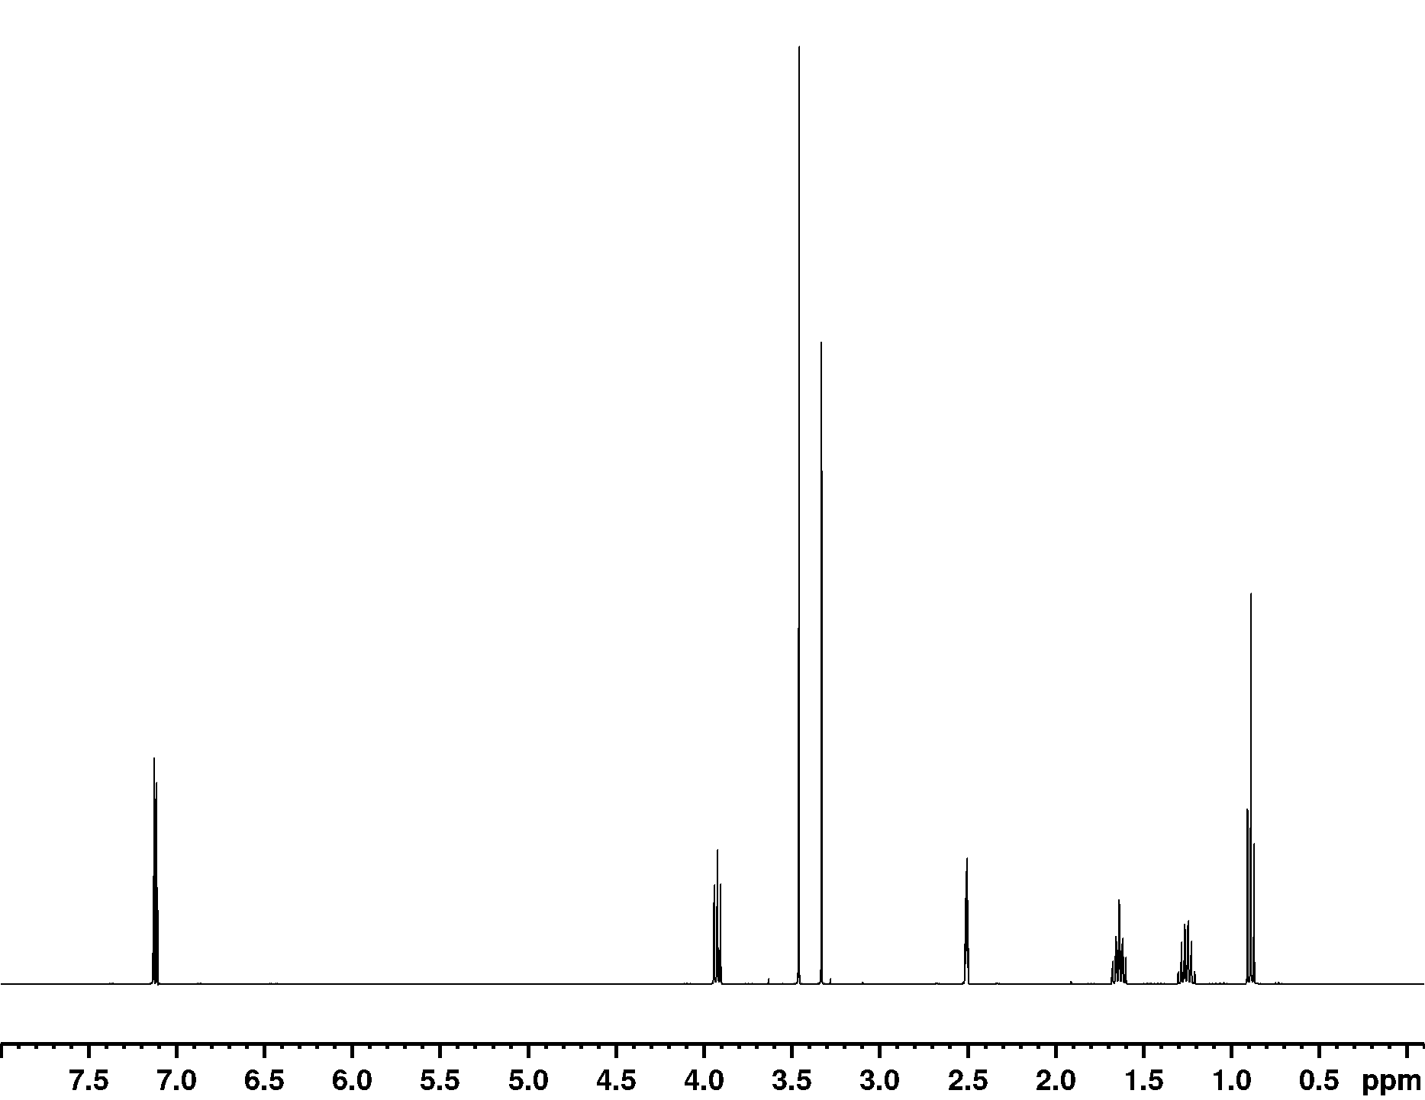
¹H NMR spectrum of 4

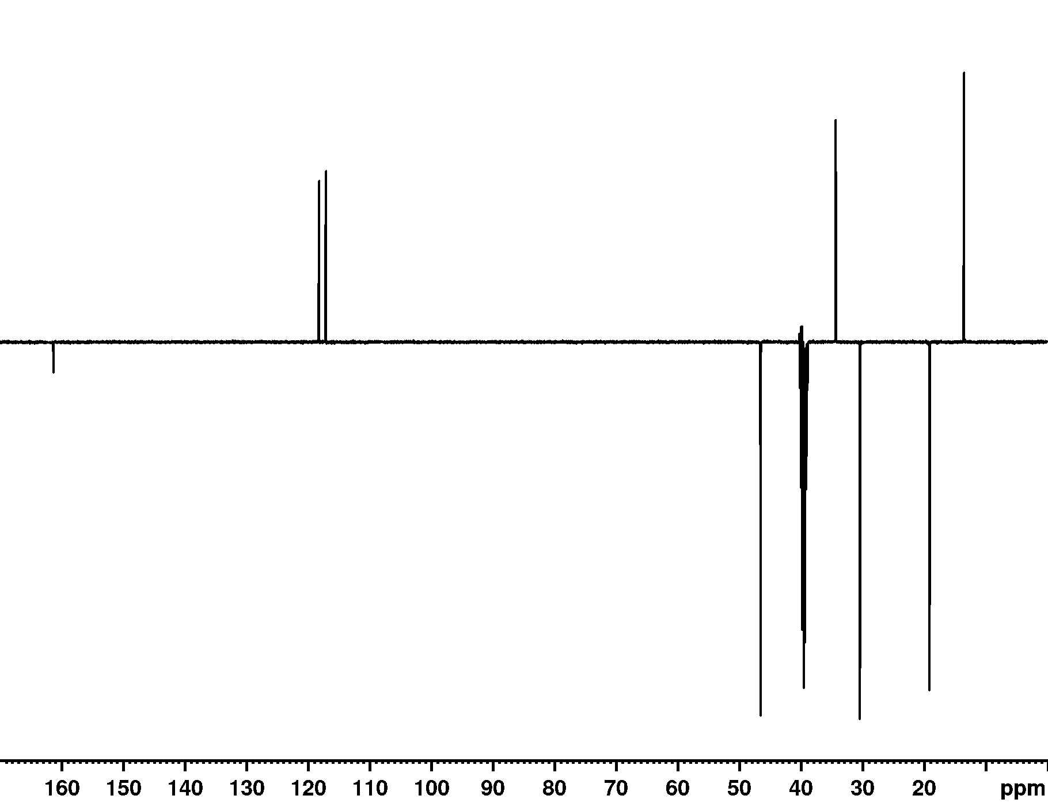
¹³C NMR spectrum of 4
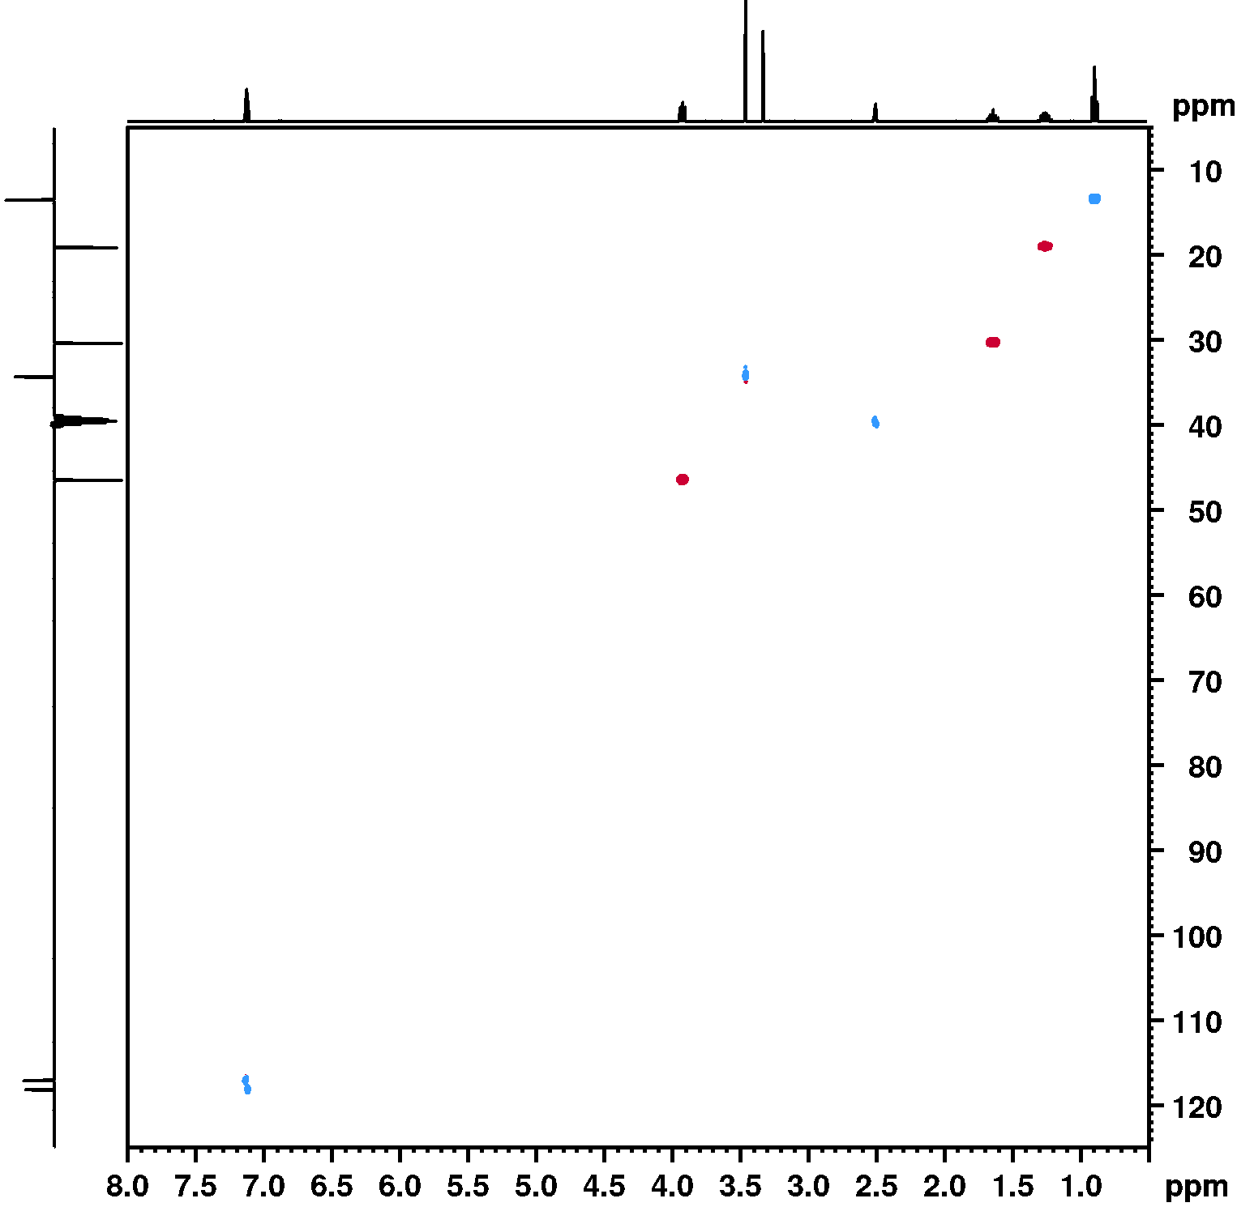
¹H - ¹³C HSQC NMR spectrum of 4

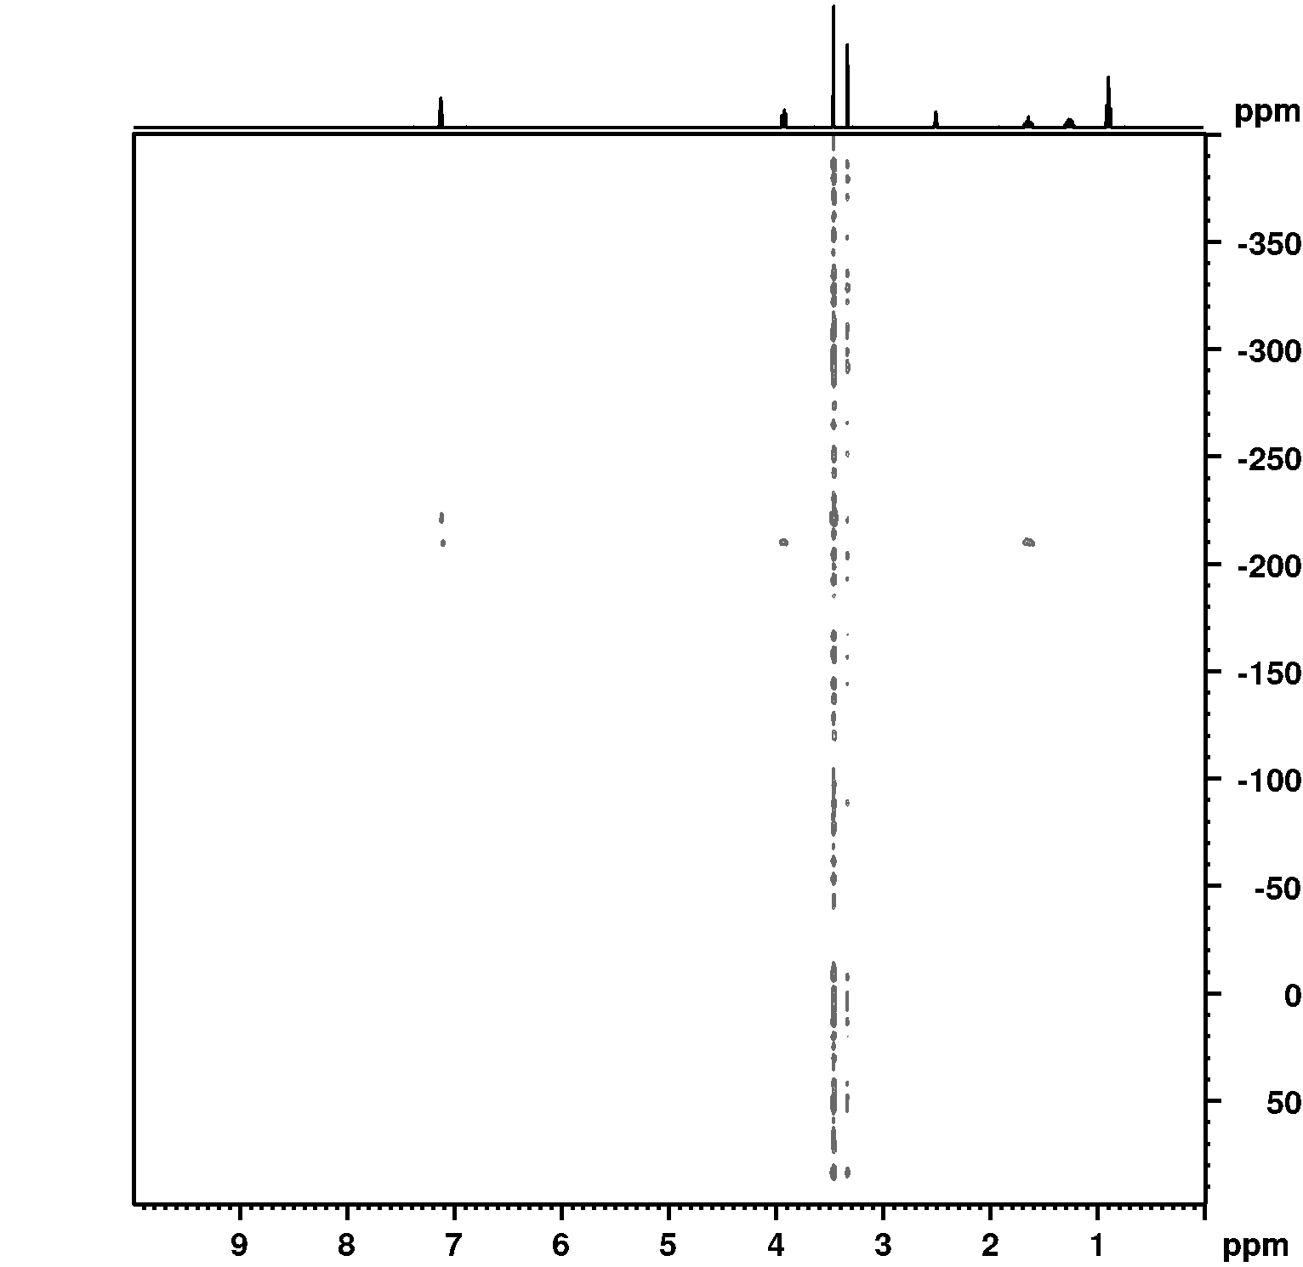
¹H – ¹⁵N HMBC NMR spectrum of 4
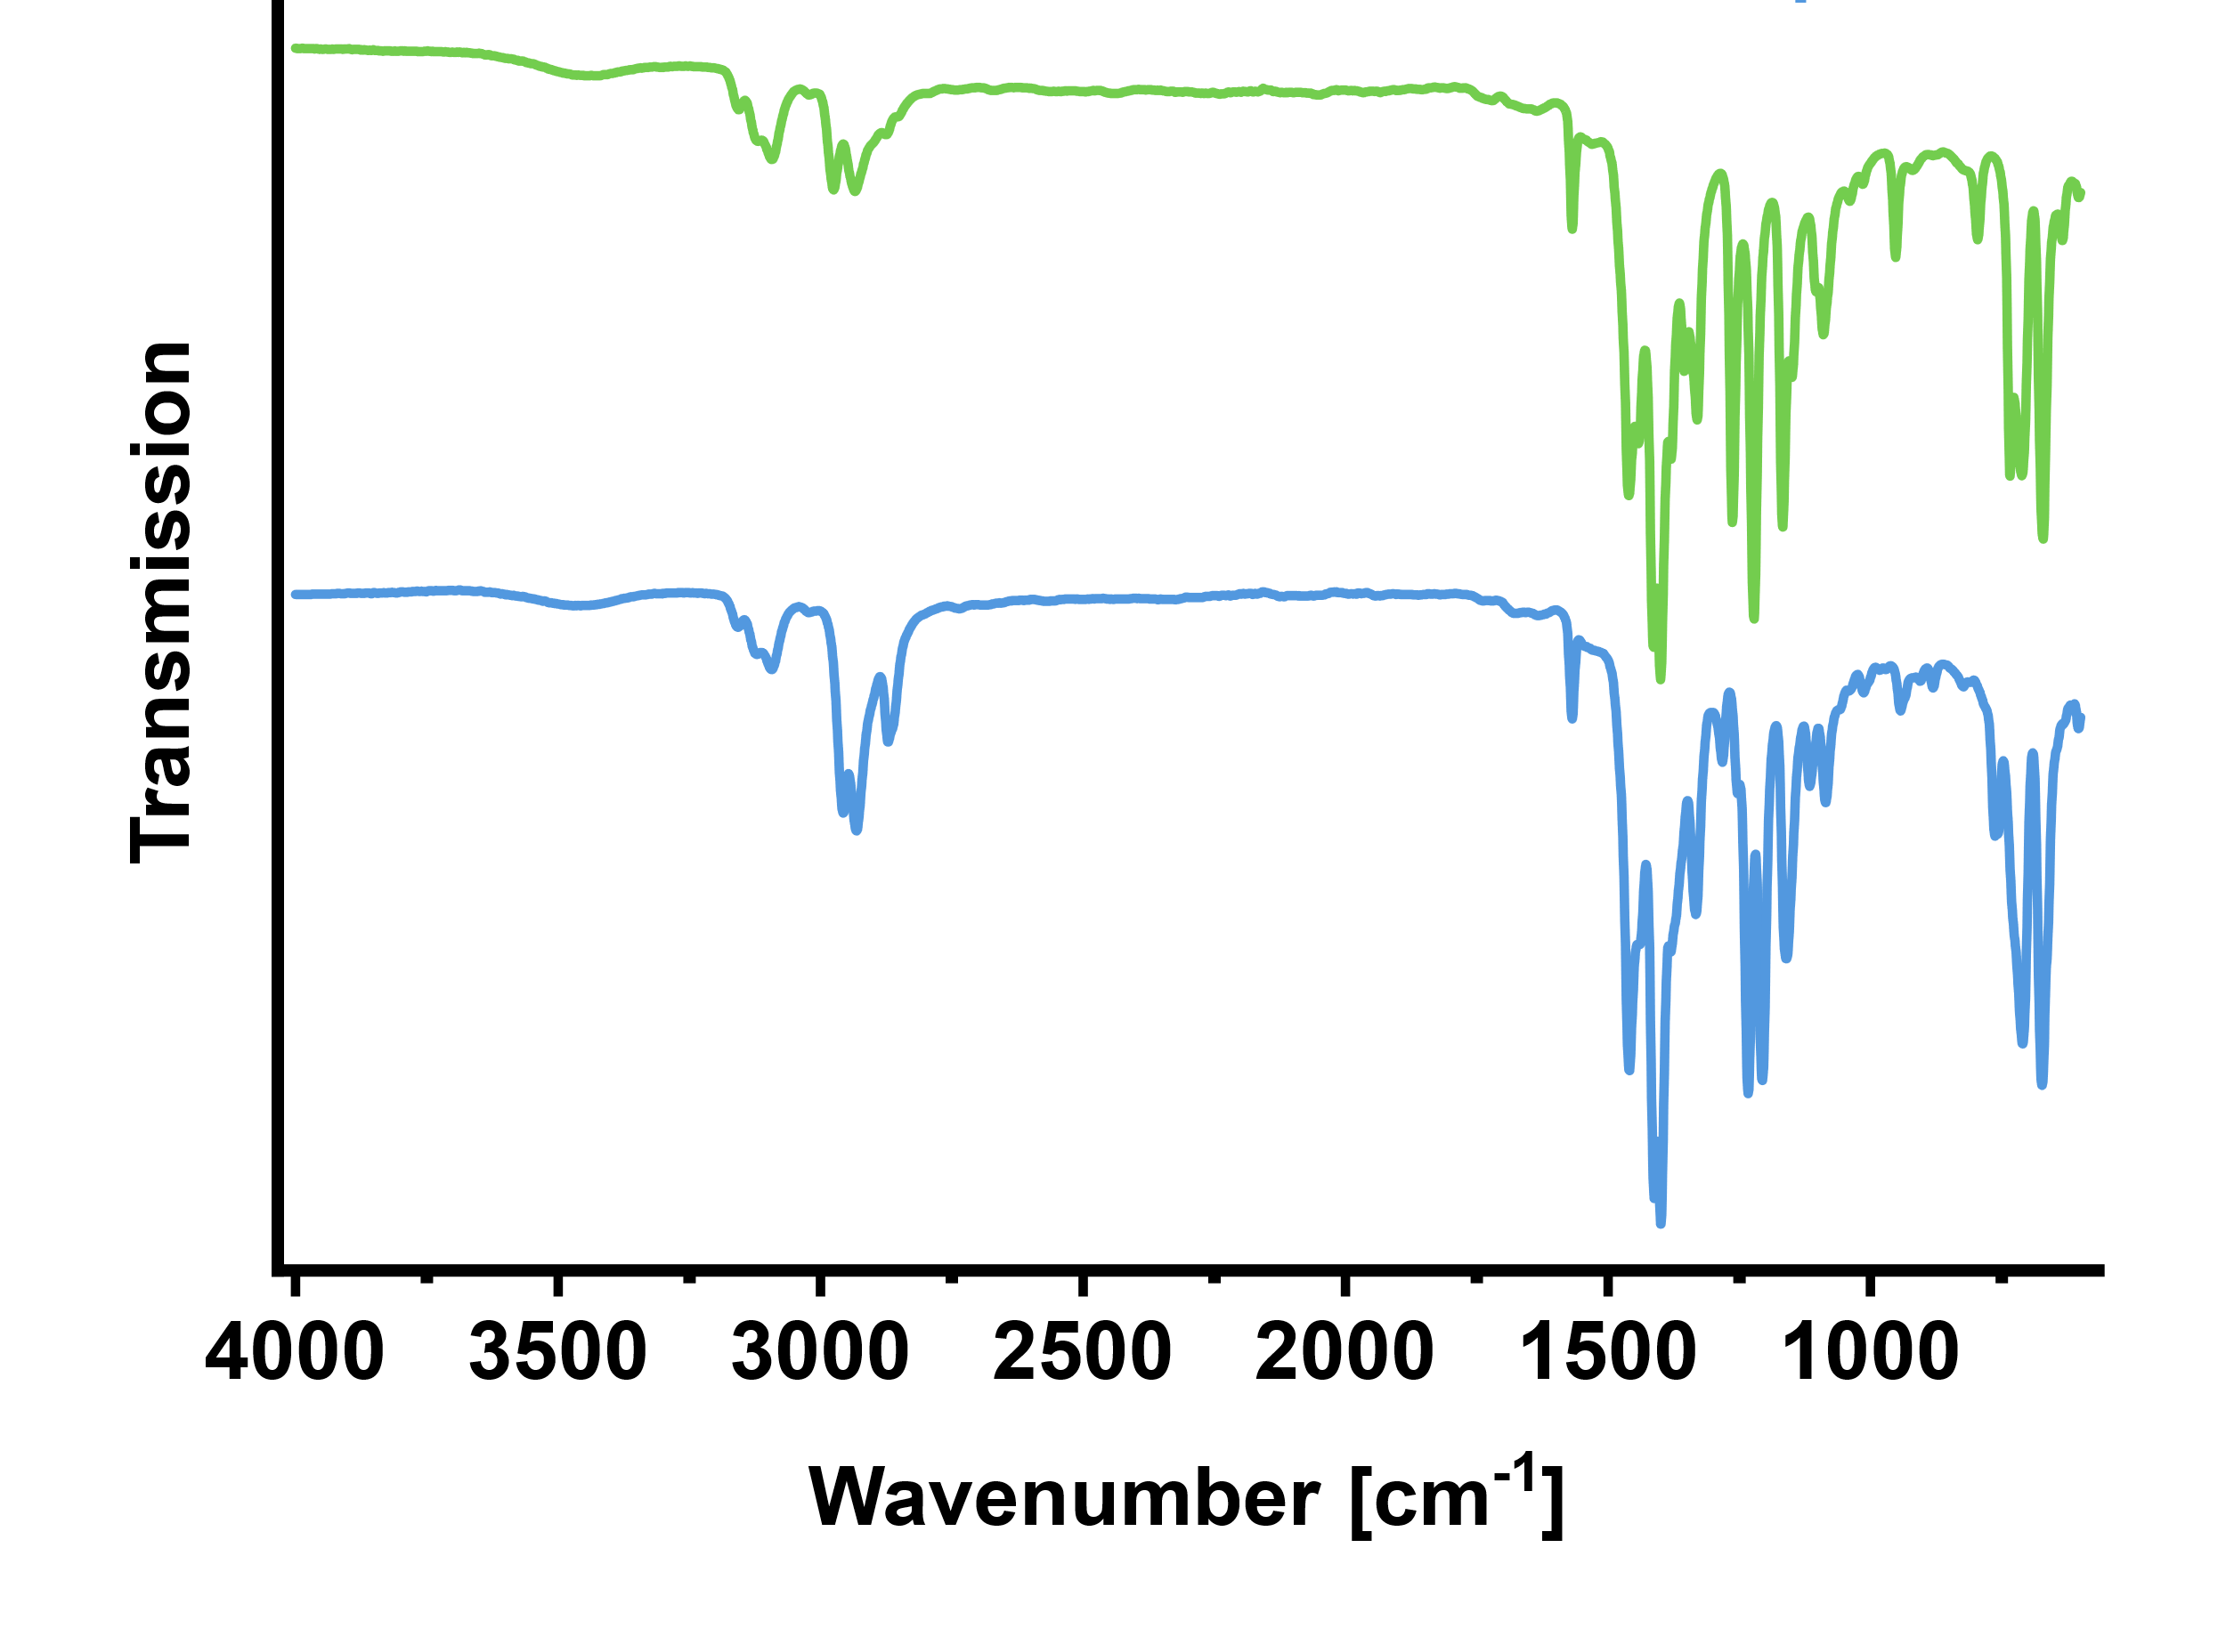

ATR-FTIR spectra of compounds 3 and 4
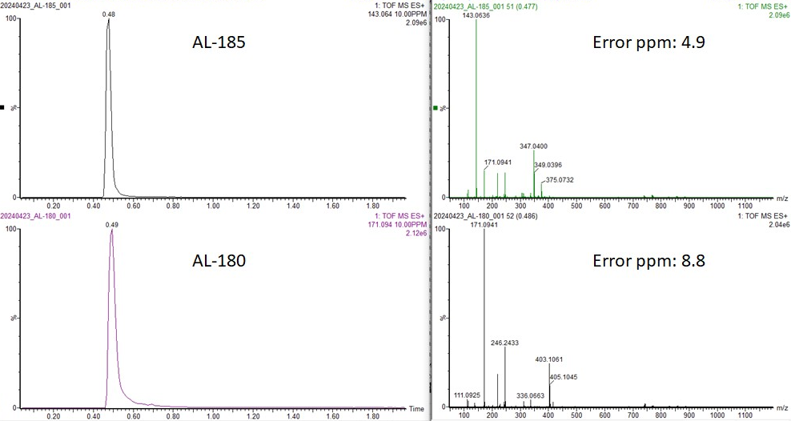
UHPLC chromatograms (left) and ESI-QToF-HRMS spectra (right) of compounds 3 (top) and 4 (bottom)

