Green Synthesis and Optimization of Selenium Nanoparticles using Response Surface Methodology
Samanta Samª, Nuria Fiolª, Roberto J. Aguadoª, Elena Saguerª, Félix Carrascoª, Marc Delgado-Aguilarª and Quim Tarrés^{a,*}
ª LEPAMAP-PRODIS Research Group, University of Girona, C/ Maria Aurèlia Capmany, 61, 17003 Girona, Spain
*corresponding author: joaquimagusti.tarres@udg.edu
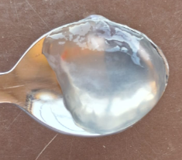

Figure 1. An image of cationic cellulose nanofiber (CCNF)

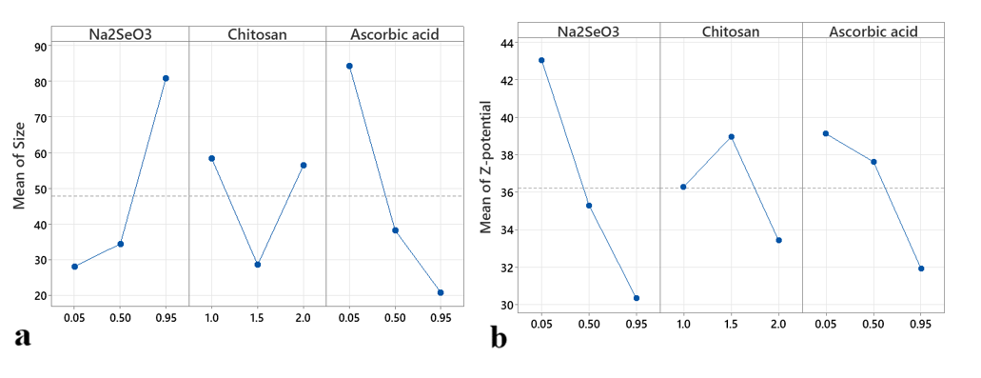
Figure 2. a) Main effect plot for size, b) zeta potential of CS-Se NPs

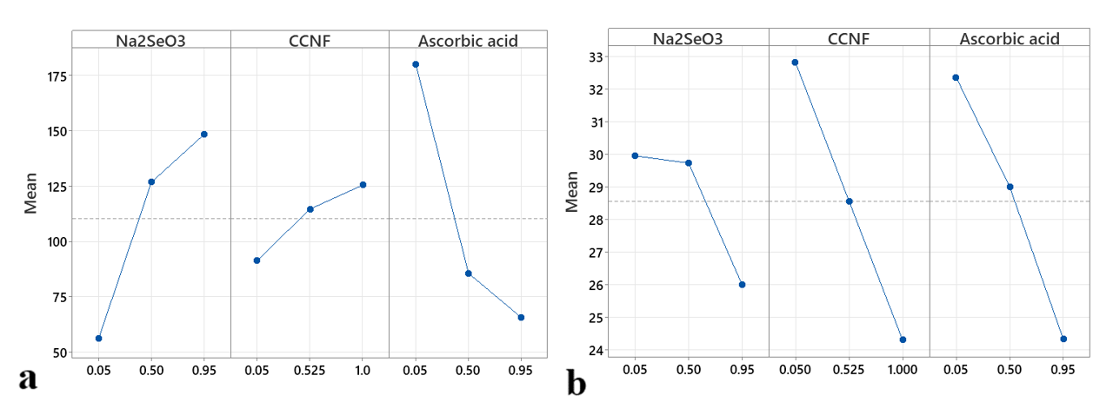
Figure 3. a) Main effect plot for a) size, b) zeta potential of CCNF-Se NPs

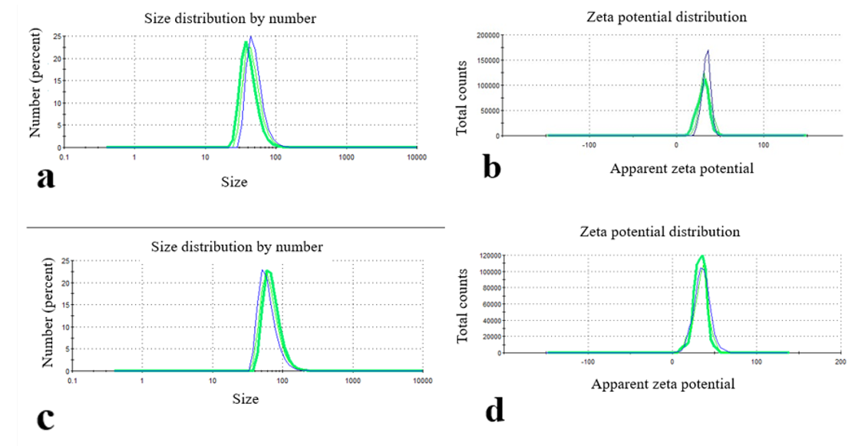

Figure 4. a) size of CS-Se NPs, b) zeta potential of CS-Se NPs, c) size of CCNF-Se NPs, d) zeta potential of CCNF-Se NPs.

