Supplementary Information
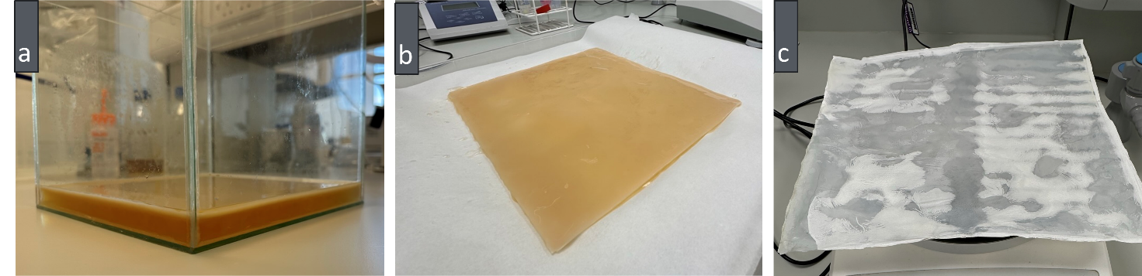
Fig S1. BC production in 10 L glass vessel through traditional static fermentation. (a) BC formation feeding after 21 days of culturing; (b) Harvested BC pellicles; (c) Dried BC pellicle

Table 1. Culturing time and harvested BC physical characteristics obtained from MDV2, 3, and 4.
 | Culturing time (days) | Wet thickness (mm) | Wet weight (g) | Dry thickness (mm) | Dry weight/Yield (g) | Dry density (kg/m3)
MDV2 | 96 | 80 | 4929.12 | 0.14 | 70.16 | 91.55
MDV3 | 66 | 60 | 2319.32 | 0.05 | 42.73 | 156.12
MDV4 | 48 | 40 | 2599.00 | 0.04 | 30.26 | 138.2
Control | 21 | 5 | 322.81 | 0.0005 | 3.37 | 1231.28

