Supplementary material and data for Enhanced production of bacterial cellulose with a mesh dispenser vessel-based bioreactor

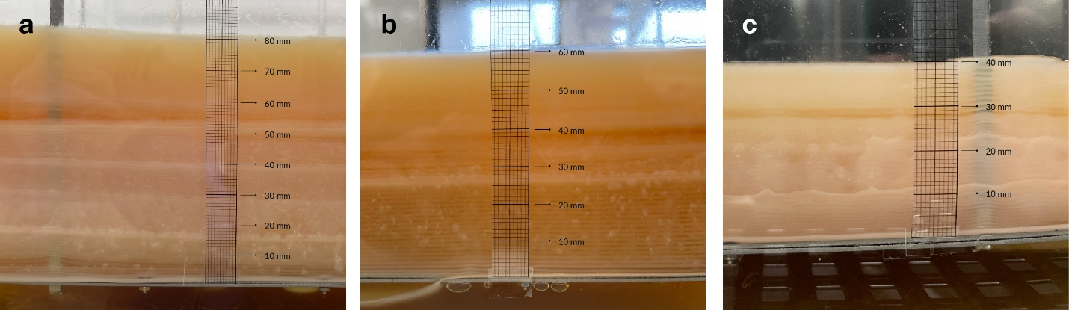
Figure. S1 showing total thickness increase for each of the MDV methods in the bioreactor. Each line of the scale bar represents 1mm. (a) MDV2 shown with a growth amounting to 80 mm in thickness, (b) MDV3 with 60 mm thickness and, (c) MDV4 with 40 mm of BC growth thickness.

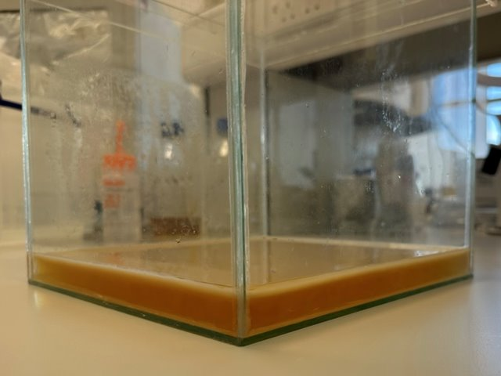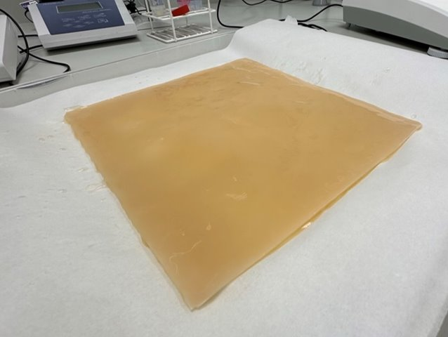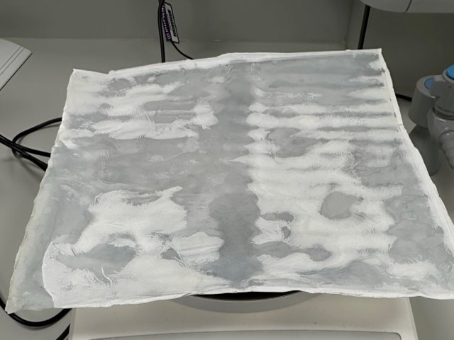
C
B
A

Figure S2. BC production in 10 L glass vessel through traditional static fermentation. (a) BC formation feeding after 21 days of culturing; (b) Harvested BC pellicles; (c) Dried BC pellicle​

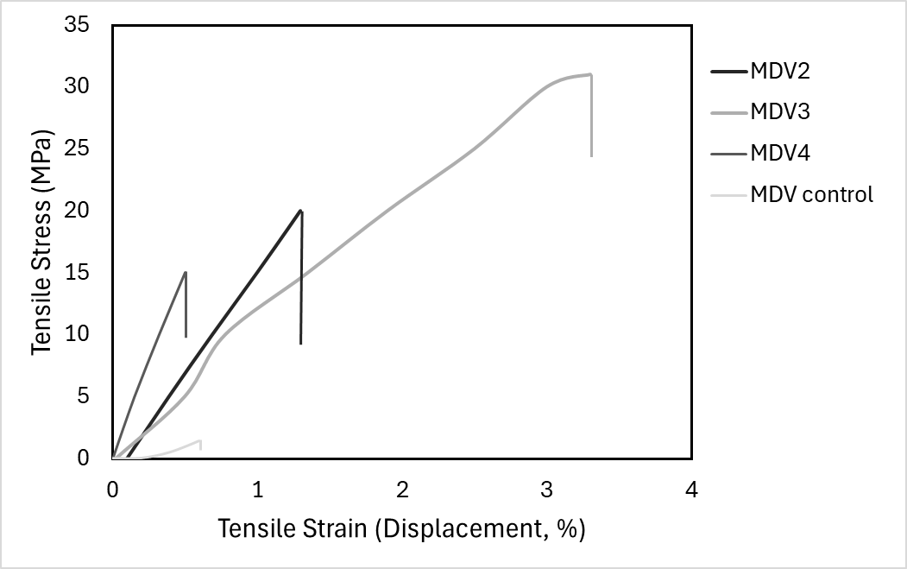
Figure S3. Typical Stress-Strain curves of pellicles from 10 L MDV bioreactor with intermittent feeding during tensile strength testing.

