Electronic Supplementary Material

Water repellency of cotton knitted fabrics treated with alkyl ketene dimers

Satoru Onodera • Chiaki Tanaka • Akira Isogai

S. Onodera ⋅ A. Isogai ()
Department of Biomaterials Science, Graduate School of Agricultural and Life Sciences, The University of Tokyo, Tokyo 113-8657, Japan
e-mail: akira-isogai@g.ecc.u-tokyo.ac.jp

S. Onodera ⋅ C. Tanaka
R&D Division, Gunze Limited, 1 Ishiburo, Inokurashin-machi, Ayabe, Kyoto 623-8512, Japan

Laundry treatment conditions

The AKD-treated CF samples were subjected to laundry treatment up to 30 cycles according to Japanese Industrial Standard entitled “Textiles-Domestic washing and drying procedures for textile testing” (JIS L 1930 F C4M, 2020). The details of the laundry conditions were as follows: the water temperature at 40 °C, and one laundry treatment time of 20 min including the following sequences, washing for 6 min, dehydration for 3 min, rinsing for 2 min, dehydration for 3 min, rinsing for 2 min, dehydration for 3 min, and drying at 40 °C for 30min. A commercial detergent (Attack®, Kao, Tokyo, Japan) was used in laundry treatment at a concentration of 0.67 g/L..

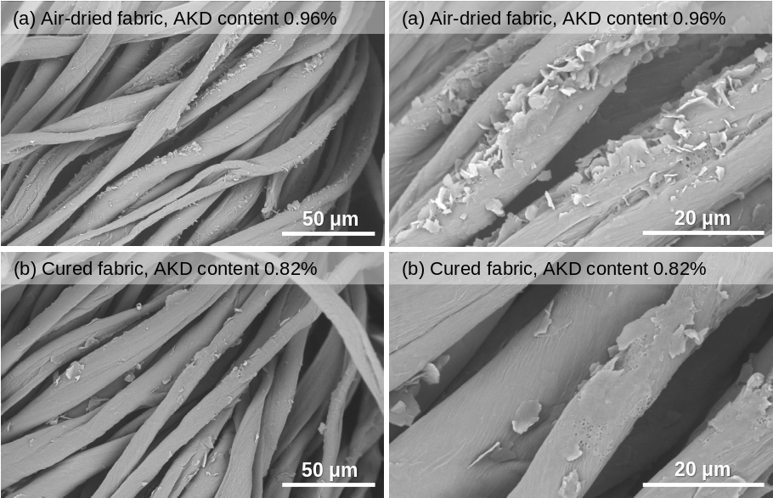
Fig. S1 SEM images of fiber surfaces of (a) AKD-treated and air-dried, and (b) AKD-treated and cured cotton fabrics, prepared by soaking in a weakly cationic 10 g/L AKD dispersion. The contents of the AKD-related compounds in the fabrics were determined by FTIR, and are expressed as wt% on the dry mass of fabric (odmf)
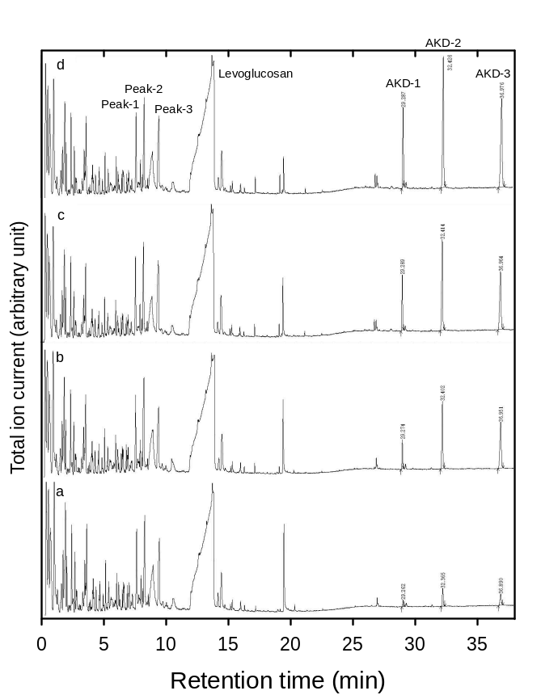
Fig. S2 Pyrolysis–gas chromatograms of the AKD-treated and cured cotton fabrics, prepared by soaking the cotton fabrics in weakly cationic (a) 1.0, (b) 5.0, (c) 10.0, and (d) 15.0 g/L AKD dispersions
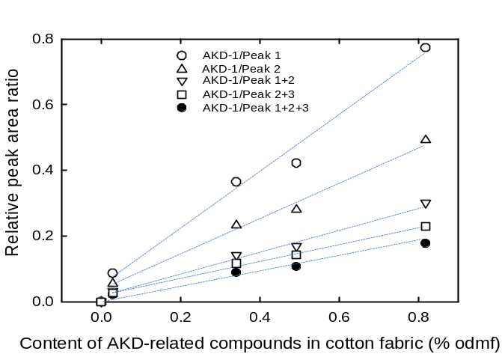
Fig. S3 Relationships between the content of AKD-related compounds in the AKD-treated and cured cotton fabrics, and the relative peak ratio obtained from the pyrolysis–gas chromatograms. The contents of the AKD-related compounds are expressed as wt% on the dry mass of fabric (% odmf). A weakly cationic AKD dispersion was used to soak the fabric
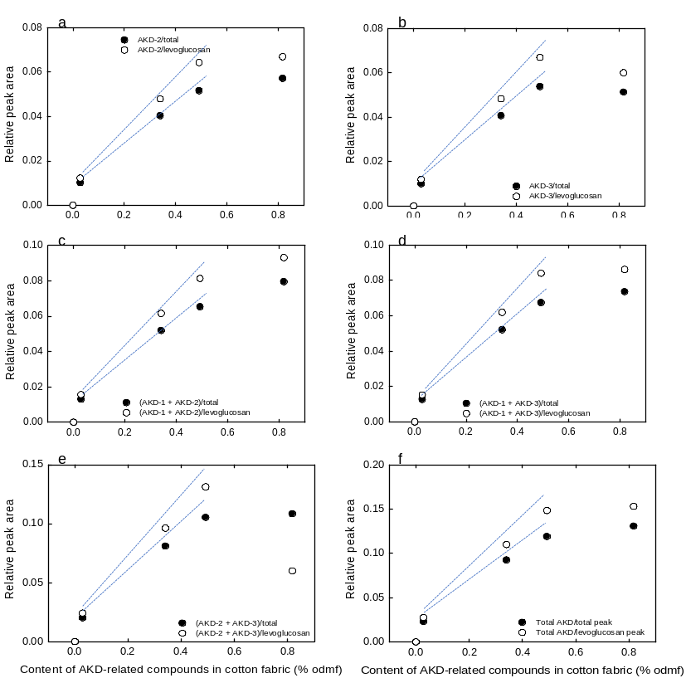
Fig. S4 Relationships between the content of AKD-related compounds in the AKD-treated and cured cotton fabrics, and the relative AKD/total and AKD/levoglucosan peak ratios obtained from the pyrolysis–gas chromatograms. Weakly cationic AKD dispersions were used for fabric soaking. The contents of the AKD-related compounds are expressed as wt% on the dry mass of fabric (% odmf)
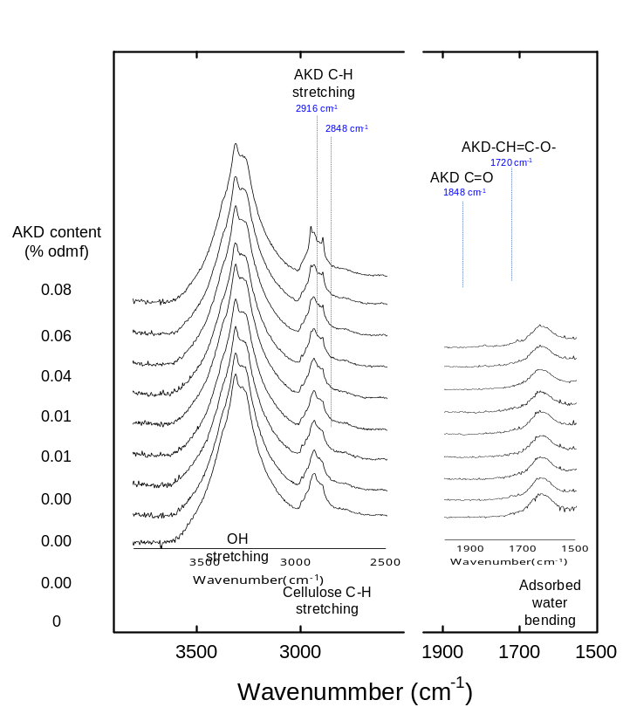
Fig. S5 FTIR spectra of the AKD-treated and cured cotton fabrics after one cycle of laundry treatment (see Fig. 1, Fig. 3, and Fig. 4 in the main text). Weakly cationic AKD dispersions were used for fabric soaking
Fig. S6 Photographs of water droplets on the AKD-treated and cured cotton fabrics with different water-absorption times, and the contents of the AKD-related compounds. Weakly cationic AKD dispersions were used for fabric soaking at different pHs of 4.5 and 10 for the upper and lower samples, respectively

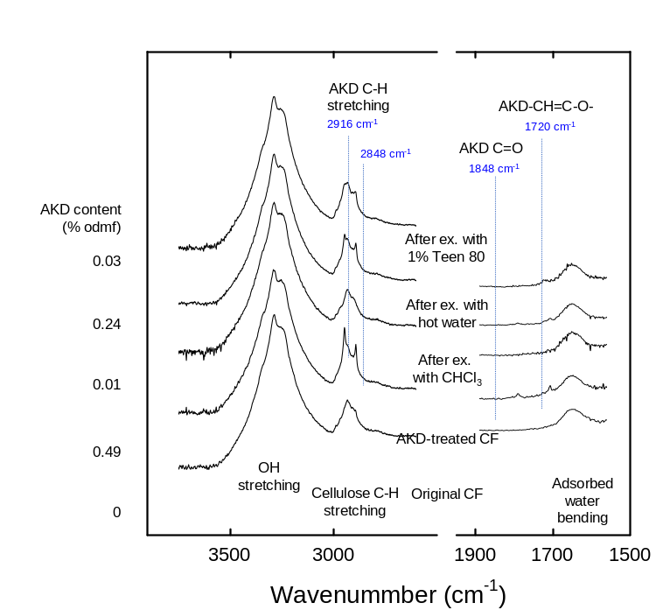
Fig. S7 FTIR spectra of the original CF, and the AKD-treated and cured CF before and after extractions with CHCl₃, hot water, and 1% Tween 80
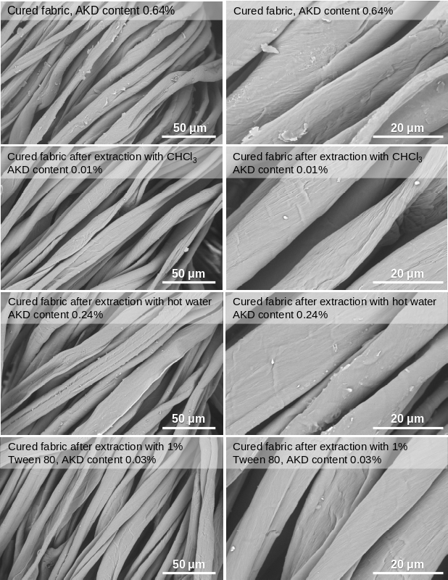

Fig. S8 SEM images of the original AKD-treated and cured cotton fabrics, and the fabrics after extraction with CHCl₃, hot water, or 1% Tween 80. A weakly cationic AKD dispersion was used for fabric soaking. The contents of the AKD-related compounds are expressed as wt% on the dry mass of fabric (% odmf)
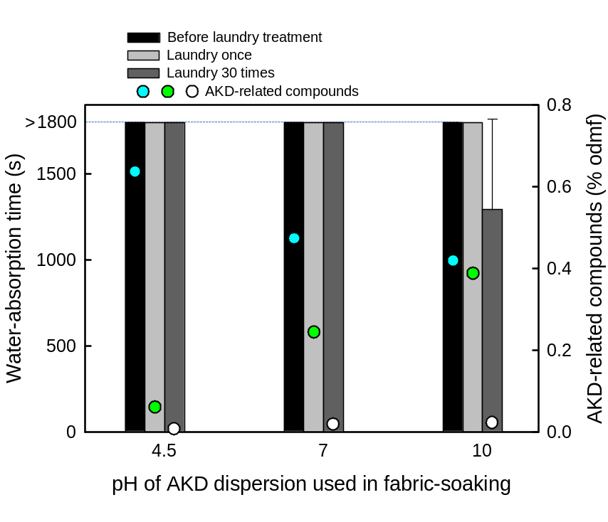
Fig. S9 Water-absorption times and contents of AKD-related compounds of the AKD-treated and cured cotton fabrics, prepared by soaking in weakly cationic AKD dispersions at various pH values controlled by adding 0.1 M NaOH. The AKD concentration of the dispersion used for soaking was 6.7 g/L
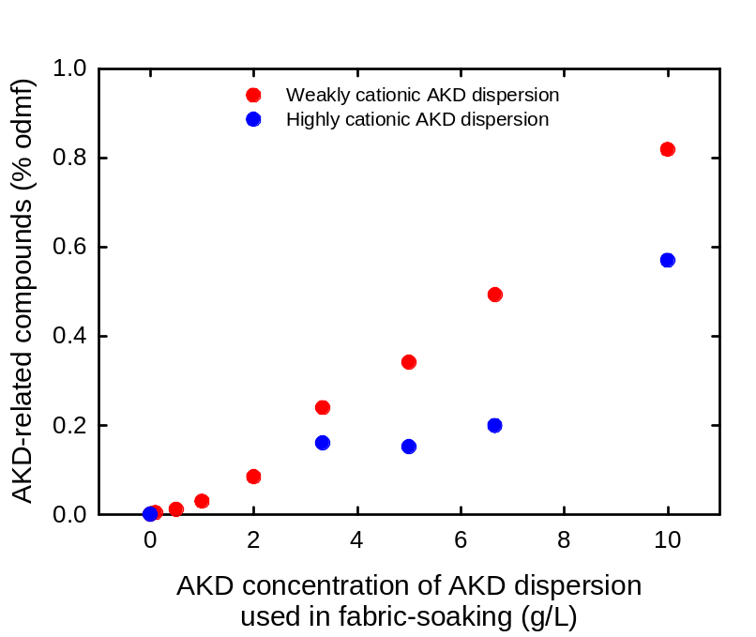
Fig. S10 Relationships between the AKD concentration of the weakly and highly cationic AKD dispersions used for fabric soaking, and the content of AKD-related compounds in the AKD-treated and cured cotton fabrics, calculated from their FTIR spectra. The contents of AKD-related compounds are expressed as wt% on the dry mass of fabric (% odmf)

