Supporting information
for

Blue beyond time: preservation properties of natural and synthetic indigo in cellulose aging.
Ivan Melikhov¹, Irina Sulaeva², Hubert Hettegger^{1,3}, Thomas Rosenau¹, Antje Potthast¹
¹ BOKU University, Department of Chemistry, Institute of Chemistry of Renewable Resources, Konrad-Lorenz-Strasse 24, A-3430 Tulln, Austria
² BOKU University, Core Facility „Analysis of Lignocellulosics” ALICE, Konrad-Lorenz-Strasse 24, A-3430 Tulln, Austria
³ BOKU University, Christian-Doppler-Laboratory for Cellulose High-Tech Materials, Konrad-Lorenz-Strasse 24, A-3430 Tulln, Austria

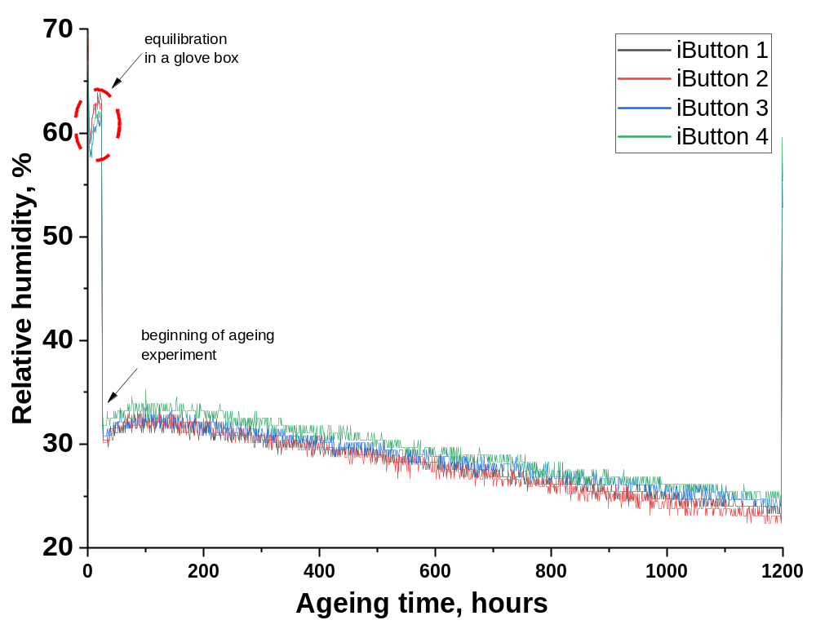
Fig. S1 Relative humidity (%) measured by iButton data loggers in four sealed Schott bottles during the oven aging experiment, confirming uniform conditions in all samples
Error assessment for pure keto group calculations
The propagation error ($σ_{f}$) for function $f\left(x,y,…\right)$was calculated using the formula (Clifford 1973):
$$σ_{f}= \sqrt{{\left(\frac{∂f}{∂x}\right)}^{2}σ_{x}^{2}+{\left(\frac{∂f}{∂y}\right)}^{2}σ_{y}^{2}+…}$$
Pure keto group values were evaluated as differences between total carbonyl groups (measured with CCOA labelling protocol) and reducing end groups (REGs), estimated as 1/M_{n} (where M_{n} is number average molar mass). Considering that relative error for REGs is equal to relative error of M_{n} (which is 6.86%) (Sulaeva et al. 2024) the error for the keto group was calculated as follows:
$$σ_{f}= \sqrt{σ_{x}^{2}+σ_{y}^{2}}$$
where $f\left(x,y\right)=x-y$ represents the pure keto groups, $x$ – total carbonyl groups (CCOA results), and $y$ – REGs. The error of measurements of carbonyl groups was 2.88% (Röhrling et al. 2002).
Table S1 Results of GPC analysis for Whatman filter paper samples treated with synthetic and natural indigo aged by the closed vials method (hydrolysis mode) for 7 weeks at 80°C, along with calculated statistical uncertainties. The number of Pure Keto groups was calculated as the difference between the Total C=O and the number of REGs
 | Aging time,  weeks | M_{n},  kg/mol | M_{w},  kg/mol | M_{z},  kg/mol | Total C=O,  µmol/g | REGs,  µmol/g | Pure Keto,  µmol/g
Natural  indigo | 0 | 168 ± 12 | 358 ± 13 | 586 ± 23 | 0.76 ± 0.02 | 5.95 ± 0.41 | -5.19 ± 0.41
Natural  indigo | 1 | 161 ± 11 | 343 ± 12 | 565 ± 22 | 0.50 ± 0.01 | 6.21 ± 0.43 | -5.71 ± 0.43
Natural  indigo | 2 | 162 ± 11 | 306 ± 11 | 485 ± 19 | 0.81 ± 0.02 | 6.17 ± 0.42 | -5.36 ± 0.42
Natural  indigo | 3 | 140 ± 10 | 302 ± 11 | 510 ± 20 | 1.37 ± 0.04 | 7.14 ± 0.49 | -5.77 ± 0.49
Natural  indigo | 4 | 140 ± 10 | 295 ± 10 | 494 ± 19 | 0.93 ± 0.03 | 7.17 ± 0.49 | -6.24 ± 0.49
Natural  indigo | 7 | 131 ± 9 | 250 ± 9 | 403 ± 16 | 1.64 ± 0.05 | 7.66 ± 0.53 | -6.02 ± 0.53
Blank | 0 | 180 ± 12 | 364 ± 13 | 595 ± 23 | 0.18 ± 0.01 | 5.56 ± 0.38 | -5.38 ± 0.38
Blank | 1 | 165 ± 11 | 327 ± 11 | 563 ± 22 | 1.59 ± 0.05 | 6.06 ± 0.42 | -4.47 ± 0.42
Blank | 2 | 137 ± 9 | 278 ± 10 | 468 ± 18 | 2.42 ± 0.07 | 7.30 ± 0.50 | -4.88 ± 0.51
Blank | 3 | 134 ± 9 | 263 ± 9 | 429 ± 17 | 2.84 ± 0.08 | 7.46 ± 0.51 | -4.62 ± 0.52
Blank | 4 | 116 ± 8 | 266 ± 9 | 459 ± 18 | 2.74 ± 0.08 | 8.66 ± 0.59 | -5.92 ± 0.60
Blank | 7 | 106 ± 7 | 226 ± 8 | 369 ± 14 | 3.68 ± 0.11 | 9.43 ± 0.65 | -5.75 ± 0.66
Synthetic  indigo | 0 | 157 ± 11 | 333 ± 12 | 555 ± 22 | 0.69 ± 0.02 | 6.39 ± 0.44 | -5.70 ± 0.44
Synthetic  indigo | 1 | 173 ± 12 | 314 ± 11 | 473 ± 18 | 0.61 ± 0.02 | 5.78 ± 0.40 | -5.17 ± 0.40
Synthetic  indigo | 2 | 160 ± 11 | 318 ± 11 | 508 ± 20 | 0.71 ± 0.02 | 6.27 ± 0.43 | -5.56 ± 0.43
Synthetic  indigo | 3 | 171 ± 12 | 307 ± 11 | 466 ± 18 | 0.89 ± 0.03 | 5.85 ± 0.40 | -4.96 ± 0.40
Synthetic  indigo | 4 | 156 ± 11 | 304 ± 11 | 490 ± 19 | 0.9 ± 0.03 | 6.41 ± 0.44 | -5.51 ± 0.44
Synthetic  indigo | 5.5 | 154 ± 11 | 306 ± 11 | 493 ± 19 | 0.96 ± 0.03 | 6.51 ± 0.45 | -5.55 ± 0.45
Synthetic  indigo | 7 | 136 ± 9 | 298 ± 10 | 499 ± 19 | 1.26 ± 0.04 | 7.35 ± 0.50 | -6.09 ± 0.51
Blank | 0 | 171 ± 12 | 343 ± 12 | 533 ± 21 | 0.67 ± 0.02 | 5.85 ± 0.40 | -5.17 ± 0.40
Blank | 1 | 161 ± 11 | 314 ± 11 | 509 ± 20 | 1.19 ± 0.03 | 6.20 ± 0.43 | -5.01 ± 0.43
Blank | 2 | 152 ± 10 | 298 ± 10 | 492 ± 19 | 1.67 ± 0.05 | 6.58 ± 0.45 | -4.91 ± 0.45
Blank | 3 | 133 ± 9 | 286 ± 10 | 493 ± 19 | 2.37 ± 0.07 | 7.55 ± 0.52 | -5.18 ± 0.52
Blank | 4 | 133 ± 9 | 288 ± 10 | 479 ± 19 | 2.26 ± 0.07 | 7.52 ± 0.52 | -5.26 ± 0.52
Blank | 5.5 | 131 ± 9 | 285 ± 10 | 502 ± 20 | 2.95 ± 0.08 | 7.66 ± 0.53 | -4.72 ± 0.53
Blank | 7 | 116 ± 8 | 249 ± 9 | 419 ± 16 | 3.37 ± 0.10 | 8.62 ± 0.59 | -5.25 ± 0.60
Table S2 Results of GPC analysis for Whatman filter paper samples treated with synthetic and natural indigo aged in a climate chamber with UV light radiation for 10 weeks at 40°C, along with calculated statistical uncertainties. The number of Pure Keto groups was calculated as the difference between the Total C=O and the number of REGs
 | Aging time,  weeks | M_{n},  kg/mol | M_{w},  kg/mol | M_{z},  kg/mol | Total C=O,  µmol/g | REGs,  µmol/g | Pure Keto,  µmol/g
Natural  indigo | 0 | 168 ± 12 | 358 ± 13 | 586 ± 23 | 0.76 ± 0.02 | 5.95 ± 0.41 | -5.19 ± 0.41
Natural  indigo | 1 | 110 ± 8 | 294 ± 10 | 542 ± 21 | 8.83 ± 0.25 | 9.09 ± 0.62 | -0.26 ± 0.67
Natural  indigo | 2 | 100 ± 7 | 266 ± 9 | 506 ± 20 | 11.42 ± 0.33 | 10.00 ± 0.69 | 1.42 ± 0.76
Natural  indigo | 4 | 89 ± 6 | 226 ± 8 | 431 ± 17 | 19.49 ± 0.56 | 11.24 ± 0.77 | 8.25 ± 0.95
Natural  indigo | 6 | 84 ± 6 | 214 ± 7 | 405 ± 16 | 20.80 ± 0.60 | 11.90 ± 0.82 | 8.89 ± 1.01
Natural  indigo | 8 | 67 ± 5 | 197 ± 7 | 392 ± 15 | 24.37 ± 0.70 | 14.93 ± 1.02 | 9.44 ± 1.24
Natural  indigo | 10 | 53 ± 4 | 182 ± 6 | 397 ± 16 | 29.03 ± 0.84 | 19.05 ± 1.31 | 9.98 ± 1.55
Blank | 0 | 180 ± 12 | 364 ± 13 | 595 ± 23 | 0.18 ± 0.01 | 5.56 ± 0.38 | -5.38 ± 0.38
Blank | 1 | 108 ± 7 | 294 ± 10 | 544 ± 21 | 7.51 ± 0.22 | 9.26 ± 0.64 | -1.75 ± 0.67
Blank | 2 | 102 ± 7 | 270 ± 9 | 526 ± 21 | 10.31 ± 0.30 | 9.80 ± 0.67 | 0.51 ± 0.74
Blank | 4 | 75 ± 5 | 214 ± 7 | 424 ± 17 | 20.55 ± 0.59 | 13.33 ± 0.91 | 7.21 ± 1.09
Blank | 6 | 45 ± 3 | 169 ± 6 | 432 ± 17 | 26.63 ± 0.77 | 22.22 ± 1.52 | 4.41 ± 1.71
Blank | 8 | 40 ± 3 | 155 ± 5 | 341 ± 13 | 27.69 ± 0.80 | 25.00 ± 1.72 | 2.69 ± 1.89
Blank | 10 | 34 ± 2 | 123 ± 4 | 280 ± 11 | 38.22 ± 1.10 | 29.41 ± 2.02 | 8.81 ± 2.30
Synthetic  indigo | 0 | 157 ± 11 | 333 ± 12 | 555 ± 22 | 0.69 ± 0.02 | 6.39 ± 0.44 | -5.70 ± 0.44
Synthetic  indigo | 2 | 98 ± 7 | 281 ± 10 | 563 ± 22 | 11.74 ± 0.34 | 10.20 ± 0.70 | 1.54 ± 0.78
Synthetic  indigo | 4 | 58 ± 4 | 230 ± 8 | 438 ± 17 | 18.93 ± 0.55 | 17.24 ± 1.18 | 1.69 ± 1.30
Synthetic  indigo | 6 | 57 ± 4 | 202 ± 7 | 441 ± 17 | 28.68 ± 0.83 | 17.54 ± 1.20 | 11.13 ± 1.46
Synthetic  indigo | 8 | 54 ± 4 | 184 ± 6 | 411 ± 16 | 29.45 ± 0.85 | 18.52 ± 1.27 | 10.93 ± 1.53
Synthetic  indigo | 10 | 52 ± 4 | 156 ± 5 | 337 ± 13 | 39.19 ± 1.13 | 19.23 ± 1.32 | 19.96 ± 1.74
Blank | 0 | 191 ± 13 | 389 ± 14 | 617 ± 24 | 0.38 ± 0.01 | 5.24 ± 0.36 | -4.86 ± 0.36
Blank | 2 | 91 ± 6 | 272 ± 10 | 511 ± 20 | 9.02 ± 0.26 | 10.99 ± 0.75 | -1.97 ± 0.80
Blank | 4 | 79 ± 5 | 190 ± 7 | 332 ± 13 | 21.71 ± 0.63 | 12.66 ± 0.87 | 9.05 ± 1.07
Blank | 6 | 49 ± 3 | 156 ± 5 | 342 ± 13 | 29.72 ± 0.86 | 20.62 ± 1.41 | 9.10 ± 1.65
Blank | 8 | 66 ± 5 | 171 ± 6 | 344 ± 13 | 27.02 ± 0.78 | 15.15 ± 1.04 | 11.86 ± 1.30
Blank | 10 | 41 ± 3 | 148 ± 5 | 326 ± 13 | 33.53 ± 0.97 | 24.39 ± 1.67 | 9.14 ± 1.93

Error assessment for color difference calculations
The error for color difference calculations in CIELAB color space was estimated as follows:
$$σ_{∆E}= \frac{1}{∆E}\sqrt{{∆L}^{2}\left(σ_{L_{1}}^{2}+σ_{L_{2}}^{2}\right)+{∆a}^{2}\left(σ_{a_{1}}^{2}+σ_{a_{2}}^{2}\right)+{∆b}^{2}\left(σ_{b_{1}}^{2}+σ_{b_{2}}^{2}\right)}$$
where $∆E=\sqrt{{\left(L_{2}-L_{1}\right)}^{2}+{\left(a_{2}-a_{1}\right)}^{2}+{\left(b_{2}-b_{1}\right)}^{2}}=\sqrt{{∆L}^{2}+{∆a}^{2}+{∆b}^{2}}$ represents the color difference, $L$ – lightness, $a$ – greenness, $b$ – yellowness (Robertson 1977). The errors for $L$, $a$ and $b$ were calculated based on five measurements for each parameter.

Table S3 Results of CIELAB color measurements and corresponding color differences, including calculated statistical uncertainties
 | Aging time,  weeks | $$L$$ | $$a$$ | $$b$$ | $$∆E$$
Natural indigo | 0 | 34.12 ± 0.39 | 0.44 ± 0.14 | -6.36 ± 0.05 | -
Natural indigo | 2 | 53.16 ± 1.27 | -1.48 ± 0.10 | -3.70 ± 0.30 | 19.32 ± 1.31
Natural indigo | 4 | 63.02 ± 1.45 | -1.86 ± 0.05 | -2.00 ± 0.24 | 29.32 ± 1.48
Natural indigo | 6 | 70.66 ± 2.16 | -1.56 ± 0.16 | -0.70 ± 0.38 | 37.03 ± 2.17
Natural indigo | 8 | 75.50 ± 1.19 | -1.52 ± 0.12 | 0.24 ± 0.17 | 41.95 ± 1.24
Natural indigo | 10 | 84.17 ± 2.05 | -0.85 ± 0.12 | 0.92 ± 0.26 | 50.59 ± 2.07
Synthetic indigo | 0 | 44.54 ± 0.21 | 1.34 ± 0.08 | -9.06 ± 0.08 | -
Synthetic indigo | 2 | 52.64 ± 0.56 | -0.06 ± 0.08 | -8.16 ± 0.05 | 8.27 ± 0.59
Synthetic indigo | 4 | 62.02 ± 1.56 | -0.64 ± 0.10 | -6.50 ± 0.40 | 17.78 ± 1.55
Synthetic indigo | 6 | 60.01 ± 1.31 | -0.52 ± 0.19 | -6.68 ± 0.19 | 15.76 ± 1.30
Synthetic indigo | 8 | 60.26 ± 1.08 | -0.48 ± 0.16 | -6.48 ± 0.12 | 16.03 ± 1.08
Synthetic indigo | 10 | 71.78 ± 2.52 | -0.88 ± 0.12 | -4.92 ± 0.47 | 27.64 ± 2.49

Error assessment for the calculations of the change in reflectance values
The error for reflectance change was estimated as follows:
$$σ_{∆R}= \sqrt{σ_{R_{1}}^{2}+σ_{R_{2}}^{2}}=\sqrt{2^{2}+2^{2}}≈2.83$$
where $∆R=R_{2}-R_{1}$ represents the change in reflectance values. The measurement error for the reflectance value was ±2 units (Khaliliyan et al. 2024).

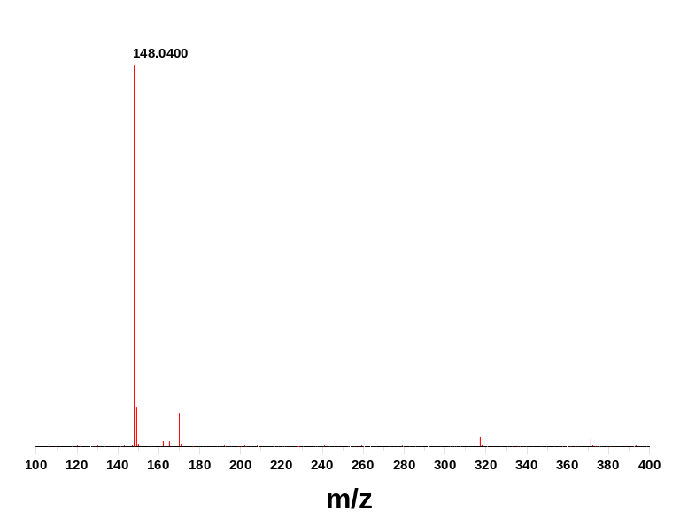
Fig. S2 Mass spectra of isatin standard, acquired with QToF-ESI-MS in positive polarity

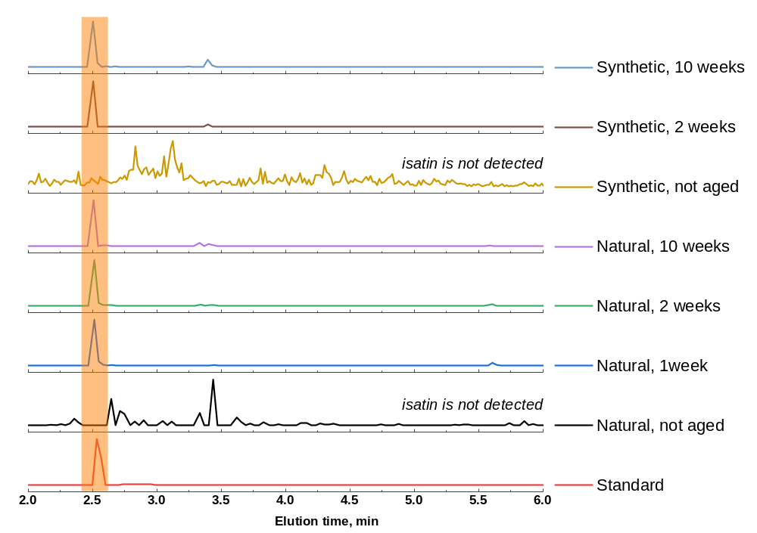
Fig. S3 Extracted ion chromatograms (XIC) (with m/z 148.0400) for isatin standard, as well for MeOH extracts of natural and synthetic indigo samples aged in UV-climate chamber. XIC obtained from SFC-QToF-MS chromatograms in positive polarity mode

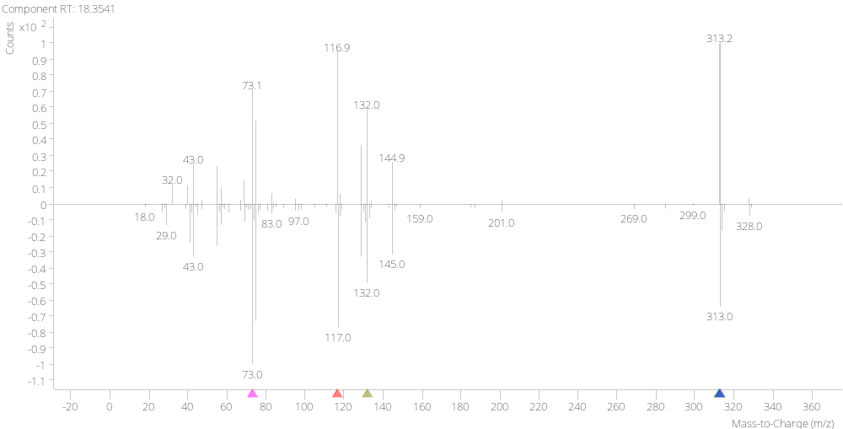
Fig. S4 Mass spectra of a compound corresponding to peak 1 (as shown in Table 1 and Fig. 8), identified as palmic acid mono-TMS, with a match factor of 80.6

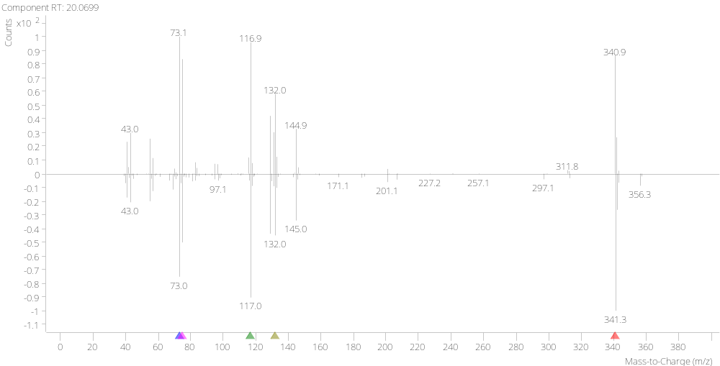
Fig. S5 Mass spectra of a compound corresponding to peak 2 (as shown in Table 1 and Fig. 8), identified as stearic acid mono-TMS, with a match factor of 91.2

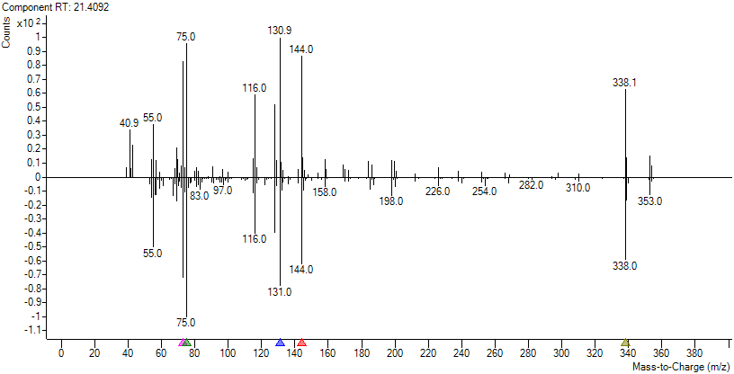
Fig. S6 Mass spectra of a compound corresponding to peak 3 (as shown in Table 1 and Fig. 8), identified as oleamide mono-TMS, with a match factor of 80.6

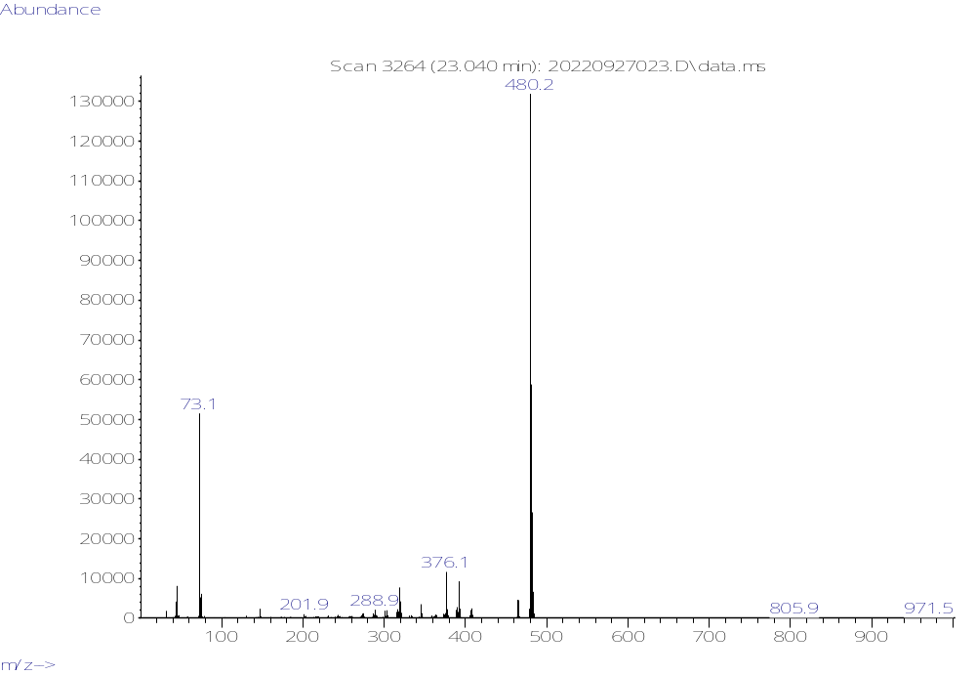
Fig. S7 Mass spectra of Indigo tris-TMS corresponding to peak 4 (as shown in Table 1 and Fig. 8)

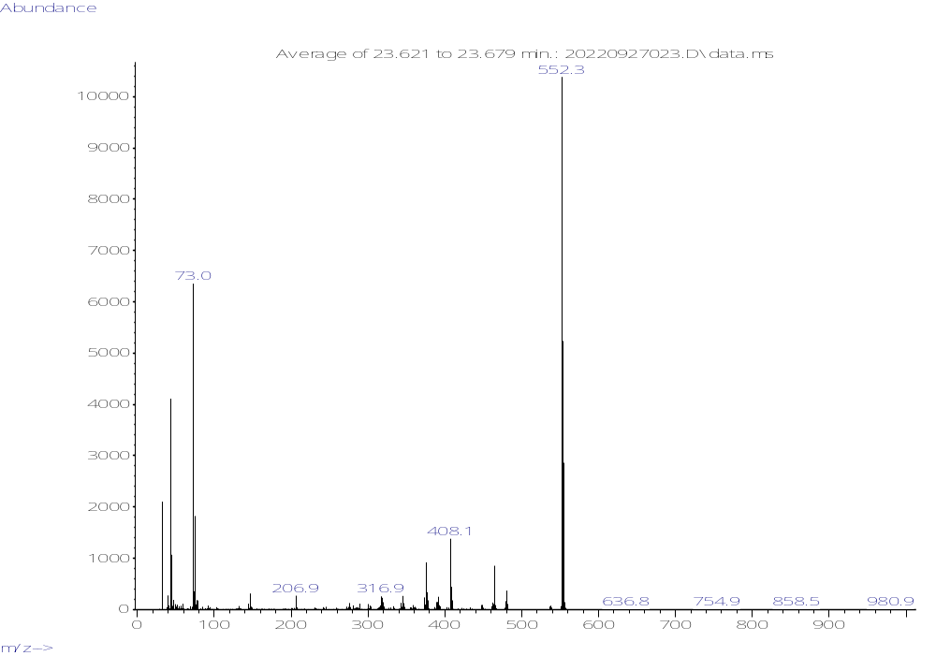
Fig. S8 Mass spectra of Indigo tetra-TMS corresponding to peak 5 (as shown in Table 1 and Fig. 8)

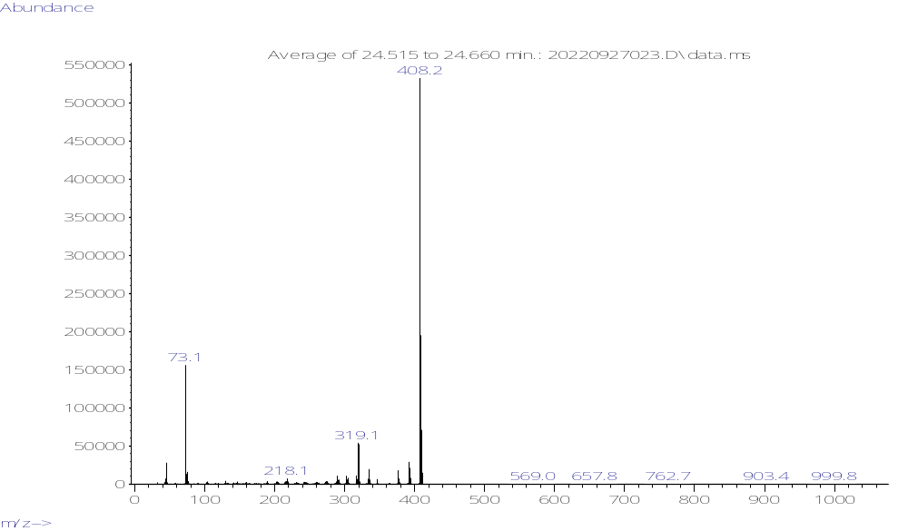
Fig. S9 Mass spectra of Indigo bis-TMS corresponding to peak 6 (as shown in Table 1 and Fig. 8)

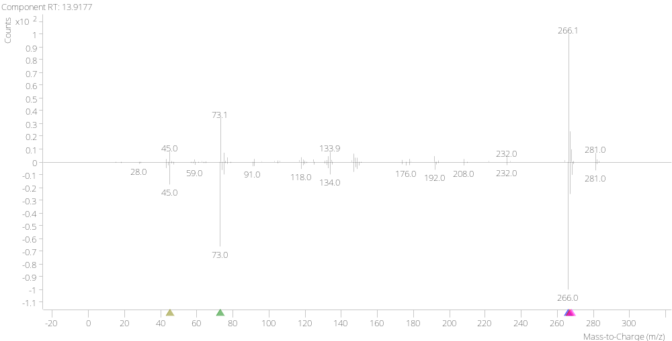
Fig. S10 Mass spectra of compound corresponding to peak S1 (as shown in Table 1 and Fig. 8), identified as anthranilic acid bis-TMS, with a match factor of 93.4

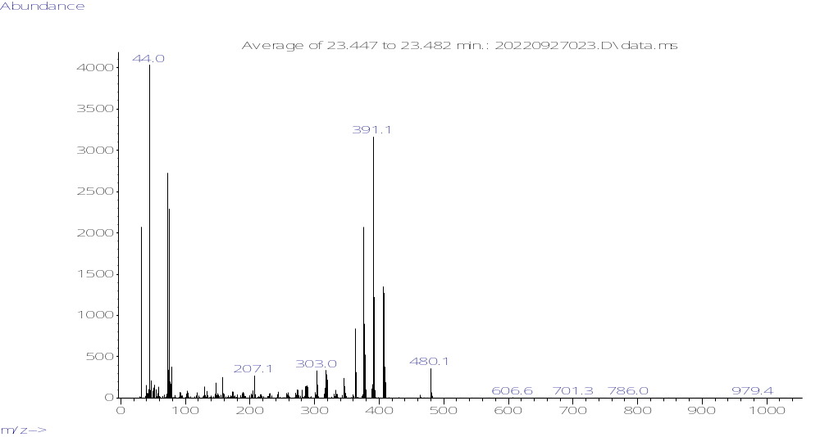
Fig. S11 Mass spectra of an unknown compound corresponding to peak S2 (as shown in Table 1 and Fig. 8)

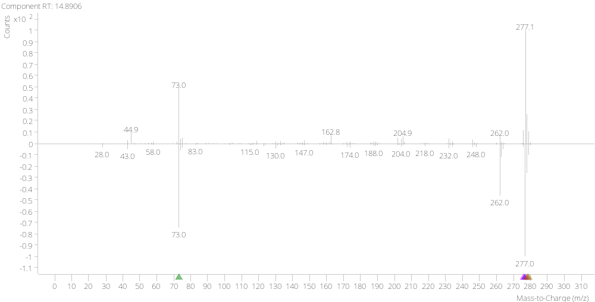
Fig. S12 Mass spectra of a compound corresponding to peak N1 (as shown in Table 1 and Fig. 8), identified as Indoxyl bis-TMS, with a match factor of 81.9

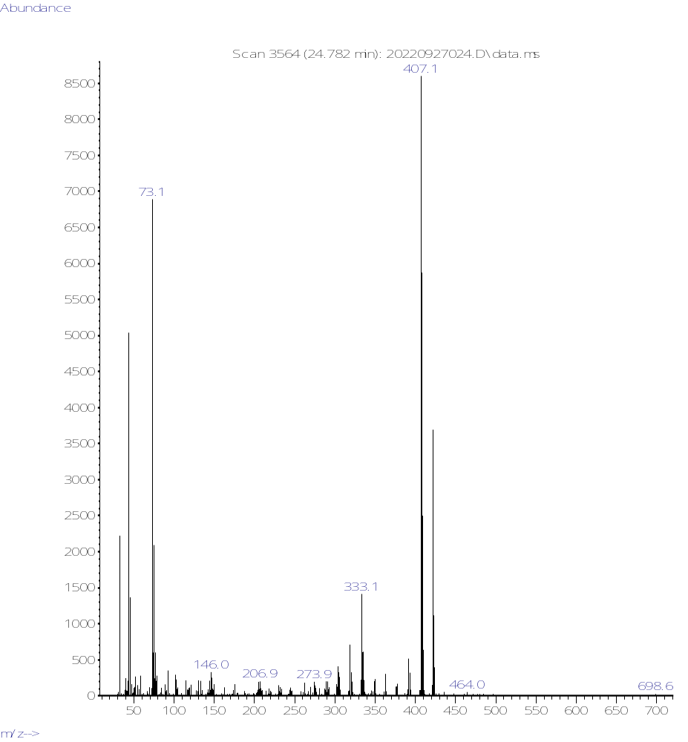
Fig. S13 Mass spectra of an unknown compound corresponding to peak N2 (as shown in Table 1 and Fig. 8)

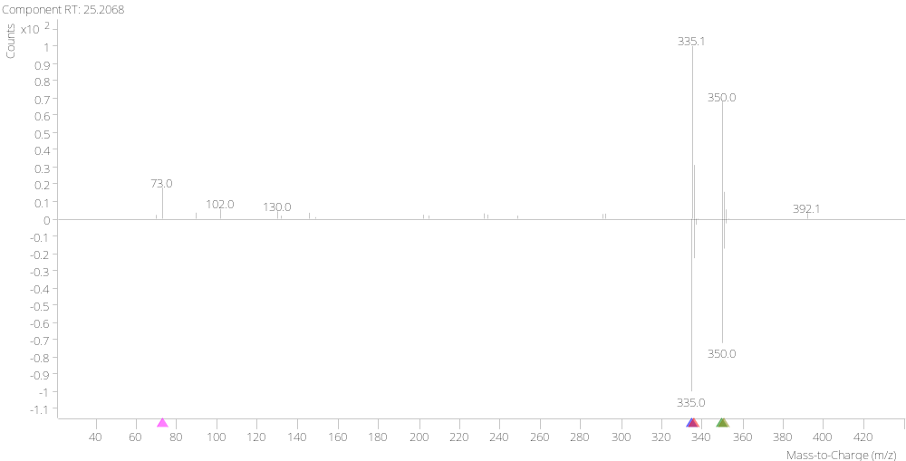
Fig. S14 Mass spectra of an unknown compound corresponding to peak N3 (as shown in Table 1 and Fig. 8) identified as benz[a]anthracene-1,7,12(2H)-trione, with a match factor of 88.6

References
Clifford AA (1973) Multivariate error analysis: a handbook of error propagation and calculation in many-parameter systems. Wiley, New York
Khaliliyan H, Rinnan Å, Völkel L, et al (2024) Strategies for multivariate characterization and classification of pulps and papers by near-infrared spectroscopy. Analytica Chimica Acta 1318:342895. https://doi.org/10.1016/j.aca.2024.342895
Robertson AR (1977) The CIE 1976 Color‐Difference Formulae. Color Research & Application 2:7–11. https://doi.org/10.1002/j.1520-6378.1977.tb00104.x
Röhrling J, Potthast A, Rosenau T, et al (2002) A Novel Method for the Determination of Carbonyl Groups in Cellulosics by Fluorescence Labeling. 1. Method Development. Biomacromolecules 3:959–968. https://doi.org/10.1021/bm020029q
Sulaeva I, Sto̷pamo FG, Melikhov I, et al (2024) Beyond the Surface: A Methodological Exploration of Enzyme Impact along the Cellulose Fiber Cross-Section. Biomacromolecules 25:3076–3086. https://doi.org/10.1021/acs.biomac.4c00152

