Supplementary material

Feedstock-specific insights into TEMPO-mediated oxidation for cellulose nanofiber production
André Mazegaª, Anna F. Lehrhofer^{b}, Roberto J. Aguadoª, Antje Potthast^{b}, Ronald Marquezª, Thomas Rosenau^{b}, Marc Delgado-Aguilarª*.
ªLEPAMAP-PRODIS research group, University of Girona, C/ Maria Aurèlia Capmany, 61, 17003 Girona, Spain
^{b}Institute of Chemistry of Renewable Resources, Department of Chemistry, University of Natural Resources and Life Sciences (BOKU). Muthgasse, 18 – A-1190 Vienna, Austria
*corresponding author: m.delgado@udg.edu

This file contains photographs, plots, and tables that were kept out of the main body of the article for the sake of conciseness. They correspond to the visual aspect of the samples (Figure S1), their rheological behavior at different CNF concentrations (Figure S2, Table S1), XRD (Figure S3), and XPS (Figure S4, Table S2). Every item is referred to in the article.

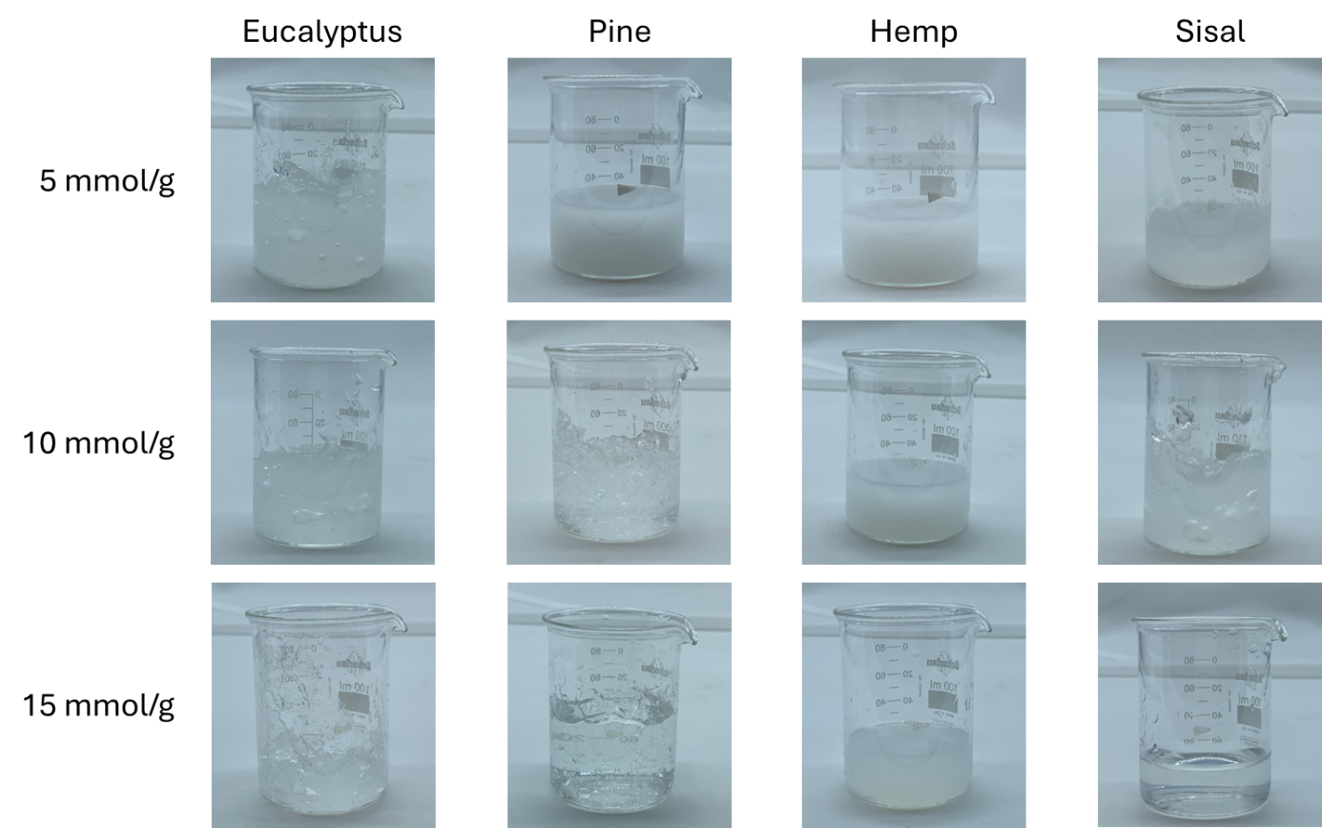
Figure S1. Pictures of CNF suspensions at 1 wt% consistency

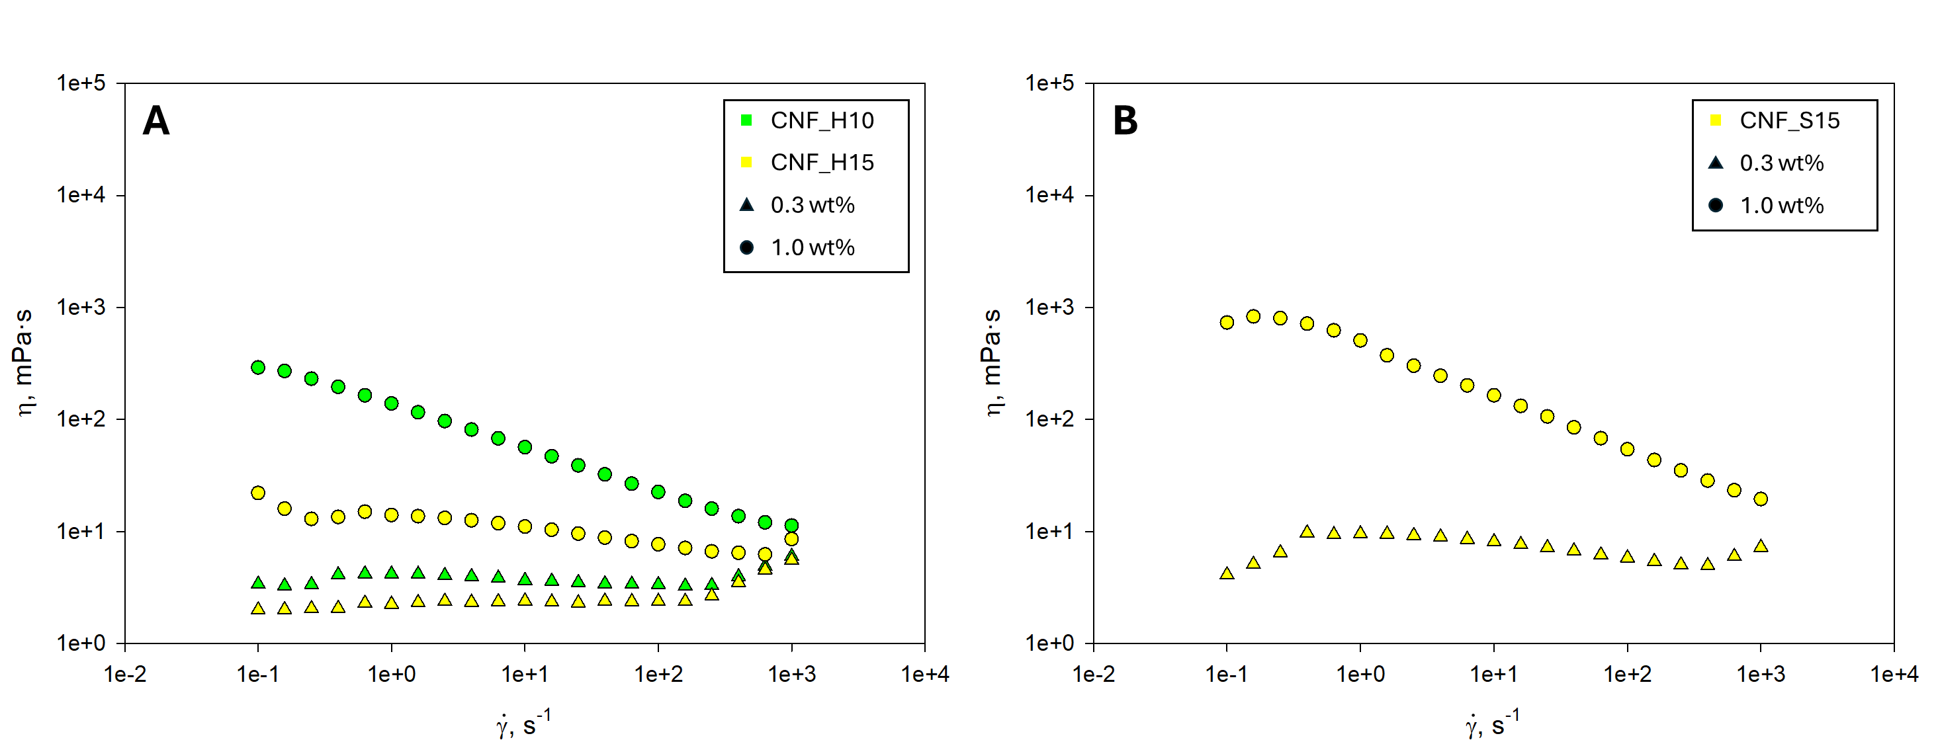
Figure S2. Rheological curves of hemp (A) and sisal (B) CNF suspensions at 0.3 and 1.0 wt% consistency. Only those samples not fitting the Ostwald-de Waele model at 0.3 wt% are provided

Table S1. Ostwald-de Waele regressors for hemp and sisal CNF suspensions at 1 wt%
Feedstock | OA (mmol/g) | K (mPa) | n | R²
Hemp | 10 | 134.01 | 0.62 | 0.9946
Hemp | 15 | 13.74 | 0.89 | 0.8660
Sisal | 15 | 424.41 | 0.56 | 0.9035

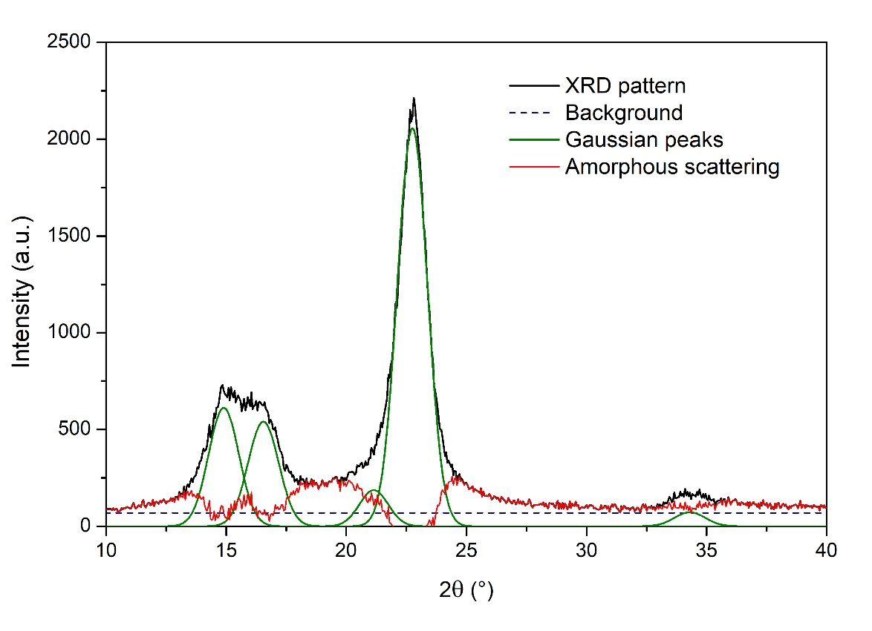
Figure S3. Example of baseline adjustment (blue line) and peak deconvolution (green lines) in X-ray diffraction patterns. The black line corresponds to the untreated pattern. The red line, including both the background and the amorphous contributions, is modeled as subtracting the crystalline peaks from the pattern. The graph corresponds to hemp fibers
Table S2. Area and amplitude (Amp.) of the Gaussian peaks obtained after deconvolution. Miller indices (hkl) indicate the corresponding crystalline peaks
hkl | 2θ (°) | Eucalyptus |  | Pine |  | Hemp |  | Sisal
hkl | 2θ (°) | Area | Amp. | Area | Amp. | Area | Amp. | Area | Amp.
1-10 | ~14.9 | 1030 | 508 | 1313 | 710 | 944 | 612 | 766 | 459
110 | ~16.4 | 889 | 438 | 1298 | 702 | 834 | 541 | 967 | 580
102 | ~20.6 | 245 | 121 | 242 | 131 | 288 | 187 | 238 | 143
200 | ~22.5 | 3039 | 1499 | 3403 | 1840 | 3173 | 2056 | 2342 | 1404
040 | ~34.5 | 331 | 163 | 256 | 139 | 114 | 74 | 242 | 145

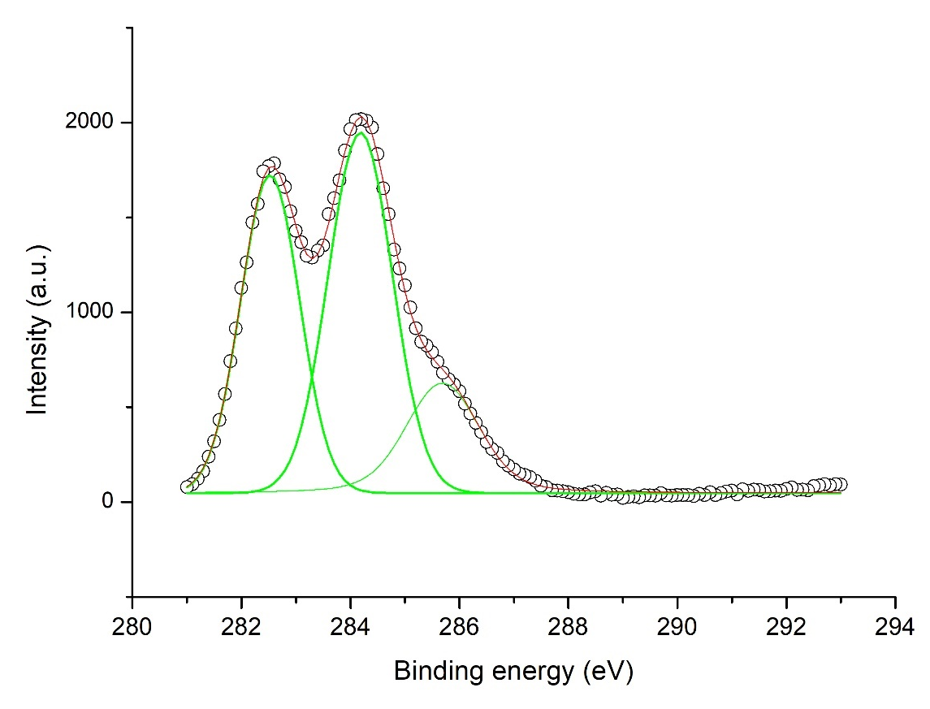
Figure S4. Example of peak deconvolution in OriginLab’s OriginPro for high-resolution X-ray photoelectron spectra. The graph corresponds to a non-oxidized sample from eucalyptus. Green peaks are fittings to the Voigt function without fixing any of the parameters

Table S3. Maxima and areas of the deconvoluted peaks in the C1s region of X-ray photoelectron spectra.
Material | OA  (mmol/g) | Binding energy (eV) |  |  | Relative peak area
Material | OA  (mmol/g) | 1st peak | 2nd peak | 3rd peak | 1st peak | 2nd peak | 3rd peak
Eucalyptus | 0 | 282.6 | 284.2 | 285.7 | 36.8% | 45.5% | 17.7%
Eucalyptus | 5 | 282.8 | 284.4 | 286.0 | 35.9% | 44.7% | 19.3%
Eucalyptus | 10 | 283.1 | 284.7 | 286.2 | 26.2% | 55.0% | 18.8%
Eucalyptus | 15 | 283.0 | 284.5 | 286.1 | 27.7% | 53.8% | 18.5%
Pine | 0 | 282.8 | 284.3 | 285.5 | 26.1% | 63.9% | 10.1%
Pine | 5 | 282.8 | 284.5 | 286.5 | 9.0% | 80.6% | 10.4%
Pine | 10 | 282.6 | 284.3 | 286.4 | 26.1% | 63.4% | 10.6%
Pine | 15 | 282.6 | 284.4 | 286.1 | 13.4% | 81.2% | 5.4%
Hemp | 0 | 282.7 | 284.4 | 286.0 | 26.9% | 63.9% | 9.2%
Hemp | 5 | 282.5 | 283.7 | 286.3 | 17.6% | 73.0% | 9.4%
Hemp | 10 | 282.4 | 283.8 | 286.0 | 24.1% | 65.8% | 10.0%
Hemp | 15 | 282.7 | 284.3 | 287.0 | 18.2% | 53.0% | 28.7%
Sisal | 0 | 284.4 |  | 285.8 | 82.8% |  | 17.2%
Sisal | 5 | 285.2 |  | 288.1 | 66.9% |  | 33.1%
Sisal | 10 | 283.0 |  | 285.2 | 77.3% |  | 22.7%
Sisal | 15 | 285.0 |  | 288.6 | 81.6% |  | 18.4%

