Supporting information for
Low-cost preparation of photocatalytic hydrolyzed cellulose composites, activated with one-step synthesized graphene oxide-metal oxide for dye degradation

Huseyin Gumus¹*, Bulent Buyukkidan²,
¹*Osmaneli Vocational School, Bilecik Seyh Edebali University, 11500, Osmaneli, Bilecik/Turkey
huseyin.gumus@bilecik.edu.tr (corresponding author) ORCID No: 0000-0002-2029-7978
² Department of Chemistry, Kutahya Dumlupinar University, Kutahya/Turkey
bulent.buyukkidan@dpu.edu.tr ORCID No: 0000-0001-9619-3246

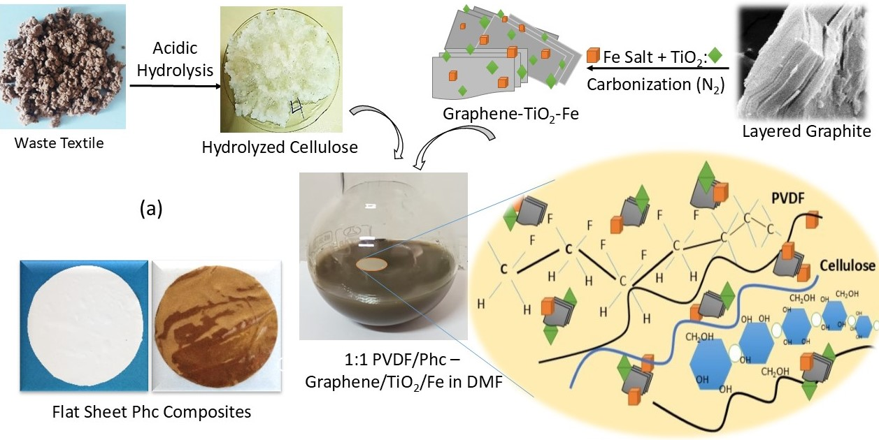

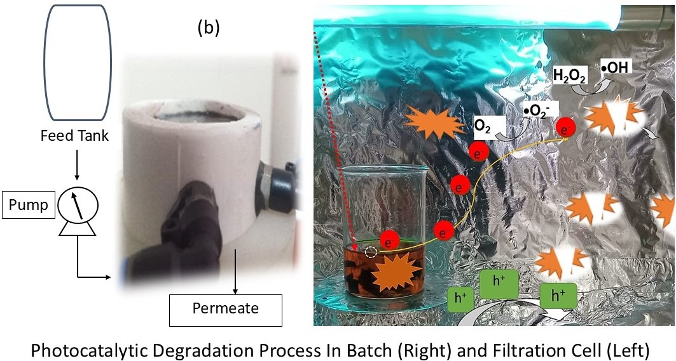

Fig. S1 Schematic representation of photocatalysis preparation (a) and photocatalytic process (b)

Table S1 Properties of model pollutant MO
Dye |  | Methyl Orange (MO)
Structure [24] | 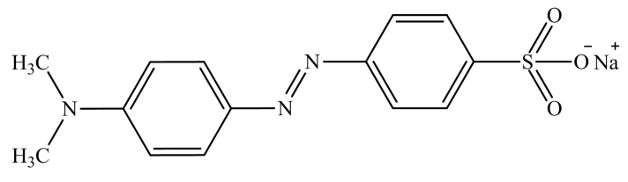
Synonym(s) | 4-[4-(Dimethylamino) phenylazo] benzenesulfonic acid sodium salt, Acid Orange 52/Orange III
Molecular formula | C₁₄H₁₄N₃NaO₃S
Molecular weight (g/mol) | 327.33
Type | Anionic dye

Table S2 Equations for adsorption kinetic and isotherms

Adsorption isotherm
Freundlich | $$Q_{e}=K_{F}C_{e}^{1/n}$$ | K_{F}: Freundlich constant/L^{n}∙mg^{1–n}∙g⁻¹  1/n: adsorption intensity
Langmuir | $$Q_{e}=\frac{Q_{m}K_{L}C_{e}}{1+K_{L}C_{e}}$$ | Q_{m}: Maximum adsorption capacity of monolayer/mg∙g⁻¹  K_{L}: binding strength/L∙mg⁻¹
Pseudo-first order (PFO) | $$InC_{t}=-k_{1}t+InC_{0}$$ | k₁: PFO rate constant/min⁻¹
Pseudo-second order (PSO) | $$\frac{t}{Q_{t}}= \frac{1}{k_{2}Q_{e}^{2}}+ \frac{t}{Q_{e}}$$ | k₂:PSOrate constant/mg∙g⁻¹∙min⁻¹

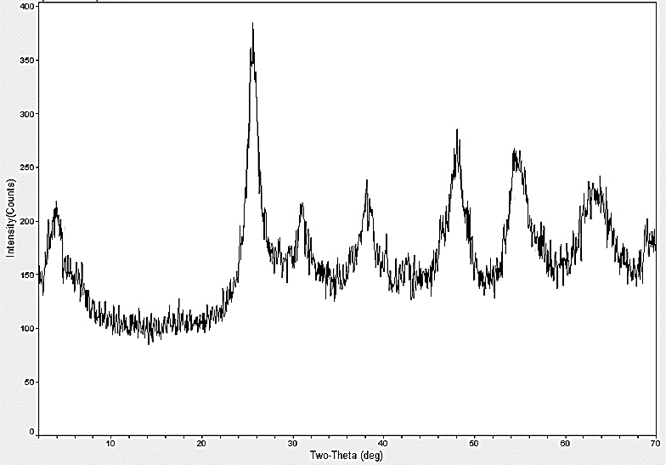

Fig. S2 XRD patterns of TiO₂
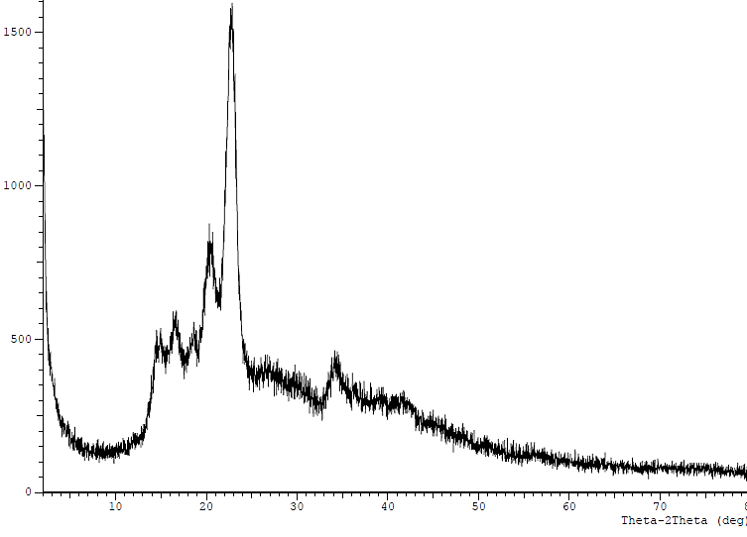
Fig. S3 XRD patterns of textile waste-based cellulose

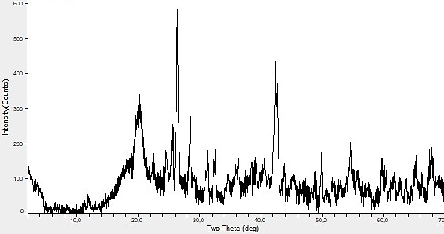
Fig. S4 XRD patterns of PVDF

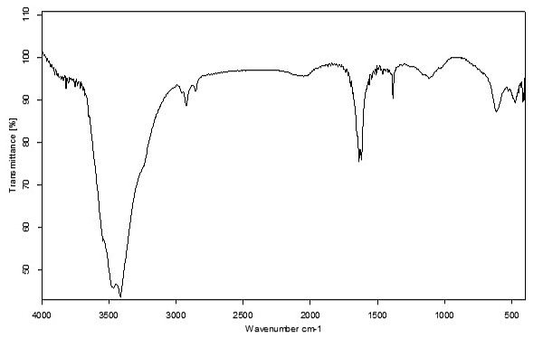

Fig. S5 Ft-IR spectrum of GO-Fe- TiO₂

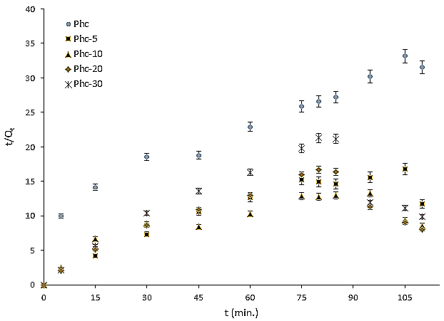
Fig. S6 Pseudo second order isotherm plots for removal of MO onto P and PFb composites (MO amount: 50 mL (50 mg/L), pH= 7.0, temperature: 298 K, adsorbent: 0.3 g, stirring rate: 150 rpm for 110 min.)

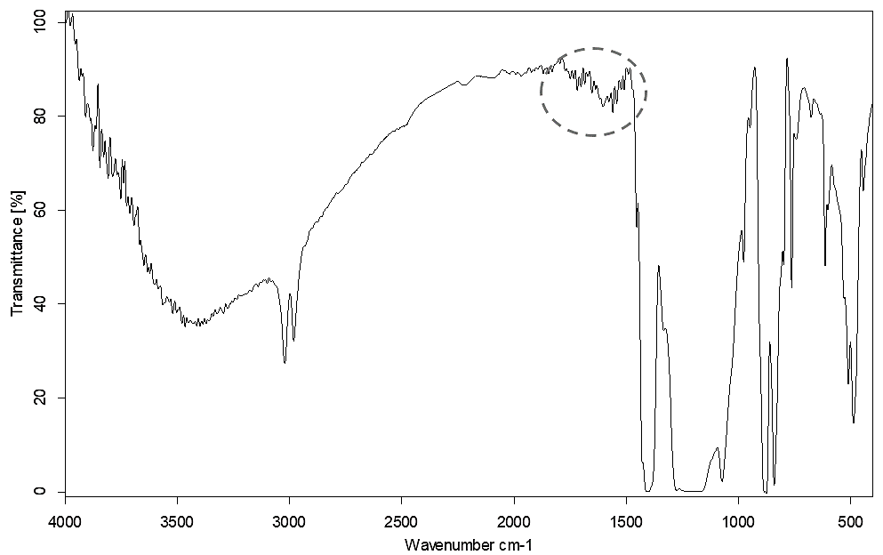

Fig.S7 Infrared spectrums of Phc-20; MO adsorbed and UV radiated with air oxygen

Table S3 Photocatalytic dye removal studies with different adsorbent-photocatalyst (Gumus and Buyukkidan 2024)

Catalyst-Biochar precursor |  | Amount or surface area  (for membranes) |  |  | Substrat and amount |  |  | Power (W) |  |  | Time |  |  |  | Removal Mechanism and efficiency
ZnO/biochar |  |  | 100 mg |  |  | 160 mg/L methylene blue |  |  | 250 |  |  | ≅200 min. |  |  |  | Degradation 95.19%
TiO₂-biochar |  |  | 10 mg |  |  | 20 mg/L  Methyl orange |  |  | 500 |  |  | 150 min. |  |  |  | Degradation 96.98%
FCF-pDA-PVDF  (Fe-biochar-) composite beads |  |  | 1.0 g |  |  | 10 mg/L  Methyl orange |  |  | 300 |  |  | ≅75 min. |  |  |  | Degradation  ≅100%
MIL-53(Fe)/PVDF |  |  | 4.7 cm diameter |  |  | 20 ppm of tetracycline |  |  | 100 W Xe lamp, UV light |  |  | 30 min. |  |  |  | Degradation  93 %
Fe (III)-TiO₂/ PVDF composite membrane |  |  | 13 cm -5 cm |  |  | 10 mg/L 250mL bisphenol-A (BPA) |  |  | 500 W sunlight Xenon lamp- |  |  | 180 min |  |  |  | Degradation  69.9%
TiO₂-PVDF-co-HFP matrix |  |  | 0.10 m × 0.15 m |  |  | 100 mg/L Congo red (CR) and methylene blue (MB) |  |  | 8W UV light |  |  | 4 h. |  |  |  | Degradation-cleaning  ≅100%
MCU-C₃N₄/PVDF membrane |  |  | (0.22 µm, 47 mm) |  |  | 5 mg/L rhodamine B (RhB) 5mg/L tetracycline hydrochloride (TC) |  |  | 300W Xe lamp |  |  | 60 min. |  |  |  | Degradation  84.24%  71.26%
Bi₂WO₆ @MIL-100(Fe)-PVDF |  |  | 14.6 cm² |  |  | 10 mg/L 100 mL Pirimicarb |  |  | 70 W visible light |  |  | 240 |  |  |  | Degradation  86%
Fe-CTW  (FeCl₂ treated Waste Textile based) biochar |  |  | 50 mg |  |  | 75 mg/L  methyl orange |  |  | 30 W |  |  | 35 + 10 min. |  |  |  | Degradation  87.4%
PFb-10 |  |  | 0.3 g |  |  | 75 mg/L  Methyl orange |  |  | 30 W |  |  | 75+30+5 min. |  |  |  | Removal**  97.41%
Phc  Phc-5  Phc-10  Phc-20  Phc-30  (G-TiO₂-Fe-PVDF-Hcell) |  |  | 0.3 g |  |  | 50 mg/L  Methyl orange |  |  | 30 W |  |  | 75+30+5* min. |  |  |  | Removal**  23.2%  62.5%  85.59%  91.8%  83.52%  (This study)
* : 30W UV radiation for 30 min. (after the 75th minute) and, 30 W UV radiation for 5 min. with 0.01 mol/L (after the 105th minute)
** : Total removal by adsorption and degradation

