Supplementary material
Enzymatic Degumming of Hemp: A Literature Review
(Cellulose)

Siyan Wang¹, Sonja Salmon^{2,}*
^{1,2} Department of Textile Engineering, Chemistry and Science, Wilson College of Textiles, North Carolina State University, Raleigh, NC 27695-8301, USA
¹ swang76@ncsu.edu (ORCID 0000-0002-4640-1841)
^{2,*} Correspondence: sisalmon@ncsu.edu (ORCID 0000-0003-2477-9023)

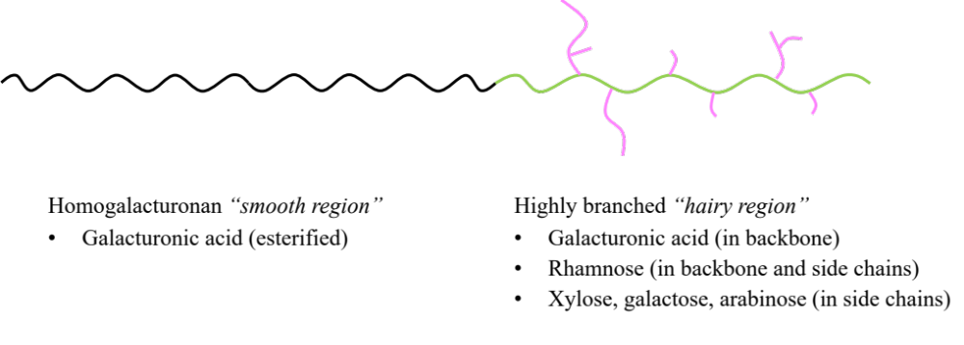
Fig. S1 Schematic illustration of pectin structure

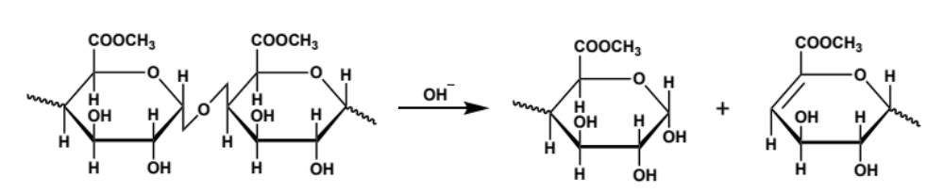
Fig. S2 β-elimination reaction of pectin at alkaline conditions

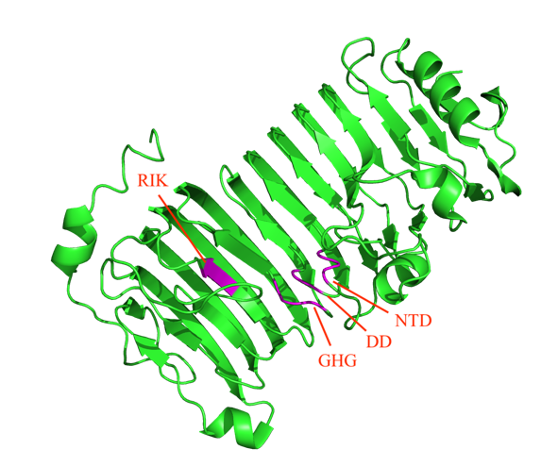 | 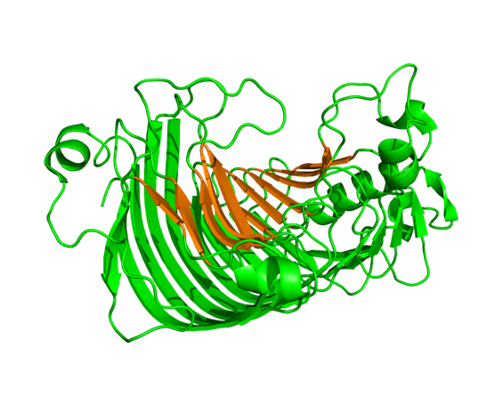
a | b
Fig. S3 a Schematic diagram of an endo-polygalacturonase (PDB code: 7B7A) from top view. Four conserved AA sequence fragments are colored in magenta and labeled in red text. b Schematic diagram of the same polygalacturonase from side view. A cleft composed of β-sheet is highlighted in orange (Safran et al. 2023)

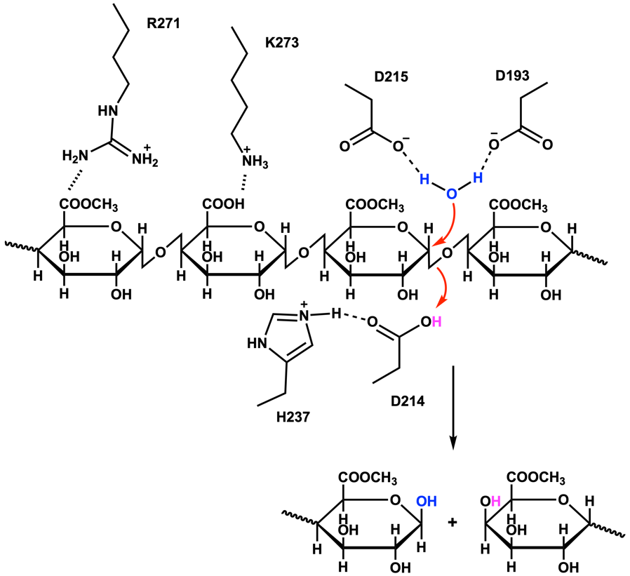
Fig. S4 Schematic diagram of polygalacturonase catalysis mechanism (Van Santen et al. 1999; Safran et al. 2023). AA labels are based on the enzyme with PDB code 7B7A

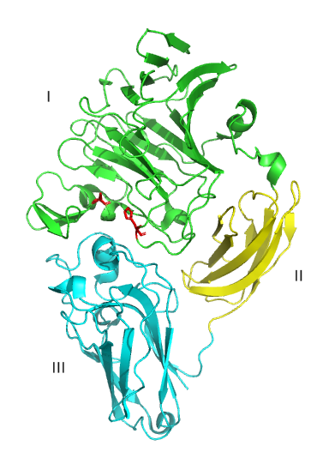 | 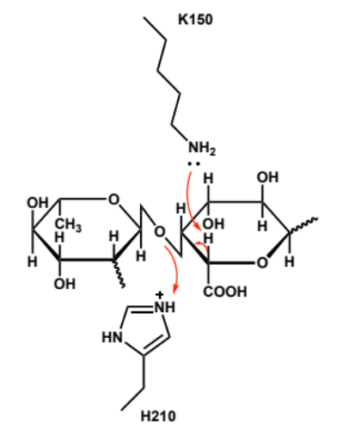
a | b
Fig. S5 Schematic diagrams of a rhamnogalacturonan lyase structure (three domains are marked in different colors: I in green, II in yellow and III in cyan; two conserved AA residues at the active site are highlighted in red) and b the catalysis mechanism at its active site (Jensen et al. 2010) (PDB code: 1NKG)

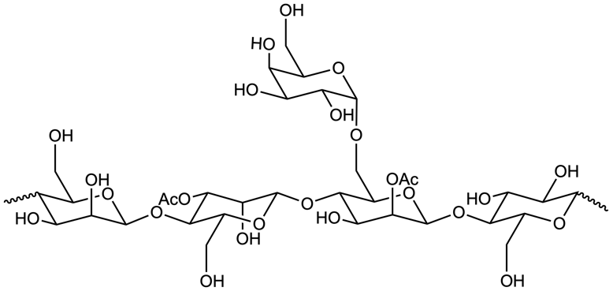
a
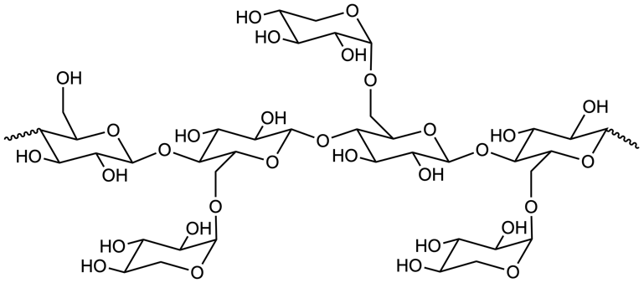
b
Fig. S6 Chemical structures of a galactoglucomannan and b xyloglucan

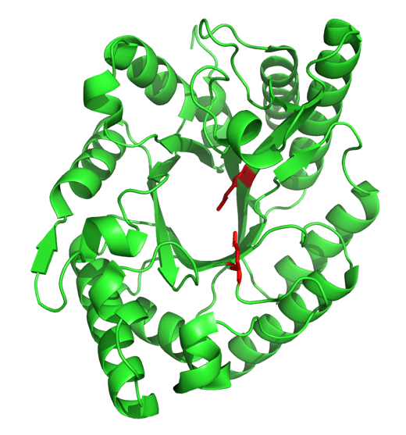
a
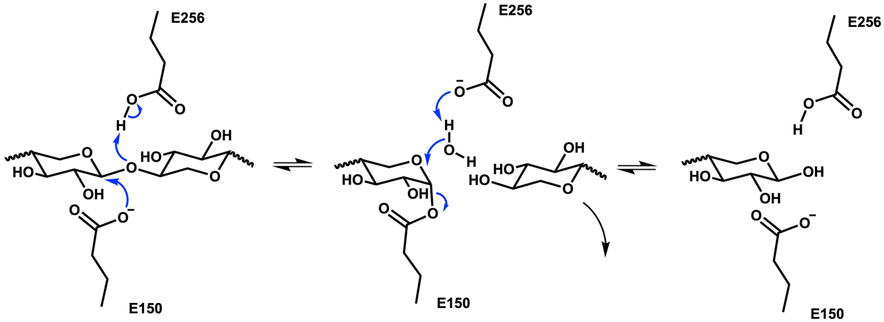
b
Fig. S7 a Structure of a GH10 xylanase (two catalytic residues Glu150 and Glu256 are colored in red) and b catalysis mechanism at its active site (Collins et al. 2005) (PDB code: 3NIY)

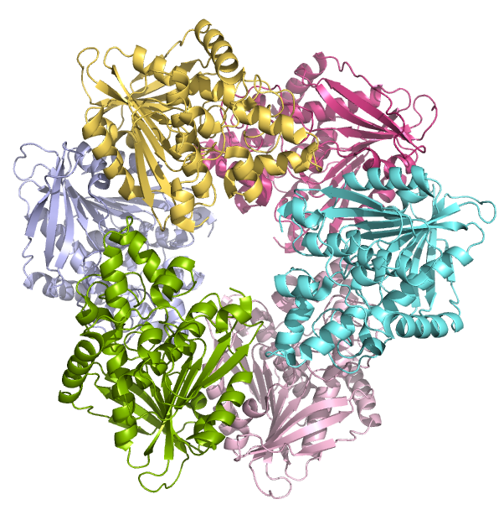 | 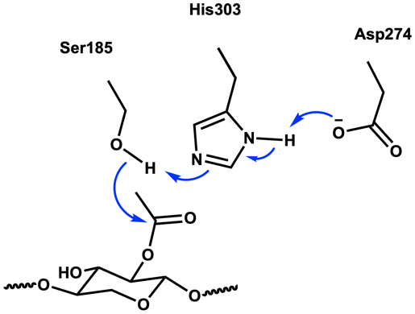
a | b
Fig. S8 Schematic diagrams of a acetyl xylan esterase crystal structure and b reaction mechanism of catalytic triad (PDB code: 6AGQ)

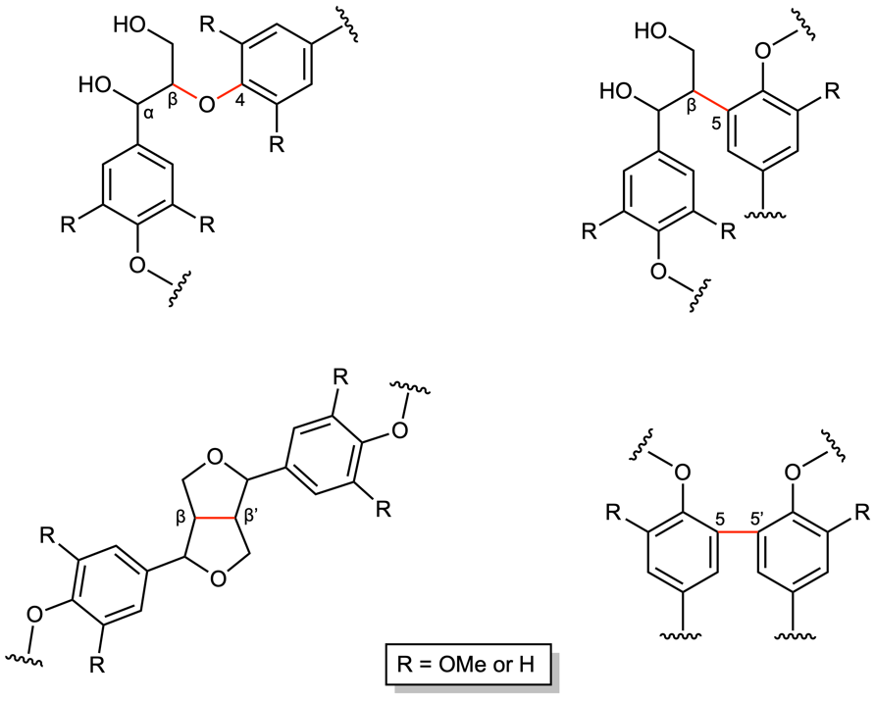
Fig. S9 Common linkages within lignin. Linkages are colored in red

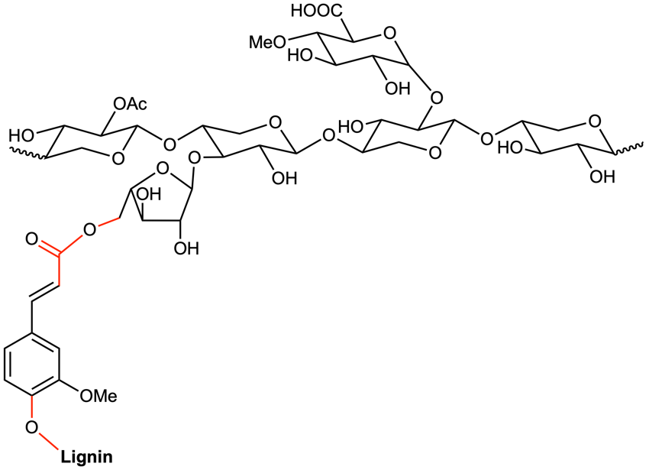
Fig. S10 Schematic diagram of a typical LCC linked with ferulic acid residue (Sun et al. 2004; Katahira et al. 2018). Ester and ether linkages are highlighted in red

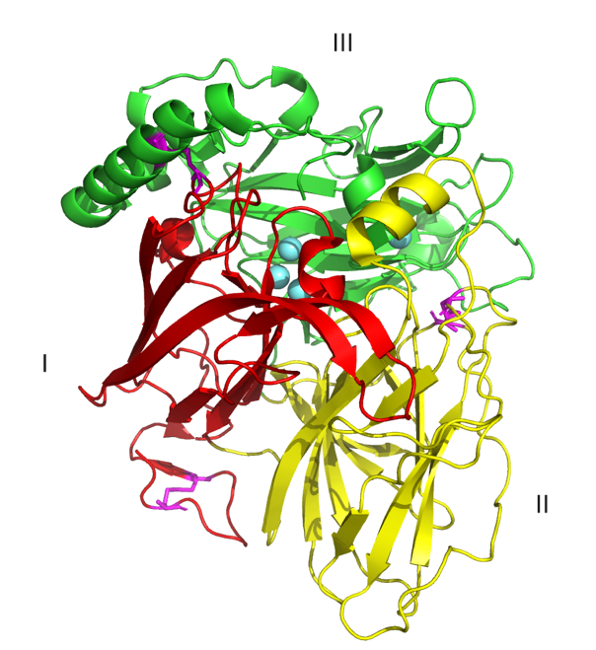
Fig. S11 Schematic diagram of a laccase structure in four copper form (PDB code: 1GW0). Three domains are marked in different colors: I in red, II in yellow and III in green. Four copper atoms are in cyan while three disulfide bridges are in magenta

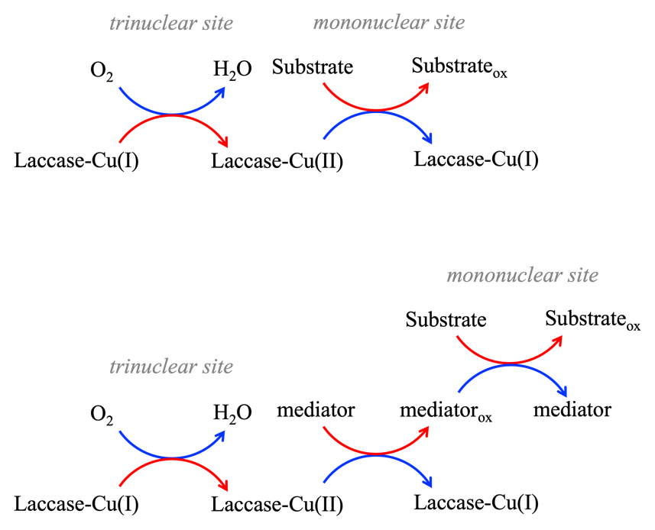
Fig. S12 Schematic diagram of laccase catalysis system (w/ and w/o mediator). Blue arrows represent reduction reactions while red arrows represent oxidation reactions

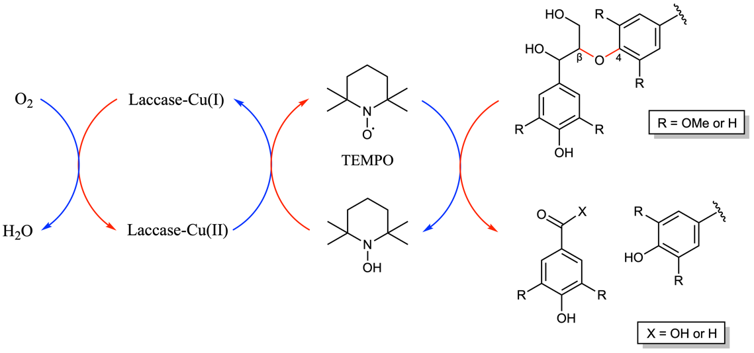
Fig. S13 Schematic diagram of TEMPO-laccase system on β-O-4 lignin depolymerization

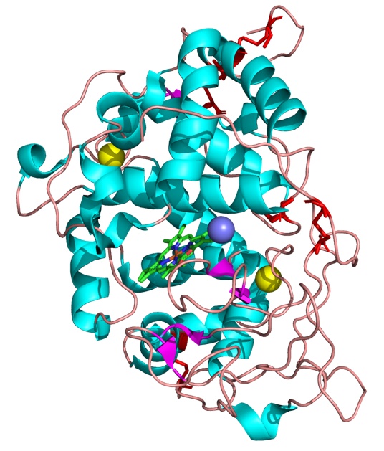
Fig. S14 Schematic diagram of manganese peroxidase structure (PDB code: 3M5Q). The heme prosthetic group is highlighted in stick form. The manganese ion Mn(II) is colored in purple, which binds to one heme propionate. Two calcium ions are in yellow and five disulfide bridges are in red

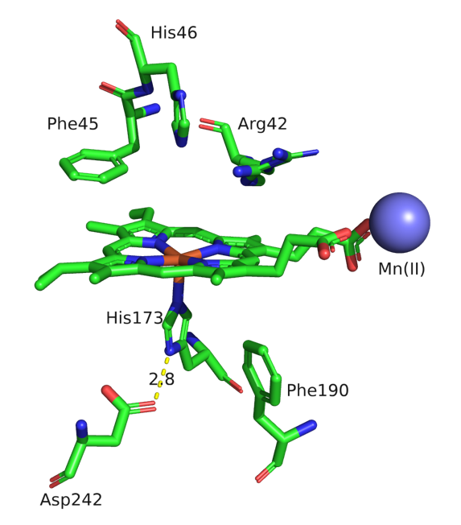
Fig. S15 The active site of MnP (PDB code: 3M5Q). The iron atom is coordinated with four nitrogen atoms of porphyrin and one nitrogen atom on histidine. A hydrogen bond between conserved amino acids His173 and Asp242 is highlighted

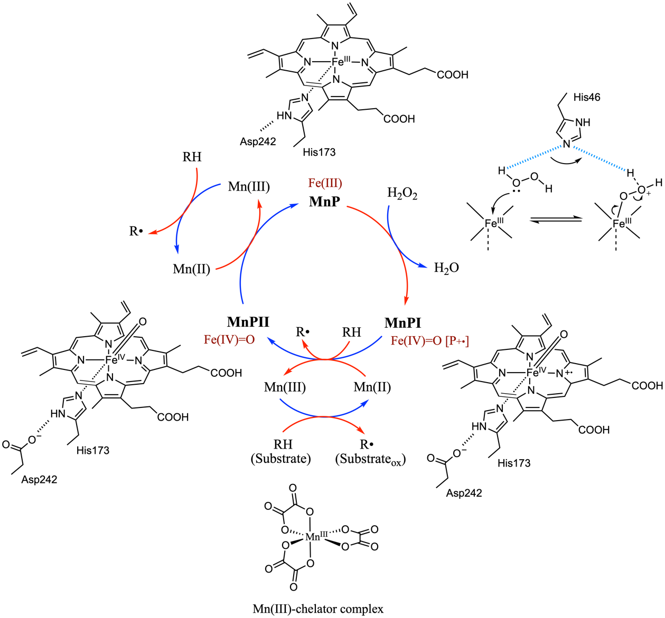
Fig. S16 Catalytic mechanism schematic for MnP (Gold et al. 2000; Kumar and Chandra 2020). The structure of heme changes over time under different enzyme states. RH represents phenol or aromatic amine substrates and R• is the corresponding radical form upon the one-electron oxidation

References
Collins T, Gerday C, Feller G (2005) Xylanases, xylanase families and extremophilic xylanases. FEMS Microbiol Rev 29:3–23. https://doi.org/10.1016/J.FEMSRE.2004.06.005
Gold MH, Youngs HL, Sollewijn Gelpke MD (2000) Manganese Peroxidase. In: Sigel H (ed) Metal ions in biological systems. Marcel Dekker, Inc., New York, pp 559–586
Jensen MH, Otten H, Christensen U, et al (2010) Structural and Biochemical Studies Elucidate the Mechanism of Rhamnogalacturonan Lyase from Aspergillus aculeatus. J Mol Biol 404:100–111. https://doi.org/10.1016/J.JMB.2010.09.013
Katahira R, Elder TJ, Beckham GT (2018) A Brief Introduction to Lignin Structure. In: Lignin Valorization: Emerging Approaches. The Royal Society of Chemistry, pp 1–20
Kumar A, Chandra R (2020) Ligninolytic enzymes and its mechanisms for degradation of lignocellulosic waste in environment. Heliyon 6:e03170. https://doi.org/10.1016/J.HELIYON.2020.E03170
Safran J, Tabi W, Ung V, et al (2023) Plant polygalacturonase structures specify enzyme dynamics and processivities to fine-tune cell wall pectins. Plant Cell 35:3073–3091. https://doi.org/10.1093/PLCELL/KOAD134
Sun RC, Sun XF, Tomkinson J (2004) Hemicelluloses and their derivatives. ACS Symposium Series 864:2–22. https://doi.org/10.1021/BK-2004-0864.CH001
Van Santen Y, Benen JAE, Schröter KH, et al (1999) 1.68-Å crystal structure of endopolygalacturonase II from Aspergillus niger and identification of active site residues by site-directed mutagenesis. J Biol Chem 274:30474–30480. https://doi.org/10.1074/jbc.274.43.30474

