Supplementary Data
Preparing, by cutting, composite material specimens for density and tensile testing.

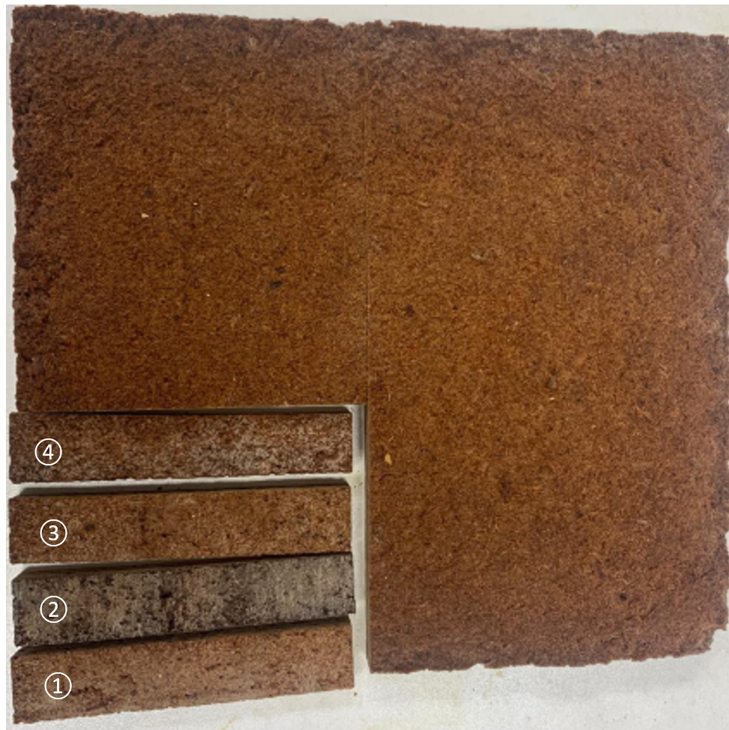

Figure. S1 - Tensile tests and density measurement specimens (10x2x1 cm). The composite in the figure was prepared with Glyc/CA=0.5 and sawdust=Glyc (values in weight).

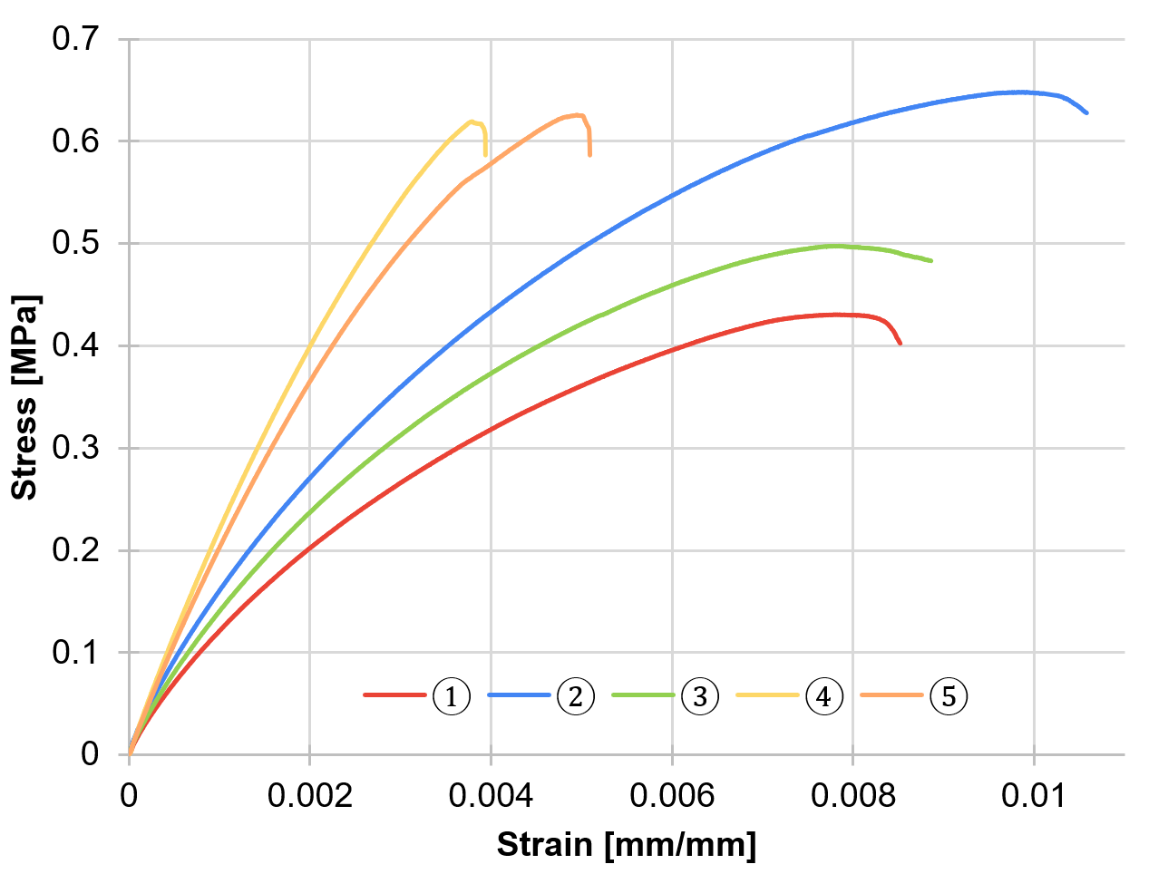
Figure. S2 – Typical data from tensile tests.

