The impact of brewers' spent grain type on the structure and performance of poly(ε-caprolactone)-based composites
Aleksander Hejna^{a,b,}*, Hubert Cieśliński^{c}, Katarzyna Skórczewska^{d}, Paulina Kosmela^{b}, Joanna Aniśkoª, Mateusz Barczewskiª
ª Institute of Materials Technology, Poznan University of Technology, Piotrowo 3, 61-138 Poznań, Poland
^{b} Department of Polymer Technology, Gdańsk University of Technology, Narutowicza 11/12, 80-233 Gdańsk, Poland
^{c} Department of Molecular Biotechnology and Microbiology, Gdańsk University of Technology, Narutowicza 11/12, 80-233 Gdańsk, Poland
^{d} Faculty of Chemical Technology and Engineering, Bydgoszcz University of Science and Technology, Seminaryjna 3 Street, 85-326 Bydgoszcz, Poland
* Corresponding author: aleksander.hejna@put.poznan.pl

Fig. S1. Plots of particle size distribution and cumulative curves for applied BSG variants.

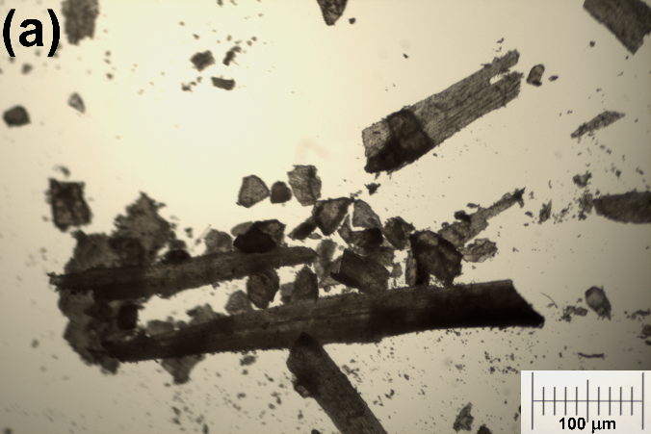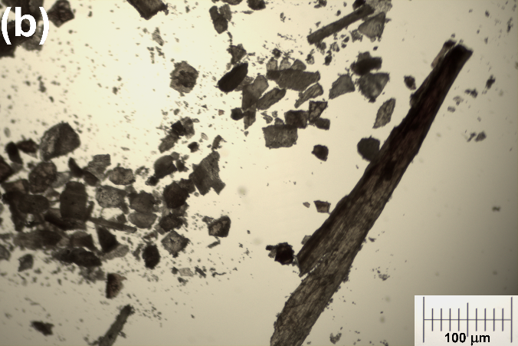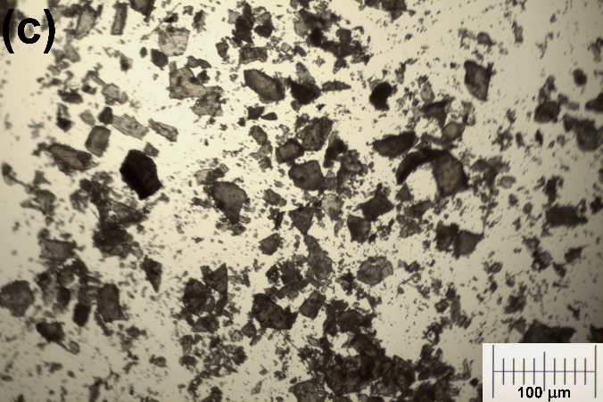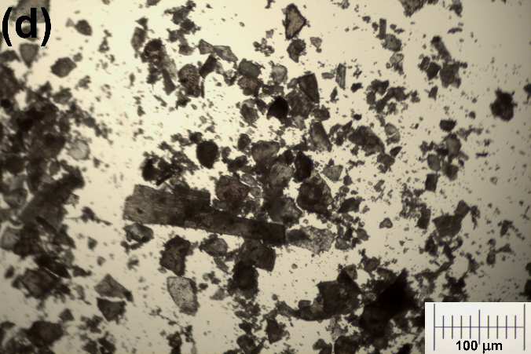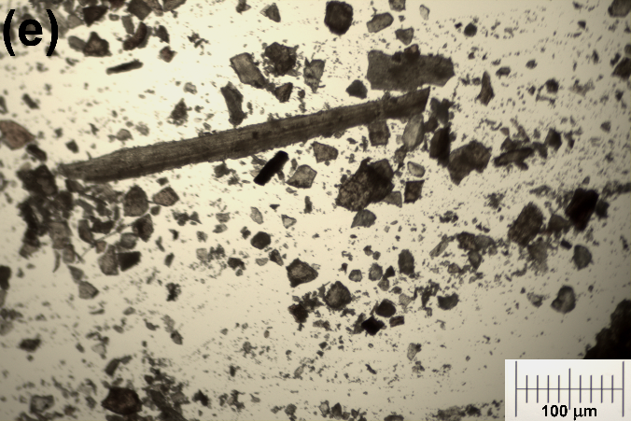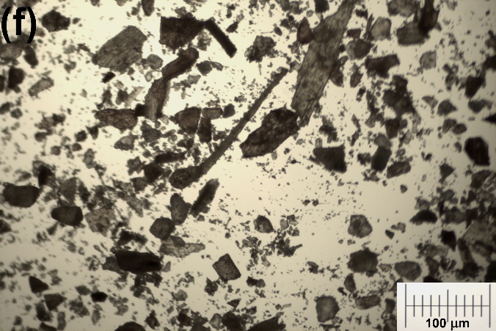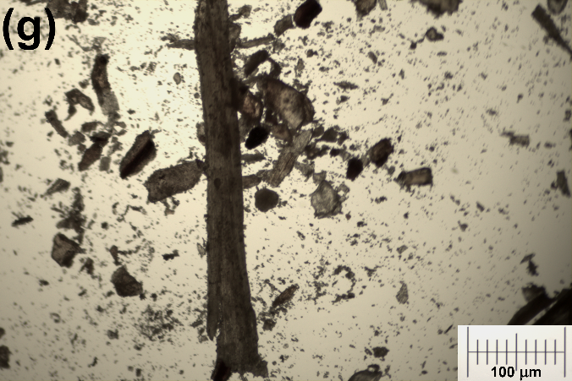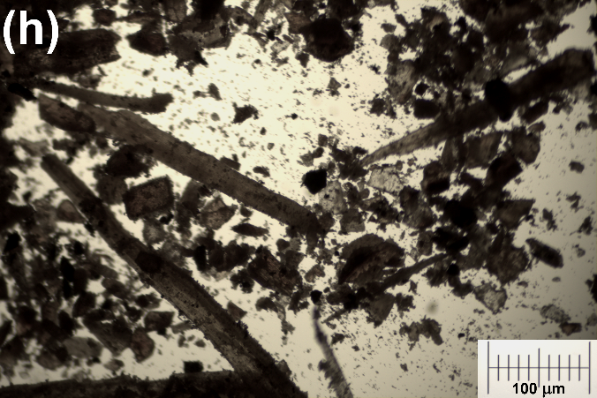
Fig. S2. Images of BSG samples obtained with optical microscopy: (a,b) Pilsen, (c) Wheat 100%, (d) Wheat 50%, (e) Rye 50%, (f) Grodziski 50%, (g) Munich II, and (h) Chocolate 900.

Fig. S3. Plots of mass loss curves and differential thermogravimetric curves for prepared PCL/BSG composites.

Fig. S4. Plots of mass loss curves and differential thermogravimetric curves for applied BSG variants.

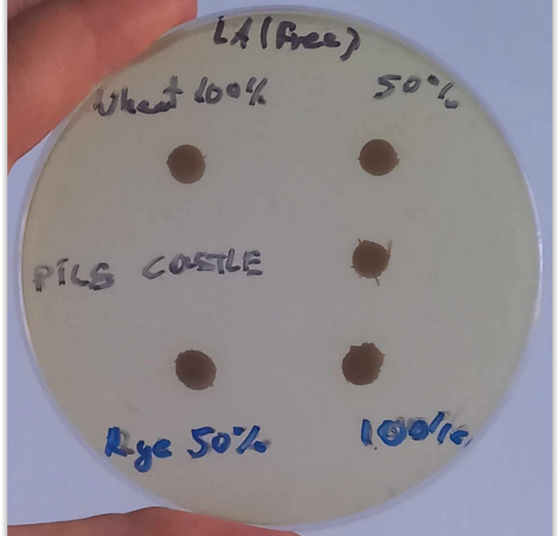
Fig. S5. The image of selected PCL/BSG composite disks placed on sterile LA agar plates not inoculated with bacterial strains.

