Enzyme-assisted high-consistency fiber refining: enhancing cellulose materials performance in the paper industry through process and physics-informed machine learning modeling
Giovana Signori-Iamin^{a*}, Ronald Marquezª, Gabriela A. Bastidaª, Quim Tarrésª, Alexandre F. Santos^{b} and Marc Delgado-Aguilarª
ª LEPAMAP-PRODIS research group, University of Girona, C/ Maria Aurèlia Capmany, 61, 17003 Girona, Spain
^{b} Department of Chemical Engineering, Federal University of Paraná, Curitiba, PR CEP81531-990, Brazil
* Corresponding author: giovana.signori@udg.edu
Supplementary information
Materials and methods
Table S1. Summary of experimental conditions for pulp treatments.
Parameter | Enzymatic biorefining | Mechanical refining (PFI)
Pulp type | BKEP | BKEP
Enzyme type | FiberCare U® (Endoglucanase) | N/A
Consistency (wt.% o.d.) | 3, 6, 9, 12, 15 | 10 (standard for PFI)
Enzyme dosage (mg/kg) | 0 (control), 200, 300, 400 (validation) | N/A
Treatment time (min) | 15, 30, 60 | N/A (defined by revolutions)
Temperature (°C) | 50 | Ambient (typically ~23°C)
pH | 5.0 | Not controlled (pulp suspension pH)
Refining levels | N/A | 0, 1000, 2000, 3000, 4000 revolutions
Quenching | NaOH to pH 11–12 | N/A

Table S2. Training set derived from experimental data
Sample_ID | Consistency | Enzyme_Dosage | Time | SR | Breaking_Length | Internal_Bonding | Burst_Index | Gurley_Porosity
BKEP_blanc | 0 | 0 | 0 | 17.25 | 2277.95 | 52.57 | 1.09 | 1.78
3%_SE_T15 | 3 | 0 | 15 | 16 | 2242.34 | 48.1 | 1.15 | 1.76
3%_SE_T30 | 3 | 0 | 30 | 14.75 | 2347.85 | 48.95 | 1.18 | 1.69
3%_SE_T60 | 3 | 0 | 60 | 15.75 | 2312.1 | 48.17 | 1.12 | 1.75
3%_E200_T15 | 3 | 200 | 15 | 15.75 | 2113.36 | 61.09 | 1.21 | 1.65
3%_E200_T60 | 3 | 200 | 60 | 15.5 | 2487.27 | 75.34 | 1.48 | 1.69
3%_E300_T30 | 3 | 300 | 30 | 15.83 | 2776.89 | 59.7 | 1.44 | 1.71
3%_E300_T60 | 3 | 300 | 60 | 16 | 2801.66 | 61.43 | 1.5 | 1.74
6%_SE_T15 | 6 | 0 | 15 | 17 | 2712.44 | 61.73 | 1.26 | 1.8
6%_SE_T30 | 6 | 0 | 30 | 17.5 | 2637.13 | 66.3 | 1.3 | 1.85
6%_E200_T15 | 6 | 200 | 15 | 16.5 | 2894.58 | 87.08 | 1.65 | 1.74
6%_E200_T30 | 6 | 200 | 30 | 16.25 | 2870.24 | 116.62 | 1.61 | 1.8
6%_E200_T60 | 6 | 200 | 60 | 16 | 3064.77 | 126.44 | 1.92 | 1.83
6%_E300_T15 | 6 | 300 | 15 | 17 | 3345.97 | 118.37 | 1.83 | 1.85
6%_E300_T30 | 6 | 300 | 30 | 16.5 | 3772.63 | 125.78 | 2.06 | 1.85
6%_E300_T60 | 6 | 300 | 60 | 16.5 | 3632.12 | 136.09 | 2.06 | 1.77
9%_SE_T15 | 9 | 0 | 15 | 17 | 2629.47 | 62.57 | 1.31 | 1.9
9%_SE_T30 | 9 | 0 | 30 | 16.5 | 2585.31 | 74.38 | 1.29 | 2
9%_SE_T60 | 9 | 0 | 60 | 17.5 | 2599.63 | 73 | 1.29 | 1.99
9%_E200_T30 | 9 | 200 | 30 | 16.5 | 3105.59 | 128.83 | 1.91 | 1.88
9%_E200_T60 | 9 | 200 | 60 | 16.5 | 3502.23 | 147.58 | 2.15 | 1.96
9%_E300_T15 | 9 | 300 | 15 | 16.75 | 3391.27 | 128.86 | 1.74 | 1.8
9%_E300_T30 | 9 | 300 | 30 | 16.25 | 3817.31 | 152.77 | 2.25 | 1.94
12%_SE_T15 | 12 | 0 | 15 | 19 | 3069.34 | 107.5 | 1.74 | 2.05
12%_SE_T30 | 12 | 0 | 30 | 19 | 2931.32 | 107.82 | 1.74 | 2.12
12%_SE_T60 | 12 | 0 | 60 | 19 | 2786.53 | 119.42 | 1.82 | 2.19
12%_E200_T30 | 12 | 200 | 30 | 18.5 | 3652.4 | 168.01 | 2.42 | 2.12
12%_E300_T15 | 12 | 300 | 15 | 19 | 3508.51 | 140.32 | 2.23 | 1.95
12%_E300_T30 | 12 | 300 | 30 | 18.25 | 3923.21 | 172.37 | 2.49 | 2.15
12%_E300_T60 | 12 | 300 | 60 | 20.5 | 4293.44 | 258.44 | 3.01 | 2.62
15%_SE_T30 | 15 | 0 | 30 | 17.75 | 2883.37 | 80.3 | 1.62 | 2.16
15%_E300_T15 | 15 | 300 | 15 | 16.5 | 3297.7 | 121.17 | 2.03 | 2.08
15%_E300_T30 | 15 | 300 | 30 | 18 | 3524.81 | 173.63 | 2.5 | 2.21
15%_E300_T60 | 15 | 300 | 60 | 20 | 3960.19 | 237.4 | 2.79 | 2.62

Table S3. Test set derived from experimental data
Sample_ID | Consistency | Enzyme_Dosage | Time | SR | Breaking_Length | Internal_Bonding | Burst_Index | Gurley_Porosity
3%_E200_T30 | 3 | 200 | 30 | 14.75 | 2340.67 | 65.88 | 1.3 | 1.66
3%_E300_T15 | 3 | 300 | 15 | 16.75 | 2704.05 | 66.51 | 1.4 | 1.77
6%_SE_T60 | 6 | 0 | 60 | 15.75 | 2710.4 | 64.7 | 1.37 | 1.84
9%_E200_T15 | 9 | 200 | 15 | 15.5 | 2614.07 | 99.55 | 1.51 | 1.83
9%_E300_T60 | 9 | 300 | 60 | 18.25 | 3997.64 | 158.53 | 2.32 | 2.09
12%_E200_T15 | 12 | 200 | 15 | 18 | 3296.9 | 150.66 | 2.25 | 2.02
12%_E200_T60 | 12 | 200 | 60 | 20 | 3848.68 | 195.79 | 2.73 | 2.41
15%_SE_T15 | 15 | 0 | 15 | 16.75 | 2554.57 | 66.3 | 1.44 | 2.04
15%_SE_T60 | 15 | 0 | 60 | 17.75 | 2809.39 | 86.06 | 1.62 | 2.15

Results and discussion
Fiber morphology and characterization
Table S4. Fiber length and diameter for neat and enzymatically treated fibers at 300 mg/kg, for 15, 30 and 60 minutes.
300 mg/kg | 15 min |  | 30 min |  | 60 min
Consistency | Length  (μm) | Diam.  (μm) | Length  (μm) | Diam.  (μm) | Length  (μm) | Diam.  (μm)
Neat | 685 ± 1 | 18.50 ± 0.07 | 685 ± 1 | 18.50 ± 0.07 | 685 ± 1 | 18.50 ± 0.07
3 wt.% | 683 ± 0 | 18.65 ± 0.07 | 711 ± 8 | 18.25 ± 0.14 | 704.00 ± 0 | 18.30 ± 0.00
12 wt.% | 692 ± 3 | 18.05 ± 0.07 | 681 ± 4 | 18.10 ± 0.10 | 686.00 ± 4 | 18.10 ± 0.00
15 wt.% | 690 ± 5 | 18.50 ± 0.00 | 708 ± 0 | 18.30 ± 0.00 | 691.00 ± 6 | 18.40 ± 0.10

Table S5. Fine content and macrofibrillation index for neat and enzymatically treated fibers at 300 mg/kg, for 15, 30 and 60 minutes.
300 mg/kg | 15 min | 30 min | 60 min | 15 min | 30 min | 60 min
Consistency | Fines (% in length) |  |  | Macrofibrillation index
Neat | 13.08 ± 0.11 |  |  | 0.40 ± 0.01
3 wt.% | 12.11 ± 0.17 | 12.34 ± 0.13 | 11.69 ± 0.23 | 0.37 ± 0.02 | 0.38 ± 0.03 | 0.36 ± 0.01
12 wt.% | 13.20 ± 0.01 | 12.76 ± 0.18 | 13.25 ± 0.28 | 0.39 ± 0.01 | 0.36 ± 0.02 | 0.38 ± 0.01
15 wt.% | 12.69 ± 0.48 | 12.00 ± 0.07 | 12.22 ± 0.30 | 0.37 ± 0.00 | 0.38 ± 0.02 | 0.37 ± 0.01

Fig.S1 Optical microscopy images (5x) of (a) neat BKEP (b) BKEP treated for 30 min at 3 wt.% consistency (300 mg/kg dosage) (c) BKEP treated for 30 min at 12 wt.% consistency (300 mg/kg dosage) (d) BKEP treated for 30 min at 15 wt.% consistency (300 mg/kg dosage). Green circles highlight slimmer fibrils, obtained only with fibers processed at high-consistency enzymatic refining.
Synergistic and comparative assessment of biorefining and mechanical refining
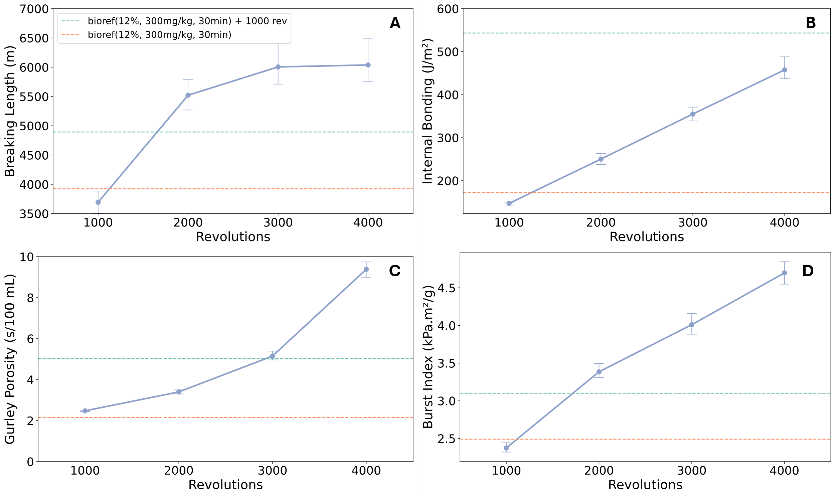
Fig.S2 Effect on breaking length (a), internal bonding (b), Gurley porosity (c) and burst index (d) for mechanically refined BKEP at different revolutions. Results for biorefined at 12 wt.%, 300 mg/kg, 30 min followed or not by mechanical refining, are also shown
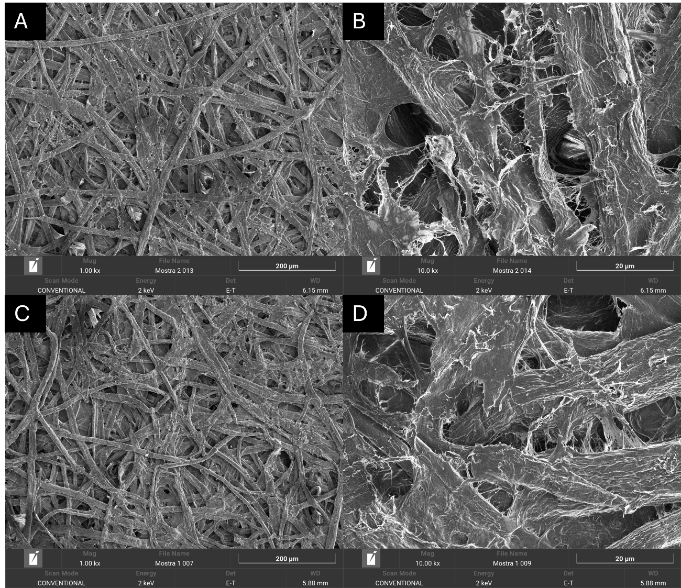
Fig.S3 SEM images of the paper surface from (a) PFI refined neat BKEP fibers at 1000 rev at 1 kx and (b) at 10 kx magnitude, (c) biorefined BKEP treated for 30 min at 12 wt.% consistency (300 mg/kg dosage) and subsequently PFI refined at 1000 revolutions at 1 kx and (d) at 10 kx magnitude

Prediction of mechanical properties using machine learning models

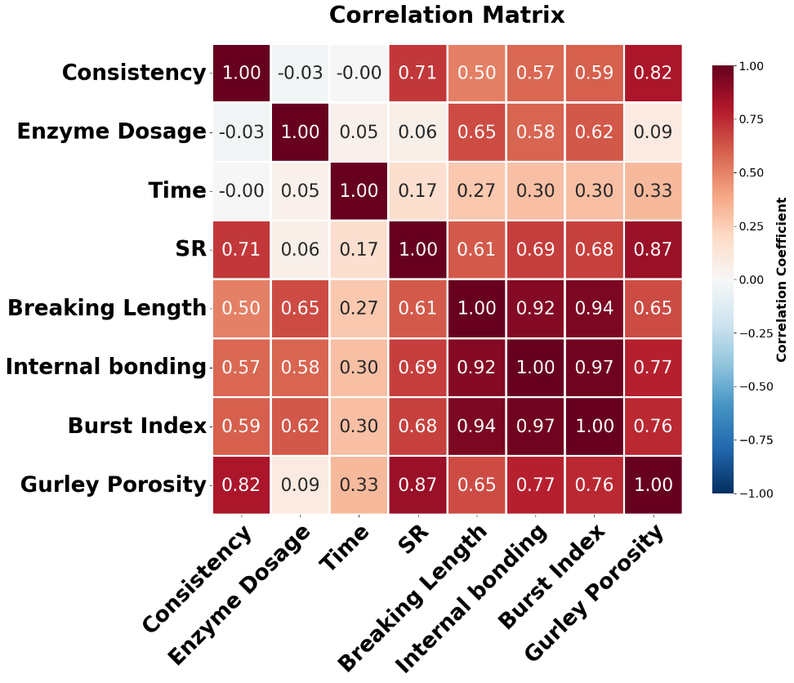
Fig.S4 Heatmap illustrating the Pearson correlation coefficients between the primary process variables (Consistency, enzyme dosage, yime), the intermediate fiber property (SR freeness), and the final material properties (Breaking length, internal bonding, burst Index, Gurley Porosity). The color scale indicates the strength and direction of the linear relationship: dark red signifies a strong positive correlation (approaching +1), while colors approaching white signify a weak or no correlation (0). Blue colors indicate a negative correlation
Table S6. Performance of the models by using time, consistency and enzyme concentration for training
Property | Model | Test R² | RMSE | MAE | MAPE (%)
Breaking length | Random Forest | 0.80 | 250.20 | 182.86 | 6.53
Breaking length | LightGBM | 0.89 | 188.56 | 133.29 | 4.94
Breaking length | SVM | 0.76 | 272.07 | 190.45 | 7.04
Breaking length | GPR | 0.47 | 403.75 | 323.04 | 10.63
Internal bonding | Random Forest | 0.86 | 17.23 | 14.57 | 15.37
Internal bonding | LightGBM | 0.91 | 13.95 | 10.38 | 8.18
Internal bonding | SVM | 0.70 | 25.71 | 20.32 | 20.94
Internal bonding | GPR | 0.71 | 25.21 | 18.95 | 20.72
Burst index | Random Forest | 0.90 | 0.16 | 0.13 | 7.88
Burst index | LightGBM | 0.96 | 0.10 | 0.09 | 5.49
Burst index | SVM | 0.78 | 0.23 | 0.21 | 12.15
Burst index | GPR | 0.84 | 0.19 | 0.17 | 9.70
Gurley porosity | Random Forest | 0.78 | 0.10 | 0.07 | 3.55
Gurley porosity | LightGBM | 0.87 | 0.08 | 0.06 | 3.13
Gurley porosity | SVM | 0.70 | 0.12 | 0.08 | 4.15
Gurley porosity | GPR | 0.77 | 0.10 | 0.07 | 3.64

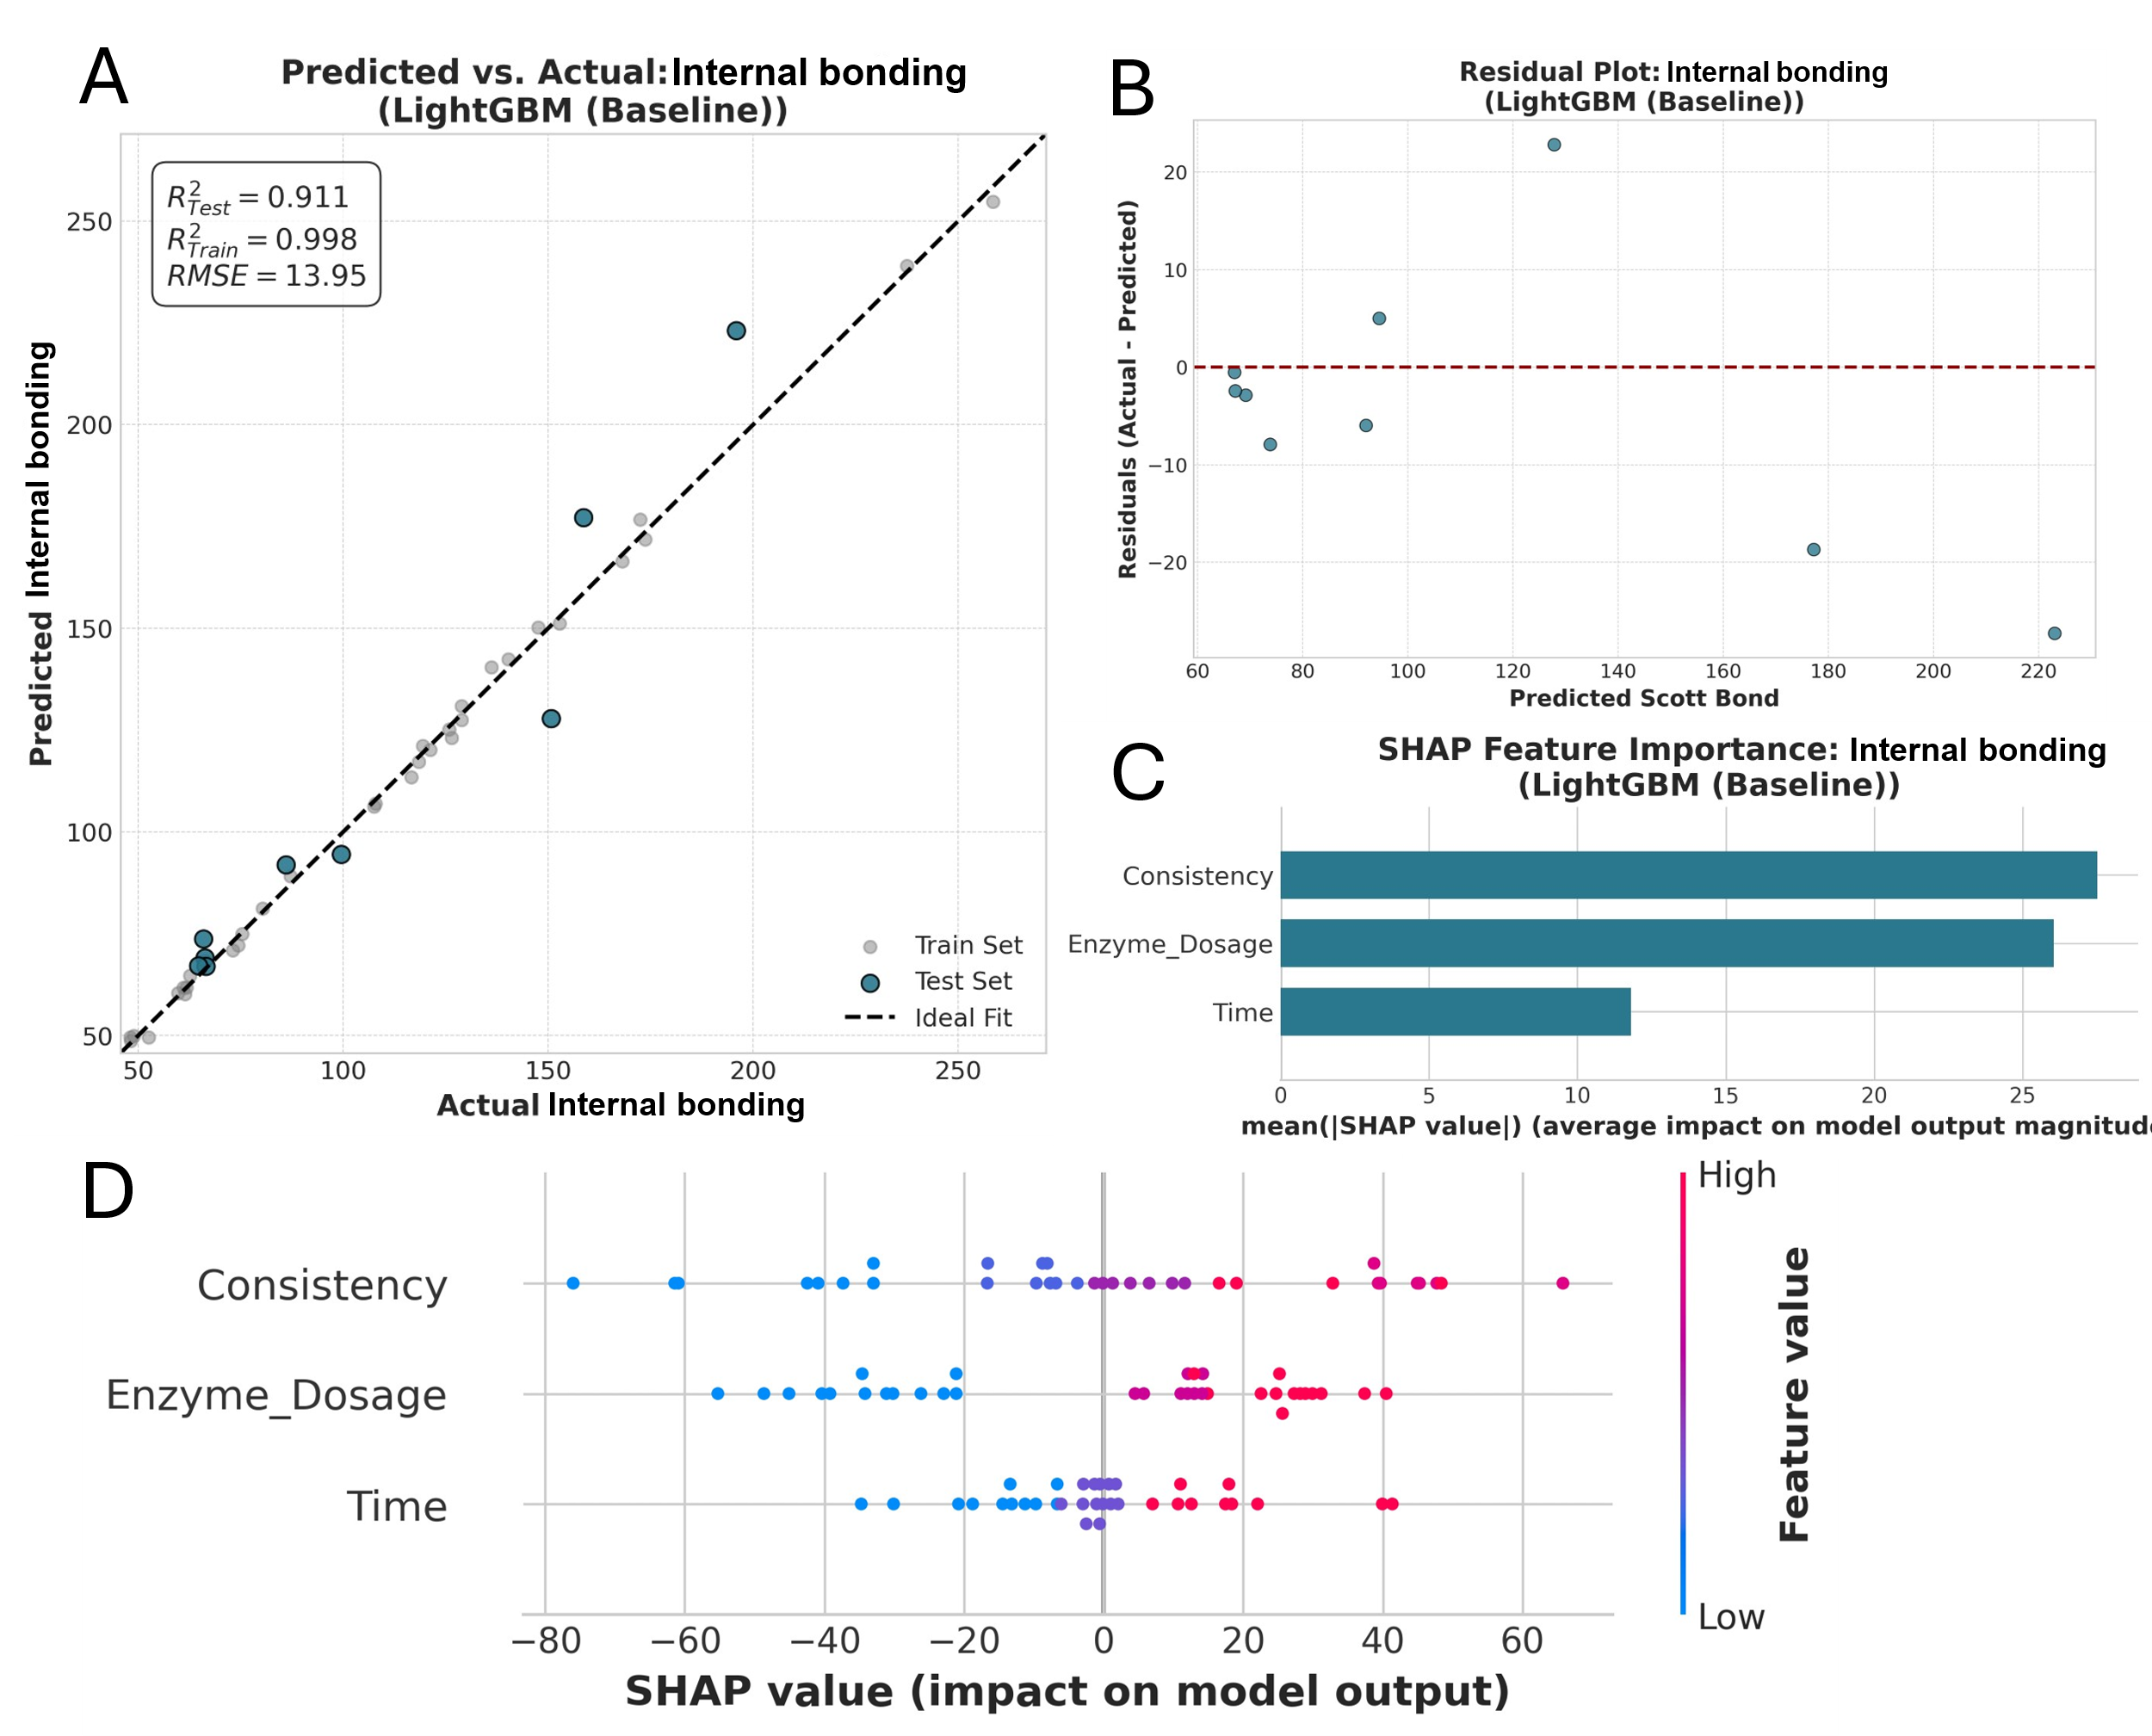
Fig.S5 Predictive modeling and SHAP analysis for internal bonding using a three feature LightGBM model (Inputs: Consistency, Time, Dosage). (a) Predicted vs. Actual plot on the test set (R²=0.911). (b) Residuals plot. (c) SHAP global feature importance. (d) SHAP feature influence plot
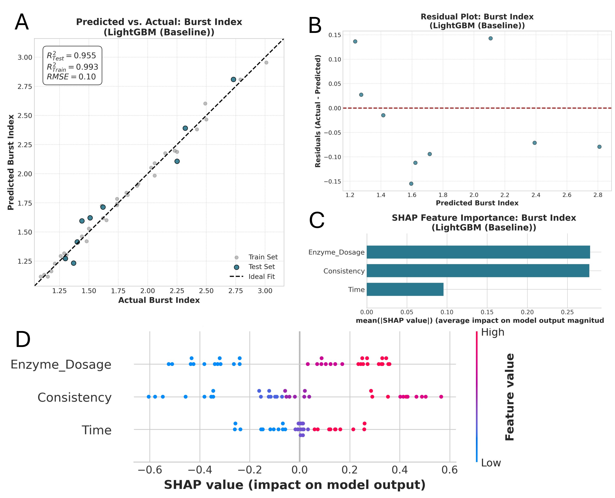
Fig.S6 Predictive modeling and SHAP analysis for Burst Index using a three feature LightGBM model (Inputs: Consistency, Time, Dosage). (a) Predicted vs. Actual plot on the test set (R²=0.955). (b) Residuals plot. (c) SHAP global feature importance. (d) SHAP feature influence plot
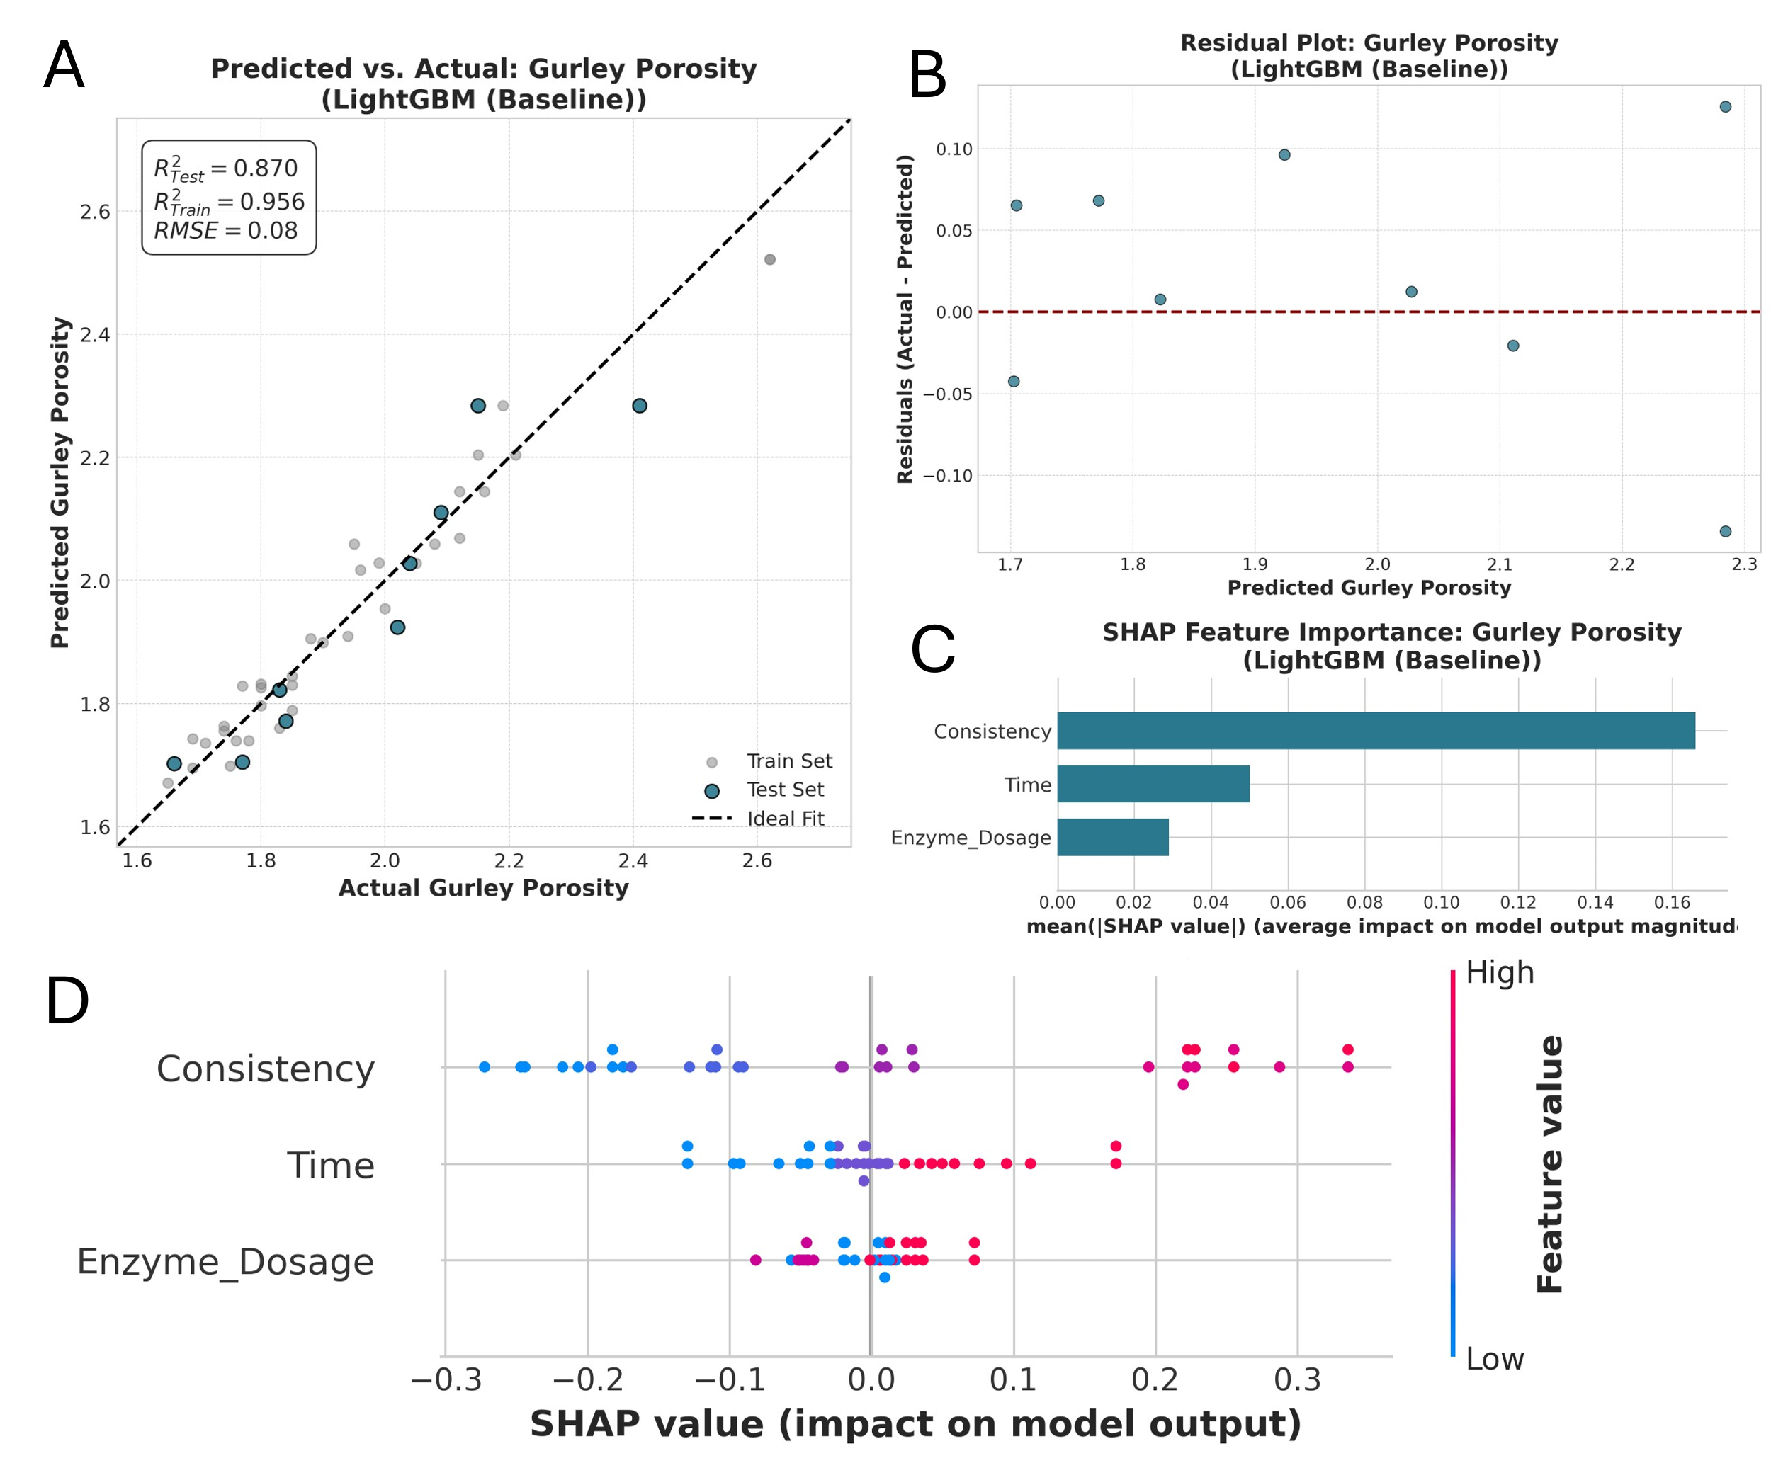
Fig.S7 Predictive modeling and SHAP analysis for Gurley porosity using a minimal-feature LightGBM model (Inputs: Consistency, Time, Dosage). (a) Predicted vs. Actual plot on the test set (R²=0.870). (b) Residuals plot. (c) SHAP global feature importance. (d) SHAP feature influence plot

Predictive modeling using as variables SR, time, consistency, enzyme concentration
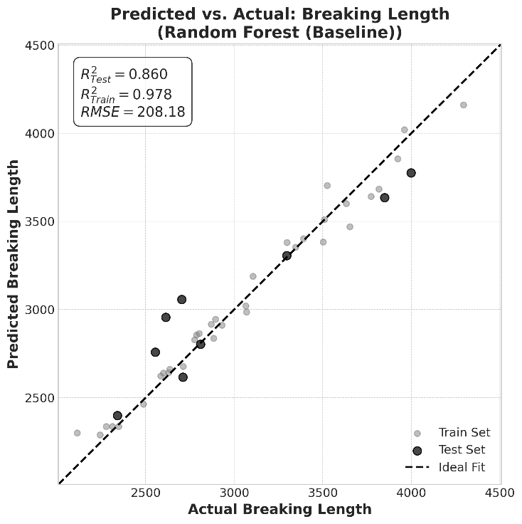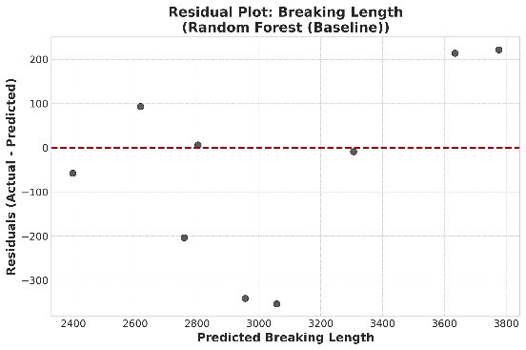
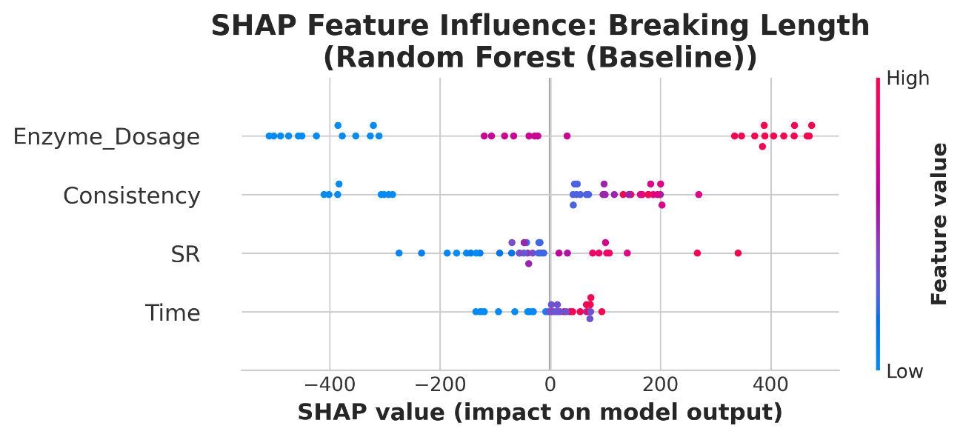
Fig.S8 Predictive modeling and SHAP analysis for breaking length using a four feature RF model (Inputs: Consistency, Time, Dosage, and SR). Top left: Predicted vs. Actual plot on the test set (R²=0.860). Top right: Residuals plot. Bottom: SHAP feature influence plot

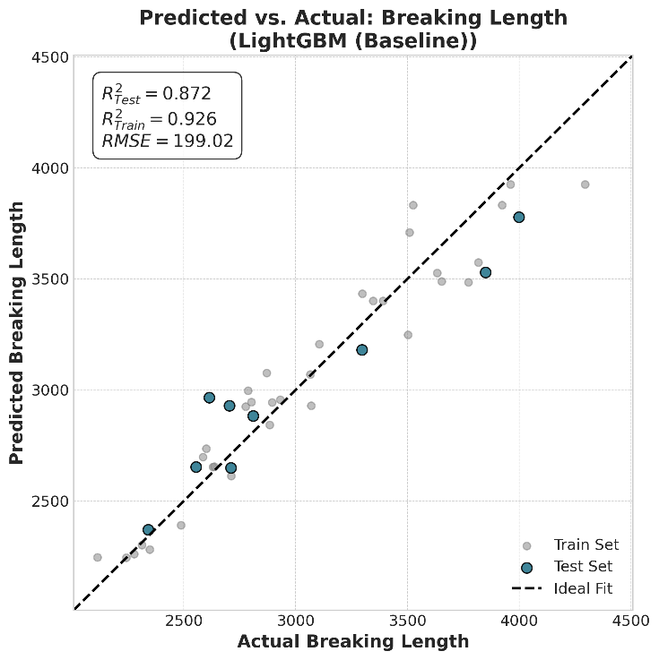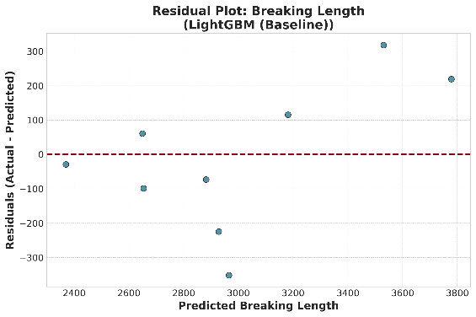
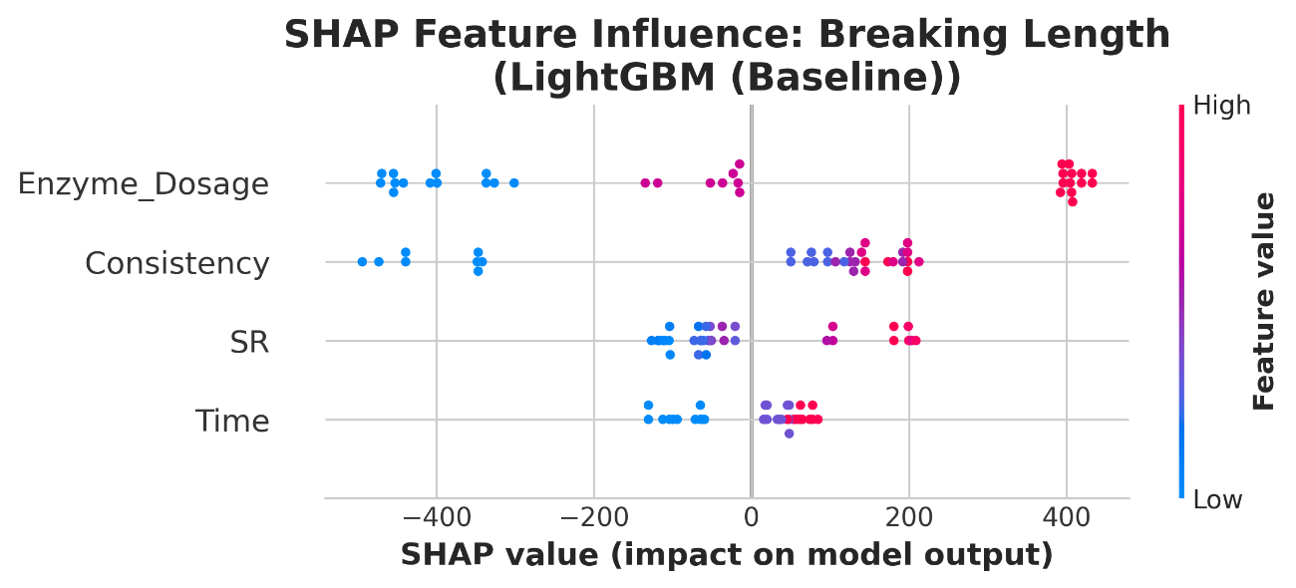
Fig.S9 Predictive modeling and SHAP analysis for breaking length using a four feature LigthGBM model (Inputs: Consistency, Time, Dosage, and SR). Top left: Predicted vs. Actual plot on the test set (R²=0.872). Top right: Residuals plot. Bottom: SHAP feature influence plot
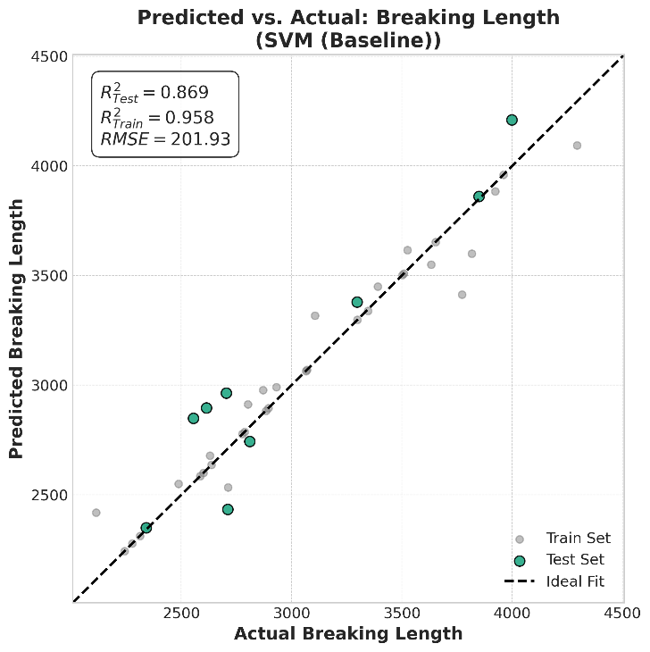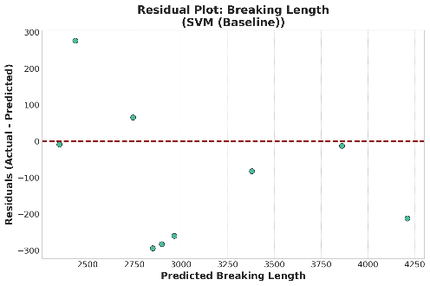
Fig.S10 Predictive modeling for breaking length using a four feature SVM model (Inputs: Consistency, Time, Dosage, and SR). Left: Predicted vs. Actual plot on the test set (R²=0.869). Right: Residuals plot

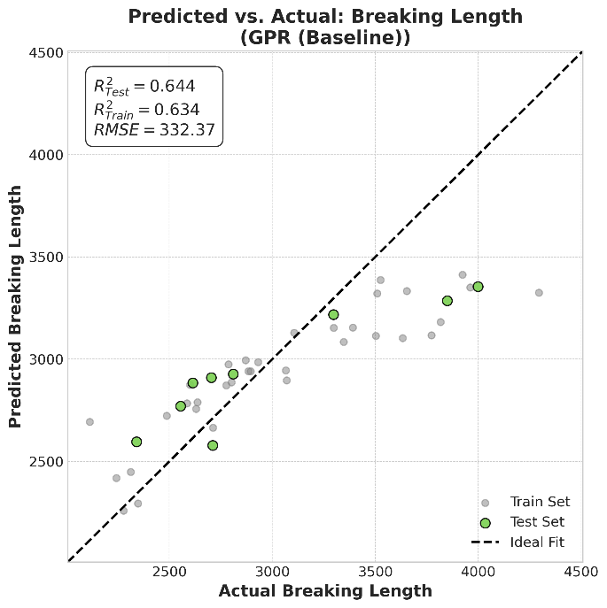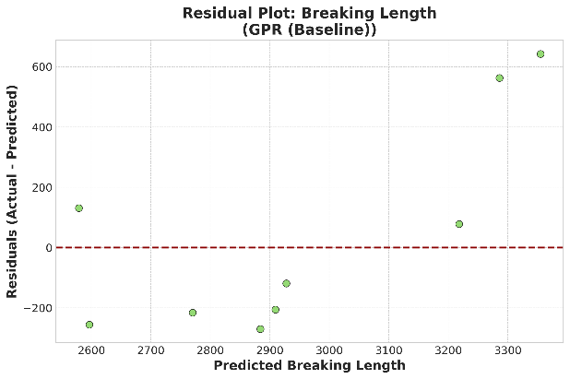
Fig.S11 Predictive modeling for breaking length using a four feature GPR model (Inputs: Consistency, Time, Dosage, and SR). Left: Predicted vs. Actual plot on the test set (R²=0.644). Right: Residuals plot
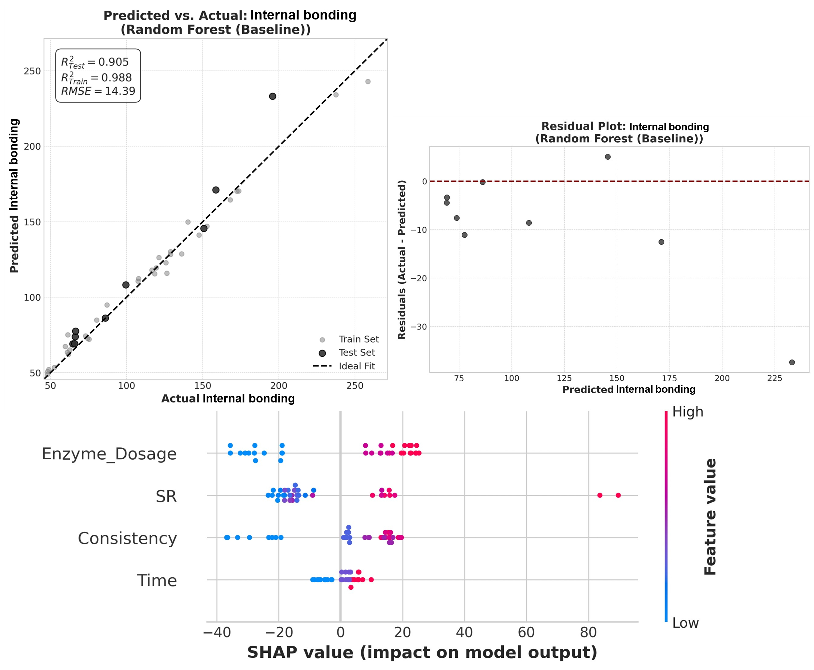

Fig.S12 Predictive modeling and SHAP analysis for internal bonding using a four feature RF model (Inputs: Consistency, Time, Dosage, and SR). Top left: Predicted vs. Actual plot on the test set (R²=0.905). Top right: Residuals plot. Bottom: SHAP feature influence plot
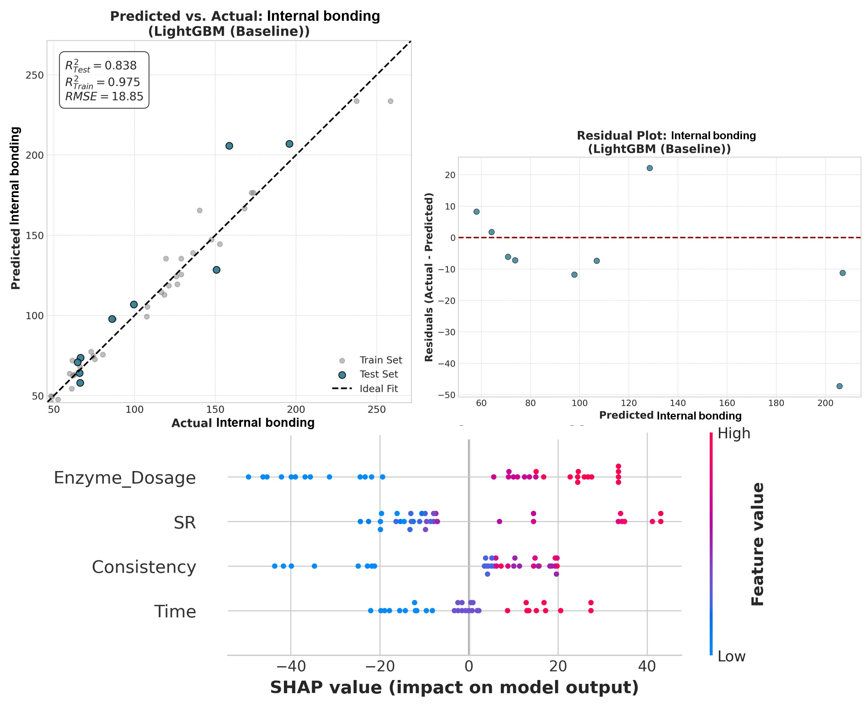
Fig.S13 Predictive modeling and SHAP analysis for internal bonding using a four feature LightGBM model (Inputs: Consistency, Time, Dosage, and SR). Top left: Predicted vs. Actual plot on the test set (R²=0.838). Top right: Residuals plot. Bottom: SHAP feature influence plot

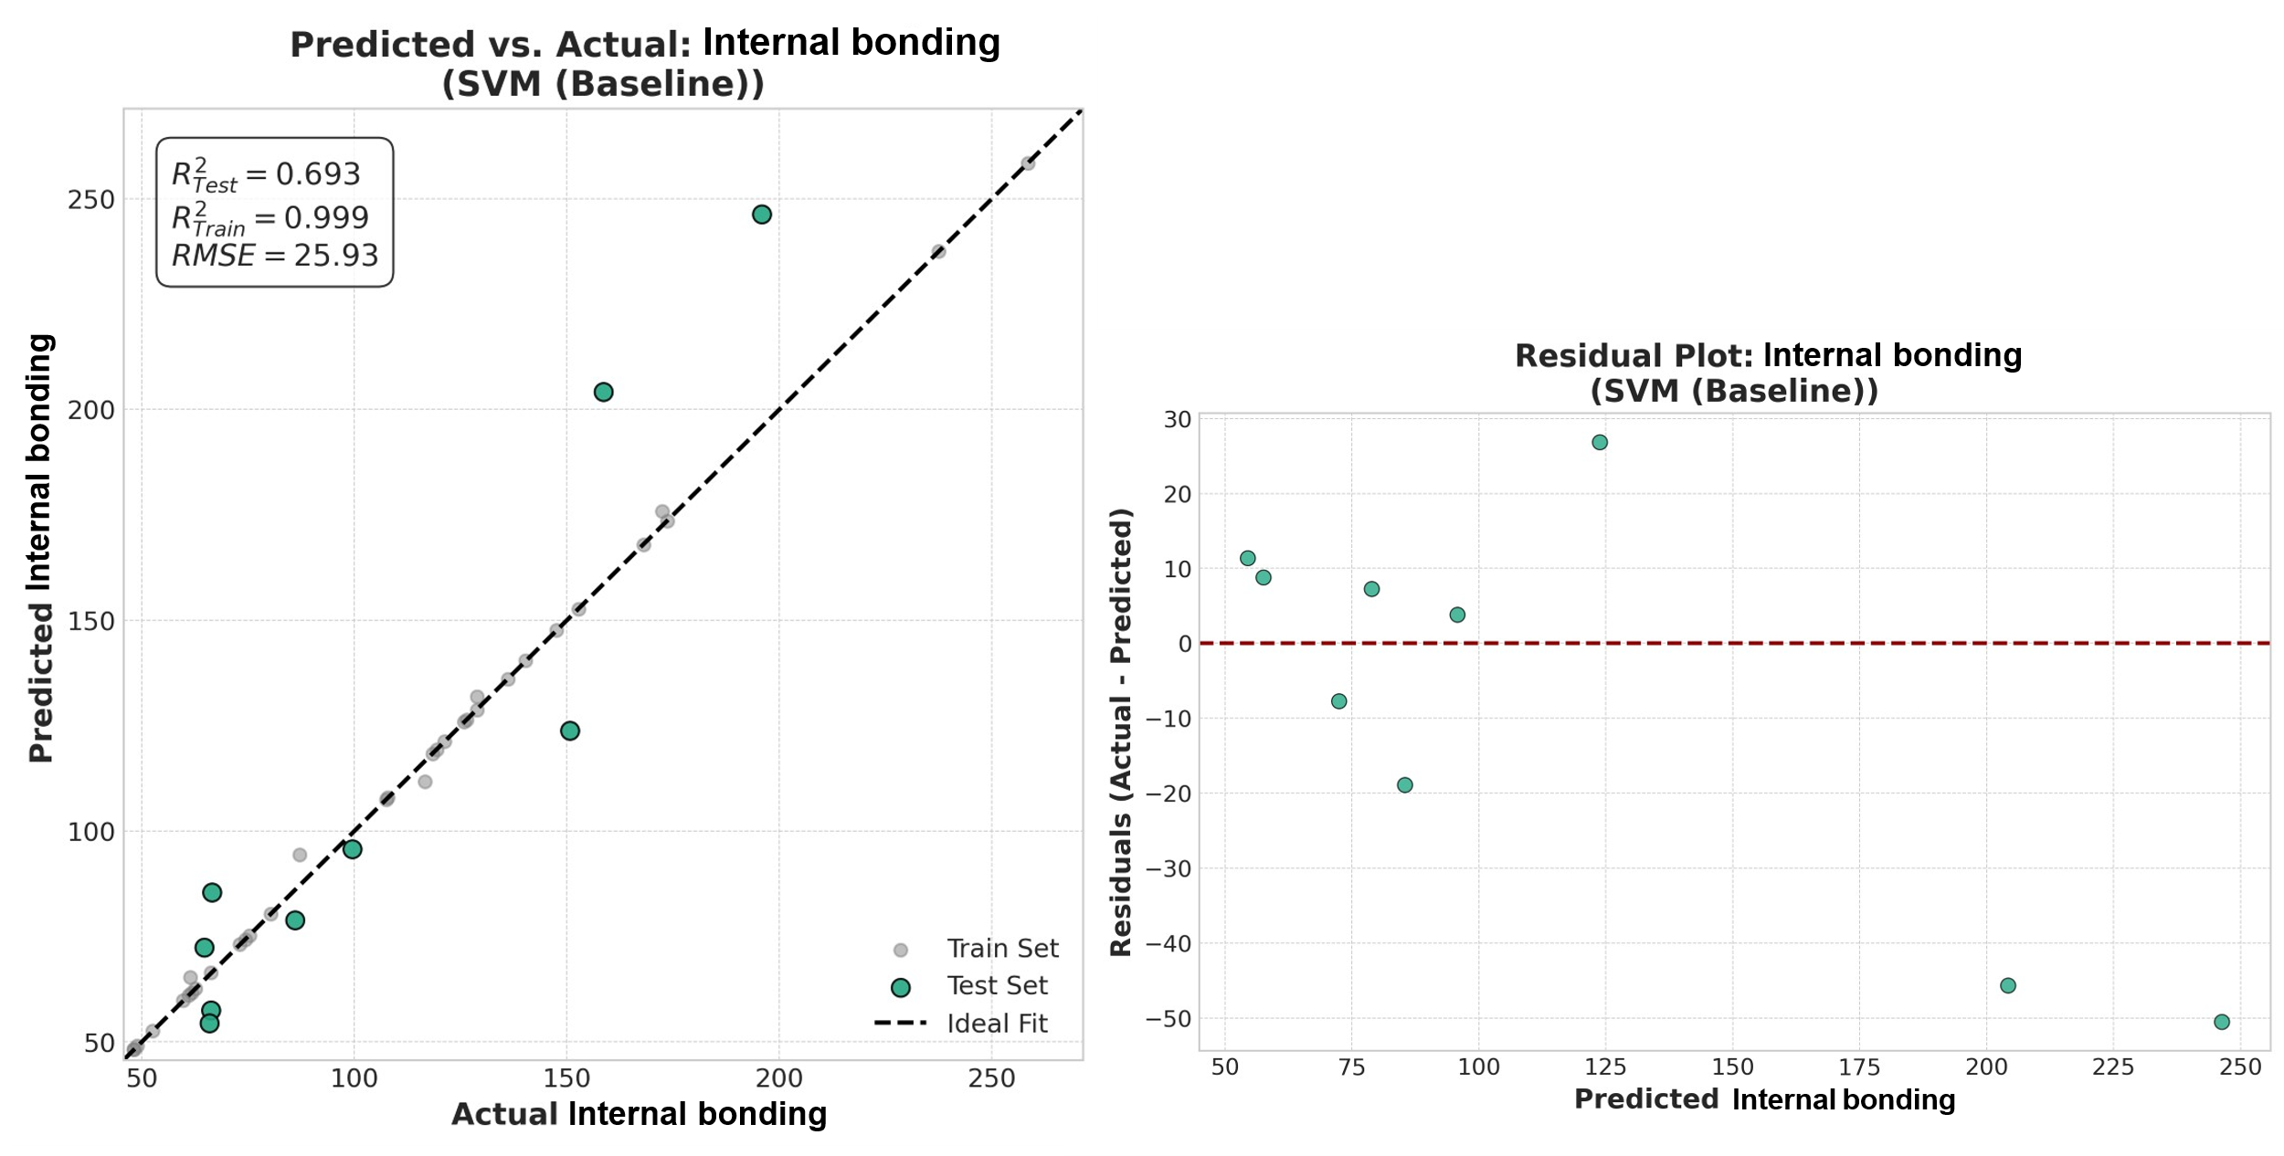
Fig.S14 Predictive modeling for internal bonding using a four feature SVM model (Inputs: Consistency, Time, Dosage, and SR). Left: Predicted vs. Actual plot on the test set (R²=0.693). Right: Residuals plo
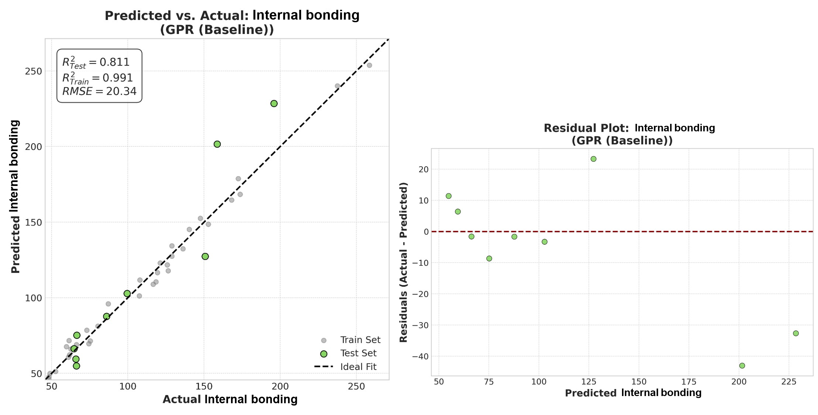
Fig.S15 Predictive modeling for internal bonding using a four feature GPR model (Inputs: Consistency, Time, Dosage, and SR). Left: Predicted vs. Actual plot on the test set (R²=0.811). Right: Residuals plot

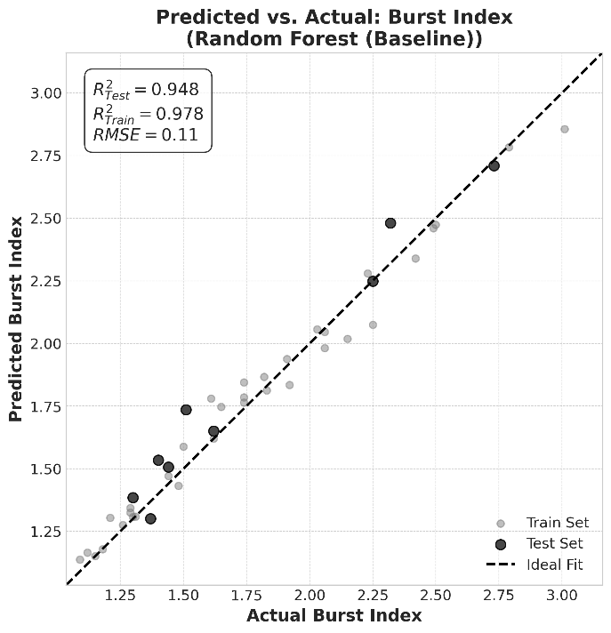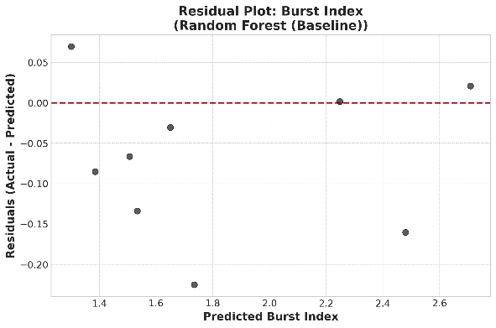
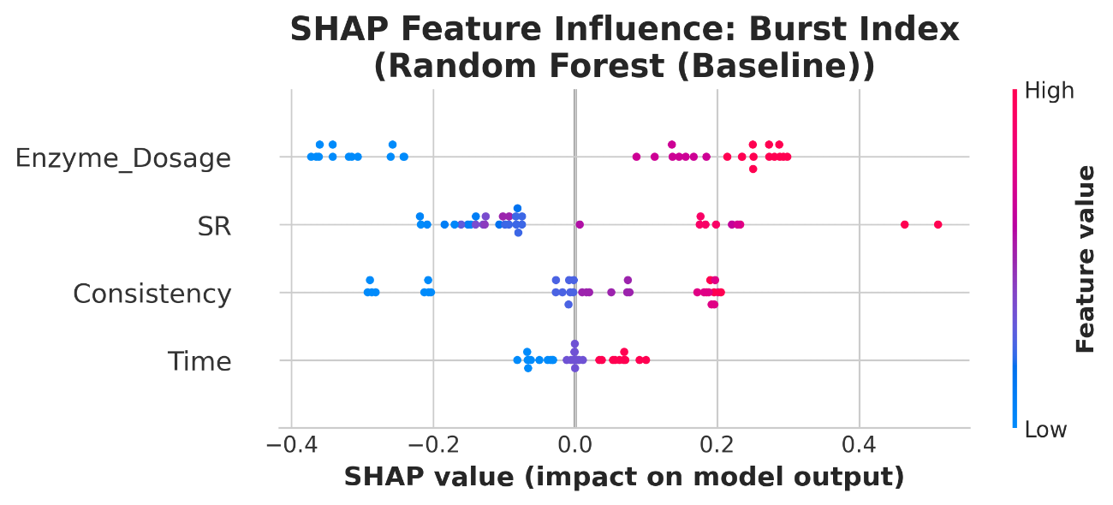
Fig.S16 Predictive modeling and SHAP analysis for burst index using a four feature RF model (Inputs: Consistency, Time, Dosage, and SR). Top left: Predicted vs. Actual plot on the test set (R²=0.948). Top right: Residuals plot. Bottom: SHAP feature influence plot

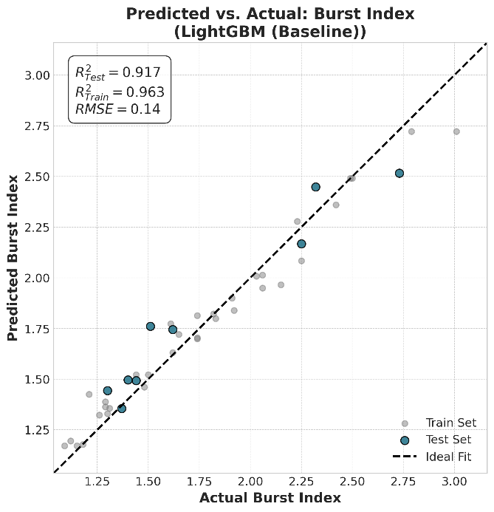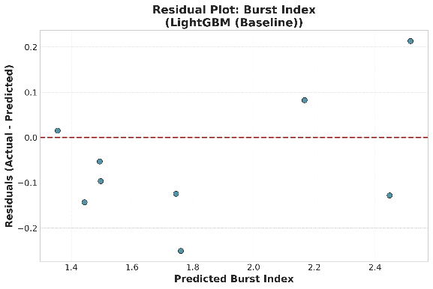
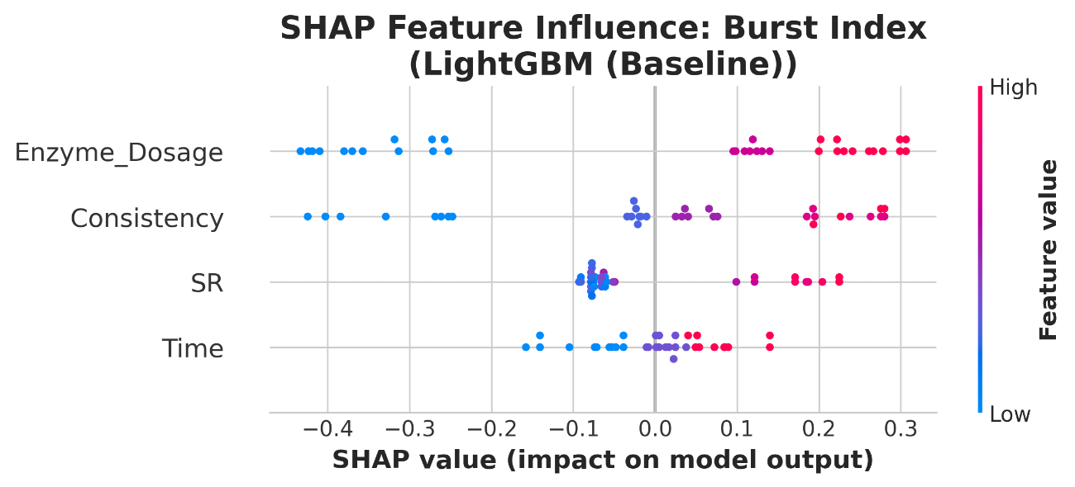
Fig.S17 Predictive modeling and SHAP analysis for burst index using a four feature LigthGBM model (Inputs: Consistency, Time, Dosage, and SR). Top left: Predicted vs. Actual plot on the test set (R²=0.963). Top right: Residuals plot. Bottom: SHAP feature influence plot

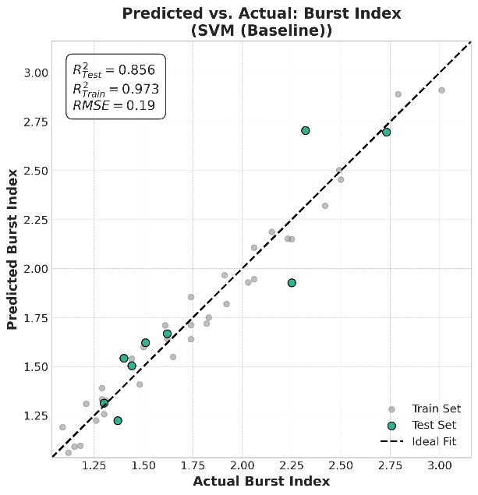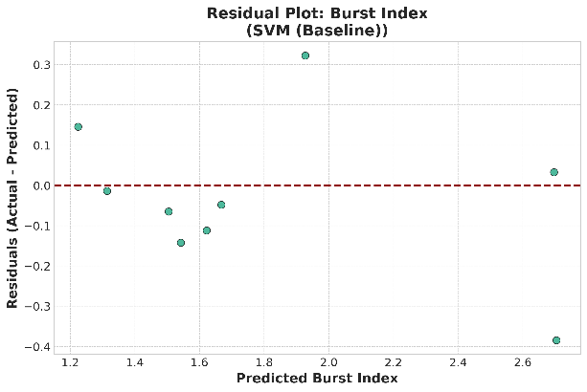
Fig.S18 Predictive modeling for burst index using a four feature SVM model (Inputs: Consistency, Time, Dosage, and SR). Left: Predicted vs. Actual plot on the test set (R²=0.856). Right: Residuals plot

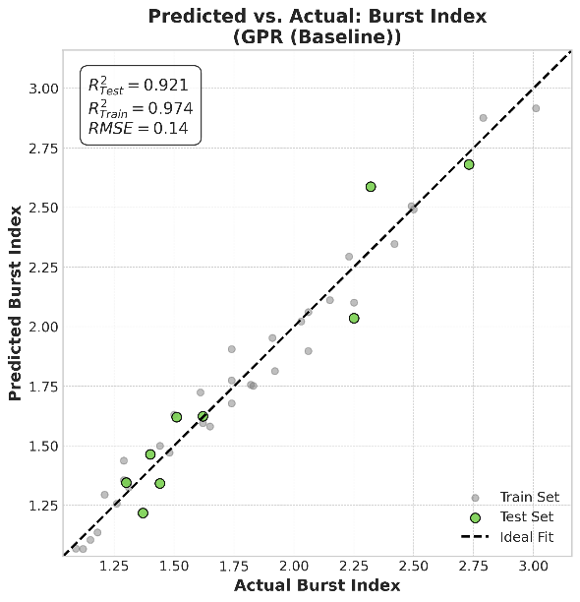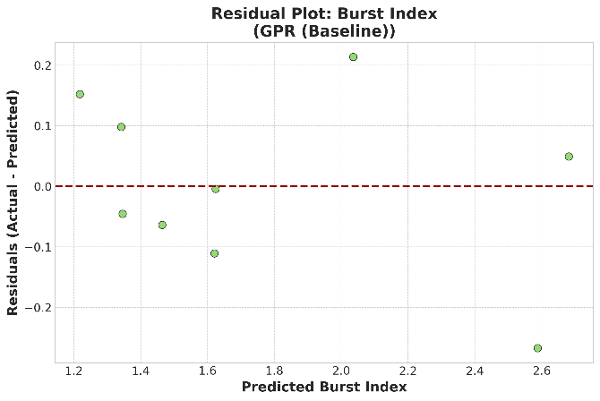
Fig.S19 Predictive modeling for burst index using a four feature GPR model (Inputs: Consistency, Time, Dosage, and SR). Left: Predicted vs. Actual plot on the test set (R²=0.921). Right: Residuals plot

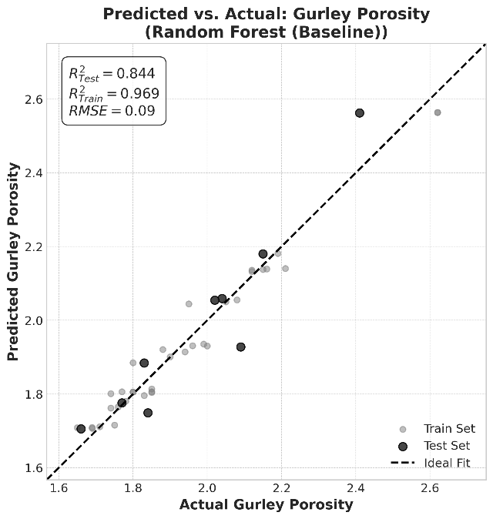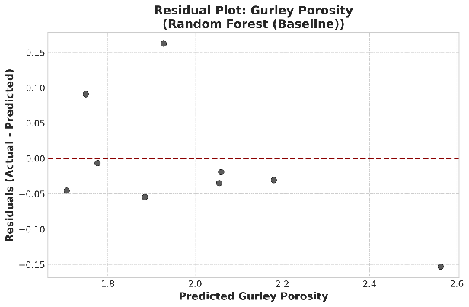

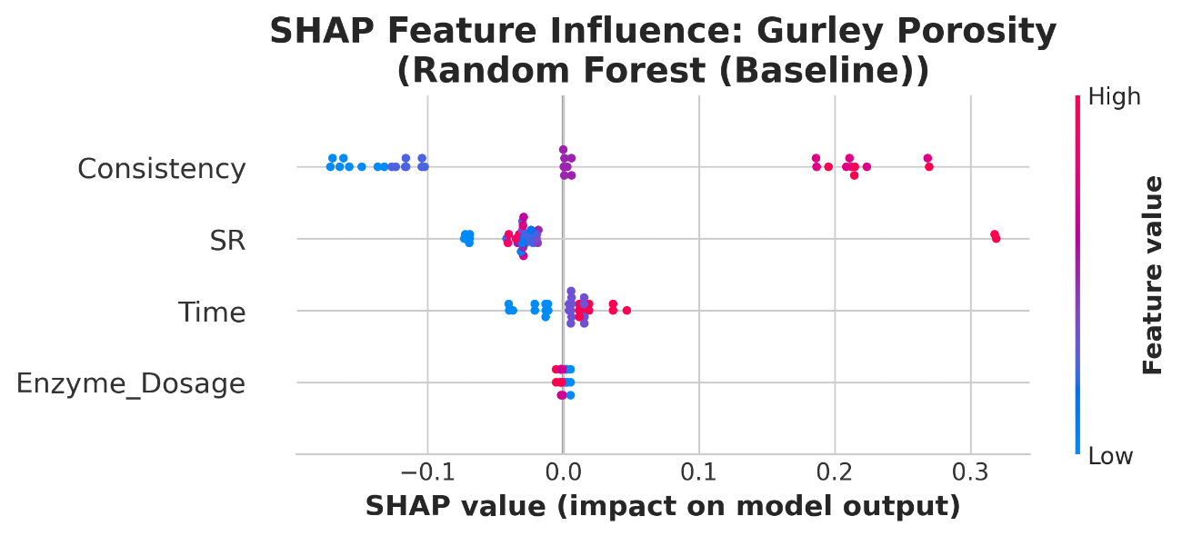
Fig.S20 Predictive modeling and SHAP analysis for Gurley porosity using a four feature RF model (Inputs: Consistency, Time, Dosage, and SR). Top left: Predicted vs. Actual plot on the test set (R²=0.844). Top right: Residuals plot. Bottom: SHAP feature influence plot

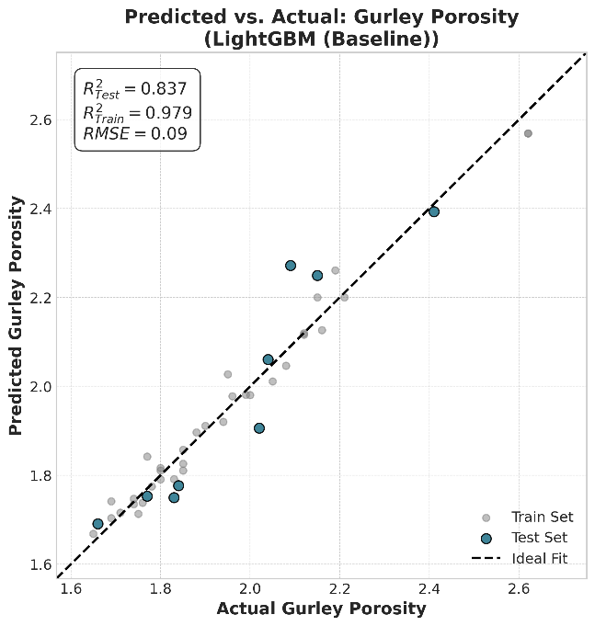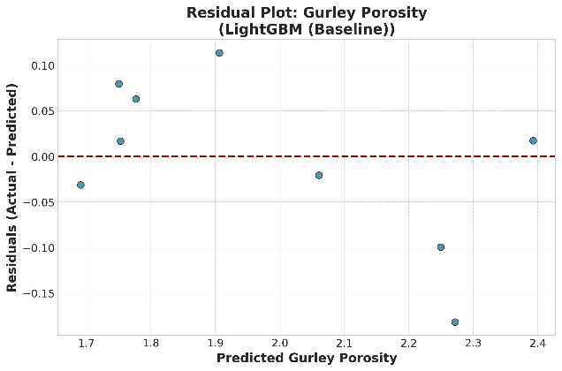
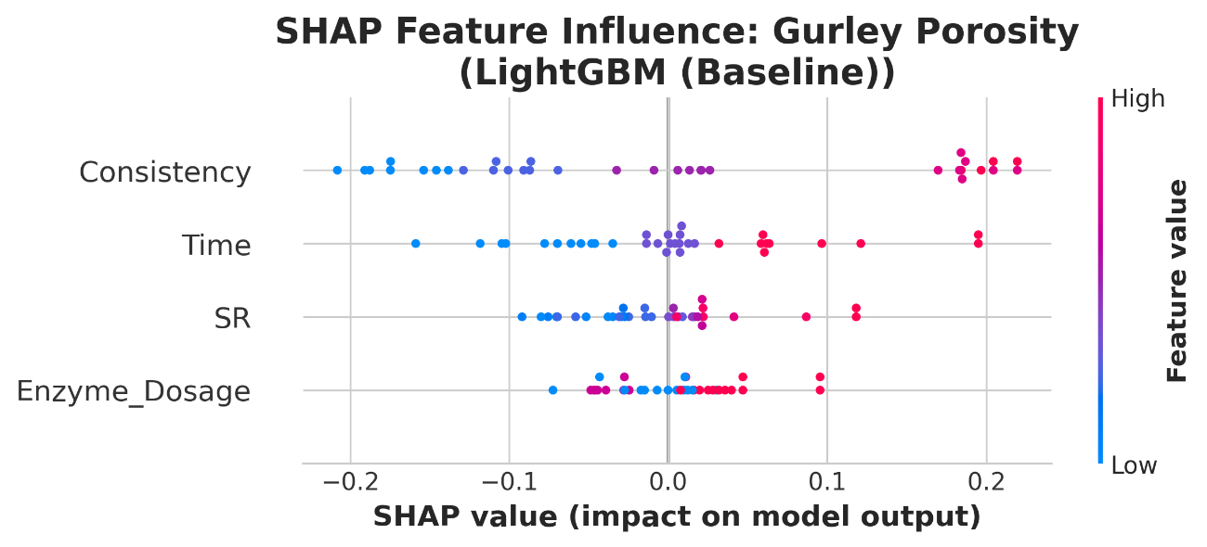
Fig.S21 Predictive modeling and SHAP analysis for Gurley porosity using a four feature LightGBM model (Inputs: Consistency, Time, Dosage, and SR). Top left: Predicted vs. Actual plot on the test set (R²=0.837). Top right: Residuals plot. Bottom: SHAP feature influence plot

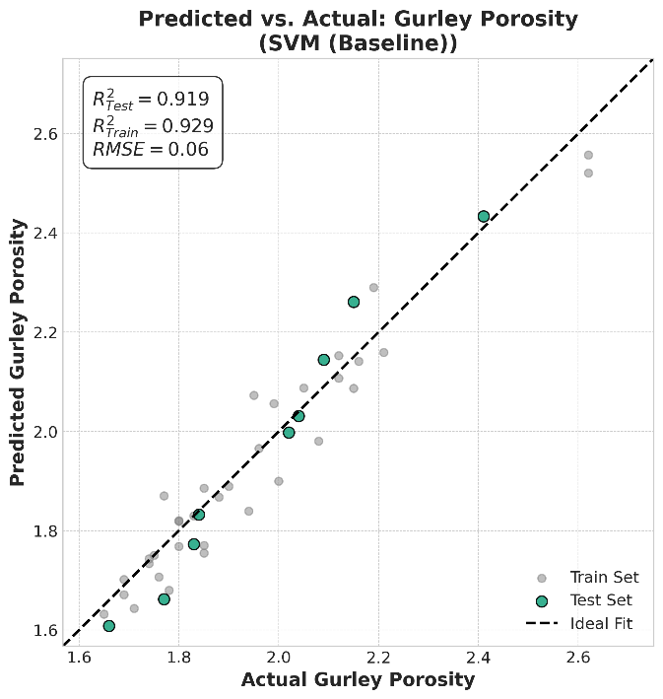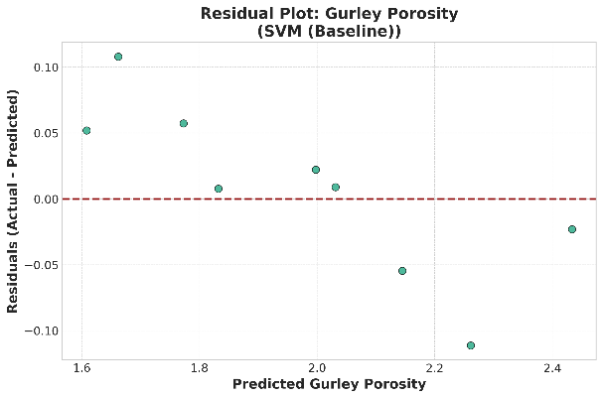
Fig.S22 Predictive modeling for Gurley porosity using a four feature SVM model (Inputs: Consistency, Time, Dosage, and SR). Left: Predicted vs. Actual plot on the test set (R²=0.919). Right: Residuals plot

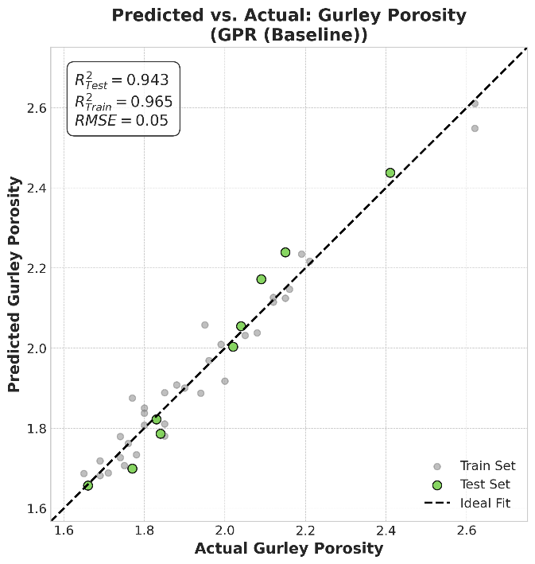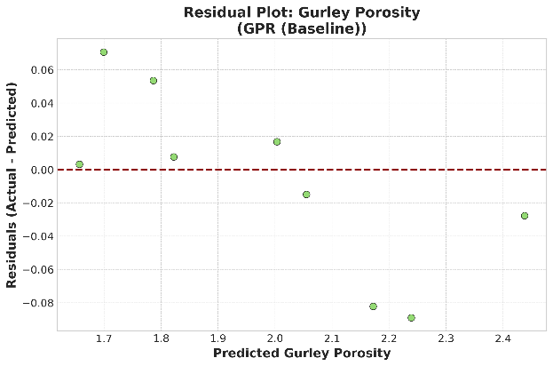
Fig.S23 Predictive modeling for Gurley porosity using a four feature GPR model (Inputs: Consistency, Time, Dosage, and SR). Left: Predicted vs. Actual plot on the test set (R²=0.943). Right: Residuals plot
S.3. Predictive modeling with data augmentation
Table S7. Generated synthetic data with random forest using as variables SR, time, consistency, enzyme concentration
Consistency | Time | Enzyme_Dosage | SR | Breaking_Length | Internal_Bonding | Burst_Index | Gurley_Porosity
3 | 15 | 100 | 15.6683 | 2294.843 | 72.3048 | 1.3102 | 1.7049
3 | 30 | 100 | 15.5754 | 2422.277 | 56.6603 | 1.2268 | 1.7161
3 | 60 | 100 | 15.0716 | 2441.89 | 60.0725 | 1.3603 | 1.6834
3 | 15 | 400 | 16.023 | 2809.225 | 71.9459 | 1.4847 | 1.7318
3 | 30 | 400 | 16.4364 | 3134.906 | 113.305 | 1.7689 | 1.8499
3 | 60 | 400 | 16.0203 | 3027.191 | 111.0309 | 1.7295 | 1.7517
6 | 15 | 100 | 17.3725 | 2911.332 | 113.4386 | 1.6874 | 1.8226
6 | 30 | 100 | 16.125 | 2904.66 | 87.1679 | 1.627 | 1.8151
6 | 60 | 100 | 15.7017 | 2929.961 | 122.0862 | 1.8646 | 1.7339
6 | 15 | 400 | 16.375 | 3422.98 | 118.9498 | 1.8785 | 1.8388
6 | 30 | 400 | 16.9425 | 3579.145 | 127.3878 | 1.9786 | 1.8102
6 | 60 | 400 | 16.345 | 3603.293 | 137.6313 | 2.0936 | 1.781
9 | 15 | 100 | 16.5125 | 3263.485 | 122.6451 | 1.9673 | 1.8567
9 | 30 | 100 | 16.3425 | 2988.717 | 119.0257 | 1.9077 | 1.9253
9 | 60 | 100 | 16.845 | 3505.842 | 136.2858 | 2.0525 | 1.8749
9 | 15 | 400 | 16.715 | 3384.394 | 128.6508 | 1.8242 | 1.8292
9 | 30 | 400 | 16.3425 | 3780.746 | 146.7597 | 2.2313 | 1.9398
9 | 60 | 400 | 16.625 | 3664.189 | 143.0299 | 2.1254 | 1.9016
12 | 15 | 100 | 19.1275 | 3379.361 | 126.4784 | 1.8563 | 2.0445
12 | 30 | 100 | 18.6425 | 3432.257 | 123.5849 | 1.8579 | 2.1433
12 | 60 | 100 | 19.86 | 3799.355 | 180.2643 | 2.7202 | 2.3354
12 | 15 | 400 | 18.8825 | 3471.123 | 148.8035 | 2.2355 | 2.0008
12 | 30 | 400 | 18.4925 | 3788.038 | 159.6748 | 2.3532 | 2.1458
12 | 60 | 400 | 20.2225 | 4139.785 | 236.9566 | 2.8198 | 2.62
15 | 15 | 100 | 17.3247 | 3149.752 | 121.8424 | 1.8202 | 2.0777
15 | 30 | 100 | 18.2325 | 3428.561 | 136.6535 | 1.9448 | 2.113
15 | 60 | 100 | 18.775 | 3609.805 | 165.0079 | 2.4996 | 2.1905
15 | 15 | 400 | 17.7575 | 3376.887 | 121.9527 | 1.8287 | 2.0549
15 | 30 | 400 | 17.8025 | 3817.709 | 174.5246 | 2.5228 | 2.1957
15 | 60 | 400 | 19.685 | 3892.924 | 201.6137 | 2.6126 | 2.283

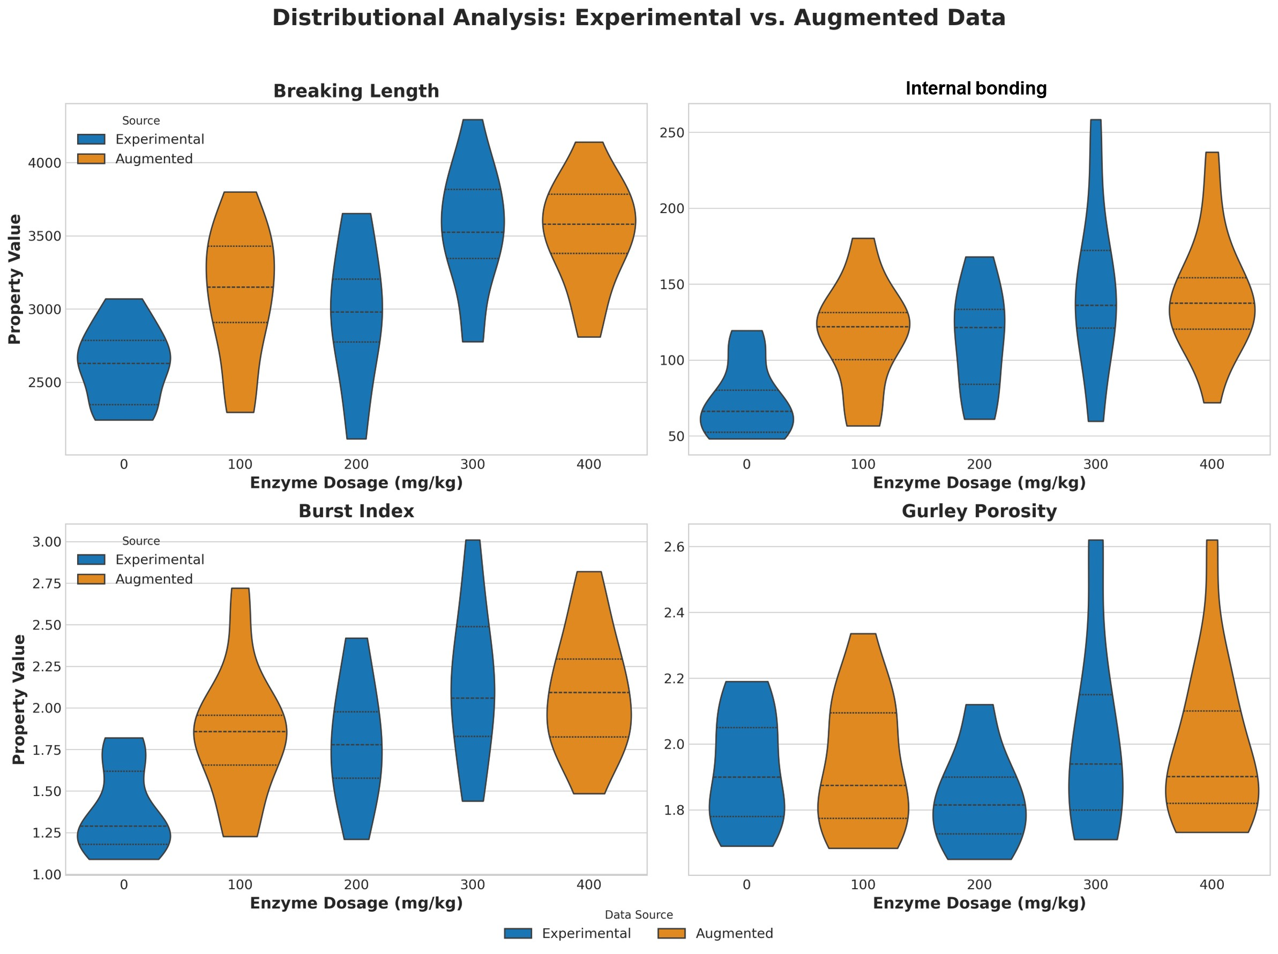

Fig.S24 Distributional comparison of experimental versus augmented data across different process conditions. The violin plots show the distribution of breaking length, internal bonding, burst index, and Gurley porosity as a function of enzyme dosage. For each property, the probability density of the original experimental data (blue) is compared against the synthetically augmented data (orange). The dashed lines within each violin represent the data quartiles (the median and interquartile range)

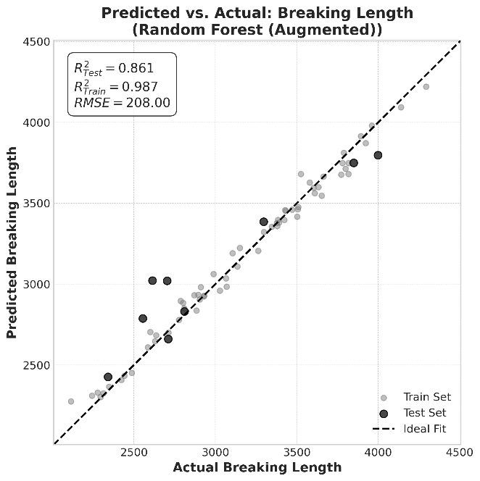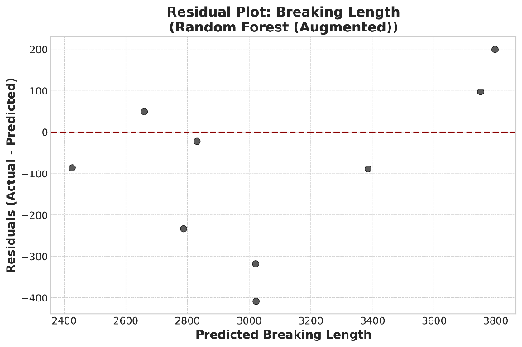
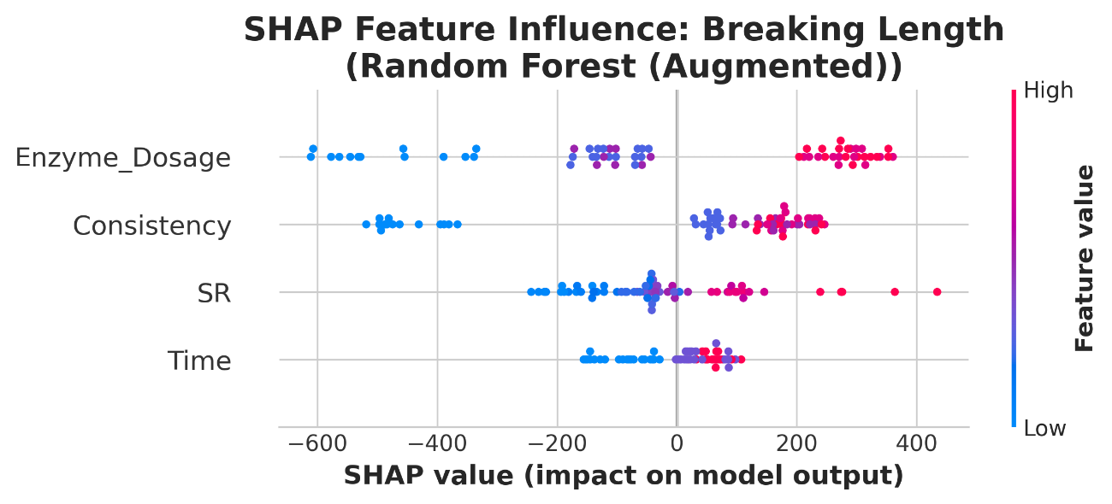
Fig.S25 Predictive modeling and SHAP analysis for breaking length using a four feature RF augmented model (Inputs: Consistency, Time, Dosage, and SR). Top left: Predicted vs. Actual plot on the test set (R²=0.861). Top right: Residuals plot. Bottom: SHAP feature influence plot

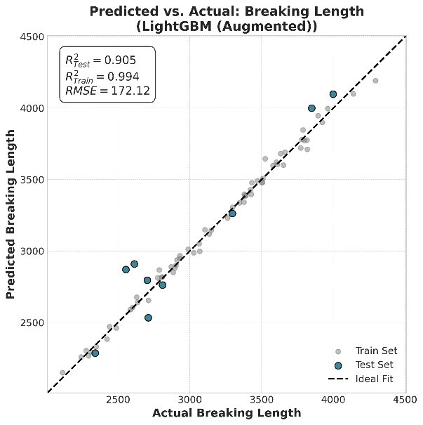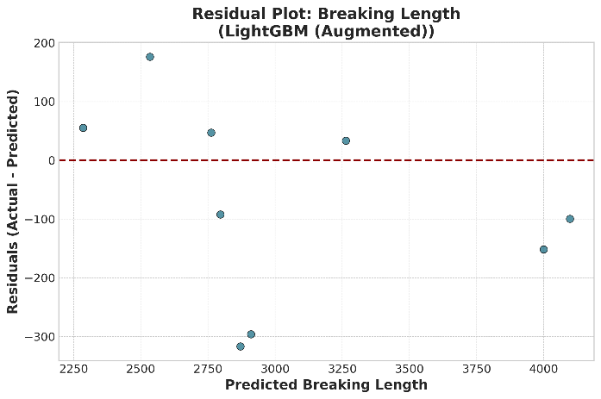
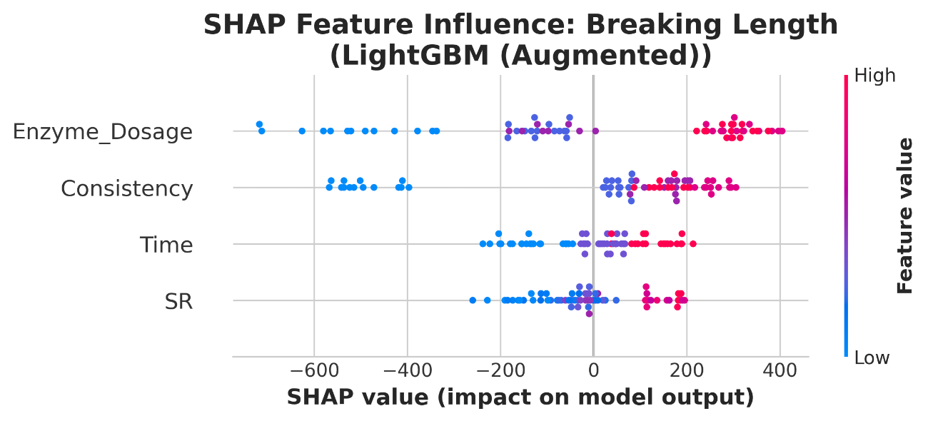
Fig.S26 Predictive modeling and SHAP analysis for breaking length using a four feature LightGBM augmented model (Inputs: Consistency, Time, Dosage, and SR). Top left: Predicted vs. Actual plot on the test set (R²=0.905). Top right: Residuals plot. Bottom: SHAP feature influence plot

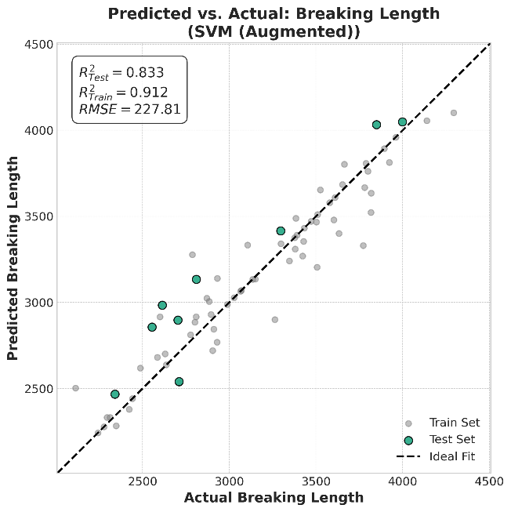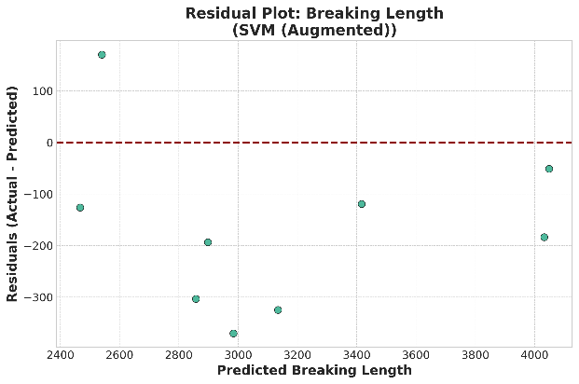
Fig.S23 Predictive modeling for breaking length using a four feature SVM augmented model (Inputs: Consistency, Time, Dosage, and SR). Left: Predicted vs. Actual plot on the test set (R²=0.833). Right: Residuals ploy

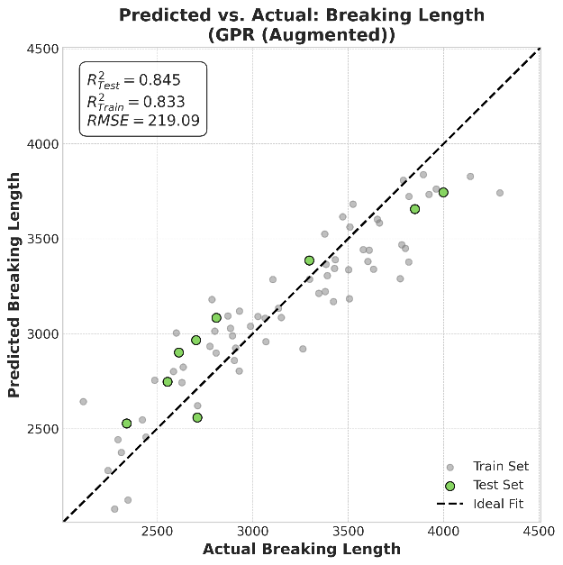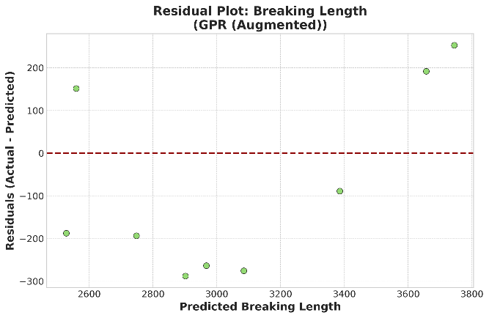
Fig.S27 Predictive modeling for breaking length using a four feature GPR augmented model (Inputs: Consistency, Time, Dosage, and SR). Left: Predicted vs. Actual plot on the test set (R²=0.845). Right: Residuals plot
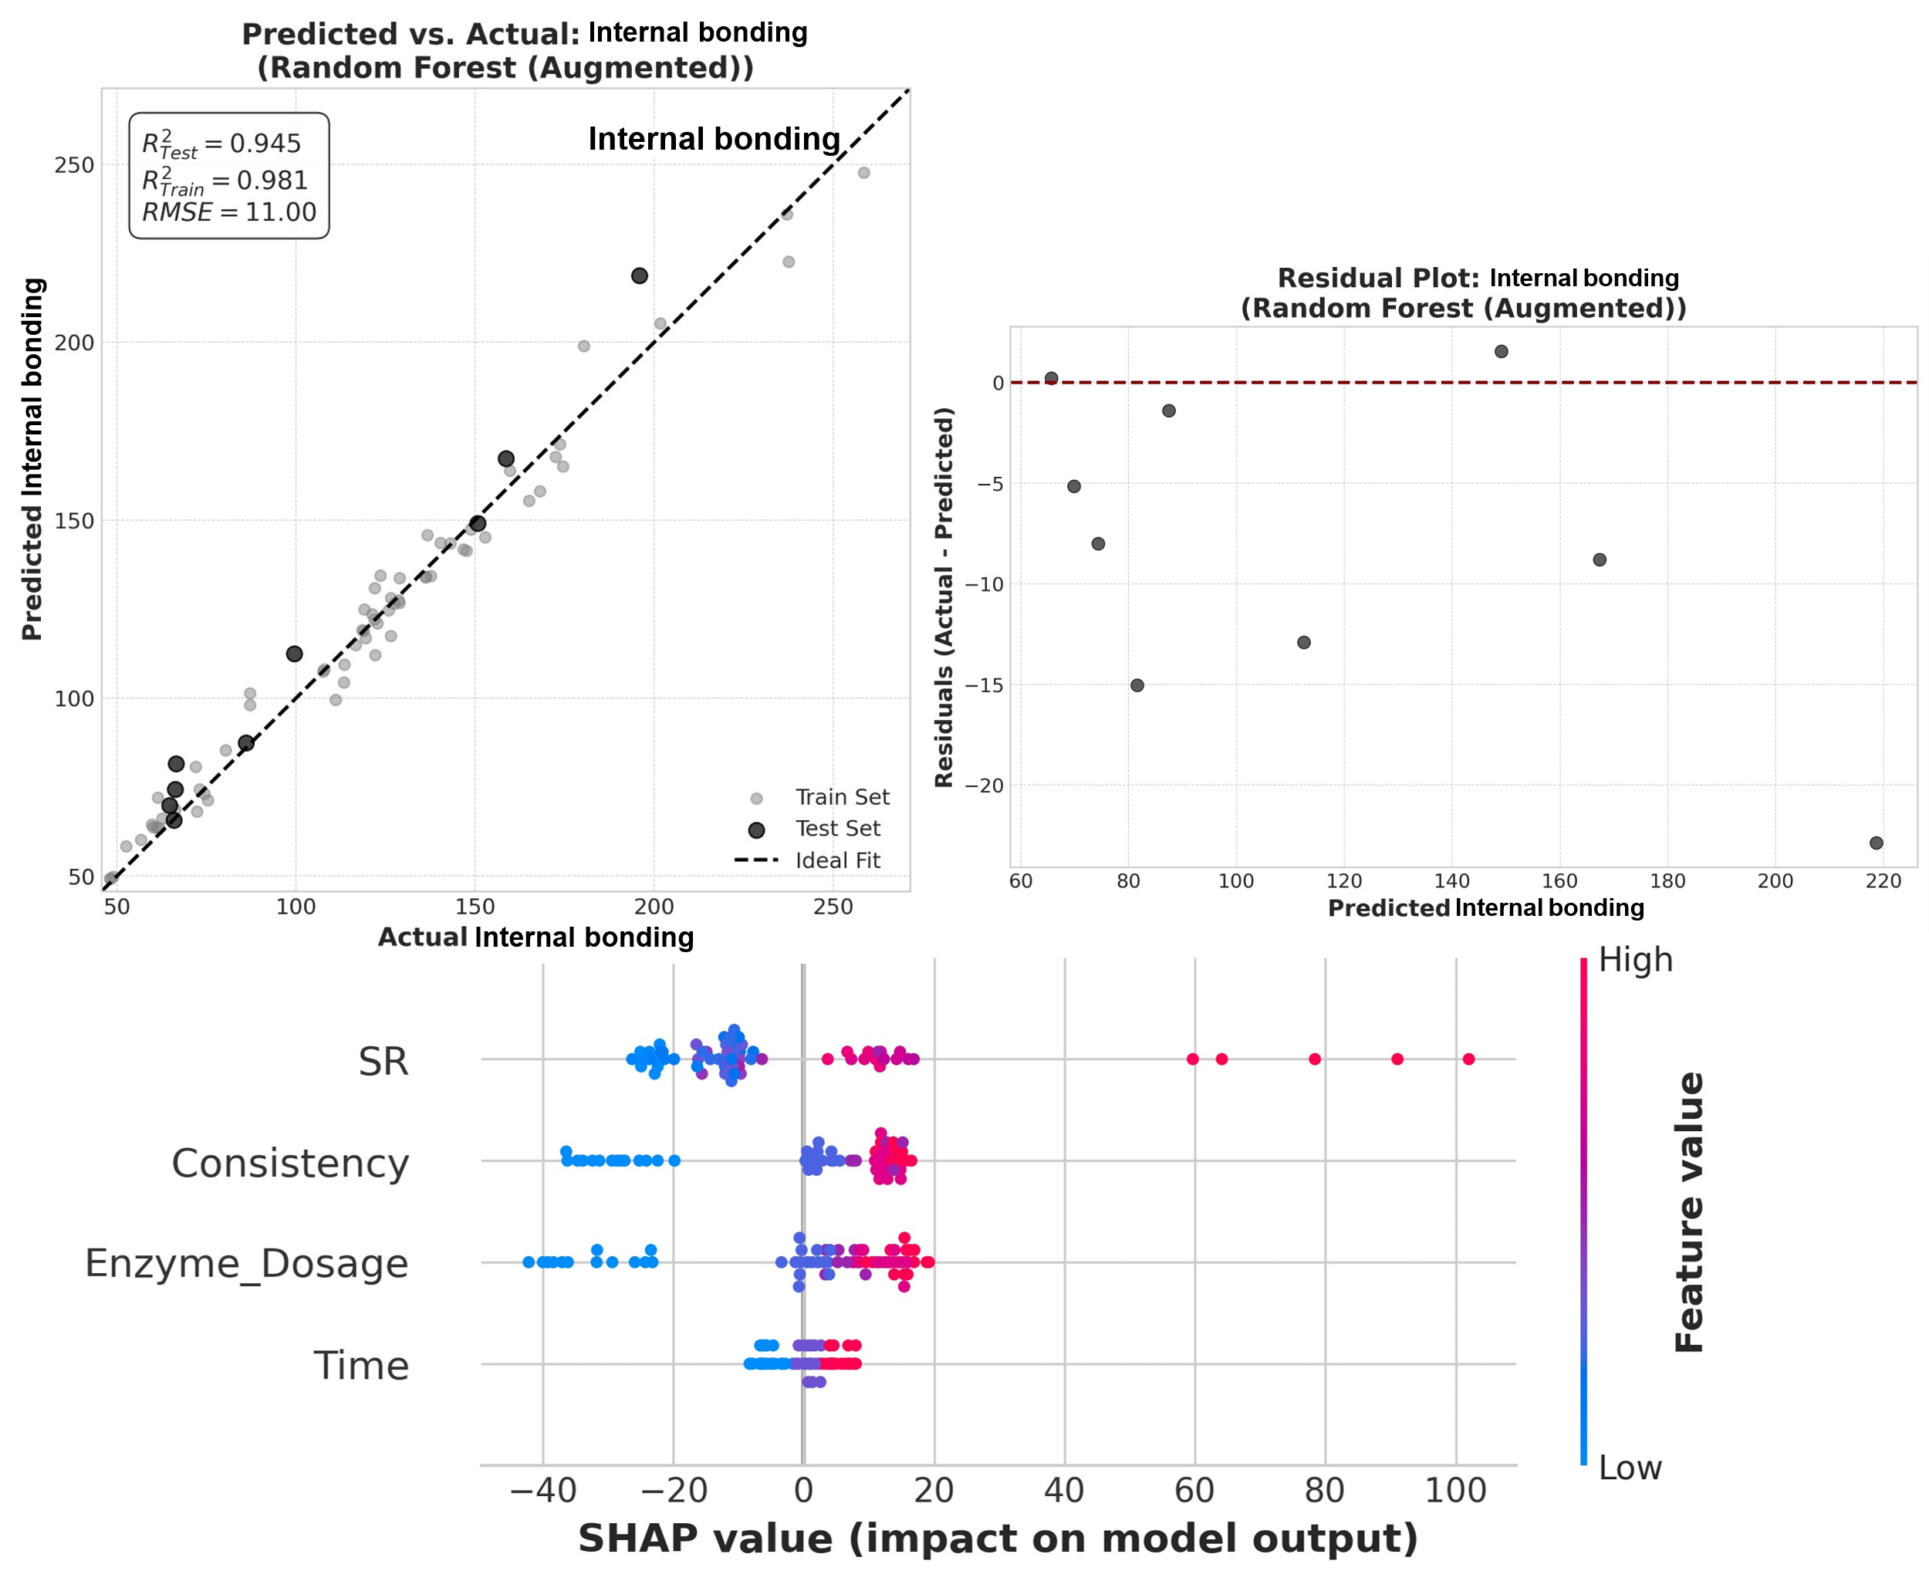
Fig.S28 Predictive modeling and SHAP analysis for internal bonding using a four feature RF augmented model (Inputs: Consistency, Time, Dosage, and SR). Top left: Predicted vs. Actual plot on the test set (R²=0.945). Top right: Residuals plot. Bottom: SHAP feature influence plot

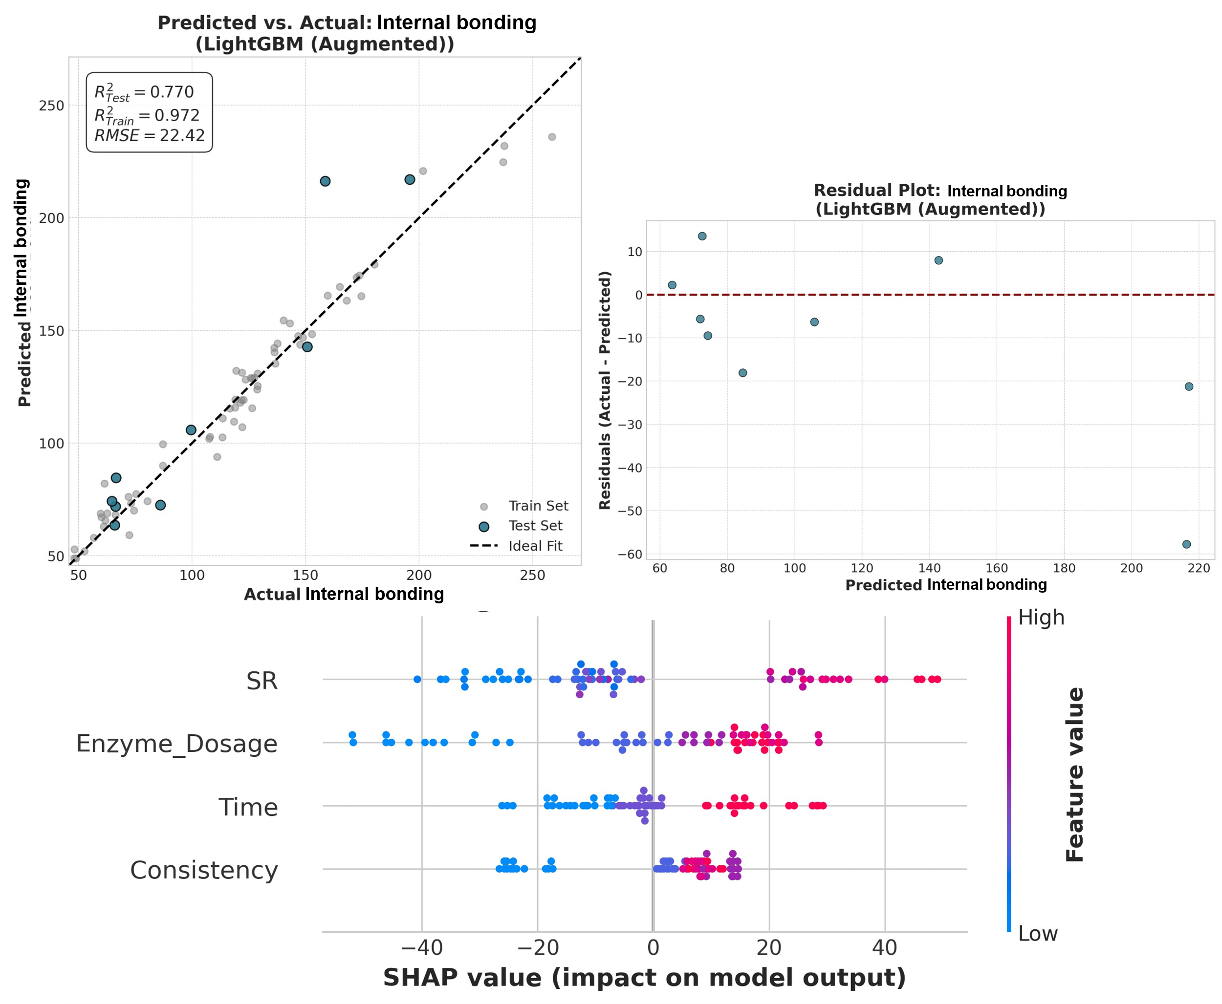Fig.S29 Predictive modeling and SHAP analysis for internal bonding using a four feature ligthGBM augmented model (Inputs: Consistency, Time, Dosage, and SR). Top left: Predicted vs. Actual plot on the test set (R²=0.770). Top right: Residuals plot. Bottom: SHAP feature influence plot
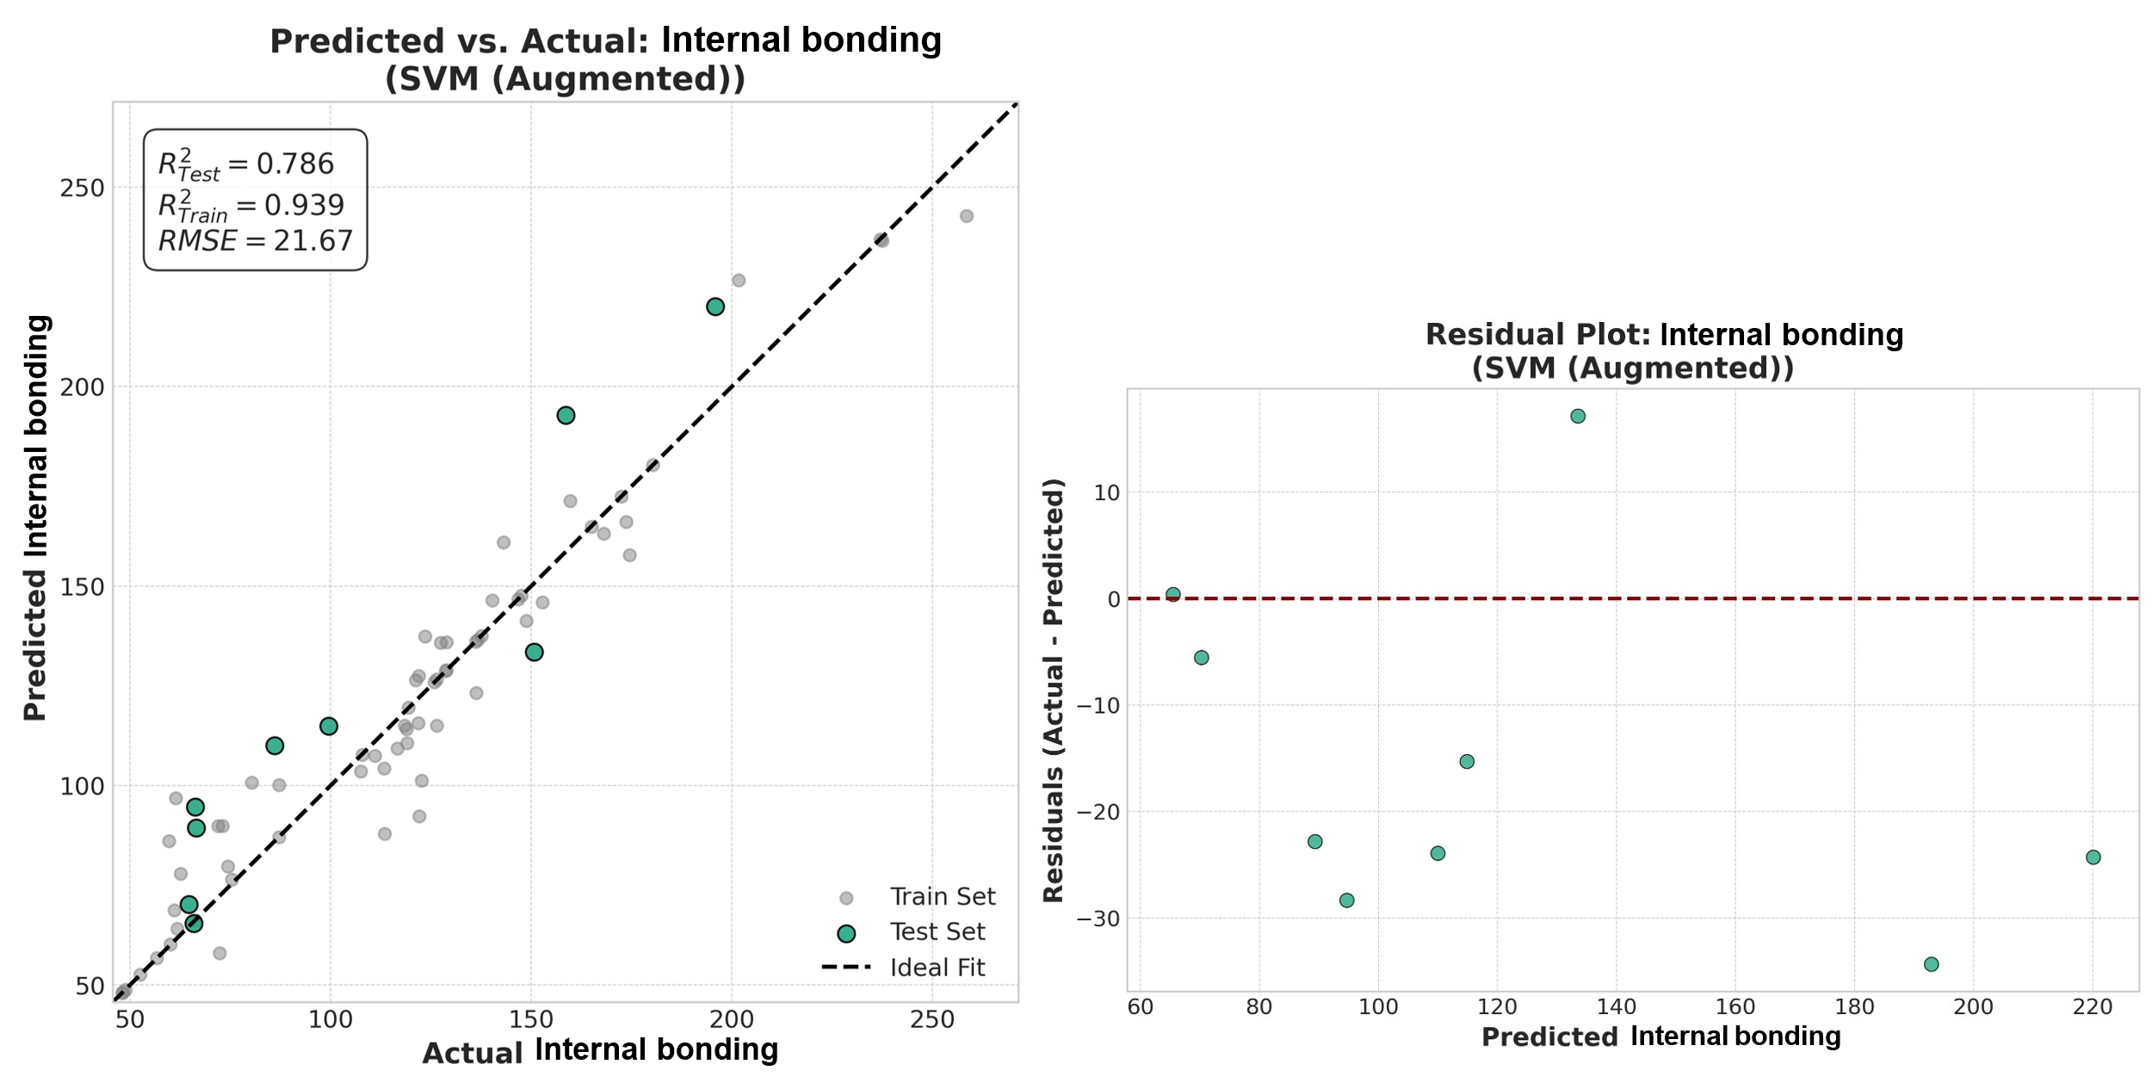
Fig.S30 Predictive modeling for internal bonding using a four feature SVM augmented model (Inputs: Consistency, Time, Dosage, and SR). Left: Predicted vs. Actual plot on the test set (R²=0.786). Right: Residuals plot

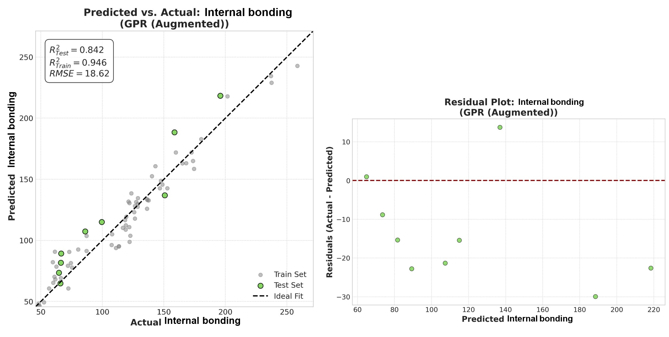
Fig.S31 Predictive modeling for internal bonding using a four feature GPR augmented model (Inputs: Consistency, Time, Dosage, and SR). Left: Predicted vs. Actual plot on the test set (R²=0.842). Right: Residuals plot

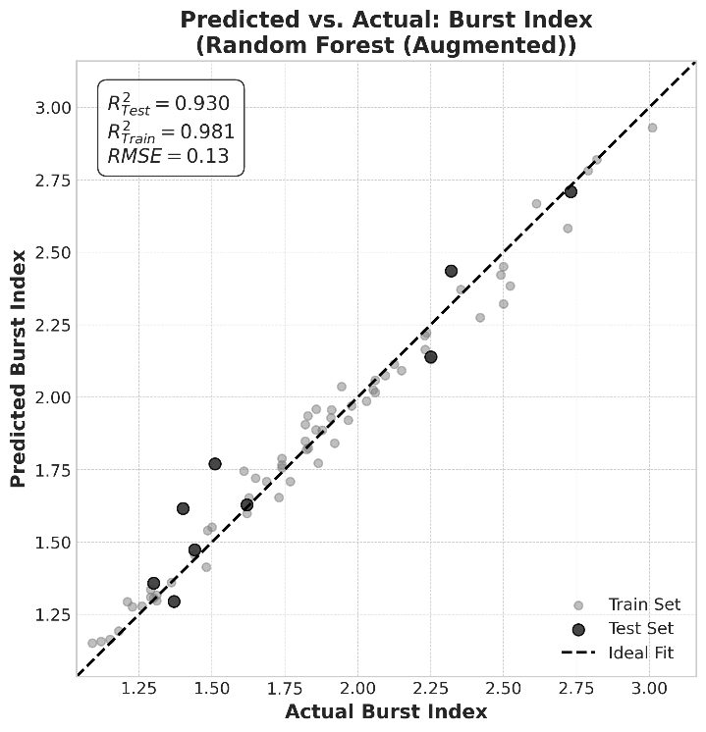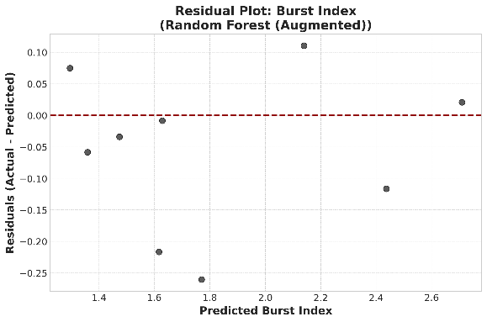
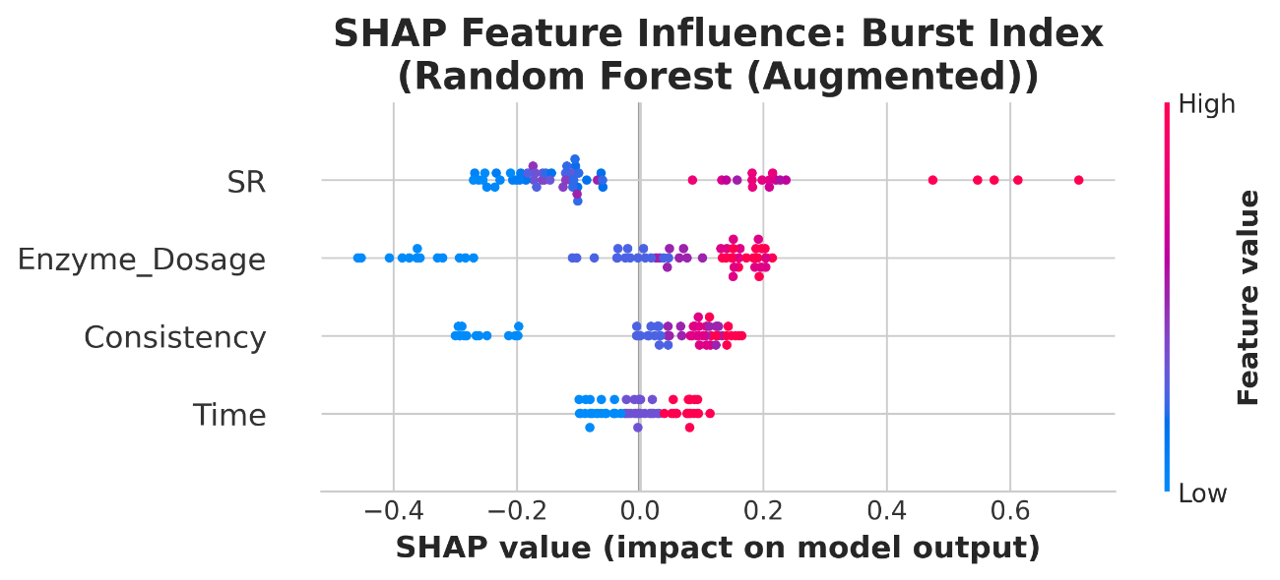
Fig.S32. Predictive modeling and SHAP analysis for burst index using a four feature RF augmented model (Inputs: Consistency, Time, Dosage, and SR). Top left: Predicted vs. Actual plot on the test set (R²=0.930). Top right: Residuals plot. Bottom: SHAP feature influence plot

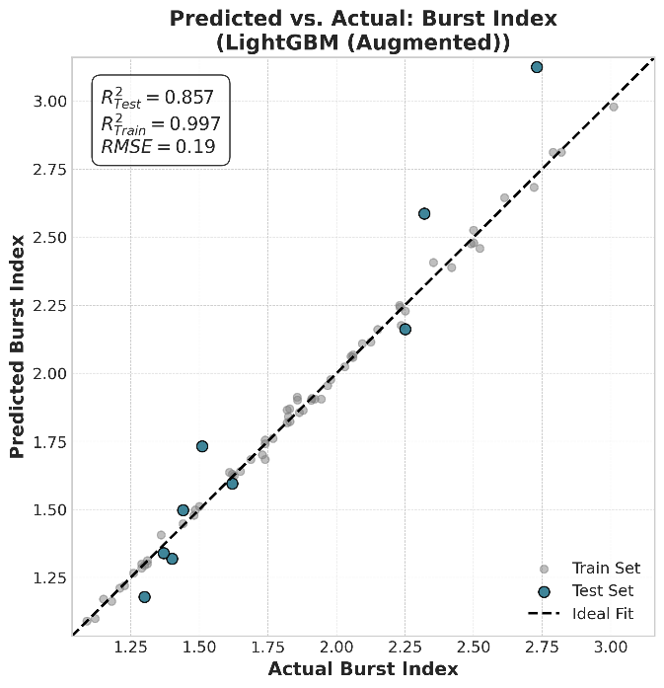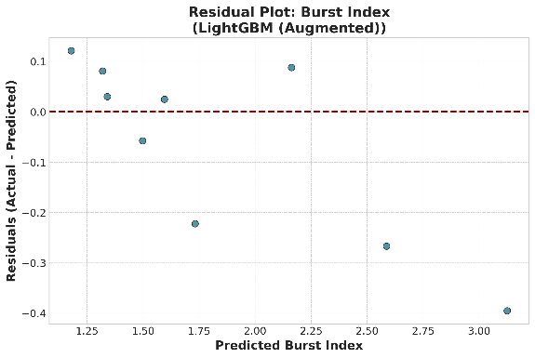
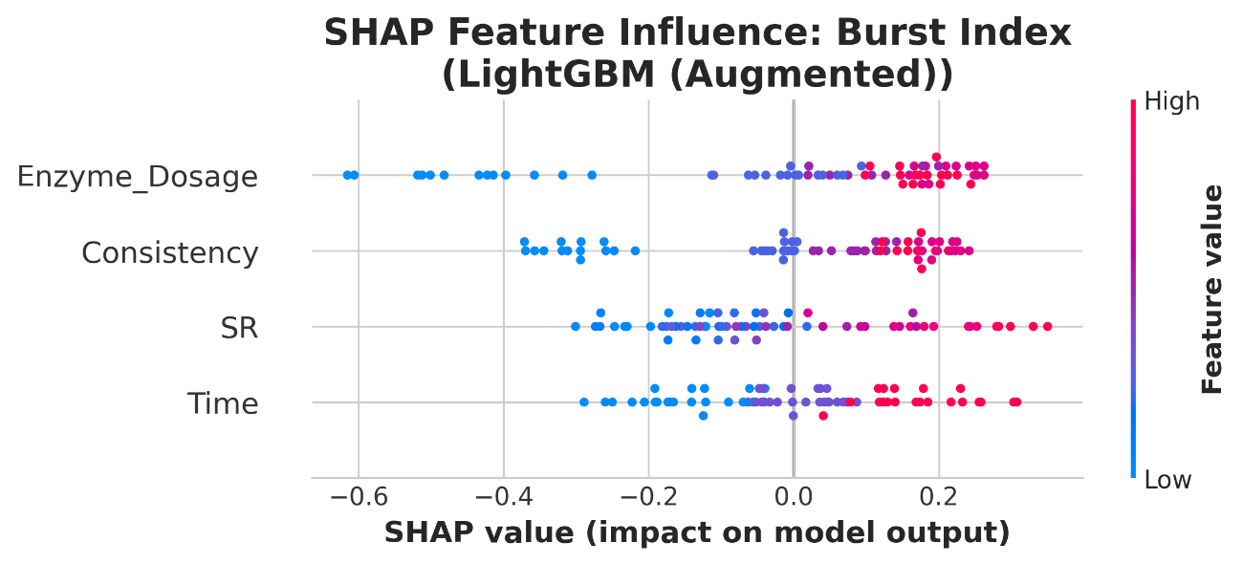
Fig.S33. Predictive modeling and SHAP analysis for burst index using a four feature LightGBM augmented model (Inputs: Consistency, Time, Dosage, and SR). Top left: Predicted vs. Actual plot on the test set (R²=0.857). Top right: Residuals plot. Bottom: SHAP feature influence plot
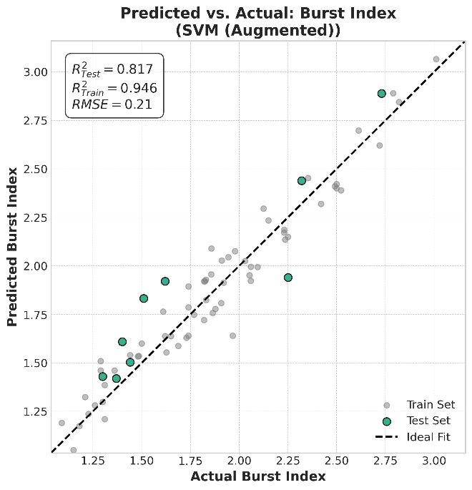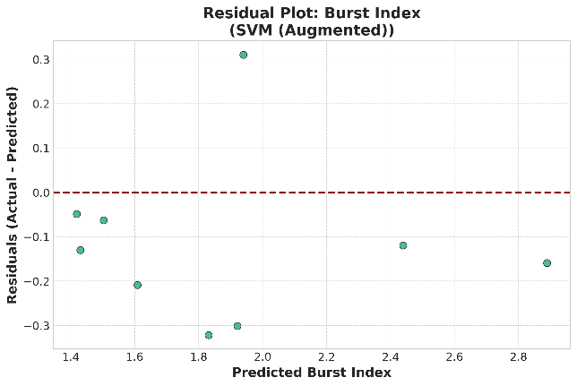
Fig.S34. Predictive modeling for burst index using a four feature SVM augmented model (Inputs: Consistency, Time, Dosage, and SR). Left: Predicted vs. Actual plot on the test set (R²=0.817). Right: Residuals plot

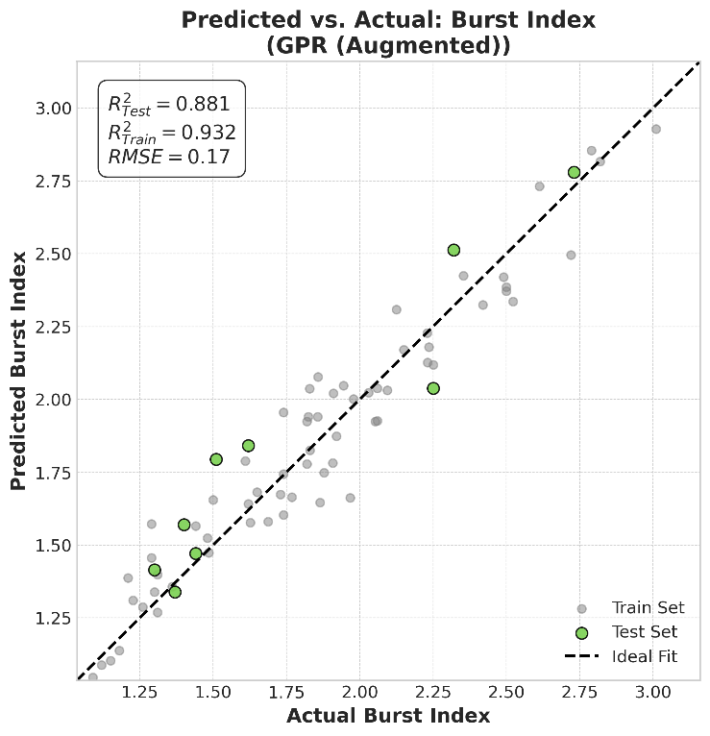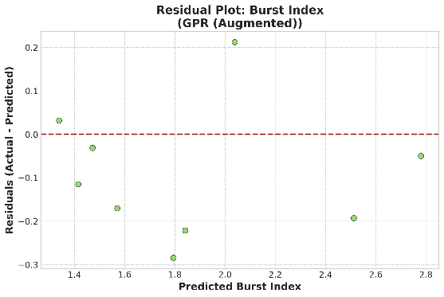
Fig.S35 Predictive modeling for burst index using a four feature GPR augmented model (Inputs: Consistency, Time, Dosage, and SR). Left: Predicted vs. Actual plot on the test set (R²=0.881). Right: Residuals plot

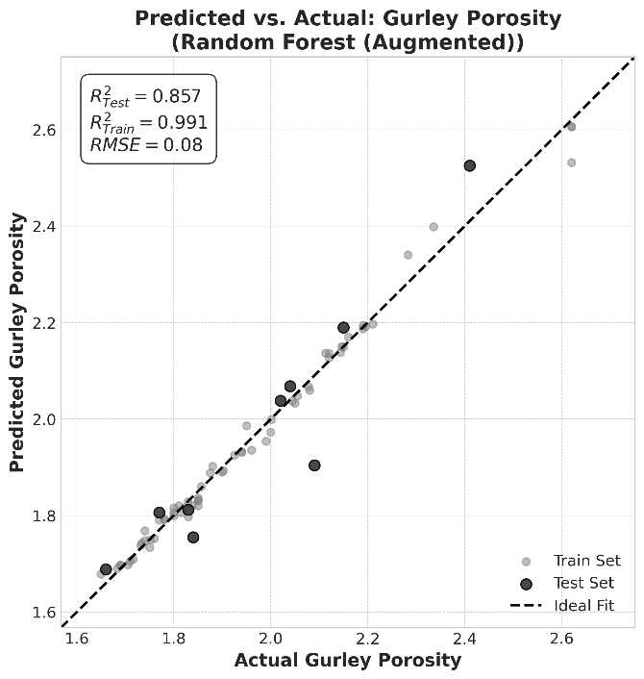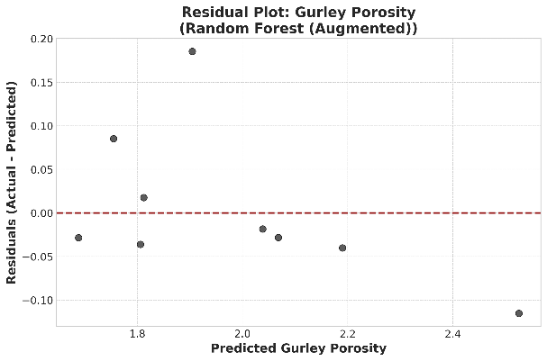
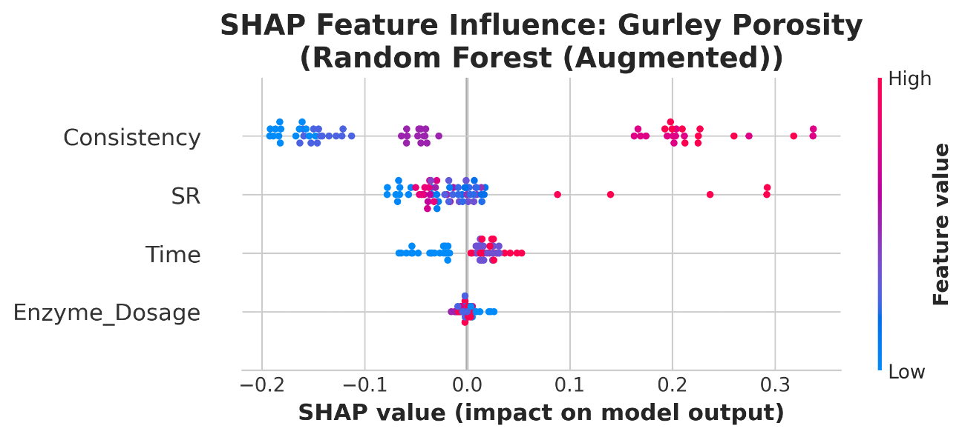
Fig.S36. Predictive modeling and SHAP analysis for Gurley porosity using a four feature RF augmented model (Inputs: Consistency, Time, Dosage, and SR). Top left: Predicted vs. Actual plot on the test set (R²=0.857). Top right: Residuals plot. Bottom: SHAP feature influence plot
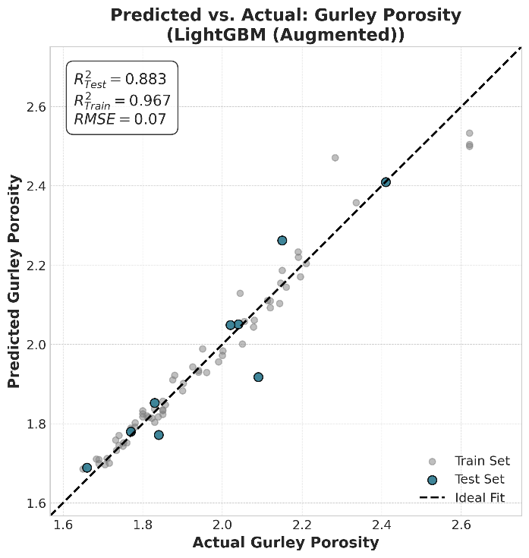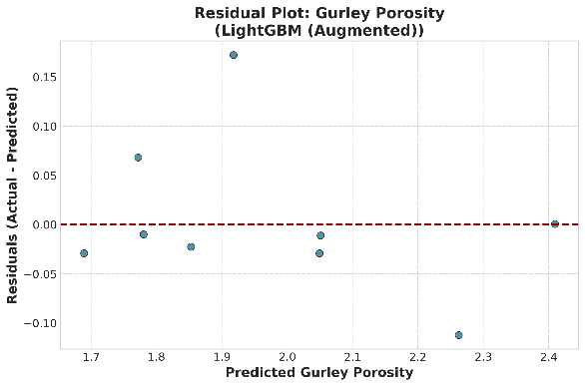
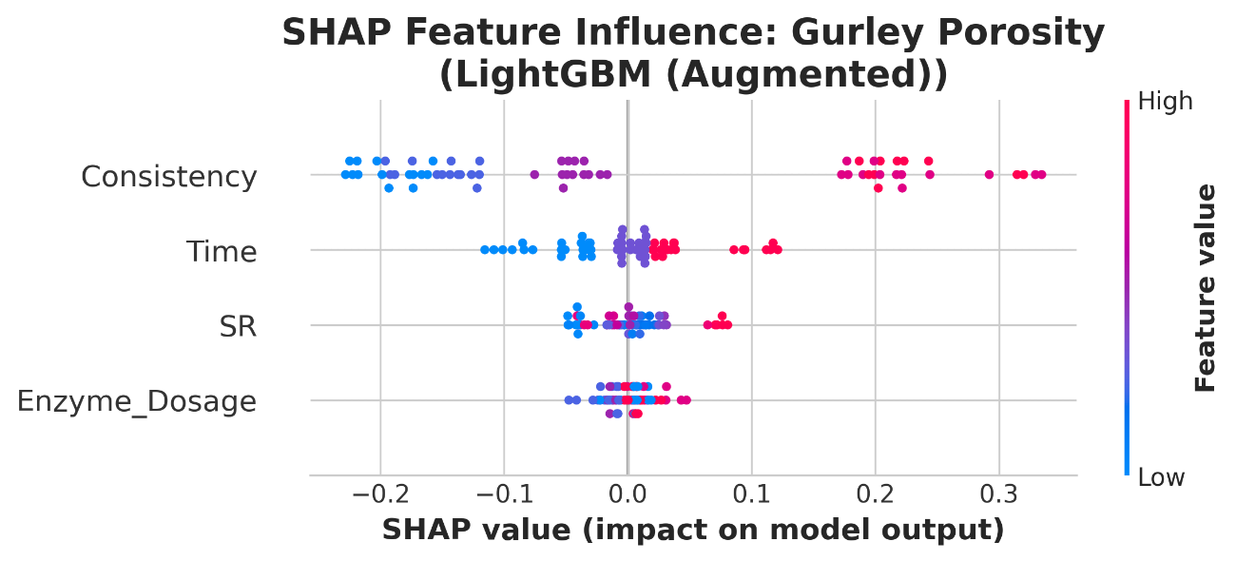
Fig.S37 Predictive modeling and SHAP analysis for Gurley porosity using a four feature RF augmented model (Inputs: Consistency, Time, Dosage, and SR). Top left: Predicted vs. Actual plot on the test set (R²=0.883). Top right: Residuals plot. Bottom: SHAP feature influence plot
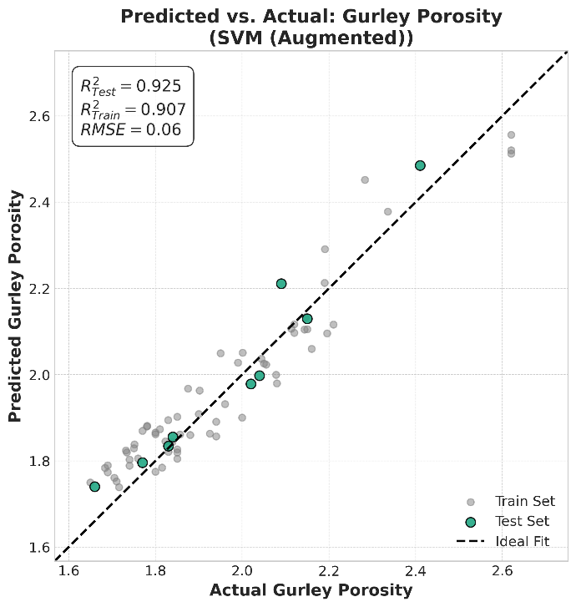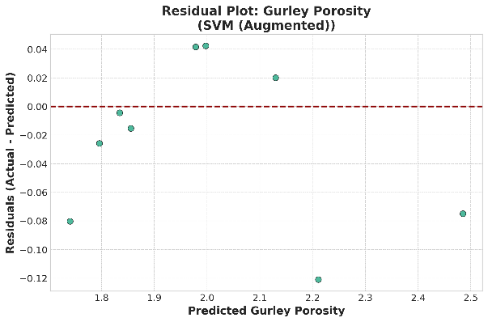
Fig.S38 Predictive modeling for Gurley porosity using a four feature SVM augmented model (Inputs: Consistency, Time, Dosage, and SR). Left: Predicted vs. Actual plot on the test set (R²=0.925). Right: Residuals plot

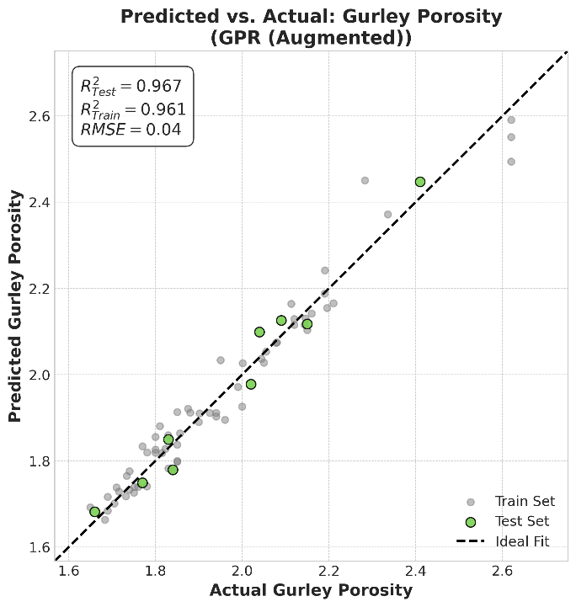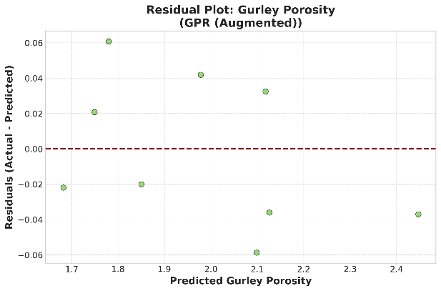
Fig.S39 Predictive modeling for Gurley porosity using a four feature GPR augmented model (Inputs: Consistency, Time, Dosage, and SR). Left: Predicted vs. Actual plot on the test set (R²=0.967). Right: Residuals plot

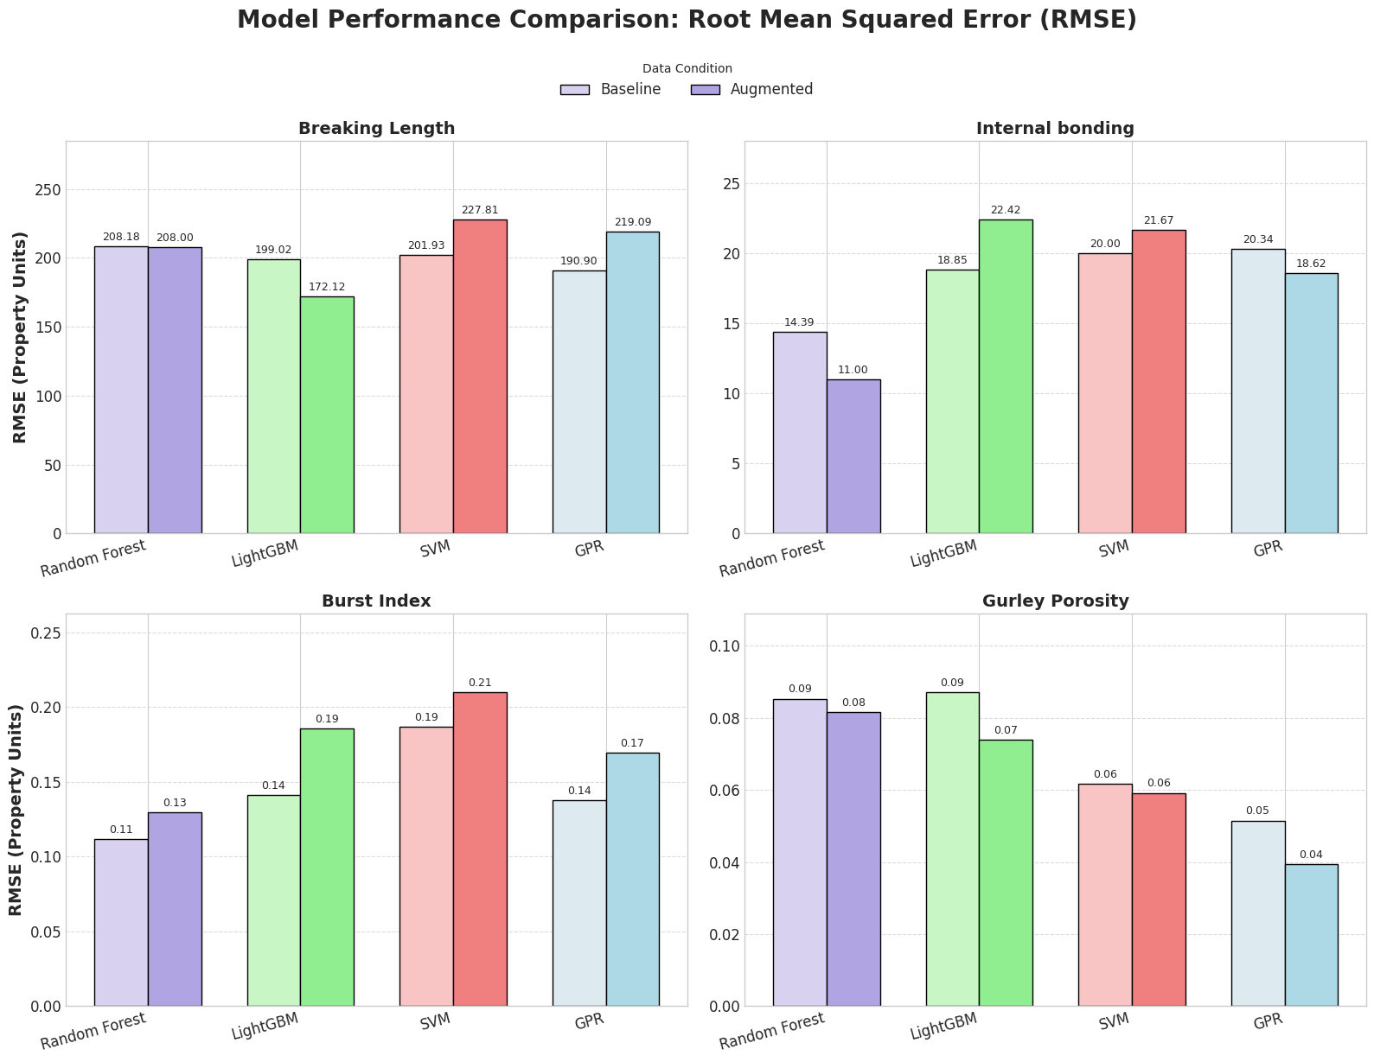
Fig.S40 Model performance (RSME) using as variables SR, time, consistency, enzyme concentration
Discussion on the selection of models for the physics informed generative augmentation strategy
Different models were tested for data augmentation and prediction of properties at a target enzyme dosage, consistency and time. Random forest and LightGBM were the highest performing models. However, LightGBM tends to generate overfitting. Then, for data extrapolation and prediction, the choice between RF, LightGBM, and GPR (GPR has a different approach, it is an statistical method) is not a matter of one being superior, but rather a trade-off dependent on the analytical goal. The GPR model provides a mathematically rigorous representation of uncertainty. Its prediction curves and confidence intervals are suitable for applications where understanding the model's confidence is crucial, such as guiding future experiments through active learning. If the underlying physical process is assumed to be continuous and smooth, GPR offers a more elegant and interpretable solution.
The RF model, while producing less smooth native predictions, is robust. Its strength lies in its ability to capture complex, non-linear interactions without strong assumptions about the data underlying structure. The method of simulating variability via residuals provides a practical and effective estimation of the expected predictive error range. RF is often preferred for high-dimensional problems or when the data may contain sharp, non-continuous behaviors that would challenge the smoothness assumptions of a GPR kernel.
In this case, RF presents overfitting resistance via ensemble averaging. While each individual decision tree in the forest is deep and massively overfit to a bootstrap sample of the data, the process of averaging the predictions of hundreds of these decorrelated trees cancels out the noise. The model converges to the true underlying function without fitting the noise. This makes the RF residuals the most reliable estimate of the true, irreducible process error. The ensemble nature makes RF a low-variance model. RF is robust, performing well with default or minimally tuned hyperparameters, which is a significant advantage when working with a dataset too small for reliable, exhaustive hyperparameter optimization. Then, the GPR model is utilized to extrapolate by utilizing the RF as an intermediate step for SR and residuals prediction.
In the case of other models tested, and not utilized for the augmented data strategy, LightGBM is highly susceptible to overfitting on small, noisy datasets. It will chase down the random noise in the samples, producing residuals that are deceptively small and have lost their random, independent nature. On the other hand, SVR performance is sensitive to the C (regularization) and gamma (kernel) parameters. On a small dataset, the cross-validation process to find these parameters is highly unstable. A small change in the data can lead to a drastically different model and, therefore, a different set of residuals. This challenges the need for stability. Moreover, the epsilon-insensitive loss function systematically treats all errors below a certain threshold as zero. This would artificially censor the residual distribution, removing the small fluctuations that are a critical part of the real process noise.
Therefore, the RF overall model structure is much less sensitive to small changes in the training data compared to GBM or SVR. If we were to collect a different set of samples, a new RF model would likely be very similar to our current one, while the other models may present variability due to their intrinsic structure when analyzing small datasets.

