Supplementary Information

Comparison of Industrial Processabilities of Cellulosic Raw Materials for Lyocell Textiles

Giiguulen Enkhsaikhan† ¹, Kaniz Moriam†* ^{1,2}, Monika Kokko ¹, Heikki Hassi ³, Huy Quang Lê ^{1,3}, Eric Enqvist ³, and Michael Hummel*¹

1 Department of Bioproducts and Biosystems, Aalto University, 02150, Espoo, Finland
2 Department of Mechanical Engineering, Massachusetts Institute of Technology, Cambridge, MA 02139, USA
3 SciTech-Service Ltd, Eteläesplanadi 22, 00130 Helsinki, Finland.
† these authors have contributed equally to the manuscript
*Corresponding authors kanizm@mit.edu; michael.hummel@aalto.fi

Abstract
The Lyocell process is regarded as a sustainable industrial technology for producing regenerated cellulosic fibers and its production capacity has been expanded significantly in recent years. Although fibers are currently spun mostly from dissolving-grade pulp, the Lyocell process has the potential to utilize a wide range of cellulose-based raw materials due to the dissolution power of N-methylmorpholine N-oxide (NMMO) monohydrate. This work assesses the suitability of different cellulose-based raw materials for the NMMO-Lyocell technology with an emphasis on industrial processability. Selected raw materials were tested for their solubility in NMMO, and the resulting solutions (dopes) were thoroughly analyzed, emphasizing rheological properties as a basis for assessing their potential spinnability in the Lyocell process. Subsequently, dopes derived from different pulps were spun into fibers using a monofilament dry-jet wet spinning unit, and the fiber properties were analyzed. This work specifically addresses the influence of the hemicellulose content and wood type (hardwood vs softwood) on the spinning performance and the fiber properties. The insights gained in this study contribute to the understanding of the correlation between pulp composition, spinnability and mechanical properties of Lyocell fibers, promoting the use of various cellulose sources.

Table S1: Molecular weight characteristics (Mn, Mw, Mz), dispersity (Đ) calculated from rheology data and scaling constant K of the cellulose solutions. K values were derived from relaxation time–molecular weight scaling (τ = K·M³·⁴).
Samples | Mn (Da) | Mw (Da) | Mz (Da) | Đ | K (s·(g/mol)^-3.4)
SWK1 | 70699 | 120902 | 206754 | 1.71 | 7.87 E-19
SWK2 | 75791 | 139639 | 257273 | 1.84 | 7.93 E-19
SWAS1 | 44563 | 128040 | 367889 | 2.87 | 3.02 E-18
SWAS2 | 75649 | 139328 | 256610 | 1.84 | 8.61 E-19
SWPHK | 75398 | 174897 | 405698 | 2.32 | 8.37 E-20
HWK1 | 43224 | 98584 | 224846 | 2.28 | 1.73 E-18
HWK2 | 59719 | 177730 | 528940 | 2.98 | 2.33 E-18
HWK3 | 61963 | 91042 | 133770 | 1.47 | 4.20 E-19
HWPHK | 77232 | 141549 | 259426 | 1.83 | 6.37 E-19
RC | 42171 | 84891 | 170886 | 2.01 | 7.98 E-19

Relaxation time spectra

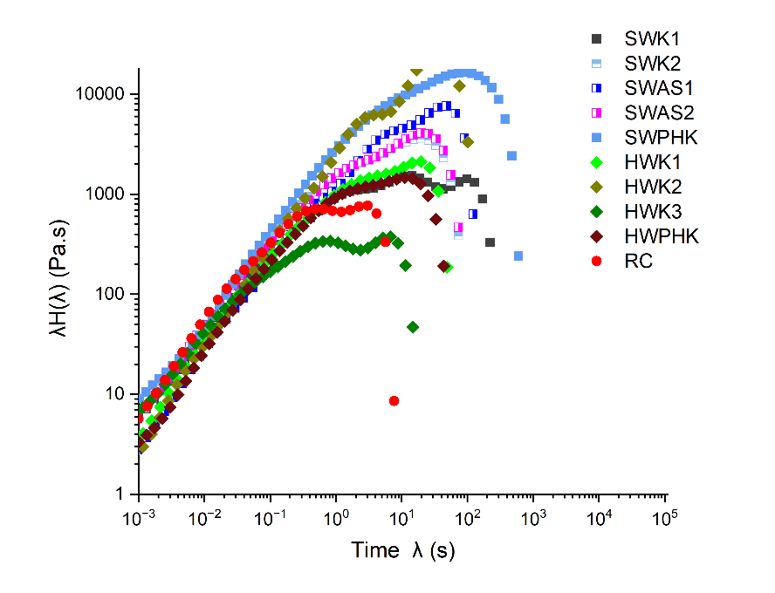
Fig. S1: Relaxation spectra λH(λ) of cellulose pulp solutions obtained from frequency sweep data. The spectra highlight differences in relaxation strength and timescales among different cellulose solutions.
Comparison of Molar mass distribution calculated from Rheology and GPC

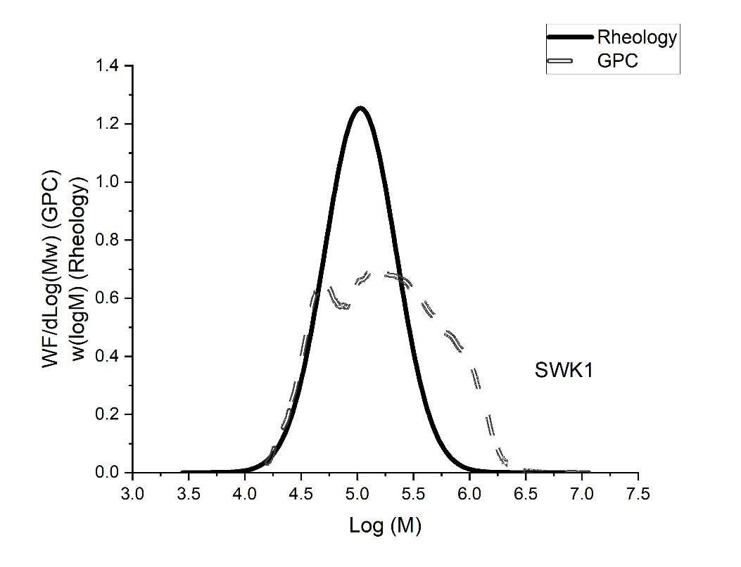
Fig. S2:Molecular weight distribution of SWK1 determined by rheology (solid line) and GPC (dashed line).
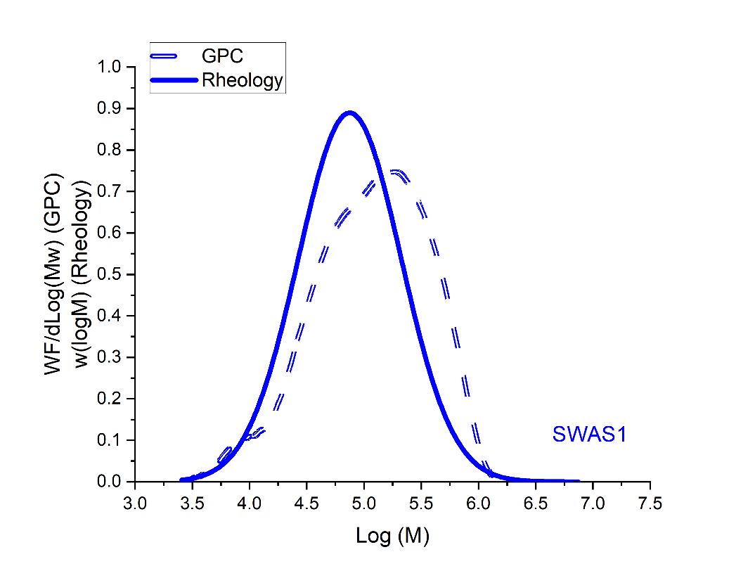
Fig. S3: Molecular weight distribution of SWAS1 determined by rheology (solid line) and GPC (dashed line).

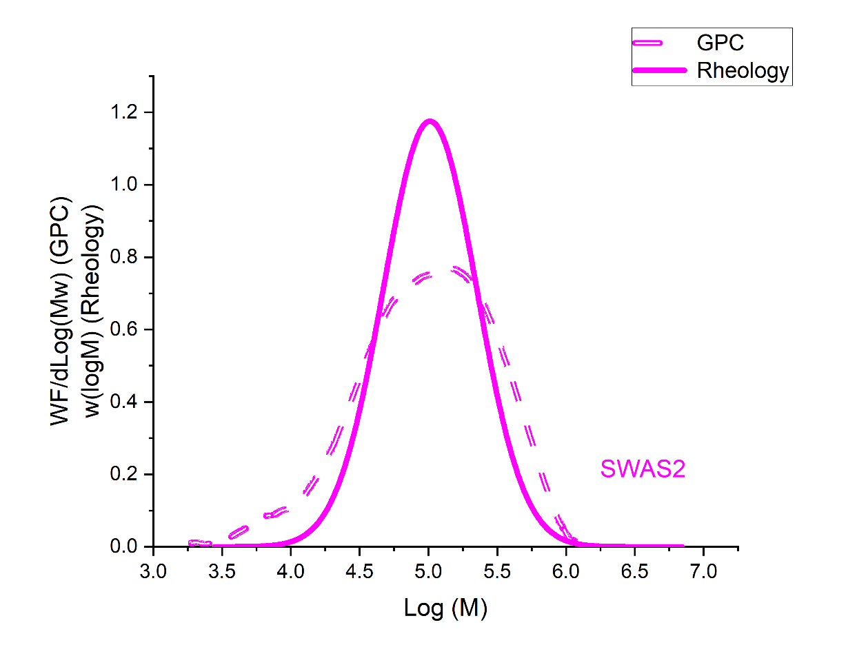
Fig. S4:Molecular weight distribution of SWAS2 determined by rheology (solid line) and GPC (dashed line).

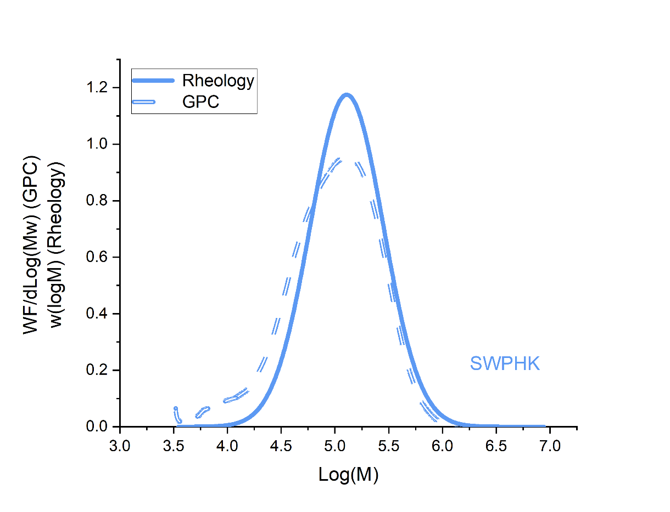
Fig. S5:Molecular weight distribution of SWPHK determined by rheology (solid line) and GPC (dashed line).

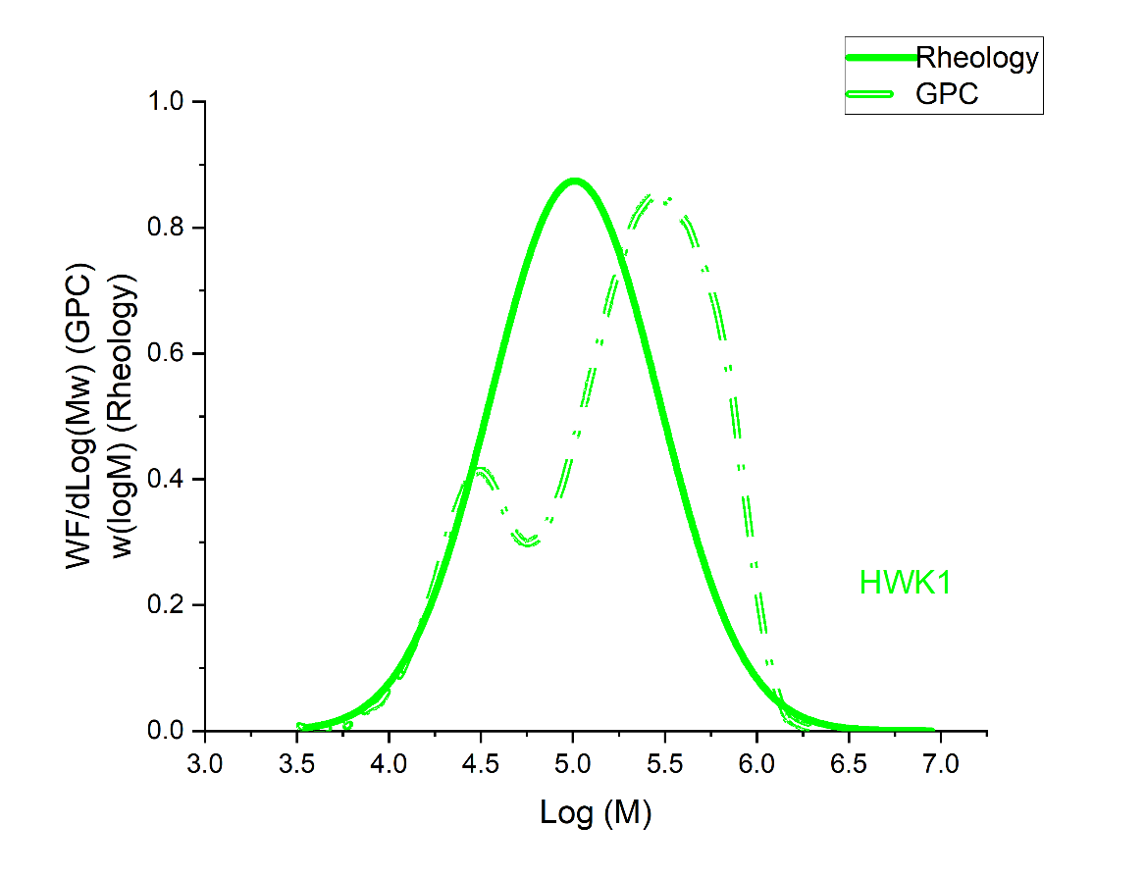
Fig. S6: Molecular weight distribution of HWK1 determined by rheology (solid line) and GPC (dashed line).

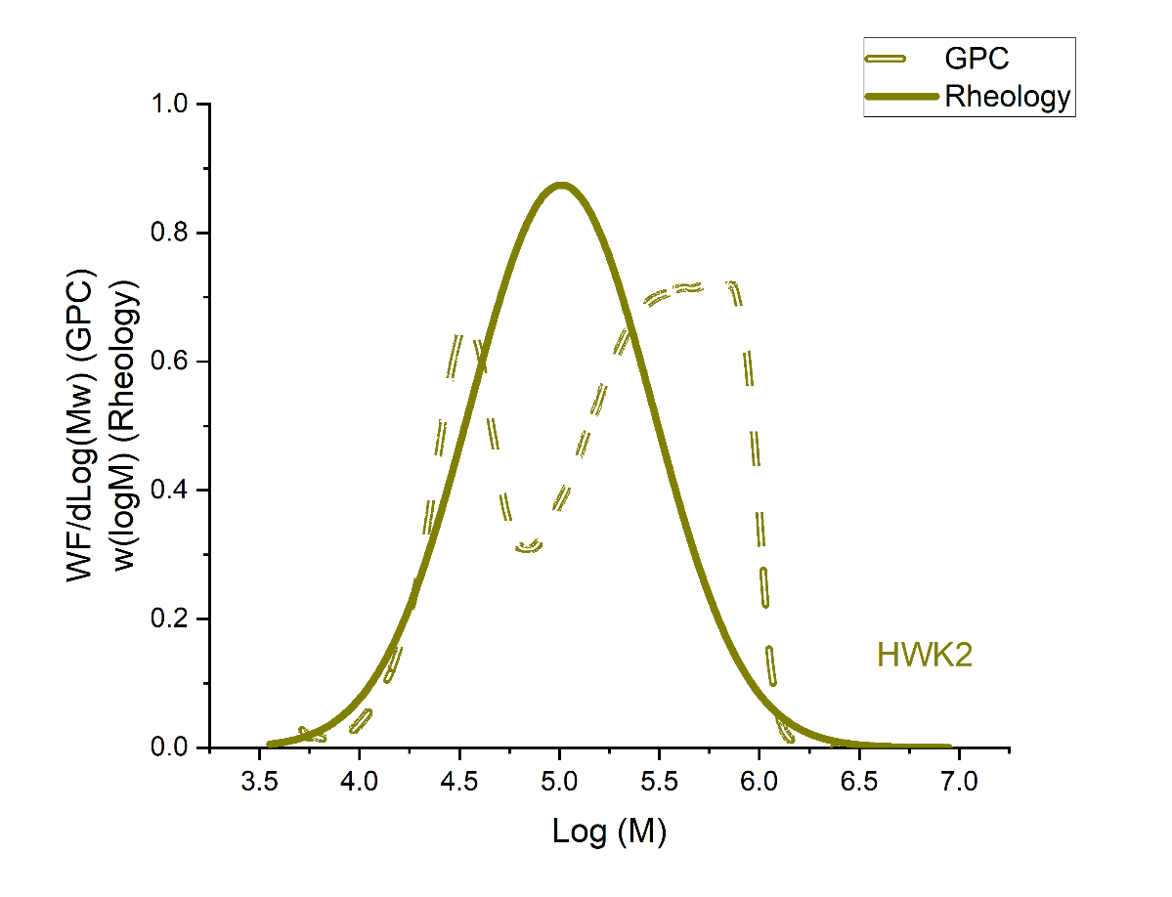
Fig. S7: Molecular weight distribution of HWK2 determined by rheology (solid line) and GPC (dashed line).
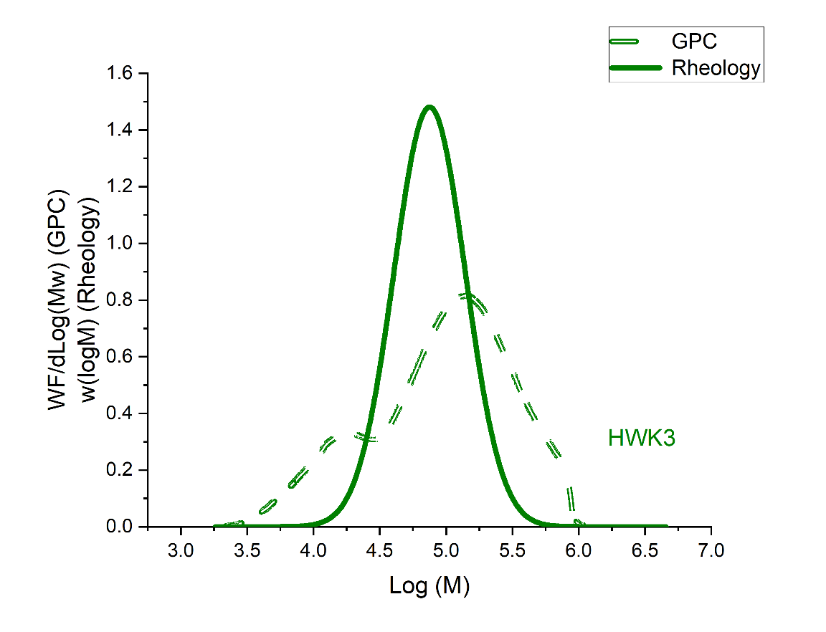
Fig. S8: Molecular weight distribution of HWK3 determined by rheology (solid line) and GPC (dashed line).

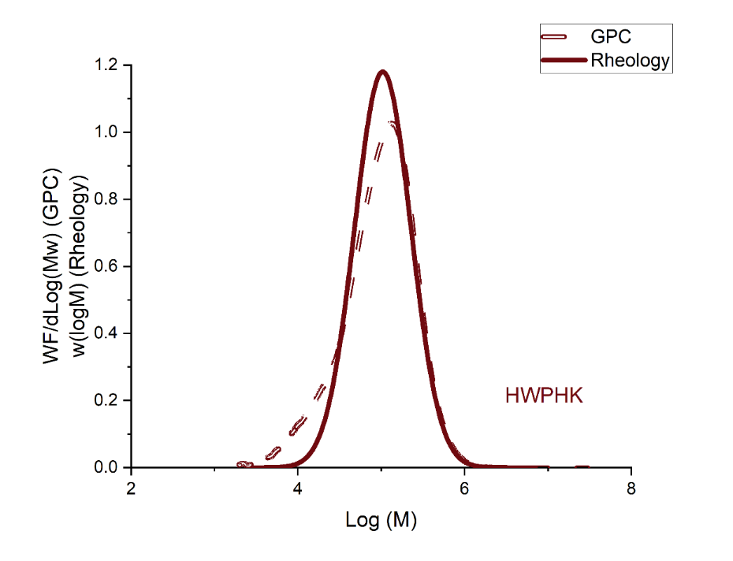
Fig. S9: Molecular weight distribution of HWPHK determined by rheology (solid line) and GPC (dashed line).

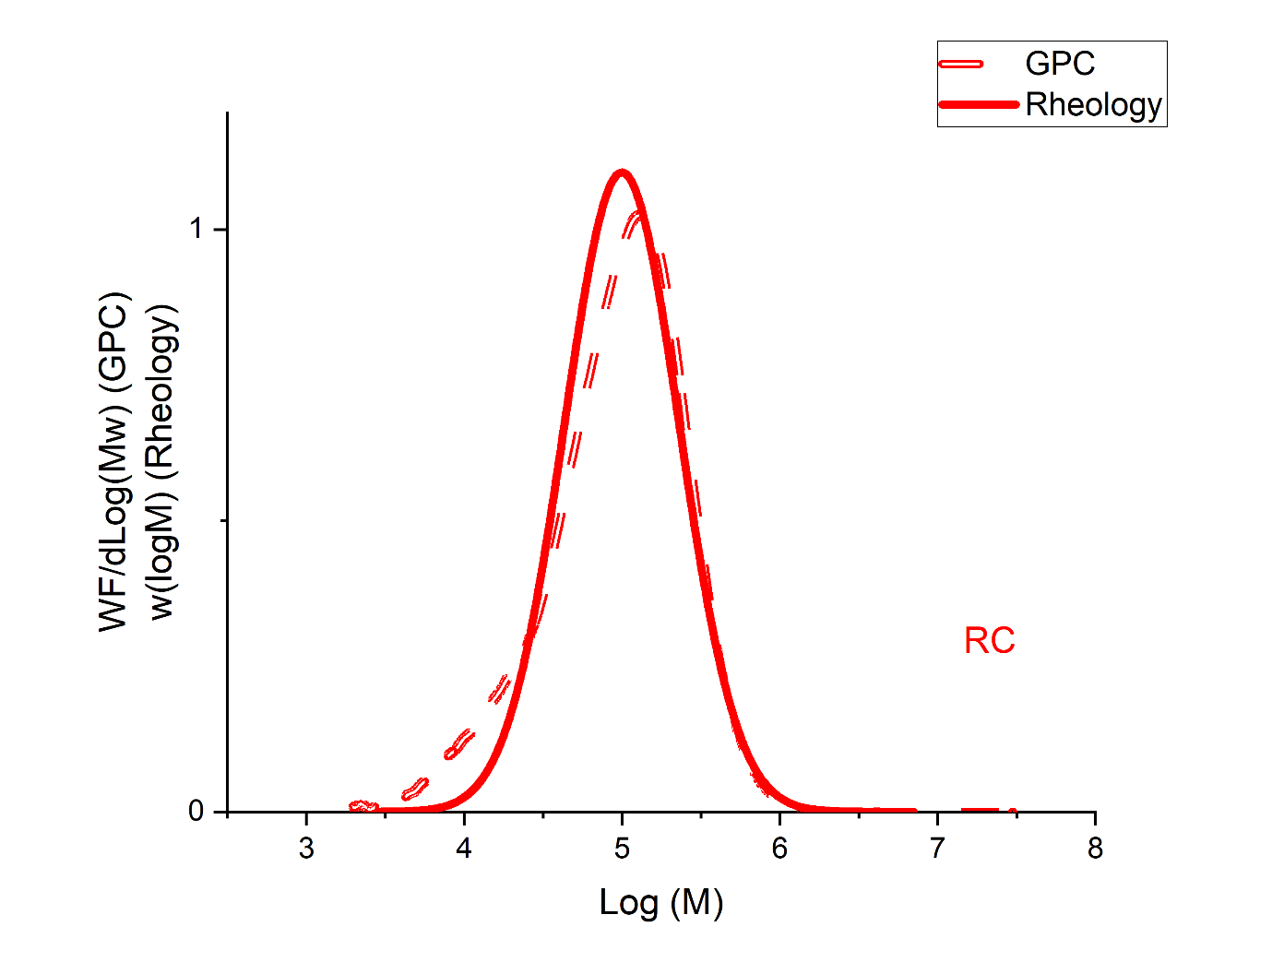
Fig. S10: Molecular weight distribution of RC determined by rheology (solid line) and GPC (dashed line
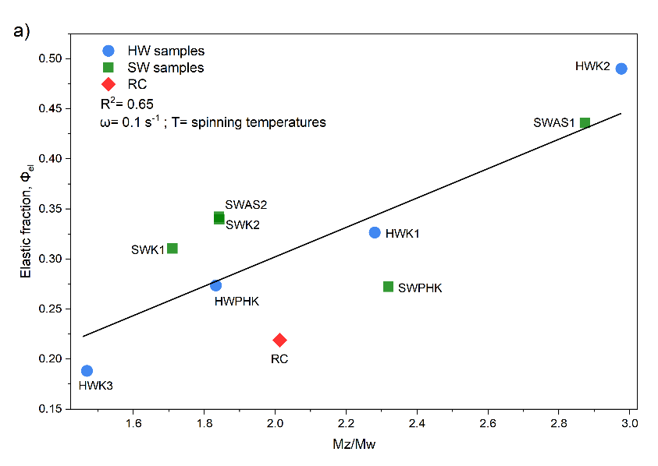
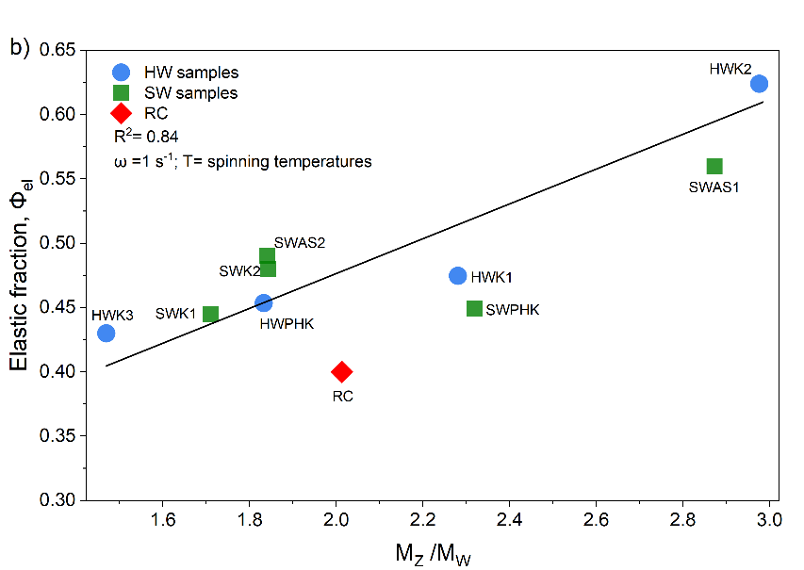
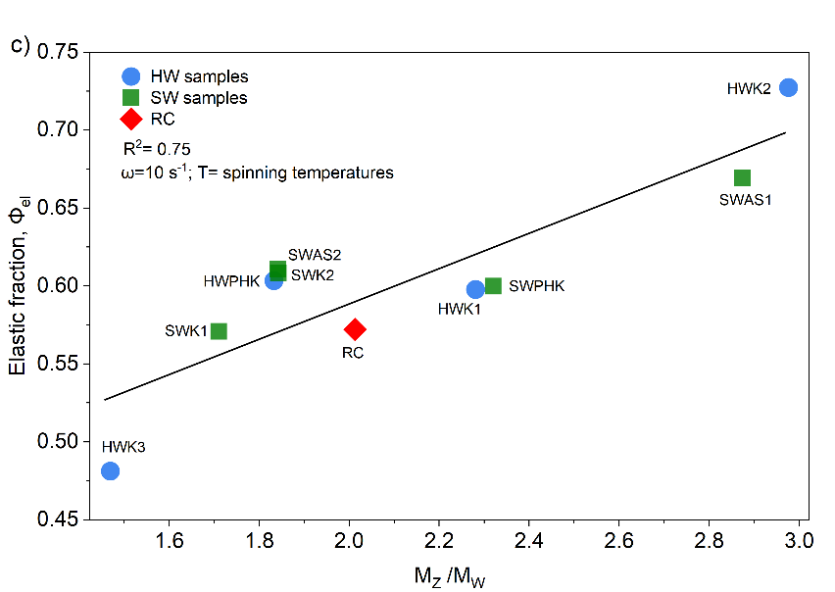
Fig. S11: Correlation between molecular weight distribution breadth ($\frac{M_{z}}{M_{w}})$ and the elastic fraction ($Φ_{el}$) of the spinning dopes at different frequencies, evaluated at the respective spinning temperatures.
(a) $Φ_{el}$ at 0.1 rad s⁻¹ (r = 0.65), (b) $Φ_{el}$ at 1 rad s⁻¹ (r = 0.84), and (c) $Φ_{el}$ at 10 rad s⁻¹ (r = 0.75). A consistent increase in $Φ_{el}$ with $\frac{M_{z}}{M_{w}}$ indicates that samples with broader molecular weight distributions, reflecting a higher fraction of long chains exhibit more elastic response across frequencies. HW, SW, and RC denote hardwood, softwood, and recycled cotton cellulose samples, respectively.

