Supplementary Information

Fabrication of sisal fiber-derived beads from sustainable solvents: Investigating their potential for pH-responsive sorption of bovine serum albumin
Thamiris Voltarelli Ferracini ^{a,b}, Pieter De Wever ^{b}, Roberta Teixeira Polez ^{c}, Xiaoyan Qing ^{b}, Elisabete Frollini ª, Pedro Fardim ^{b}
ª Macromolecular Materials and Lignocellulosic Fibers Group, Center for Research on Science and Technology of BioResources, São Carlos Institute of Chemistry, University of São Paulo, São Paulo, São Carlos, Brazil
^{b} Department of Chemical Engineering, Chemical and Biochemical Reactor Engineering and Safety, KU Leuven, Leuven, Belgium
^{c} Department of Bioproducts and Biosystems, School of Chemical Engineering, Aalto University, Espoo, Finland

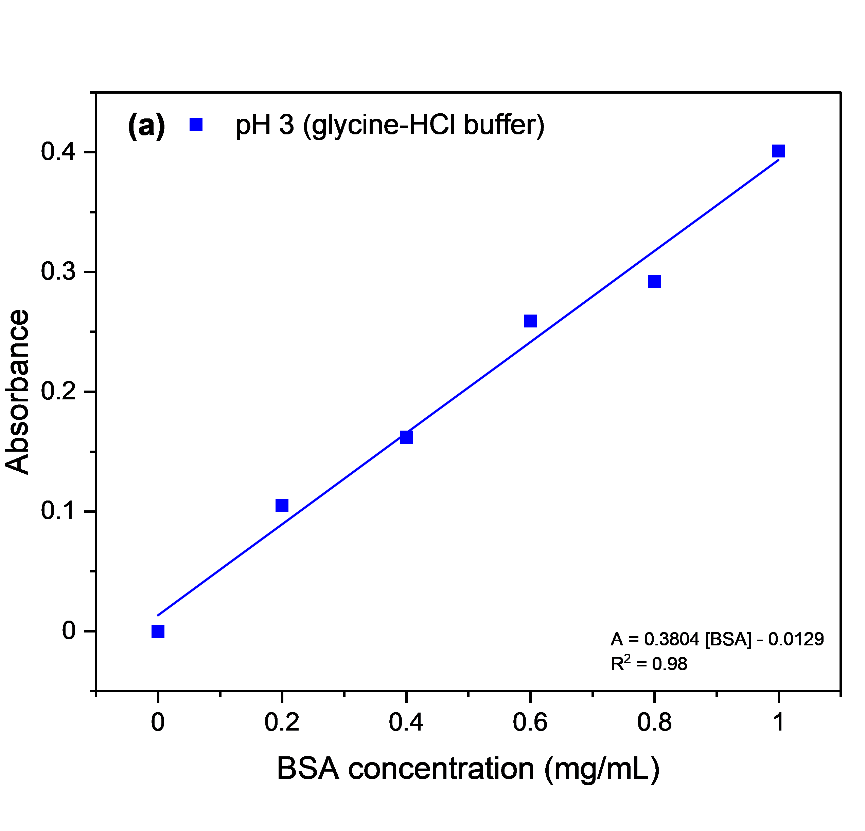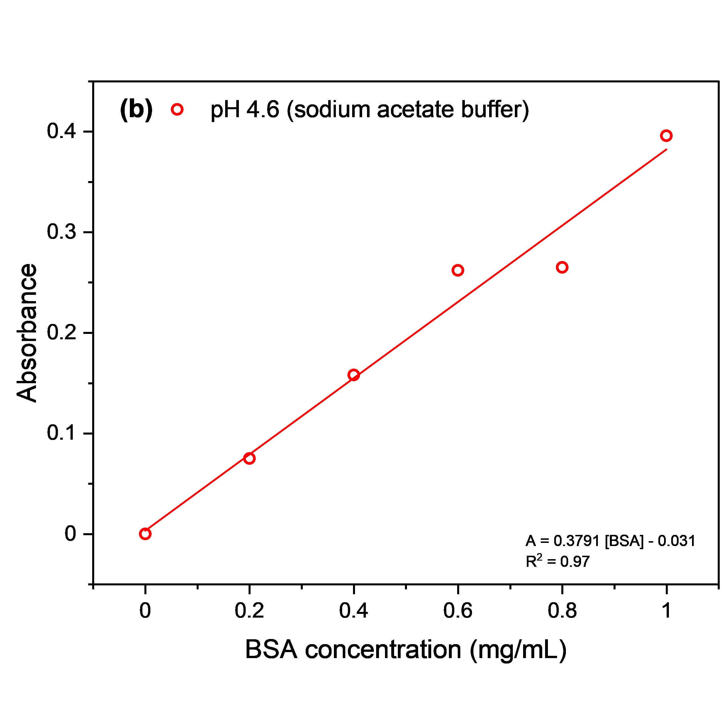
Figure S1. Standard calibration curve absorbance (λ = 595 nm) of bovine serum albumin (BSA) at different concentrations used for quantification of protein adsorption.

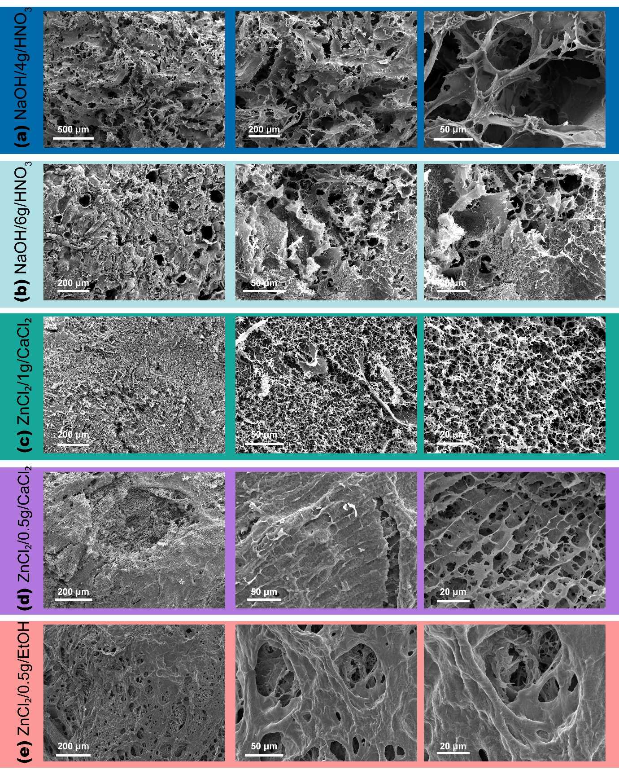
Figure S2. SEM surface images at different magnifications of the sisal beads: (a) NaOH-urea/4g/HNO₃, (b) NaOH-urea/6g/HNO₃, (c) ZnCl₂/1g/CaCl₂, (d) ZnCl₂/0.5g/CaCl₂, and (e) ZnCl₂/0.5g/EtOH.

(c) | pH 3 |  |  | pH 4.6
(c) | q_{e} (mg/g)^{A} | k₁ (1/min) ^{B} | R² | q_{e} (mg/g) | k₁ (1/min) | R²
NaOH/4g/HNO₃ | 34.50 ± 2.88 | 0.18 ± 0.06 | 0.961 | 7.98 ± 0.76 | 0.44 ± 0.15 | 0.928
NaOH/6g/HNO₃ | 39.08 ± 5.78 | 0.30 ± 0.16 | 0.879 | 6.41 ± 0.23 | 0.46 ± 0.06 | 0.990
ZnCl2/1g/CaCl2 | 40.23 ± 6.33 | 1.19 ± 0.92 | 0.791 | 8.79 ± 1.14 | 0.40 ± 0.18 | 0.872
ZnCl₂/0.5g/CaCl₂ | -0.26 ± 0.23 | -0.24 ± 0.04 | 0.989 | 3.87 ± 0.46 | 0.43 ± 0.18 | 0.896
ZnCl₂/0.5g/EtOH | 108.17 ± 6.68 | 0.13 ± 0.03 | 0.990 | 9.23 ± 0.35 | 1.06 ± 0.19 | 0.985
^{A} q_{e} is the amount id BSA adsorbed at the equilibrium.
^{B} k₁ is the pseudo first-order rate constant.
Figure S3. Sorption capacity of BSA as a function of time plots and pseudo-first-order kinetic model fitting at (a) pH 3 and (b) pH 4.6. (c) Kinetic model parameters of pseudo first order for BSA sorption on sisal beads.

(c) | pH 3 |  |  | pH 4.6
(c) | q_{e} (mg/g) ^{A} | k₂ (1/min) ^{B} | R² | q_{e} (mg/g) | k₂ (1/min) | R²
NaOH/4g/HNO₃ | 8.75 ± 0.90 | 0.07 ± 0.03 | 0.9453 | 42.28 ± 4.82 | 0.004 ± 0.002 | 0.9715
NaOH/6g/HNO₃ | 7.01 ± 0.53 | 0.08 ± 0.03 | 0.9705 | 46.14 ± 10.33 | 0.006 ± 0.006 | 0.8696
ZnCl2/1g/CaCl2 | 9.66 ± 1.36 | 0.05 ± 0.03 | 0.9034 | 43.57 ± 7.03 | 0.037 ± 0.041 | 0.8338
ZnCl₂/0.5g/CaCl₂ | 4.28 ± 0.60 | 0.12 ± 0.08 | 0.9061 | 202494.06 ± 1.21 | 5x10⁻¹¹ ± 7x10⁻⁷ | 0.7583
ZnCl₂/0.5g/EtOH | 9.62 ± 0.57 | 0.20 ± 0.08 | 0.9735 | 145.46 ± 13.99 | 7 x10⁻⁴ ± 2 x10⁻⁴ | 0.9923
^{A} q_{e} is the amount id BSA adsorbed at the equilibrium.
^{B} k₂ is the PSO rate constant.
Figure S4. Sorption capacity of BSA as function of time plots and pseudo second order kinetic model fitting at (a) pH 3 and (b) pH 4.6. (c) Kinetic model parameters of pseudo second order for BSA sorption on sisal beads.

(c) | pH 3 |  |  | pH 4.6
(c) | C (mg/g) ^{A} | k_{diff}  (mg/g min^{0.5}) ^{B} | R² | C (mg/g) | k_{diff}  (mg/g min^{0.5}) | R²
NaOH/4g/HNO₃ | 1.57 ± 0.31 | 1.23 ± 0.95 | 0.8922 | 7.100 ± 0.39 | 1.38 ± 1.18 | 0.9909
NaOH/6g/HNO₃ | 1.23 ± 0.32 | 1.04 ± 0.99 | 0.8243 | 8.55 ± 2.316 | 1.10 ± 7.02 | 0.8197
ZnCl2/1g/CaCl₂ | 1.75 ± 0.34 | 1.27 ± 1.04 | 0.8963 | 7.68 ± 2.81 | 11.36 ± 8.53 | 0.7134
ZnCl₂/0.5g/CaCl₂ | 0.77 ± 0.18 | 0.54 ± 0.55 | 0.8574 | 10.28 ± 3.43 | 9x10⁻²⁷ ± 23.30 | 0.6241
ZnCl₂/0.5g/EtOH | 1.49 ± 0.66 | 3.10 ± 2.02 | 0.6266 | 21.82 ± 1.19 | 8 x10⁻²⁵ ± 8.07 | 0.9796
^{A} C is a constant related to the boundary layer thickness.
^{B} k_{diff} is the intraparticle diffusion rate constant.
Figure S5. Sorption capacity of BSA as function of time plots and intraparticle diffusion kinetic model fitting at (a) pH 3 and (b) pH 4.6. (c) Kinetic model parameters of intraparticle diffusion model for BSA sorption on sisal beads.

