Supplementary Information

Highly conductive regenerated cellulose fibers containing high-quality single-walled carbon nanotubes
Ken Mukai ª, Takahiro Baba ª, Rihito Watanabe ª, Wei Ming Chu ^{b}, Fumika Inada ^{b}, Naoko Tajima ^{c}, Kazufumi Kobashi ^{c}, Takahiro Morimoto ^{c}, Yuichi Kato ^{d}, Masahiro Yamamura ^{d}, Takushi Sugino ^{d}, Konami Izumi ^{e}, Hirobumi Ushijima ^{e}, Ken Kokubo ^{c} and Toshiya Okazaki ^{c,}*
ª Life Innovation Strategic Business Unit, Asahi Kasei Corporation, 5-4960 Nakagawara, Nobeoka, Miyazaki, Japan
^{b} Life Innovation Strategic Business Unit, Asahi Kasei Corporation, 515 Kojima-cho, Moriyama, Shiga, Japan
^{c} Nano Carbon Device Research Center, National Institute of Advanced Industrial Science and Technology (AIST), Tsukuba Central 5, 1-1-1 Higashi, Tsukuba, Ibaraki 305-8565, Japan
^{d} Nanomaterials Research Institute, National Institute of Advanced Industrial Science and Technology (AIST), Osaka 563-8577, Japan
^{e} Human Augmentation Research Center, National Institute of Advanced Industrial Science and Technology (AIST), Kashiwa, Chiba 277-0882, Japan
AUTHOR INFORMATION
*Corresponding Author. E-mail: toshi.okazaki@aist.go.jp (Toshiya Okazaki)

(a)
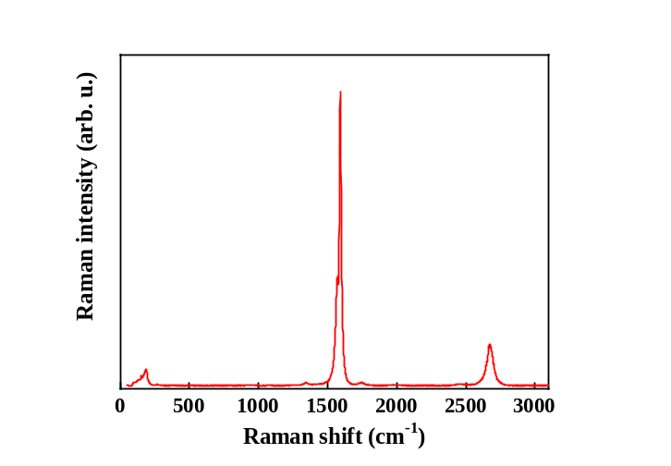
(b)
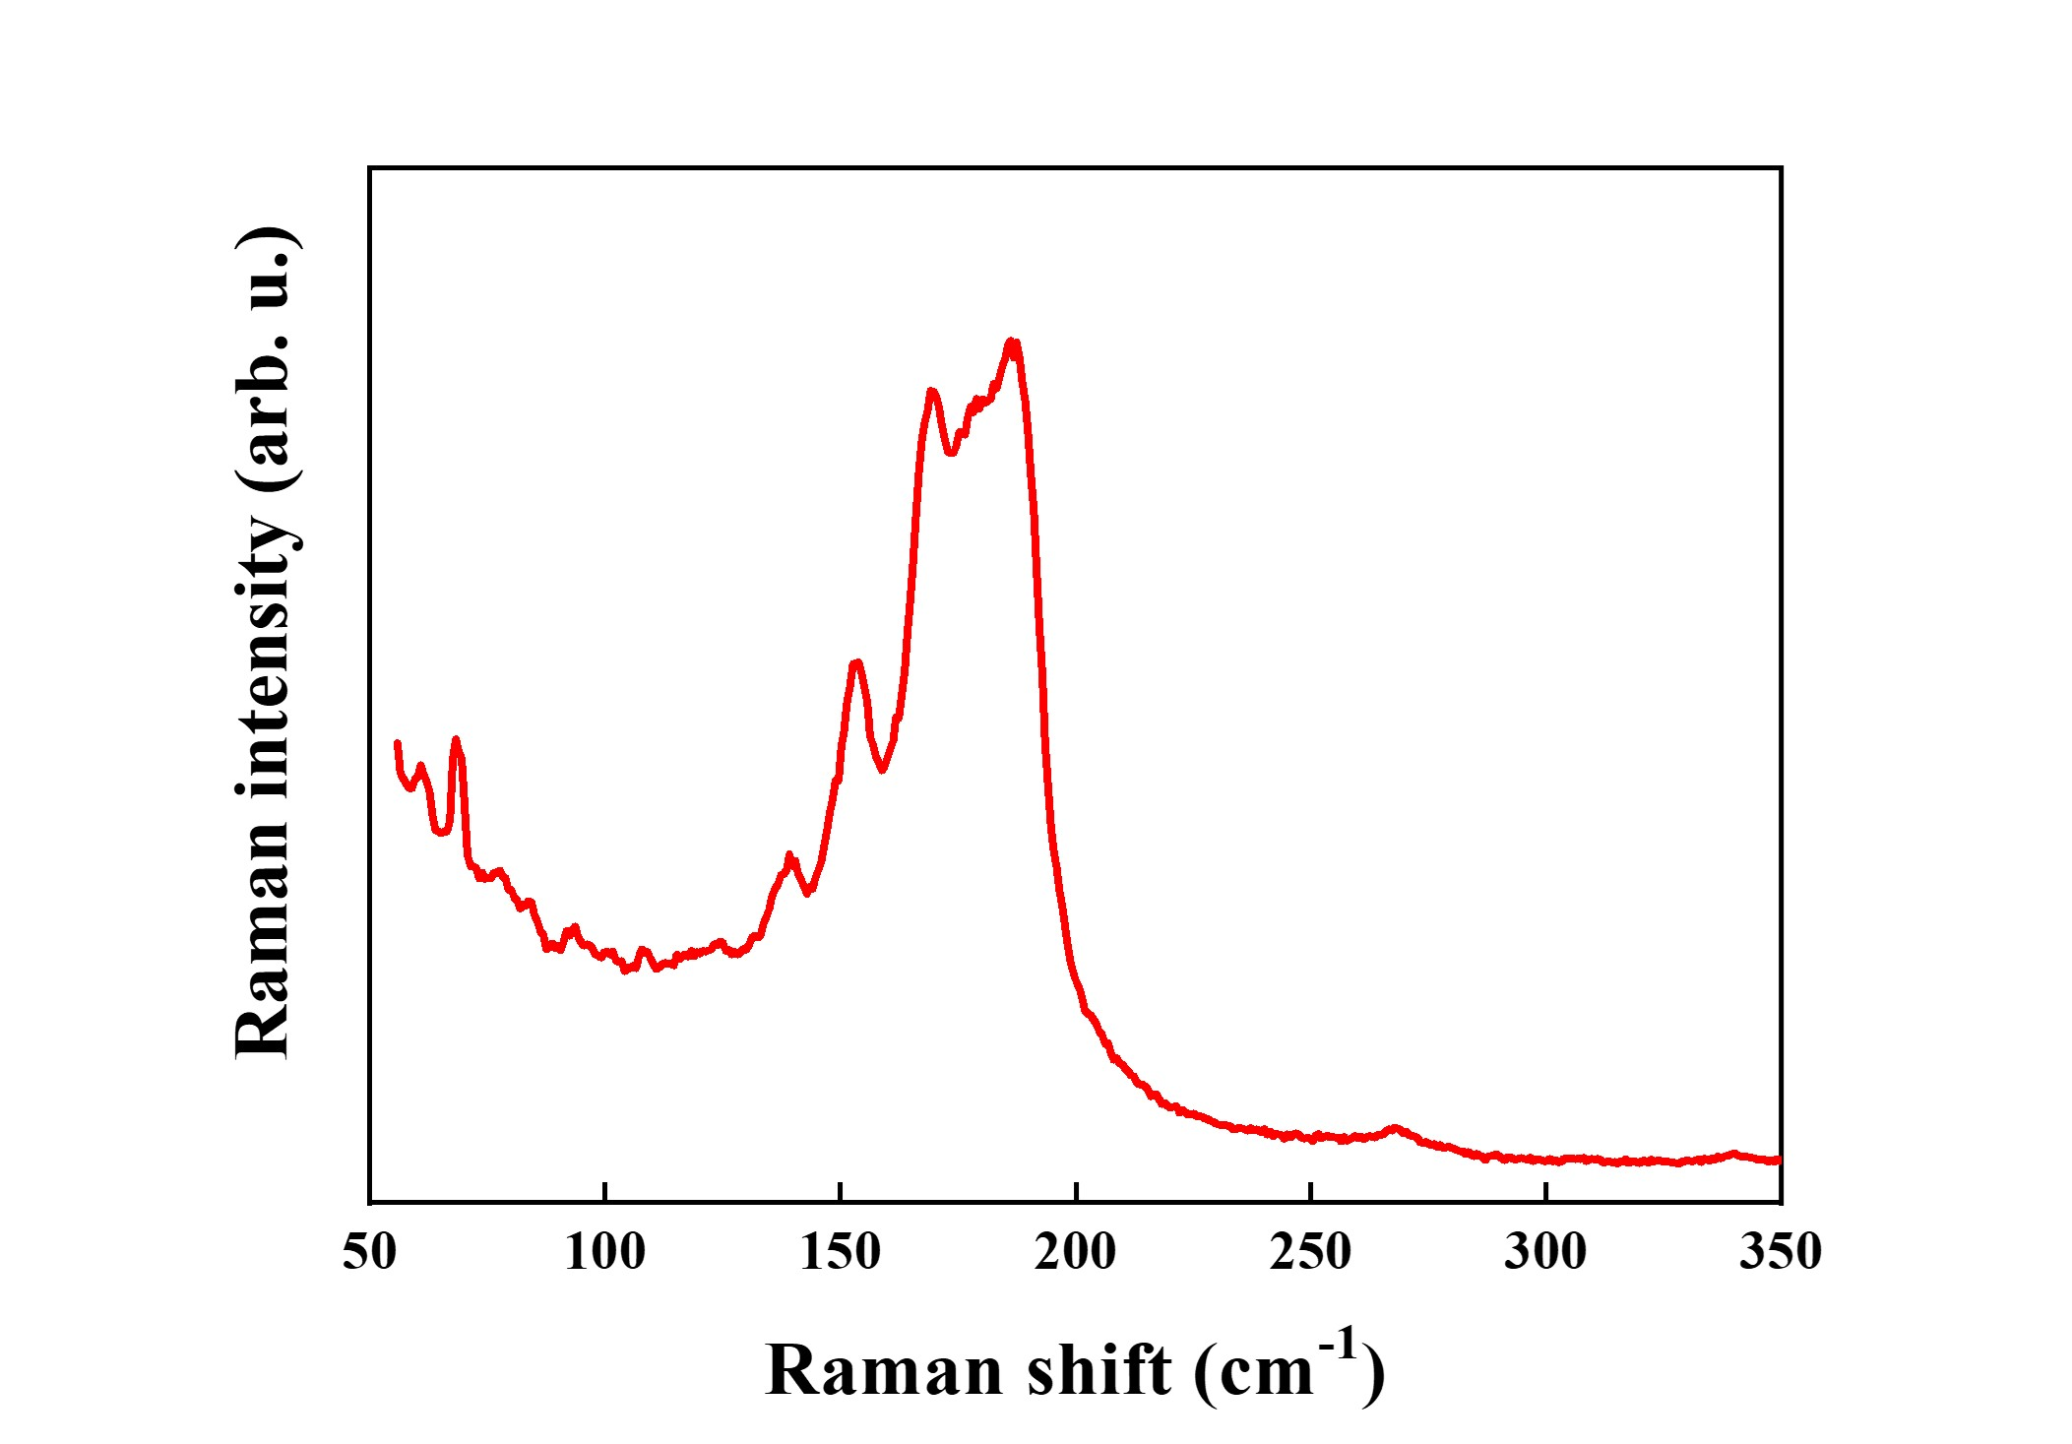

Fig. S1 (a) Raman spectrum of the as-received CNT powder used in this study. The RBM, D, G, and 2D bands were observed at approximately 130–200, 1346, 1594, and around 2675 cm⁻¹, respectively. (b) Enlarged view of the RBM region.

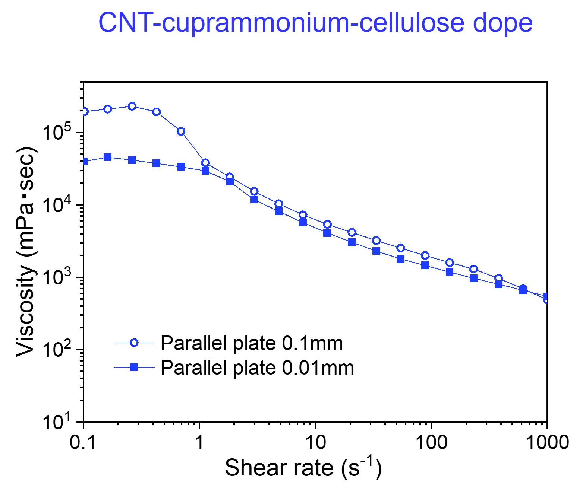
Fig. S2 Viscosity of 1.2 wt% CNT/6.1% cellulose-containing cuprammonium dope prepared by blending the 3.0 wt% CNT dispersion and the 10.1 wt% cellulose-containing cuprammonium solution at a weight ratio of 40:60. The measurements were done with a parallel plate gap of 0.01 mm or 0.1 mm, showing a shear-thinning behavior.

Interestingly, viscosity of the CNT-cuprammonium cellulose dope exhibit a drop beyond a shear rate of approximately 0.7 to 3 s⁻¹. To investigate the dynamic behavior, we visualized the macroscopic structure of the CNTs between the parallel plates of the rheometer using an optical microscope and a high-speed camera (Supplementary Movies 1 and 2). Above a shear rate of ~10 s⁻¹, distinct stripe patterns were observed. The thin parallel plate gap of 0.01 mm only allowed the in-situ optical microscope observation. We notice that the small gap might differentially affect the rheological behavior of the dope, however, a thicker gap of 0.1 mm resulted in the invisible black image. The movies 1 and 2 capture the stripe patterns under shear rates of approximately 1-10 s⁻¹ and 10-200 s⁻¹, respectively. The high-speed camera images at a shear rate of ~100 s⁻¹ indicate a shear-induced CNT alignment, which could be subsequently transferred to the cellulose fibers during wet spinning.

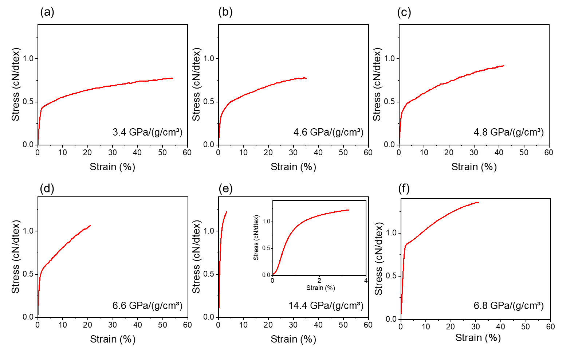
Fig. S3 Typical stress–strain curves of the CNT–RCF composite fibers prepared under different draw ratios: (a) CNT-RCF-1, (b) CNT-RCF-2, (c) CNT-RCF-3, (d) CNT-RCF-4, and (e) CNT-RCF-5, together with (f) cupra RCF as a control. An enlarged view of the initial region for panel (e) is shown as an inset. The specific elastic modulus estimated from the initial slope of each stress–strain curve is indicated in the lower-right corner of each panel.
Demonstration experiments of breathing monitoring
Cuprammonium rayon fiber is widely used in the apparel, decoration and textile industries as an alternative to natural silk due to its smoothness and feel. The matrix material of CNT-RCF is cuprammonium rayon, so the fabric is soft to the touch and has excellent durability. In fact, CNT-RCF can be knitted using an automatic tube knitting machine (Figure S4a). The photograph clearly shows that the CNT-RCFs were looped together to form a typical weft-knitted textile structure (the zoomed one in Figure S4a). In this time, we employed a CNT-RCF with a conductivity of approximately 1.5 S/cm for the demonstration experiments of sensor application. The spinning conditions are detailed in Table S1. CNT-RCF fibers were knitted on a tube knitting machine (Eiko Industrial Co. Ltd, Model: NCR-BW) to produce knitted sensors of 30 x 150 mm size. A 10 x 150 mm electrode section made of silver threads (Nippon Shinsozai Corporation) was attached to the top of the knit sensor. The fabricated knit sensor was soaked in a boiling detergent to remove oil from the fiber surface. The knit sensors were dried at room temperature and sewn into garments without tension. The knit sensor and garment were attached with covering chain stitch using non-conductive thread, and the electrode portion of the knit sensor was attached to the snap button at the left waist using silver thread. The snap button and device (data logger) were connected, and data was sent wirelessly through the device to the personal computer (Figure S4b). The evaluation test was conducted in an environment maintained at 20 °C and 65 % relative humidity. One of the promising applications of conducting fibers is a strain sensor. Figure S4 shows an overview of thoracic and abdominal breathing monitoring using CNT-RCFs. The sensor bodies are placed at two locations on the anterior thoracic (sensor 1) and anterior abdomen (sensor 2) and connected to a data logger. The detected electrical resistance is transferred via Bluetooth to a personal computer in a timely manner.
Figure S4c shows electrical resistance change over time for sensor 1 (black line) and sensor 2 (red line) during normal breathing in the standing position. The resistance values of sensor 1, located in the thoracic, and sensor 2, located in the abdomen, similarly oscillate between approximately 0 and 12 kΩ in synchronization with breathing. The electrical resistances of the sensors 1 and 2 increased for deep breathing (Figure S4d). When thoracic breathing was performed, the resistance change of sensor 1 was about twice that of sensor 2 (Figure S4e), while the resistance change of sensor 2 became larger than that of sensor 1 for abdominal breathing (Figure S4f). The CNT-RCF sensor is capable of distinguishing between normal, deep, chest, and abdominal breathing.
The participant was provided informed consent before participating in the study. The institution does not require ethics approval for reporting this case.

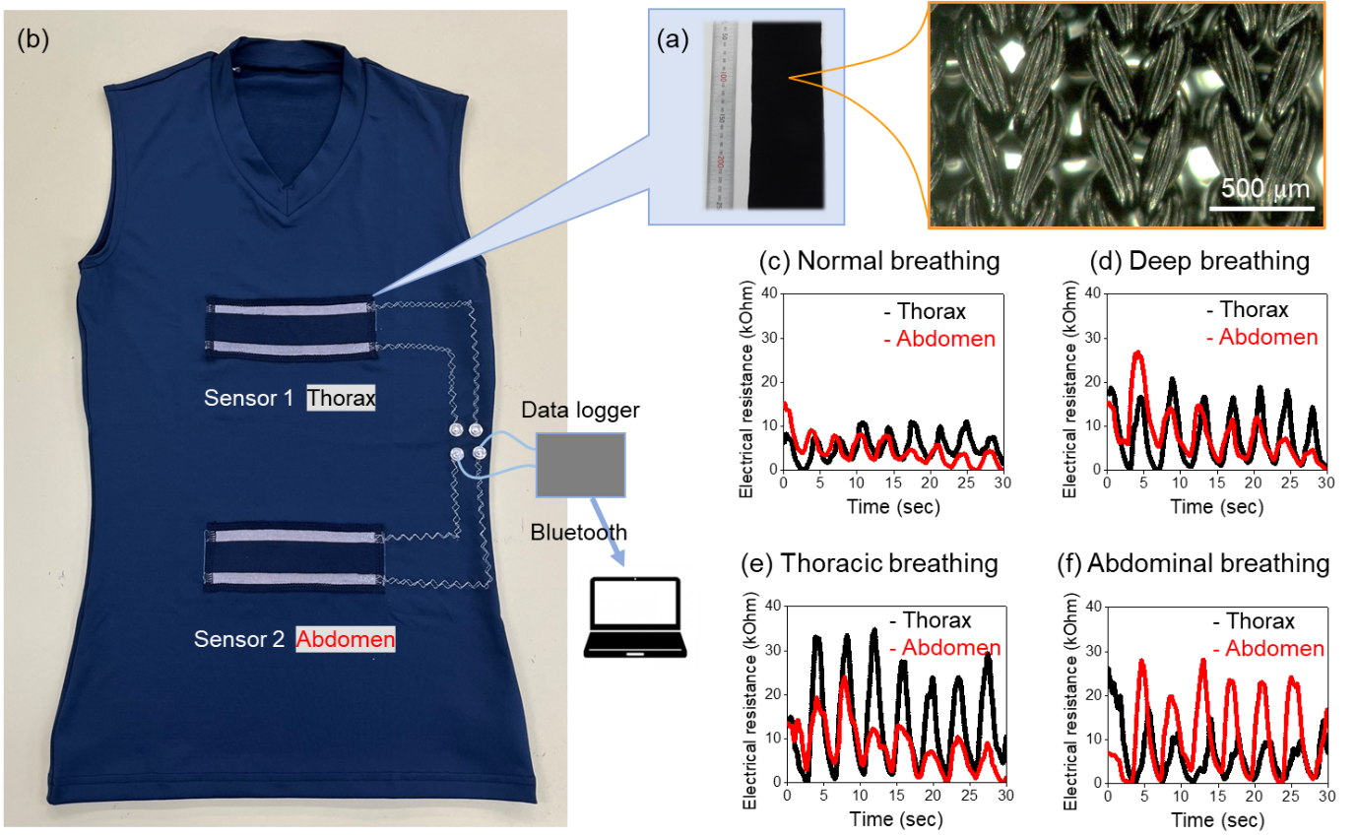
Fig. S4 (a) Photographs of knitted fabrics made of the CNT-RCFs. (b) Overview of thoracic and abdominal breathing monitoring using CNT-RCFs. Electrical resistance changes of sensors 1 (black line) and 2 (red line) during (c) normal breathing, (d) deep breathing, (e) abdominal breathing and (f) thoracic breathing in the standing position.

Table S1. Process parameters of CNT-RCF for sensor application
CNT concentration [wt%] | 4.7
Draw ratio | 33.5
Specific Conductivity [Scm²/g] | 1.01
Resistance [Ω/cm] | 6316
Fracture strength [cN/dtex] | 1.12
Fracture elongation [%] | 9.7
Fineness [dtex] | 156
Number of filaments | 19
Fineness (Monofilament) [dtex] | 8.2

