Lazarini et al., 2026

Supporting Information SI 4. Interaction ability of pGEX-4T1 DNA plasmid by the Ag-PROB complex
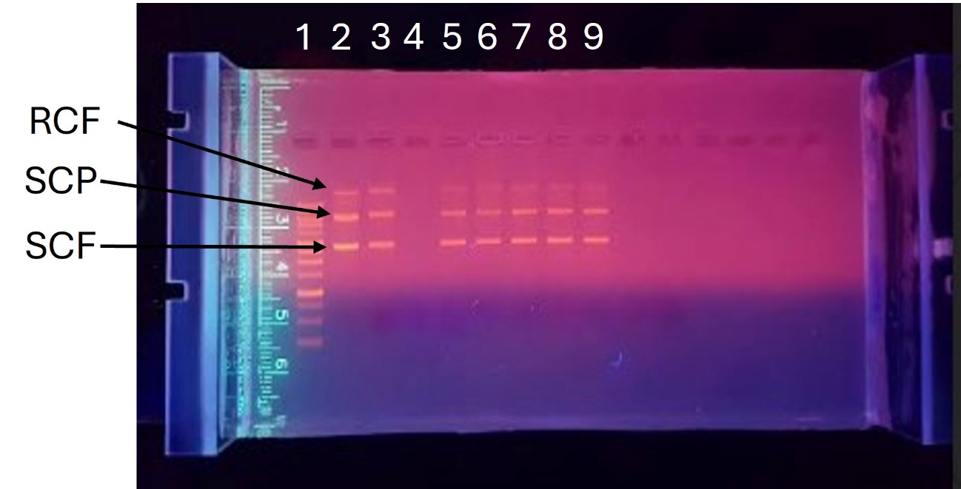
Lanes 5 – 8 shows that the Ag-PROB complex did not interact with pGEX-4T1 at the concentrations tested, demonstrating that the antibacterial and antiproliferative mechanism of action is probably not due to DNA interaction. The absence of RCF, SPF and SCF (Lane 4) confirms the interaction of cisplatin, a metal complex already used in the treatment of some types of cancer, with plasmid DNA pGEX-4T1, whose mechanism for biological activity and toxicity is already known as DNA covalent binding (Liu et al. 2010). Silver nitrate (Lane 9) did not interact with pGEX-4T1 at the concentrations tested. Given the results obtained, it can be inferred that the mechanism of action of the Ag-PROB complex is not related to the interaction with DNA.

