Polyomic analyses of neuromelanin containing granules isolated from human nigral dopaminergic neurons in Parkinson’s disease.

Affif Zaccaria^{1*}, Paola Antinori¹, Virginie Licker¹, Enikö Kövari², Johannes A Lobrinus³, Pierre R Burkhard^{1,4}.

Supplementary information

Supplementary Table S1. Samples analysed by transcriptomics with associated RIN values and number of LMD dissected Neuromelanin granules.

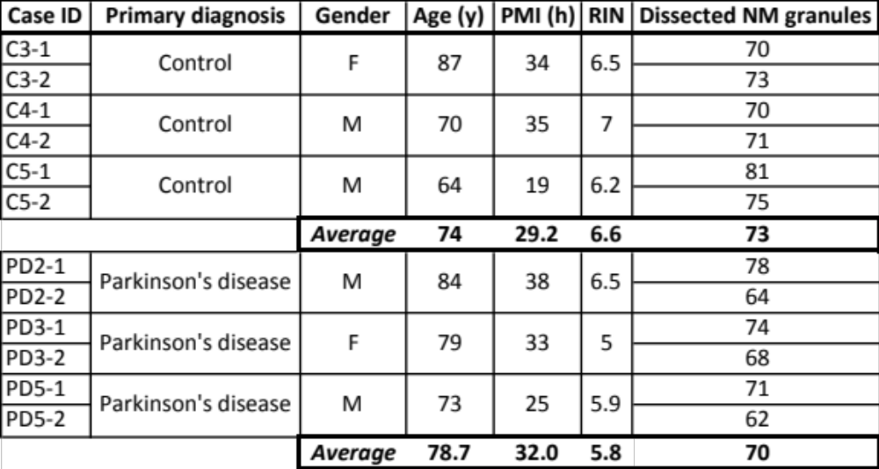

Columns:
Case ID: C = control sample
PD = Parkinson Disease sample
Gender: M = male
F = female
Age: y = years
PMI: Post Mortem Delay
h = hours
RIN: RNA integrity Number
Dissected NM granules: NM = Neuro Melanin
Number of NM granules obtained by Laser Microdissection for each sample

Supplementary Table S2. cDNA libraries.

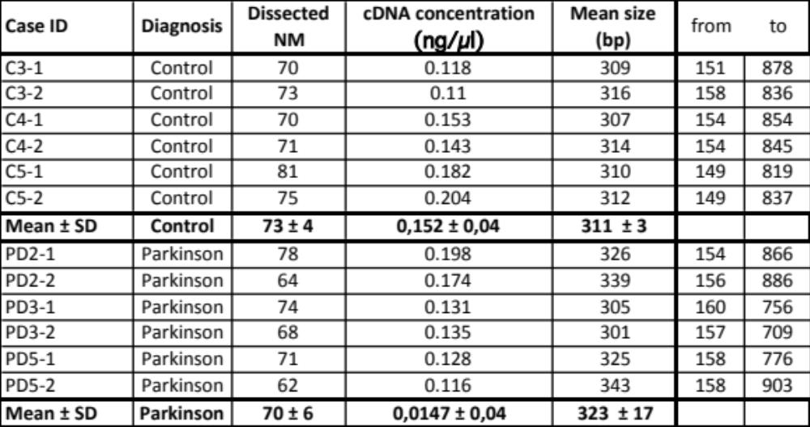

Columns:
Case ID: C = control sample (number 1 and 2 after the dash indicates the duplicates)
PD = Parkinson Disease sample (number 1 and 2 after the dash indicates the duplicates)
Dissected NM granules: NM = Neuro Melanin
Number of NM granules obtained by Laser Microdissection for each sample
cDNA concentration (ng/µL): concentration of the cDNA after RNA extraction from the samples with the RNAqueous micro kit from Life Technologies, reverse transcription and cDNA amplification with the SMARTer™ Ultra Low RNA kit from Clontech. 200 pg of cDNA were used for library preparation using the Nextera XT kit from Illumina. cDNA concentration was assessed with the Qbit
Mean size (bp): bp = base pair
The library fragment size was assessed with the Tapestation using a DNA High sensitivity chip (Agilent Technologies). The mean fragment size and the minimum (from) and maximum (to) size are given for each library in base pairs (bp) units

Supplementary Table S3. Sample analysed by proteomics and number of NM granules obtained by LMD for each sample.

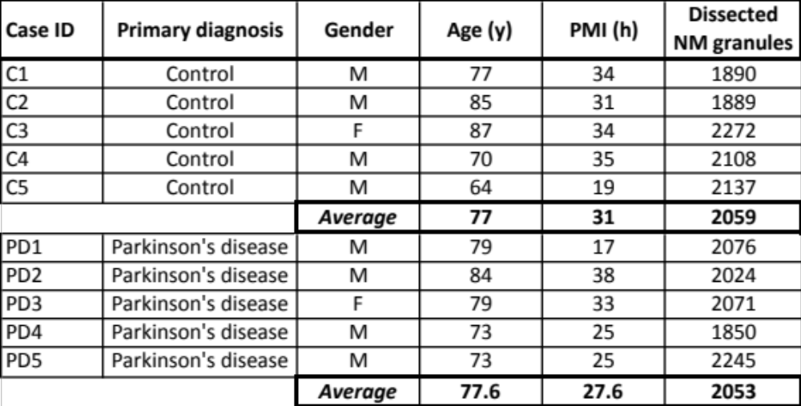

Columns:
Case ID: C = control sample
PD = Parkinson Disease sample
Gender: M = male
F = female
Age: y = years
PMI: Post Mortem Delay
h = hours
Dissected NM granules: NM = Neuro Melanin
Number of NM granules obtained by Laser Microdissection for each sample

