Supplementary Figure 1: PLP-Cre Mediated Recombination occurs primarily in non-myelinating Schwann cells. Eight-week-old PLP-CreERt;ROSA26-EYFP mice were injected with tamoxifen, and the sciatic nerves were dissected. In the sciatic nerve of the Plp-CreERt;ROSA26-EYFP mice, the expression of EYFP was detected by anti GFP antibody in both myelinating and non-myelinating Schwann cells. Higher magnification: white triangles mark EYFP positive cells that are positive for the non-myelination Schwann cell marker p75NTR, and white arrows mark EYFP positive cells that are positive for the myelination Schwann cell marker MBP. In the sciatic nerve of the Cre- negative ROSA26-EYFP mice, the expression of EYFP was not detected (see Figure 1B). N = 6 mice, 3 mice per group (Cre positive and Cre negative).

Supplementary Figure 2: Axon caliber distribution is not altered by PLP-Cre mediated APC ablation during peripheral nerve regeneration. Axon caliber distribution was assessed based on the EM micrographs. APC ablation did not affect axonal diameter distribution in the sciatic nerve. Eight-week-old APC^{Lox/Lox} (control) and PLP-CreER^{t}-APC^{Lox/Lox} mice were used. The Shapiro-Wilk test confirmed normality for both groups (W(3) = 0.8241, 𝑝 = 0.1735 for APC^{Lox/Lox} and 𝑊(3) = 0.9392, 𝑝 = 0.5241 for PLP-CreER^{t}-APC^{Lox/Lox}). Multiple unpaired t-tests were conducted for three axon diameter ranges: <3 µm ((8) = 0.6158, 𝑝 = 0.555), 3–<4 µm ((4) = 0.2290, 𝑝 = 0.830), and >4 µm (𝑡(9) = 0.9389, 𝑝 = 0.372). No significant differences were observed in any of the axon caliber groups. Multiple unpaired t-tests were conducted, revealing no significant differences in axon caliber distribution (𝑡(2) = 0.507 , 𝑝 = 0.663 ; 𝑡(4) = 1.497, 𝑝 = 0.209 ; 𝑡(4) = 0.089, 𝑝 = 0.933 ; 𝑡(4) = 0.884, 𝑝 = 0.427 ; 𝑡(3) = 0.174 , 𝑝 = 0.873). Error bars represent the standard error of the mean (S.E.M). N = 6 mice, 3 mice/group; 224 axons were analyzed for both groups combined. Significance levels: 𝑝 > 0.05 (n.s.).
Supplementary Figure 3: Nerve crush injury result in reduced paw width, paw length and reduced Sciatic nerve Functional Index (SFI).
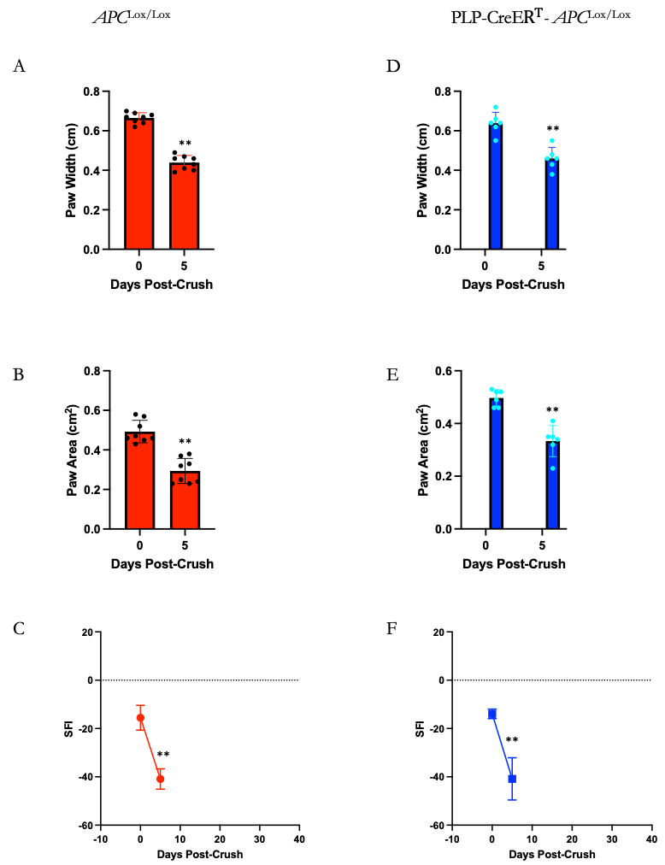
Supplementary Figure 3: Nerve crush injury result in reduced paw width, paw length and reduced Sciatic nerve Functional Index (SFI). Eight-week-old PLP-CreER^{t} -APC^{Lox/Lox} and Cre-negative APC^{Lox/Lox} (used as control) were injected with tamoxifen. Two weeks post-injection, the sciatic nerve in the right limb was subjected to nerve crush injury (see Materials and Methods). Five days post crush, the functional functions were assessed. (A-F) Statistically significant reduction in paw width, paw area, and Sciatic Nerve Functional Index (SFI) compared to prelesion (day O) condition. Similar crush induced reduction was observed in both the control group (A-C) and the PLP-CreER^{t} -APC^{Lox/Lox} (APC KO) mice. Statistical analysis included two-way ANOVA with Šídák's post hoc test. Error bars represent standard errors of the mean (S.E.M). Sample size: N = 6 mice for APC KO group, and 8 mice per controls. Significance levels: 𝑝 > 0.05 (n.s.), 𝑝 ≤ 0.05 (*), 𝑝 ≤ 0.01 (**), p<0.001 (***), p<0.0001 (****).

