Monomethyl Fumarate Modulates Iron Metabolism and Mitochondrial Function in Microglia with Implications for Multiple Sclerosis Progression

Justus Dann¹, Katharina Klöster¹, Ulas Ceylan¹, Neele Heitmann¹, Britta Eggers^{2,3}, Svitlana Rozanova^{2,3,4}, Martin Eisenacher^{2,3,4}, Katrin Marcus^{2,3}, Konstanze F. Winklhofer⁵, Ralf Gold¹, Simon Faissner¹

¹ Department of Neurology, Ruhr-University Bochum, St. Josef-Hospital, Bochum, Germany
² Medizinisches Proteom-Center, Medical Faculty, Ruhr-University Bochum, Bochum, Germany
³ Medical Proteome Analysis, Center for Protein Diagnostics (PRODI), Ruhr-University Bochum, Bochum, Germany
⁴ Core Unit for Bioinformatics (CUBiMed.RUB), Medical Faculty, Ruhr-University Bochum, Bochum, Germany
⁵ Department Molecular Cell Biology, Institute of Biochemistry and Pathobiochemistry, Ruhr-University Bochum, Bochum, Germany
Corresponding author: Prof. Dr. Simon Faissner, MD, simon.faissner@rub.de

Supplementary file S1

Assessment of the purity of primary microglial cultures
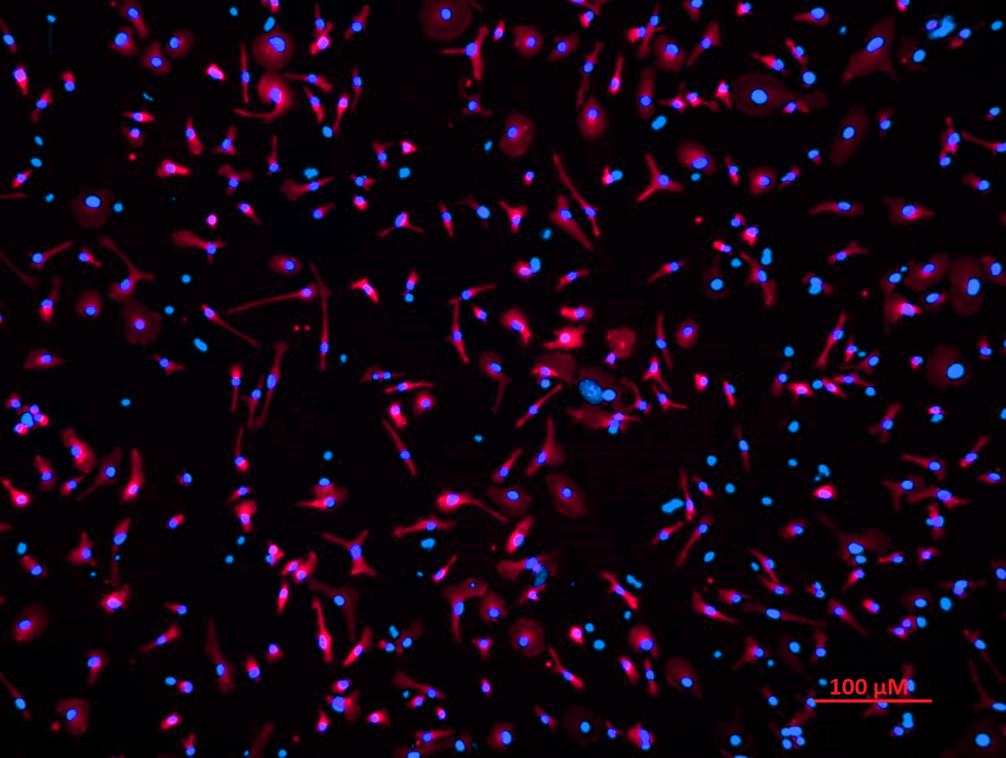
Supplementary Figure S1: Representative image of primary microglia stained for Iba1 (red) and DAPI. In total, four microscopic fields at 20× magnification were analyzed, with at least 500 cells counted overall. Cell purity was >95%.

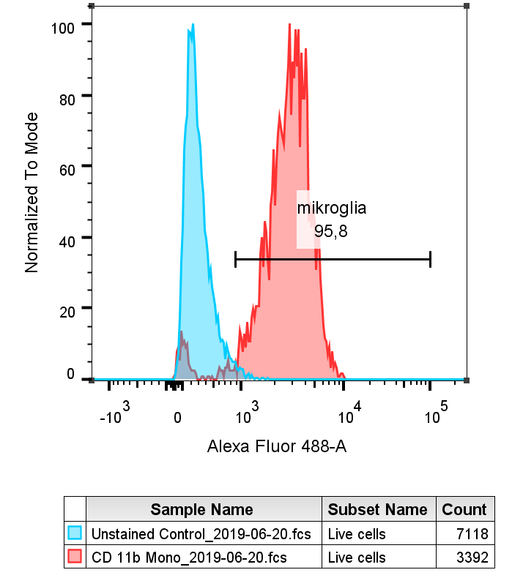
qPCR primers
Supplementary Figure S2: Representative flow cytometry analysis using CD11b staining. More than 95% of cells were CD11b-positive.
Gene | Sequence
Tnf (TNF) | F: 5´- ATG GCC TCC CTC TCA TCA GT -3´  R: 5´- TGG TTT GCT ACG ACG TGG G -3´
Slc11a2 (DMT1) | F: 5´- AAA GAT GCC AGA CGA TGG CG -3´  R: 5´- ATC CGT GGG ACC TTG GGA TA -3´
Trf (transferrin) | F: 5´- AGC CGA TGC TAT GAC CTT GG -3´  R: 5´- ACT GCC CGA GAA GAA ACT GG -3´
Slc40a1 (ferroportin) | F: 5´- GGC ACT TTG CAG TGT CTG TG -3´  R: 5´- GTG ACG TCT GGG CCA CTT TA -3´
Tbp (TATA-binding protein) | F: 5´- AGC TCT GGA ATT GTA CCG CA -3´  R: 5´- TGA CTG CAG CAA ATC GCT TG -3´
Actb (beta-actin) | F: 5´- GAC CTC TAT GCC AAC ACA GT -3´  R: 5´- AGT ACT TGC GCT CAG GAG GA-3´
Supplementary Table S1: Primer sequencing used for qPCR, including the housekeeping genes Tbp and Actb

Fumarate effects on primary murine astrocytes
Preparation of primary murine astrocyte cultures
Mixed glial cell cultures were prepared as described for microglia in the methods section. To obtain highly pure astrocytes, we used a shaking protocol previously described for rat astrocytes (Bettegazzi et al. 2011). The mixed glial cell culture flasks were shaken for 24 h at 200 rpm on day 2 and day 6 to remove any non-adhering cells. After 14 days the astrocytes were dissociated with Trypsin-EDTA 0.25% (GIBCO, Thermo Fisher Scientific; Cat.-No. 25200056) and then plated into poly-D-lysine-coated plates. In addition to the typical flat morphology observed by light microscopy, GFAP staining (Dako/Agilent, Cat.-No. Z0334) was performed to confirm the astrocytic identity of the cultured cells. Microglial contamination was assessed by Iba1 staining and revealed less than 1% Iba1-positive cells, corresponding to an astrocyte purity of >99% (see Fig. S3). Astrocytes were allowed to adhere for one week before experiments to ensure a mature phenotype. Astrocytes were seeded at a density of 20.000 cells per well and were allowed to adhere for one week before experiments to ensure a mature phenotype.
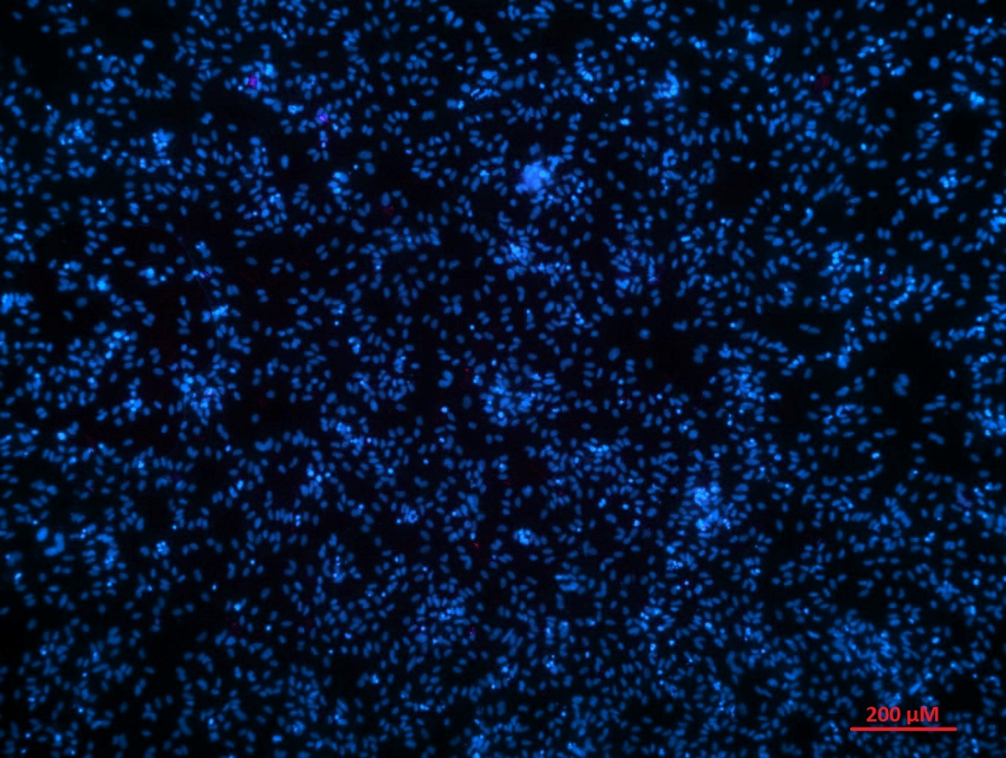
Supplementary Figure S3: Iba1/DAPI staining of primary astrocyte culture showing hardly any microglial contamination (red).

Supplementary Figure S4: In primary murine wildtype astrocyte cultures, MTT reduction appeared largely unchanged following treatment with fumaric acid esters (A) (n = 3 independent experiments). In contrast, Nrf2^{-/-} astrocytes showed an apparent increased susceptibility to DMF treatment at concentrations of 25 µM and 50 µM (B) (n = 3 independent experiments). All graphs represent means ± SD. No statistical analysis was performed due to the low number of independent experiments (n < 5), in accordance with the journal guidelines.

References
Bettegazzi B, Mihailovich M, Di Cesare A, Consonni A, Macco R, Pelizzoni I, Codazzi F, Grohovaz F, Zacchetti D (2011) β-Secretase activity in rat astrocytes: translational block of BACE1 and modulation of BACE2 expression. Eur J Neurosci 33:236–243. https://doi.org/10.1111/j.1460-9568.2010.07482.x

